Anuj Pratap Singh Yadav
 linkedin.com/in/yadavaps77 | 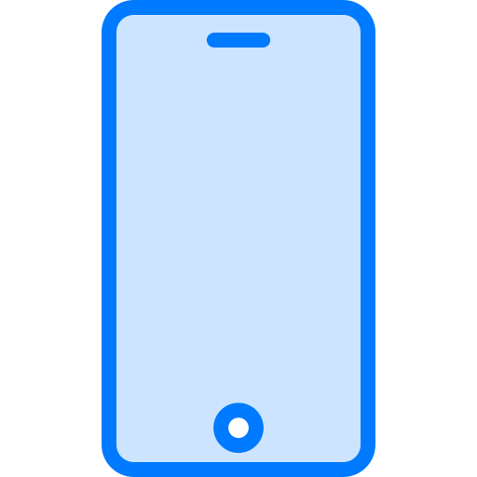 +91-97523-73677 | Noida, India |  yadav.anuj.singh@gmail.com
SUMMARY
Staff Engineer with 11 years shipping C++ at Synopsys, Microsoft and Adobe. At Synopsys VC Formal I own the DPV C++/RTL coverage subsystem end to end, including escalations from 8 semiconductor customer accounts, and led the decoupling of a Common layer used by 10-12 VC Formal apps from the Formal engine, cutting cross-layer dependencies ~75%; the pattern is now a cross-team standard.
SKILLS
Languages: C++, Python, TCL, Java, C#, TypeScript
Formal verification: DPV (datapath validation), C++ and RTL code coverage, coverage databases, cone-of-influence (COI) analysis, property and assertion density
Tools and infra: VC Formal, Verdi coverage database (VDB), FlexNet licensing, LCOV, LSF, Perforce, GDB, Linux
Architecture: Dependency inversion, header-level modularization in large C++ codebases, multi-process IPC, adaptive licensing design
AI and analysis tooling: LLVM (DG program slicer, in progress), LLM agent tooling in Cursor (custom skills, searchable doc index), Jira/Perforce automation, license-probe harness
EXPERIENCE
Staff Engineer | Synopsys Inc Noida, India | May 2023 - Present
Product: VC Formal (DPV)
- Own the DPV C++/RTL coverage subsystem (save_covdb, VDB generation, Verdi integration) end to end: design docs (reviewed by senior architects and a Distinguished Engineer), every release since V-2023.12, and escalations from 8 semiconductor customer accounts, each taken from root cause to regression test to a fix across all active streams. Presented it at a top GPU customer's internal formal-verification summit.
- Led the decoupling of Common code from the Formal engine in a 2M+ line C++ codebase whose Common layer serves 10-12 VC Formal apps, a decade-old coupling that had stalled earlier attempts. Chose incremental dependency inversion (a callback-based options layer) over a big-bang split; 2-3 changes per sprint for 6+ months with the Common and CDC teams; cross-layer dependencies down ~75% (132 to 34).
- Made the options-layer pattern a documented cross-team standard and presented it org-wide; the Low Power team adopted it, and two engineers I mentored now run their own decoupling work.
- Built save_covdb from scratch on UCAPI (proof merging, dual-design flow, Verdi VDB output), unblocking customer signoff flows that could not merge proofs or view C++ coverage in Verdi. Agreed the VDB hierarchy with the Verdi team in Taiwan; hardened it through 8+ customer-reported issues and 40+ regression tests.
- Built property and assertion density reporting (report_assertion_density) end to end across the Hector engine, VCF TCL shell, two-process XML IPC and HTML reports, giving DPV the signoff-completeness analytics FPV already had; now used by most DPV customers.
- Took DPV licensing through three models in two years (Token; per-app Cores, raising Base 1 to 4 and Elite 4 to 12; then Apex), designing the Elite fallback order so existing customers were never locked out by a tier change. Built a T0-T6 license-probe harness that cut probe-regression triage from weeks to ~2 days; trimmed the licensing suite from 38 tests to 9 with coverage preserved.
- Extended save/restore, a flow many enterprise customers rely on, so case-split procedures, SVA results, density reports and C++ coverage proofs survive a restored session (XML-based problem persistence).

- Introduced LLM agent tooling to the DPV team: built and shared Cursor skills for regression validation, code review and license checks, backed by a searchable index of 500+ internal docs; regression triage dropped from 2-3 hours to 5-10 minutes. Also built the daily Jira-compliance notifier my manager asked for.
- Building a DG/LLVM-based program slicer for C++ designs in DPV (in progress): the first phase computes the cone of influence of the signals in a design's assertion properties.
- Also: interview panels; 50+ code reviews across DPV and neighbouring teams; mentored 2 engineers on the coverage stack and ran the knowledge transfer that brought it into a new C++/RTL verification app.
Software Engineer II | Microsoft Noida, India | May 2021 - May 2023
- Built PowerPoint Recording Studio features (C++) with the team: camera modes, live background blur, video export and Cameo, a camera object placed on the slide. Monthly recording sessions grew from 1.5M to 4.2M over those releases (Cameo: ~1.2M). Led v1 test automation and Recording/Export telemetry.

- New commerce SKUs kept breaking OneDrive's upgrade path as sev-2s that took 2-3 weeks to fix in production; designed catalog filtering with an allowlist (C#) so unsupported SKUs never reached the upgrade API. Also worked on the purchase-events microservice (C#, Docker, Azure Event Hubs).

Member of Technical Staff 2 | Adobe Noida, India | Aug 2015 - Apr 2021
- Migrated Photoshop Elements and Premiere Elements from the legacy build system to Hyperdrive, parallelizing independent bundles in the CI/CD pipeline; install time down ~50% on average. Spot Award.
- Designed lazy loading for large files in the AEM web editor; load time down ~60% on the files customers had reported as freezing.
- Also: licensing deactivation on uninstall (Photoshop / Premiere Elements), MathML rendering in the AEM web editor, ColorPop in Photoshop Elements 2020. (C++, Java, React, TypeScript)
EDUCATION
B.Tech, Computer Science - Maulana Azad National Institute of Technology (NIT Bhopal) | 2011 - 2015 | GPA 8.27/10

