Anuj Pratap Singh Yadav
 linkedin.com/in/yadavaps77 | 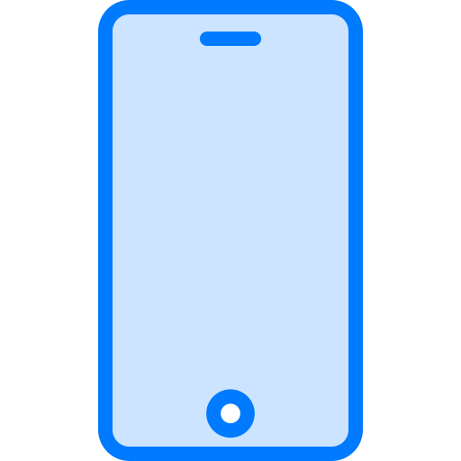 +91-97523-73677 | Noida, India |  yadav.anuj.singh@gmail.com
SUMMARY
Staff Engineer with 11 years in large, long-lived C++ codebases: Photoshop Elements (Adobe), Office Win32 (Microsoft) and now Synopsys VC Formal, a 2M+ line formal-verification product. I own a customer-facing C++ subsystem end to end and led an incremental decoupling of shared code from engine internals that cut cross-layer dependencies ~75% without a rewrite; two engineers now apply the pattern independently.
SKILLS
Languages: C++, Java, C#, TypeScript/JavaScript, Python
Systems: Modern C++ (C++17), large-codebase refactoring and modularization, dependency inversion, multi-process IPC, performance optimization, Linux, GDB
Backend / Cloud: C# services on Azure (Event Hubs), Docker, REST APIs, product telemetry
Frontend / Desktop: React, TypeScript; C++ Win32 desktop (PowerPoint, Excel, Photoshop Elements)
Tooling and AI: LLVM (program-slicing prototype), LLM agent tooling (custom Cursor skills, searchable doc index), Perforce, Git, CI/CD
EXPERIENCE
Staff Engineer | Synopsys Inc Noida, India | Feb 2024 - Present
Promoted from R&D Engineer, Senior II (May 2023 - Jan 2024). Product: VC Formal, formal verification for chip design
- Own the C++/RTL coverage subsystem of VC Formal end to end: design, every release since 2023, and escalations from 8 semiconductor customers (incl. Nvidia, Intel, AMD, Apple, Google), each taken from root cause to regression test to a fix shipped across all active release streams. Presented the work at Nvidia's internal formal-verification summit.
- Led the decoupling of shared code from engine internals in a 2M+ line C++ codebase, a decade-old coupling that had stalled earlier attempts. Chose incremental dependency inversion (a callback-based options layer) over a big-bang module split, shipping 2-3 changes per sprint for 6+ months. Cross-layer dependencies down ~75% (132 to 34) [confirm: build-time or rebuild-count effect]. Gave an org talk; two engineers now run their own decoupling work on the pattern.
- Built the coverage-database writer from scratch on a proprietary coverage API, unblocking customer signoff flows that could not merge proofs or save coverage for the viewer. Agreed the database hierarchy with the viewer team in Taiwan; hardened it through 8+ customer-reported issues and 40+ regression tests.
- Took the product line's licensing through three models in two years (token, per-app cores, tiered with fallback), designing the fallback order so existing customers were never locked out by a tier change. Built a license-probe harness that turned regression triage from weeks into ~2 days, and cut the licensing suite from 38 tests to 9 with coverage preserved.
- Built property and assertion density reporting end to end (engine, TCL shell, two-process XML IPC, HTML report) so customers could measure verification completeness on datapath designs, closing a gap with the sister product; shipped in 4 release streams.

- Built my own LLM agent tooling for this codebase in Cursor (9 custom skills, a searchable index of 500+ internal docs); cut my regression triage from 2-3 hours to 5-10 minutes and demoed it to the team [confirm: teammates now using it].
- Now prototyping an LLVM-based program slicer for cone-of-influence analysis of C++ designs [confirm: your role; drop if it can't be named].
Software Engineer II | Microsoft Noida, India | May 2021 - May 2023
- Owned Recording Studio features in PowerPoint Win32 (C++): camera modes, live background blur, video export, and Cameo, a camera object users place on the slide. Monthly recording [confirm: sessions or users] grew from 1.5M to 4.2M over those releases; Cameo reached ~1.2M of them. Led test automation for v1 and added Recording/Export telemetry.
- Built the standalone video insertion and playback component for Stream 2.0 in Excel Win32 (C++, TypeScript), for SharePoint and OneDrive video.
- New commerce SKUs kept breaking OneDrive's upgrade path as sev-2s that took 2-3 weeks to fix in production; designed catalog filtering with an allowlist (C#) so unsupported SKUs never reached the upgrade API [confirm: incidents after]. Also worked on the purchase-events microservice (C#, Docker, Azure Event Hubs).

SDE 2 / Member of Technical Staff | Adobe Noida, India | Aug 2015 - Apr 2021
- Migrated Photoshop Elements and Premiere Elements from the legacy build system to Hyperdrive, parallelizing independent bundles in the CI/CD pipeline; install time down ~50% on average. Spot Award.
- Designed lazy loading for large files in the AEM web editor; load time down ~60% on the files customers had reported as freezing.
- Also: licensing deactivation on uninstall (Photoshop / Premiere Elements), MathML rendering in the AEM web editor, ColorPop in Photoshop Elements 2020. (C++, Java, React, TypeScript)

EDUCATION
B.Tech, Computer Science - Maulana Azad National Institute of Technology (NIT Bhopal) | 2011 - 2015 | GPA 8.27/10

