Anuj Pratap Singh Yadav
 linkedin.com/in/yadavaps77 | 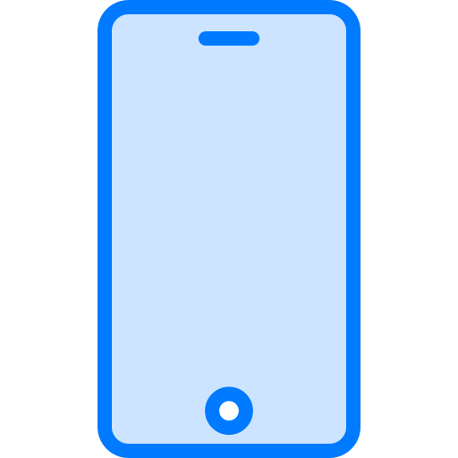 +91-97523-73677 | Noida, India |  yadav.anuj.singh@gmail.com
SUMMARY
Staff Engineer with 11 years in large, long-lived C++ codebases: Photoshop Elements (Adobe), Office Win32 (Microsoft) and now Synopsys VC Formal, a 2M+ line formal-verification product. I own a customer-facing C++ subsystem end to end and led an incremental decoupling of a shared layer used by 10-12 apps that cut cross-layer dependencies ~75% without a rewrite; the pattern is now a documented cross-team standard.
SKILLS
Languages: C++, Java, C#, TypeScript/JavaScript, Python
Systems: Modern C++ (C++17), large-codebase refactoring and modularization, dependency inversion, multi-process IPC, performance optimization, Linux, GDB
Backend / Cloud: C# services on Azure (Event Hubs), Docker, REST APIs, product telemetry
Frontend / Desktop: React, TypeScript; C++ Win32 desktop (PowerPoint, Excel, Photoshop Elements)
Tooling and AI: LLVM (program slicer, in progress), LLM agent tooling (Cursor skills, searchable doc index), Perforce, Git, CI/CD
EXPERIENCE
Staff Engineer | Synopsys Inc Noida, India | May 2023 - Present
Product: VC Formal, formal verification for chip design
- Own the C++/RTL coverage subsystem of VC Formal end to end: design docs (reviewed by senior architects and a Distinguished Engineer), every release since 2023, and escalations from 8 semiconductor customers (incl. Nvidia, Intel, AMD, Apple, Google), each taken from root cause to regression test to a fix across all active release streams. Presented it at Nvidia's internal formal-verification summit.
- Led the decoupling of shared code from engine internals in a 2M+ line C++ codebase whose shared layer serves 10-12 apps, a decade-old coupling that had stalled earlier attempts. Chose incremental dependency inversion (a callback-based options layer) over a big-bang split; 2-3 changes per sprint for 6+ months with the shared-code and CDC teams; cross-layer dependencies down ~75% (132 to 34).
- Made the pattern a documented cross-team standard and presented it org-wide; the Low Power team adopted it, and two engineers I mentored now run their own decoupling work.
- Built the coverage-database writer from scratch on a proprietary coverage API, unblocking customer signoff flows that could not merge proofs or save coverage for the viewer. Agreed the database hierarchy with the viewer team in Taiwan; hardened it through 8+ customer-reported issues and 40+ regression tests.
- Took the product line's licensing through three models in two years (token; per-app cores with 3-4x higher per-license core limits; tiered with fallback), designing the fallback order so existing customers were never locked out by a tier change. Built a license-probe harness that turned regression triage from weeks into ~2 days, and cut the licensing suite from 38 tests to 9 with coverage preserved.
- Built property and assertion density reporting end to end (engine, TCL shell, two-process XML IPC, HTML report) so customers could measure verification completeness on datapath designs, closing a gap with the sister product; now used by most of the product's customers.

- Introduced LLM agent tooling to my team: built and shared Cursor skills for regression validation, code review and license checks, backed by a searchable index of 500+ internal docs; regression triage dropped from 2-3 hours to 5-10 minutes. Also built the daily Jira-compliance notifier my manager asked for.
- Building an LLVM-based program slicer for C++ hardware designs (in progress): the first phase computes the cone of influence of the signals used in a design's assertion properties.
- Also: interview panels; 50+ code reviews across my team and neighbouring teams; mentored 2 engineers on the coverage stack and ran the knowledge transfer that brought it into a new C++/RTL verification app.
Software Engineer II | Microsoft Noida, India | May 2021 - May 2023
- Built PowerPoint Recording Studio features (C++) with the team: camera modes, live background blur, video export and Cameo, a camera object placed on the slide. Monthly recording sessions grew from 1.5M to 4.2M over those releases (Cameo: ~1.2M). Led v1 test automation and Recording/Export telemetry.
- Built the standalone video insertion and playback component for Stream 2.0 in Excel Win32 (C++, TypeScript), for SharePoint and OneDrive video.
- New commerce SKUs kept breaking OneDrive's upgrade path as sev-2s that took 2-3 weeks to fix in production; designed catalog filtering with an allowlist (C#) so unsupported SKUs never reached the upgrade API. Also worked on the purchase-events microservice (C#, Docker, Azure Event Hubs).

Member of Technical Staff 2 | Adobe Noida, India | Aug 2015 - Apr 2021
- Migrated Photoshop Elements and Premiere Elements from the legacy build system to Hyperdrive, parallelizing independent bundles in the CI/CD pipeline; install time down ~50% on average. Spot Award.
- Designed lazy loading for large files in the AEM web editor; load time down ~60% on the files customers had reported as freezing.
- Also: licensing deactivation on uninstall (Photoshop / Premiere Elements), MathML rendering in the AEM web editor, ColorPop in Photoshop Elements 2020. (C++, Java, React, TypeScript)

EDUCATION
B.Tech, Computer Science - Maulana Azad National Institute of Technology (NIT Bhopal) | 2011 - 2015 | GPA 8.27/10

