**WEB technologies**

**Title:** Canteen website creation.

**Teacher:** Aldiyar Salkenov

**Overview**

* We are team 3. Our task is to create a website for the Astana IT University canteen. A site that should be functional and attractive, with different interesting functions and beautiful pictures. Before we start working on a project, let's introduce each participant. So, there are 6 people in the group:

Aruzhan Aptarbek - team leader, homepage, body, reservation maker, footer maker, - [204025@astanait.edu.kz](mailto:204025@astanait.edu.kz)

Alikhan Abdrakhmanov - menu, HTML - [204041@astanait.edu.kz](mailto:204041@astanait.edu.kz)

Aiym Assan - documentation writer, HTML - [204068@astanait.edu.kz](mailto:204068@astanait.edu.kz)

Zhakhan Suleimenov - HTML, menu - [204159@astnait.edu.kz](mailto:204159@astnait.edu.kz)

Balzhan Salimova - CSS,body maker, documentation writer, creator telegram bot – [204044@astanait.edu.kz](mailto:204044@astanait.edu.kz)

Leyla Zhaksygeldi - menu, information collector - [204088@astanait.edu.kz](mailto:204088@astanait.edu.kz)

* To work on this project, we have decided with the group and discussed who would have what role, who can do what on his own behalf for this project, how can we make our website quality. Since everyone is good at something specific, we divided the tasks and began to take the first steps to create our website. Aruzhan, being the leader of the team, did an excellent job. She assigned roles to each group member and monitored the completion of the task. She also contributed to the creation of the homepage, header with a navigation bar, containers, carousel, body div with social media photos and footer with contacts. She created a reservation form in Mailchimp form. Alikhan worked with html and menus. Aiym wrote documentation and helped with html. Zhakhan worked with html to create the menu. Balzhan worked on the design of the site and participated in writing the documentation. Leyla collected information: she took pictures of food in the canteen and found out prices. She also helped create the menu. All participants did a good job.
* The project is needed to create a canteen site of Astana IT University, as well as to improve our knowledge of HTML and CSS. By this project, we will be able to show our knowledge and get a good grade.
* Our site can be useful for employees and students of Astana IT University. They will be able to see the canteen menu, prices and contacts. It is very convenient, people can look at the menu without leaving their office and, if necessary, reserve a table, since our site has a “Reservation” function.

**Project goals and team interests**

* Our main goal is to create a high-quality and convenient website for the canteen of our university. It would be very convenient and useful for people to use such a site. They can save their time and money.
* This project is important for us because during the process of creation this website, we will be able to learn something new in html and css, learn more about resources that can be useful to us in our work, gain good experience, learn to work in a team, distribute the role, manage and exchange knowledge and also get to know each other better.

# **Content structure**

**Site map**

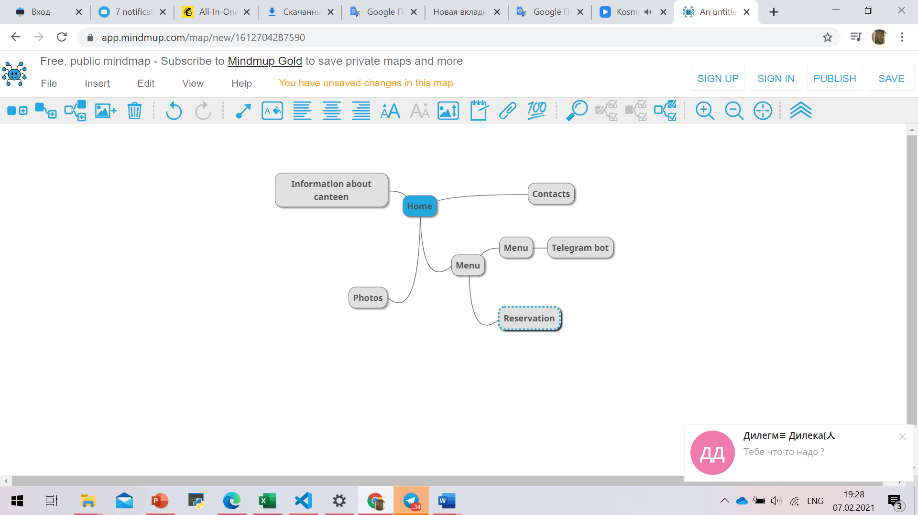

**Content types**

content types are:

• University canteen

•Registration

• Menu / order

**Design**

It is important to provide design assets and related references

There are many ways to provide design assets, for example:

• Reference links: <https://getbootstrap.com/docs/5.0/components/navbar/>

<https://cp.puzzlebot.top/constructor?b=AITUGObot>

<https://mailchimp.com/>

<https://html-color-codes.info/colors-from-image/>

• Image files: <https://i.pinimg.com/564x/99/4f/86/994f86dcb83a155566383969021bdedf.jpg>

<https://i.pinimg.com/564x/ab/5e/38/ab5e38a986c712069569b60ea9898cb4.jpg>

<https://img1.russianfood.com/dycontent/images_upl/264/big_263886.jpg>

<https://i.pinimg.com/564x/9a/8d/2f/9a8d2f269a887f1f23f05d63eea6c58d.jpg>

<https://i.pinimg.com/564x/e7/d8/0c/e7d80c8e06012a9baa8529710319910b.jpg>

<https://2recepta.com/recept/borshh/borshh.jpg>

<https://img.povar.ru/main/6c/a2/2e/2d/svekla_s_chesnokom_i_sirom-174676.jpg>

<https://www.patee.ru/r/x6/0c/a2/ab/960m.jpg>

**Functionality**

How our site actually works:

A quick guide to the university canteen menu, where you can order and register a place in the institution.

Registration page:

Name; (your name)

Last name; (your last name)

Phone number; (current number so that the establishment can call you and clarify the order or some details)

Order; (list of your orders)

Prepayment; (to reserve a place, you must pay at least 5% of your order in advance, to do this, top up your account by number x xxx xxxx and attach your code)

Email address. (We need your mail to send the check)

**Hosting**

We uploaded our site through a Github account @aptarbekaruzhan

**Accessibility**

Better text content and information accessibility.

**Deadlines**

Indicated the phases of the project and their timing.

For example,

• Stage 1 - February 2, 12:00

• Stage 2 - February 5, 18:00

• Stage 3 - February 7, 20:00

**Phases**

* Phase 1 – Make general plan or sketch of home page.
* Phase 2 – Divide work into small groups and make a schedule for work.
* Phase 3 – Find materials menu, photos, food images.
* Phase 4 – Canteen website creation with HTML (Currently)
* Phase 5 – Add styles to improve the appearance and thus draw wider audience.
* Phase 6 – Menu web page creating.
* Phase 7 – Writing documentation.
* Phase 8 – Checking site for practical work.
* Phase 9 – Submitting ready code to the GitHub.

**Summary**

We created web site about our university canteen that can offer general information about our canteen. menu with all dishes in listed in cafeteria. Web site also provides new function of reserving places to make it much more convenient to find good places. Web site is answers to all criteria’s given in task and what is more important web page has fully lived up to our expectations. Nevertheless, our great work not dissed without problems. From most frequent we can take wrong coding (using tegs, classes with mistakes) and making little mistakes that will crush whole work (like missing one letter). From less numerous not the appropriate dock format. Despite all the stings one thing that this work taught us understanding what the team work is and how it is crucial to thing not only about your self.