3/7/2025

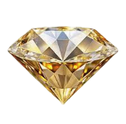

**E - Projects**

**Pascal Imitation Jewellery**

Teachers :

|  |  |
| --- | --- |
| Faculty | **SIR TAHA ABBAS** |
| Coordinator | **MAHAM**  **HAIDER** |

Team Members :

|  |  |  |
| --- | --- | --- |
| **STUDENT I’D** | **STUDENT EMAIL** | **STUDENT NAME** |
| **Student1602319** | **zoyafatimamirza@gmail.com** | **ZOYA FATIMA MIRZA** |
| **Student1604181** | **bq725338@gmail.com** | **MUHAMMAD** **BILAL** |
| **Student1604186** | **hashmisaadahmed@gmail.com** | **SAAD AHMED HASHMI.** |

Batch Code :

|  |
| --- |
| **2409E2** |

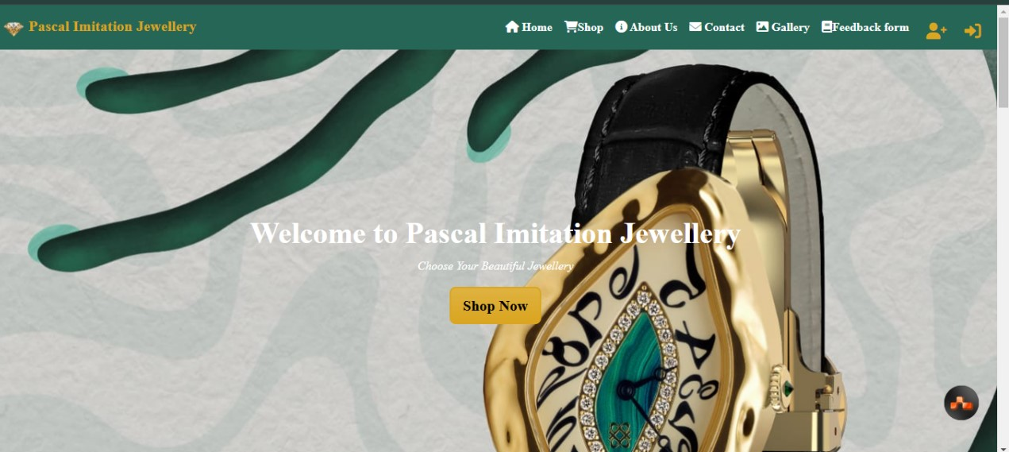 Main Page Section :

Cards Section :

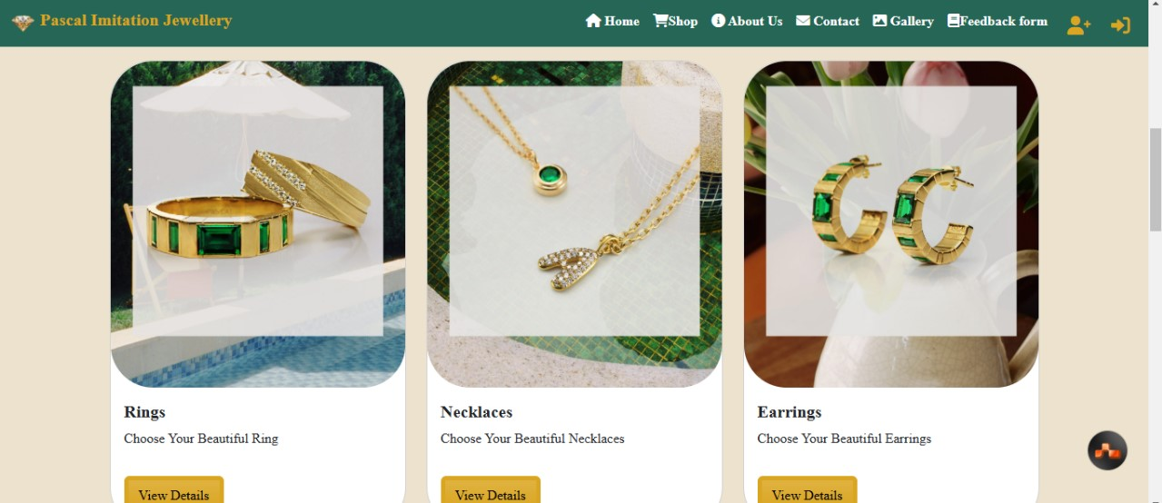

Rings Section :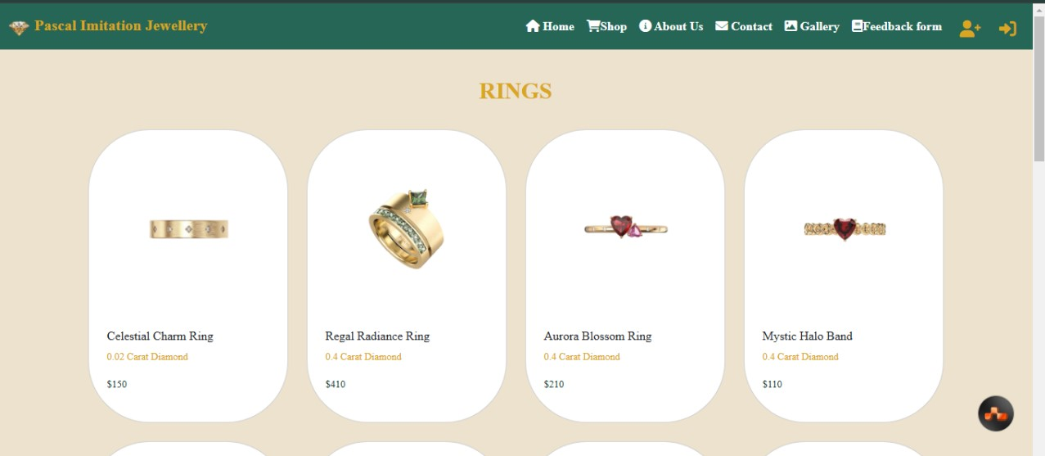

**Necklaces Section**:

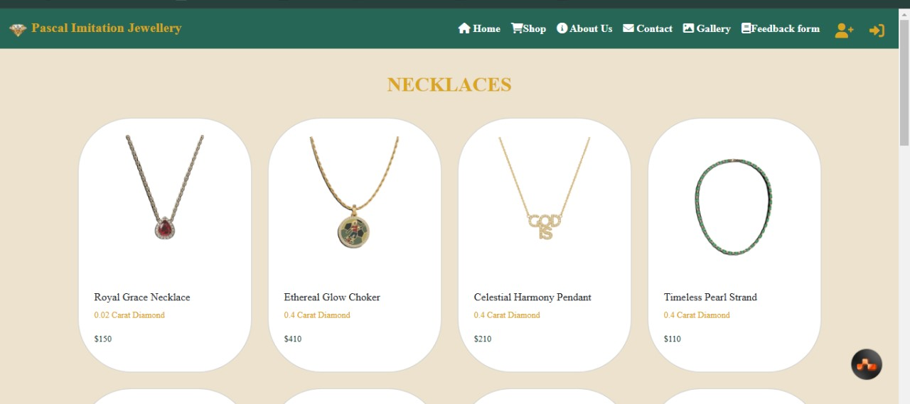

**Earrings Section**:

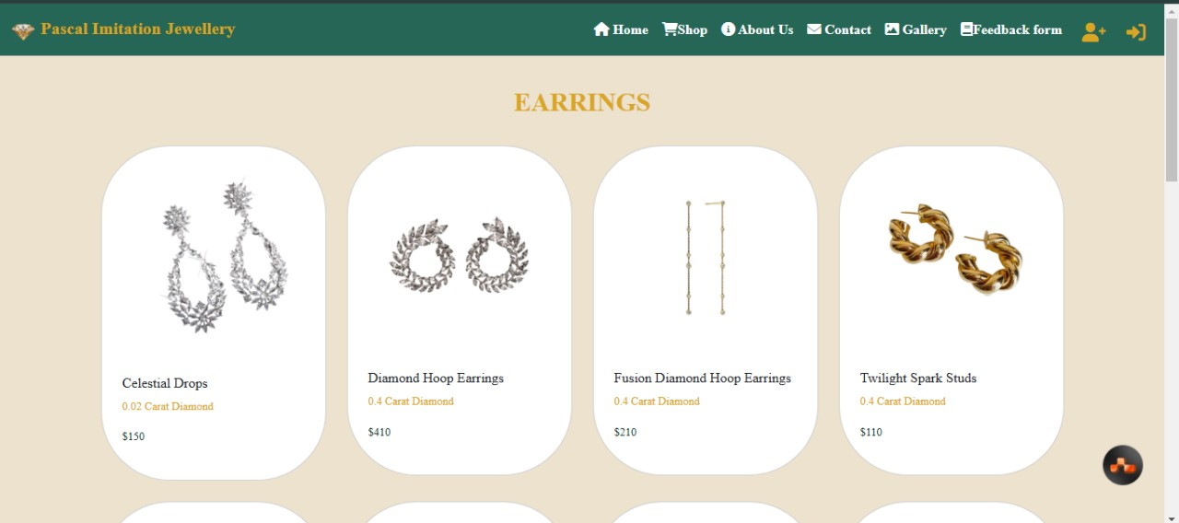

**Bracelet Section**:

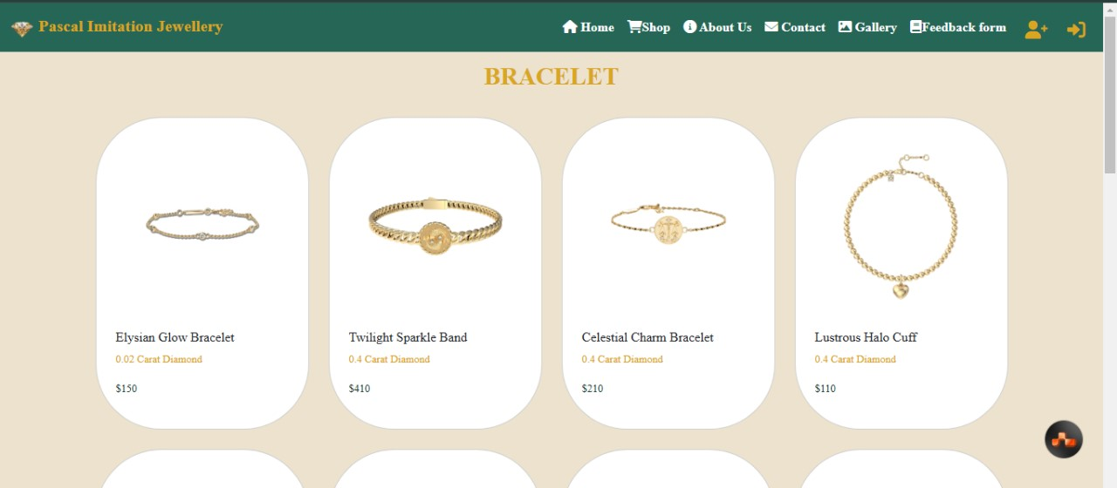

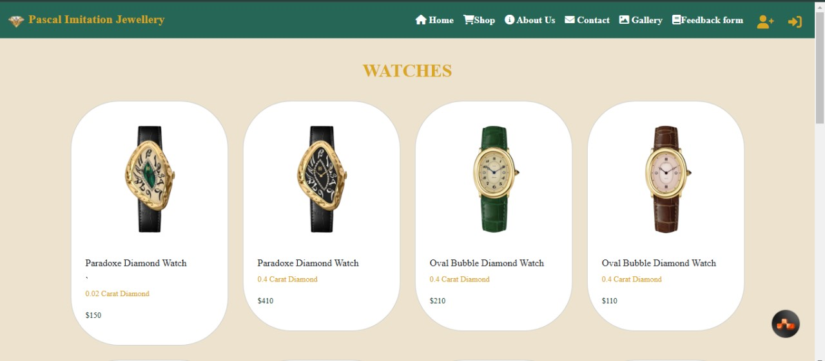**Watches Section**:

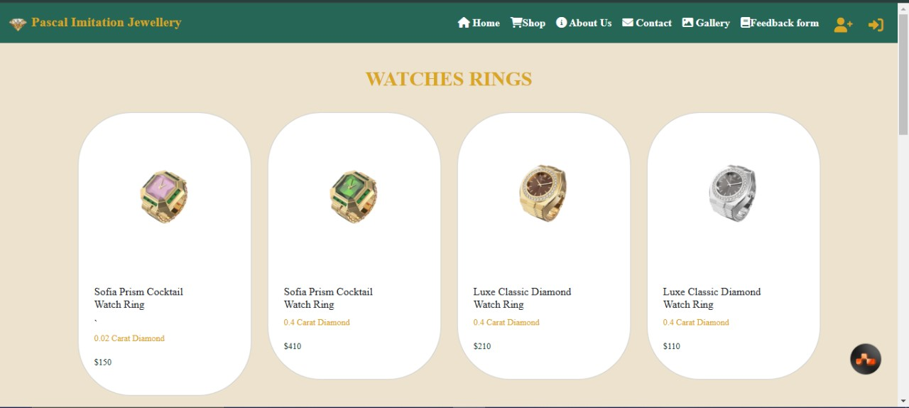**Watches Rings Section**

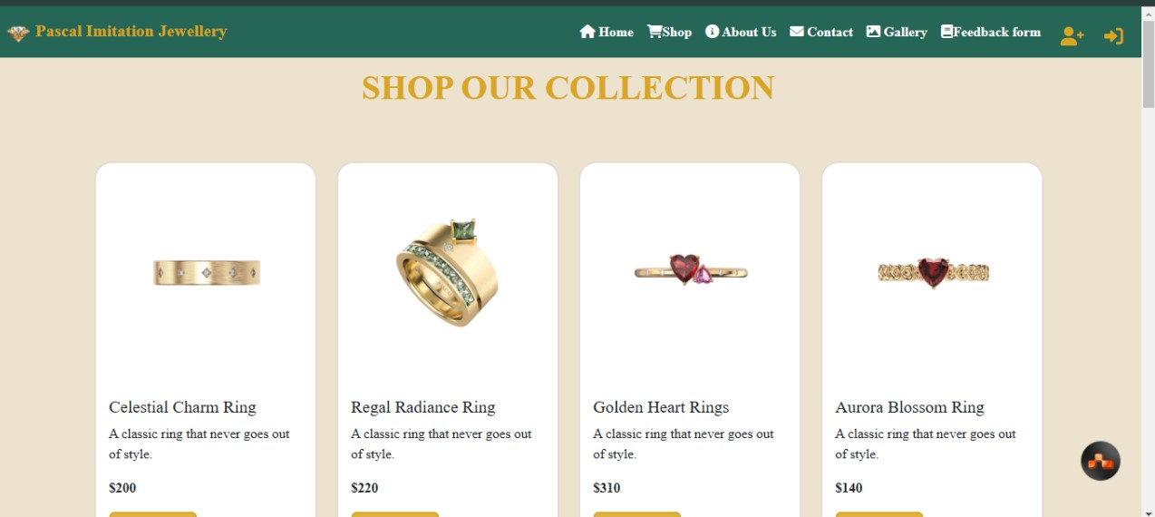**Shop Section :**

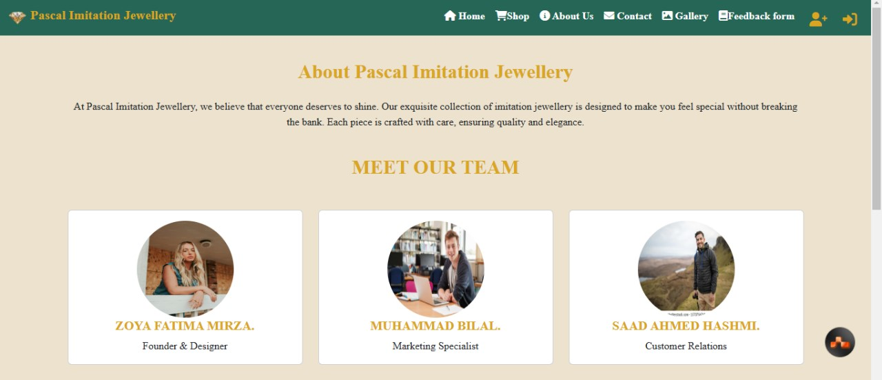**About Us Section :**

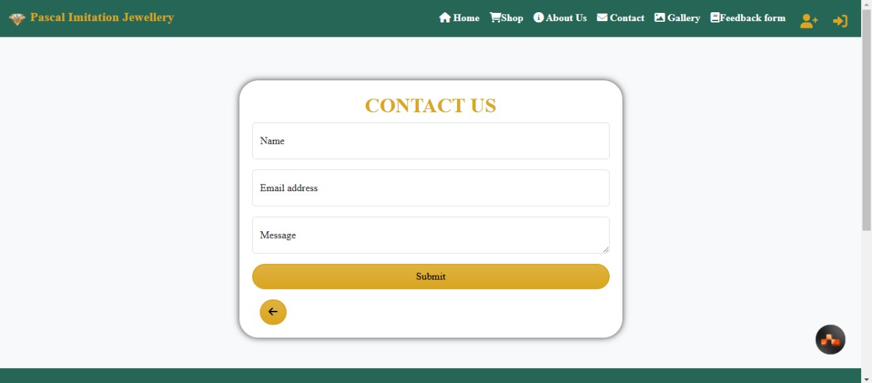**Contact Us Section :**

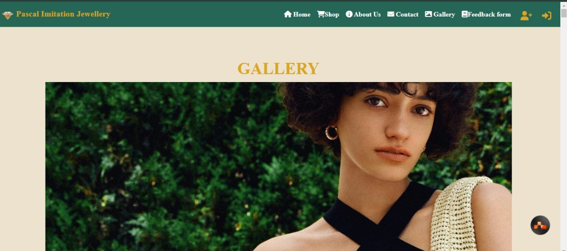**Gallery Section :**

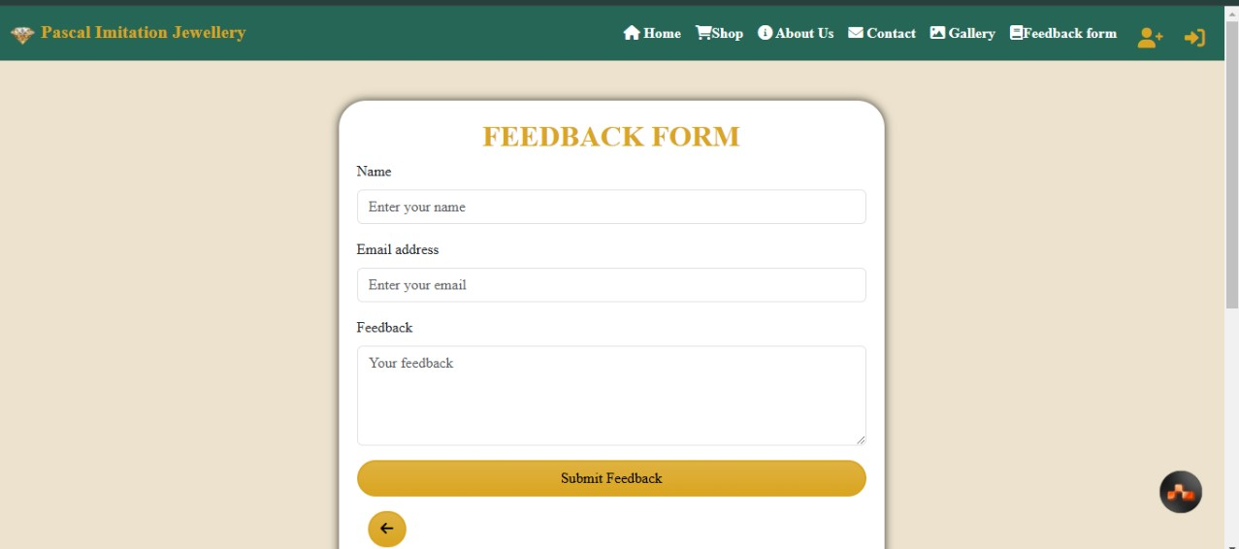**Feedback Form Section :**

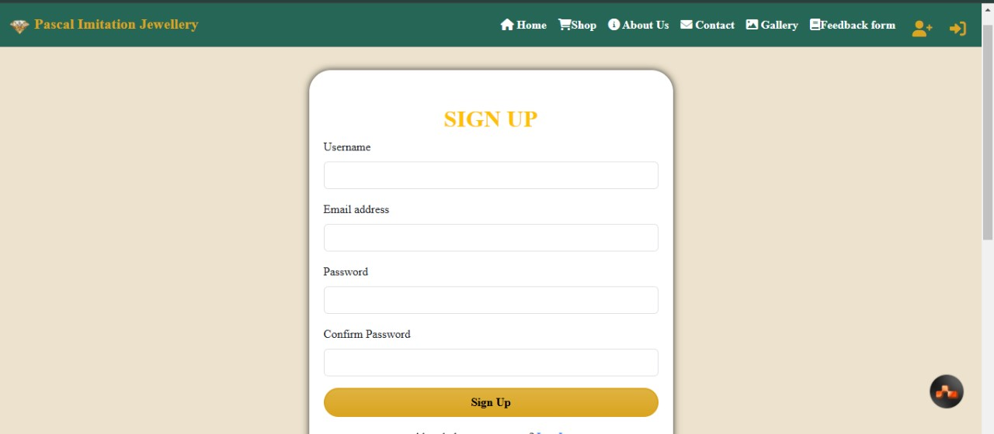**Sign Up Section :**

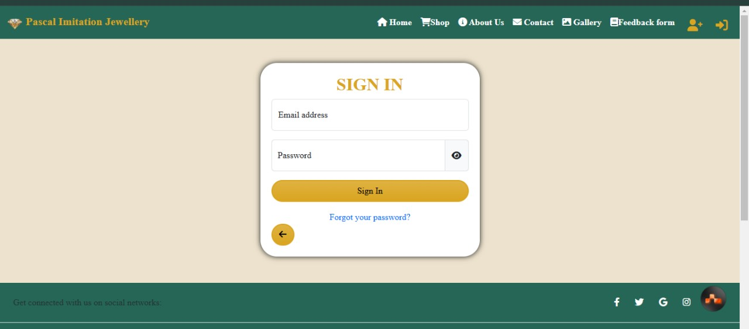**Sign In Section :**

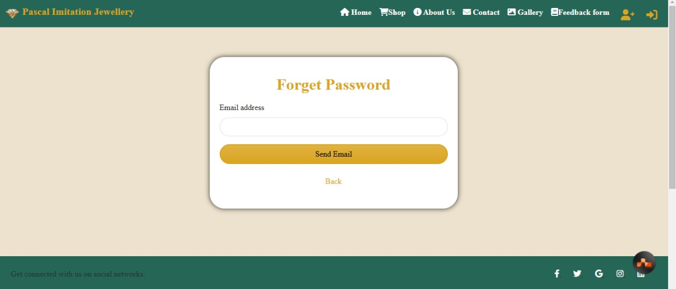**Forget Password Section :**

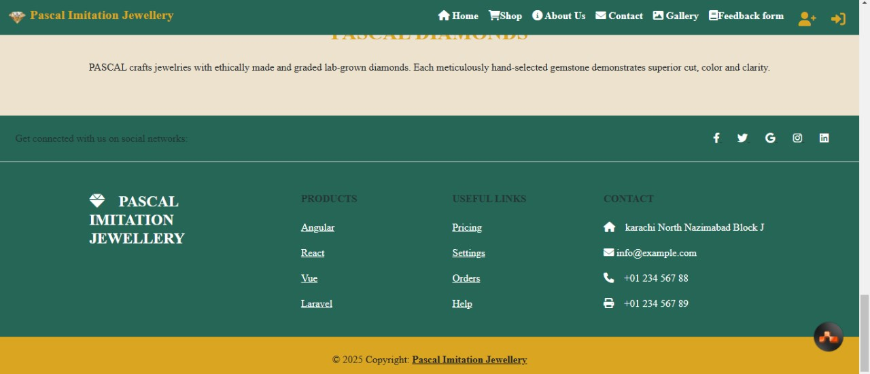**Footer Section :**

**Thank You**