

THE UNIFORM STORE

“PROJECT”

Document Type: Developer Documentation

Group Members
- Arisha Shahid
- Eman Kanwal
- Uneeza Fareed
- Quratulain Aslam


Institute: Aptech Learning
PROJECT INSTRUCTOR:
SIR ZAFEER

📘 Introduction

The Uniform Store is an online platform designed to provide schools, colleges, and institutions with a seamless experience for purchasing uniforms. This developer guide is created to assist developers in understanding, maintaining, and extending the functionalities of the platform.

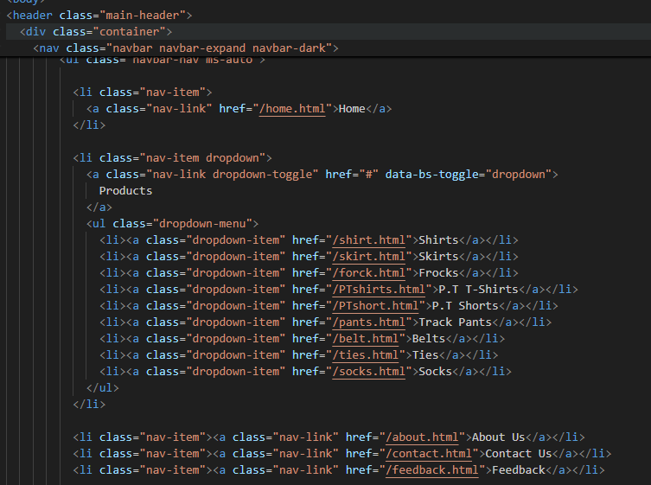

📘 Project Overview

- Project Name: The Uniform Store

- Type: Web Application

- Technologies Used: HTML, CSS, JavaScript, Bootstrap, PHP, MySQL

- Purpose: Enable users to browse, order, and manage uniforms efficiently.

📘 System Requirements

- Server: Apache or Nginx
- Database: MySQL 5.7 or above
- Browser Compatibility: Chrome, Firefox, Edge, Safari
- Development Tools: Visual Studio Code, XAMPP/WAMP

📘 Installation & Setup

- Download the Project Files:
  - Obtain the project repository from the provided source.
- Set Up the Server:
  - Install XAMPP/WAMP.
  - Start Apache and MySQL services.
- Database Configuration:
  - Create a database named uniform_store.
  - Import the provided database.sql file.
- Configure Project:
  - Update config.php with database credentials.
  - Ensure folder permissions allow file uploads.
- Run the Application:
  - Open browser and go to http://localhost/theuniformstore/.

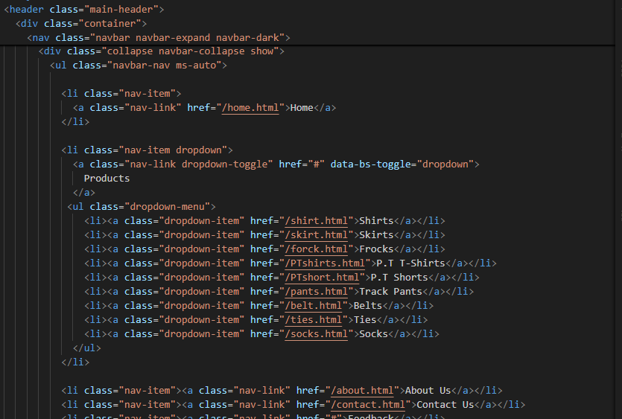

📘 Features

- User Registration & Login:
  - Secure authentication system.
  - Role-based access control (Admin/User).
- Product Management:
  - Admin can add, edit, or remove uniforms.
  - Categories for easy navigation.
- Order Management:
  - Users can place orders and view order history.
  - Admin can manage orders and update status.
- Responsive Design:
  - Fully responsive interface for desktop, tablet, and mobile.

📘 Code Structure

- index.html – Homepage
- login.php – User login page
- register.php – Registration page
- admin/ – Admin panel files
- css/ – Stylesheets
- js/ – JavaScript files
- images/ – All images
- config.php – Database configuration
- database.sql – Database schema

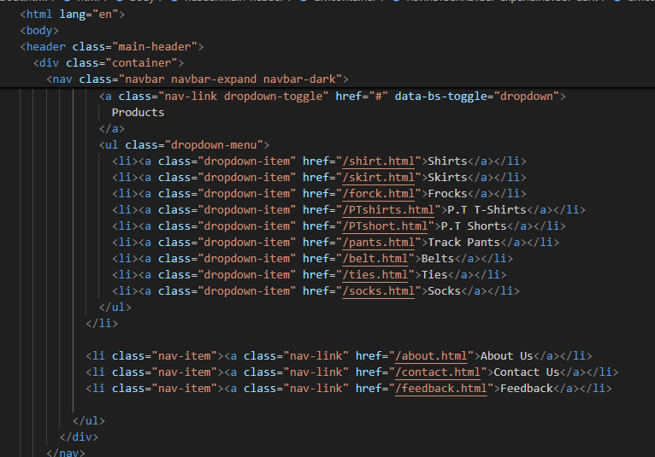

📘 Troubleshooting

- Database Connection Error: Check credentials in config.php.
- Page Not Found: Ensure correct paths and filenames.
- Styling Issues: Clear browser cache and check CSS link.

📘 Conclusion

This developer guide provides a comprehensive overview of The Uniform Store project. Developers can use this guide to set up, modify, and extend the project efficiently. Following the outlined structure ensures maintainable and scalable development.

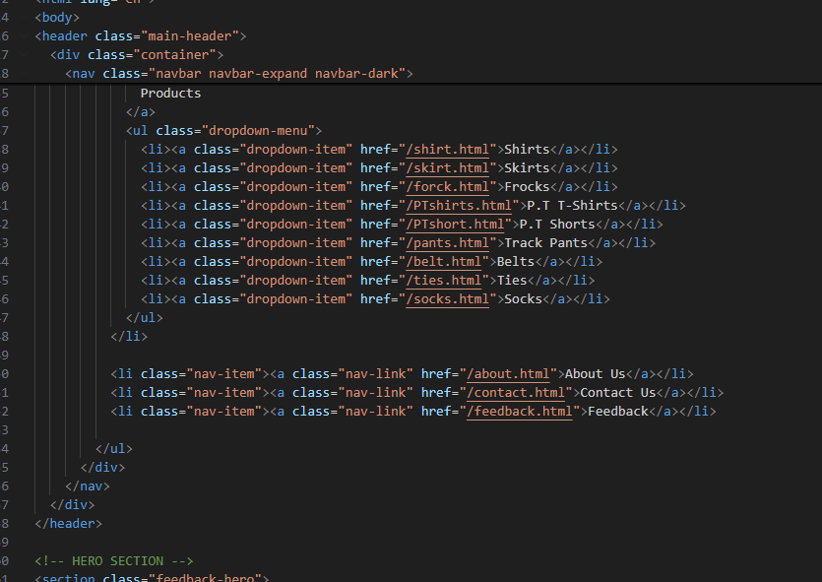

End of Developer Guide

