**PHP 13 Final Test – 27/08/2018**

**Laravel 5.5 CRUD data.**

Using :

* **PHP ^7.0**
* **Laravel 5.5**
* **Bootstrap ^4**

Required :

1. Using Composerto install Laravel via command line, naming folder of Laravel : **your-name-aptech-php-13-laravel** (example : **namnh-aptech-php-13-laravel**).
2. Creating **users** tableon database **aptech_php_13_laravel** using **migration** feature of Laravel, there are some of column's name and type of data :

|  |  |
| --- | --- |
| users | |
| **id** | Integer, Primary Key, Auto Increments |
| **name** | Varchar (100) |
| **email** | Varchar (100), Unique |
| **password** | Varchar (100) |
| **created_at** | Timestamp |
| **updated_at** | Timestamp |

1. Creating **User Model** to manipulate **users** table.
2. Adding datainto **users** table ( using **Seeder** feature **+ Faker l**ibrary, at least 5 records).
3. Creating **UserController** and 7 functions for CRUD data.
4. Creating 7 routes and pointing to 7 functions of **UserController**, using **get, post, put, delete** wisely.
5. Using **bootstrap ^4** to create **View** **Blade** of Laravel to display data, at least 4 pages :

* **Index** (Displaying one by one of user’s information: id, name, email and 3 actions show, edit, delete, …).
* **Show** (Display particular user: id, name, emaill, password, created date, updated date, …)
* **Edit** (Editing user’s data form).
* **Create** (Creating user’s data form).

1. Testing everything is working perfectly.

**INDEX PAGE**

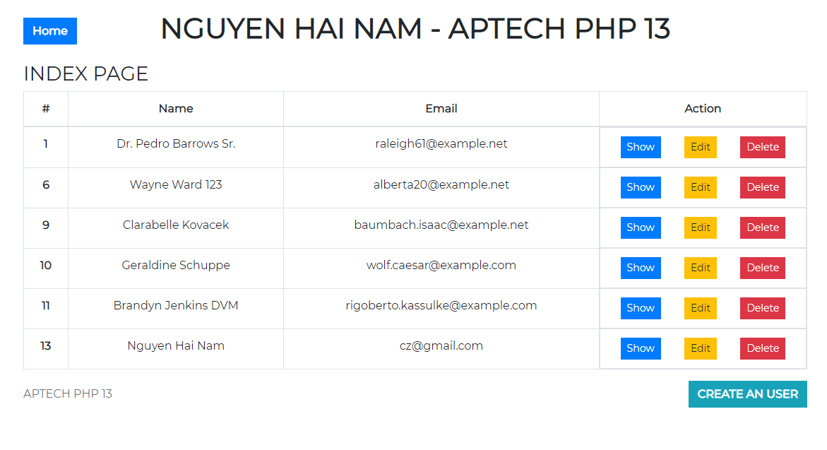

**SHOW PAGE**

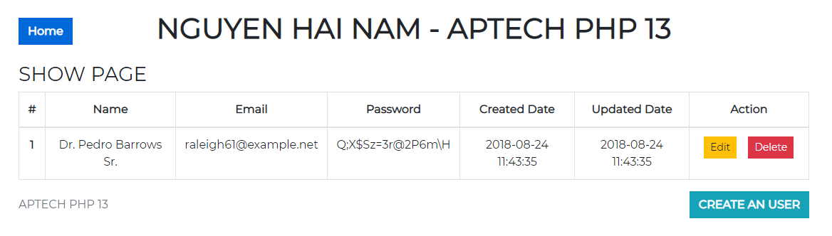

**CREATE PAGE**

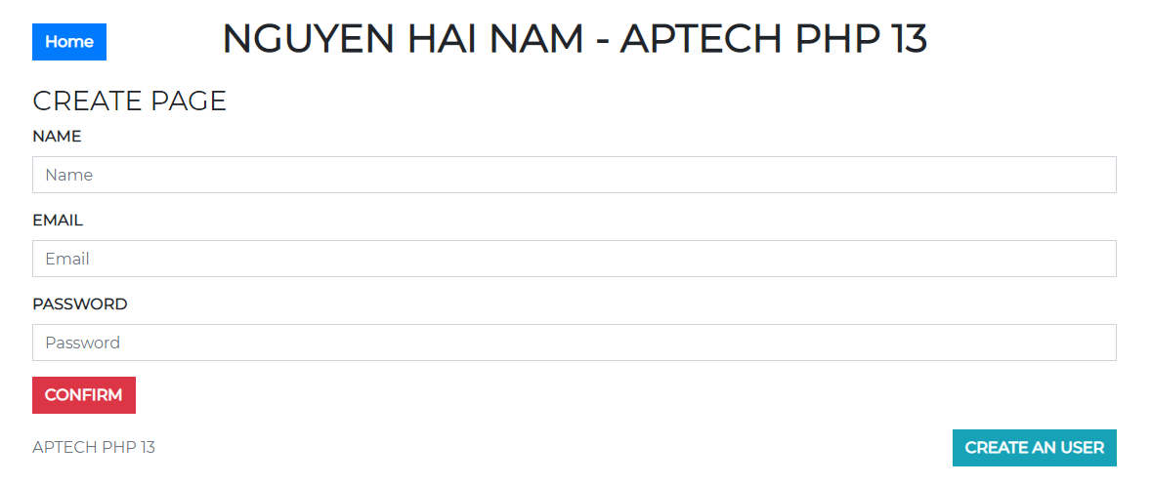

**EDIT PAGE**

