Building Modernistic Website Practical

Batch Code: 2211G2 Marks:20

Time: 1.5 hrs Date:08-04-23

Note:

* This test is self-explanatory. Don’t ask any question to your coordinator.
* All code should be done in single file. (use internal style/script only).
* File name must be your Name and Enrolment id. i.e. (Owais_khan_Student12345).
* File must be uploaded on Google Class room.
* Cheated code and logic will cause zero marks.

Q1. Choose any one layout from given layouts and design them with the help of HTML, CSS, JavaScript.

Layout 1:

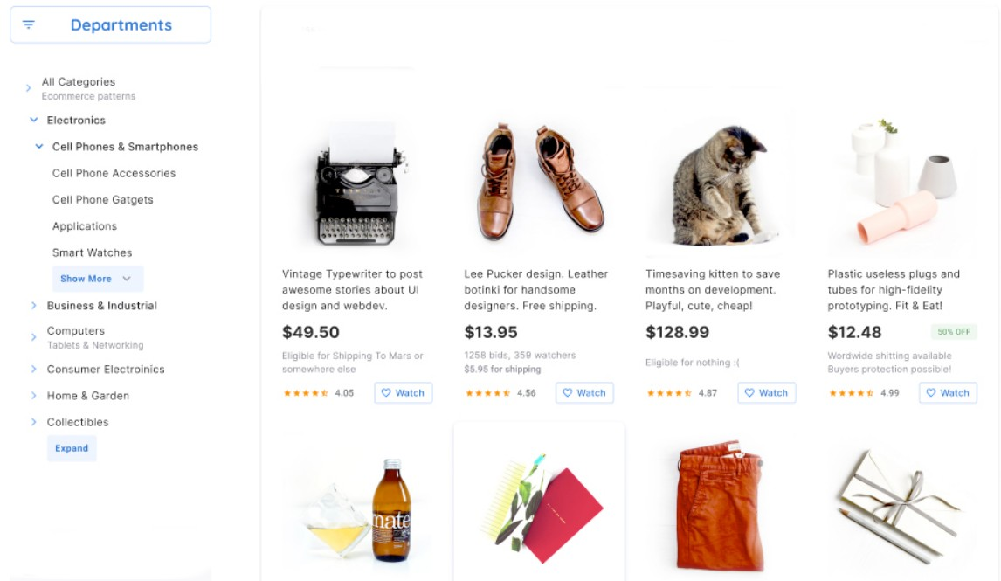

OR

