ALBERTO

WATCH COMPANY

WEBSITE USER GUIDE

• Navigation • Collections • Contact • Responsive use

Prepared from the supplied alberto.html file

Supervisor: | Abdul Hadi
Batch: | 2606f1
Group: | A
Serial no. | Enrollment No | Student Name
1. | Student 1730940 | Abdul Hadi
2. | Student 1730013 | Abdul Samad
3. | Student 1731455 | Hasnain Haider
4. | Student 1730942 | Khurram Sohail
5. | Student 1731322 | Syed Muhammad Rayyan
6. | Student 1732742 | M. Areeb ul Hafeez Shafi
7. | Student1731111 | Hafiz . M. Noman Hasan

ACKNOWLEDGEMENT

The first, we would like to express my special thanks of gratitude to my teacher Sir Umer Alo who helped us a lot in finalizing this project within the limited time frame, valuable counselling and assistance for the accomplishment of this project. Secondly, we would also like to thank the e-Project team at Aptech Head Office, who gave us the golden opportunity to do this wonderful project about Aura Watch.
Thirdly, we also thank the e-Project team, some of the benefits are as under: • Re-enforcement of skills happens in the experiential learning process. • A mentor, ensuring that we do not get drifted, constantly guides us. • It gives us a lot of confidence to face an interview as we have worked on a project. We can explain virtually everything on the subject we have learnt.
ALBERTO CLOCKS

User Guide
A simple guide to browsing and using the Alberto Clocks website
This guide explains the main sections and basic actions available on the Alberto Clocks website. It is written without screenshots so it can be read, printed, or shared as a standalone document.
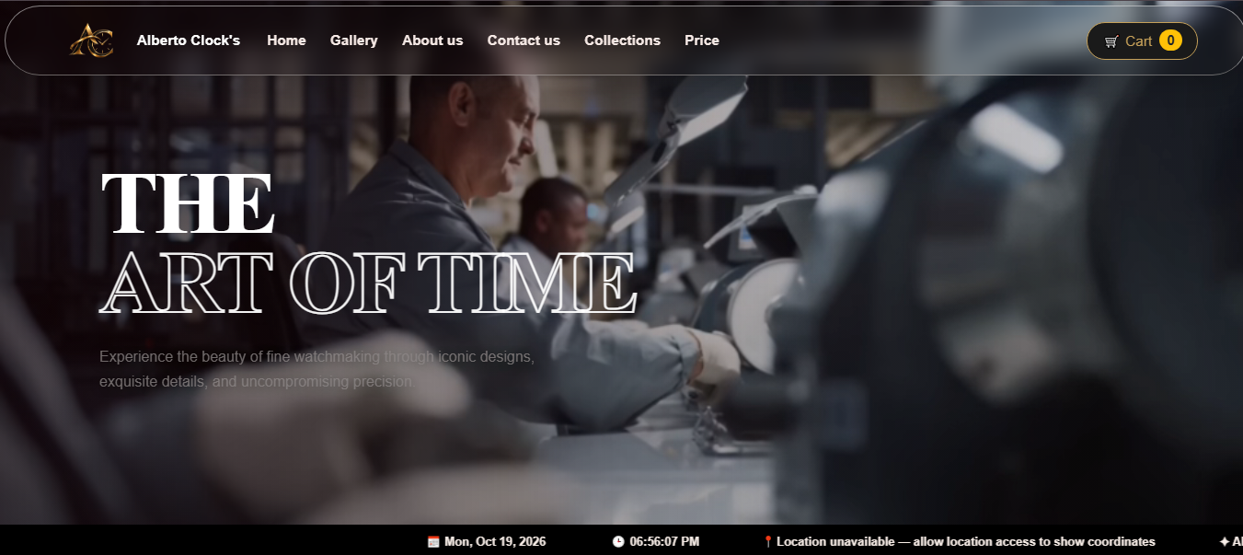

1. Getting Started
- Open the website's home page in a modern web browser.
- Use the navigation bar to move between the available sections and pages.
- For the best experience, use an updated browser and keep an internet connection active because the site loads some design libraries and images online.

2. Home Page
The home page introduces Alberto Clocks and its watch collections. Browse the featured content and use the navigation links to explore the collections, information sections, FAQs, and contact details.
A moving information strip near the bottom of the page displays date and time information and Alberto Clocks branding. The page also includes a visitor counter. The counter in the supplied website is browser-local; it should not be treated as a combined count of all visitors unless it is connected to a server and database.

3. Browsing Watch Collections
Open the Collections page to browse the watch products and the brands featured by the website, including Rolex, Omega, Casio, and G-Shock where listed.
- Review a product card to see its image, name, and displayed price.
- Select the available product action to add a watch to the cart.
- Use the cart control to review the selected items and the displayed total.
- Remove or adjust items only if those controls are available in the version you are using.

4. Cart and Checkout
The Collections page provides a cart interface and a checkout action. Review the selected products and total before continuing. The current front-end flow sends the user to the login page when checkout is selected.
Important: the supplied login page is a demonstration interface. Its JavaScript stores a temporary login flag in the browser session and redirects to Collections; it does not verify an email address or password against a real customer database. Do not enter sensitive or real account credentials into a demonstration version.

5. Login Page
- Open the Login page from the checkout flow or the website link.
- Enter an email address in the Email Address field.
- Enter a password in the Password field.
- Use the eye icon to show or hide the password while typing.
- Select “Login & Continue” to run the current demonstration flow.
- Use “Back to Collections” to return to the watch collection page.

6. Frequently Asked Questions (FAQs)
The FAQ section contains expandable questions about the website, featured watch brands, product information, purchasing, login behavior, store services, opening hours, location, and contact options. Select a question to open its answer; select another question to view a different answer.
The supplied FAQ content lists the opening hours as Monday to Saturday, 11:00 AM to 9:00 PM, and the location as Aptech Computer Education, North Karachi Center. Confirm these details with the store before visiting, as website information may change.

7. Contact Information
Use the Contact section on the home page to view the listed showroom location, email addresses, phone/WhatsApp number, and operating hours. Use the contact details displayed on the current website to ask about a particular watch or service.

8. Basic Troubleshooting
A page or image does not load | Check your internet connection and confirm that the required image files and HTML pages are in the correct folders.
Navigation opens the wrong page | Check that the linked HTML file exists and that the link's filename and folder path match it exactly.
Cart or modal does not open | Make sure the Bootstrap JavaScript bundle is loaded and that JavaScript is enabled in the browser.
Login appears to work without checking credentials | This is expected in the supplied demo login. Real account verification requires a server-side authentication system.
Visitor count is not shared across devices | The supplied counter is browser-local. A shared visitor total requires server-side storage, such as a database.

9. Important Notes
- Product prices and availability should be checked on the current website before making a decision.
- A working front-end cart or demo login does not, by itself, confirm that an order has been placed or payment has been processed.
- For real online sales, connect checkout, order storage, and customer authentication to secure server-side services.

Alberto Clocks — Elegance Beyond Time

