FRESHFIND
Project Documentation
Farmers Market Discovery & Smart Budget Basket Web Platform

Project Item | Details
Project Name | FreshFind
Project Type | Browser-based web application
Primary Purpose | Discover local farmers markets, seasonal produce, and plan purchases within a budget
Document Type | Software / Web Project Documentation
Prepared For | Academic / Project Submission
Date | September 2026

TEAM INFORMATION

Team Name | Code Verse
Category | Web Innovation Unleashed
Students Id | Student1719126, Student1722909, Student1705768, Student1722916
Names | Alisha, Aqsa, Fazal Subhan, Muhammad Fawad Shah

1. Project Overview
FreshFind is a browser-based web platform designed to make farmers-market discovery and seasonal produce information easier to access. The project combines market discovery, produce information, seasonal recommendations, bookmarks, guided assistance, and a Smart Budget Basket into one user-friendly experience.
The uploaded About Us page describes FreshFind as a platform that brings farmers-market information and seasonal produce discovery together in one accessible browser-based platform. It is intended to help residents discover local farmers markets and make better use of seasonal local produce through clear and organized information.

2. Problem Statement
Information about farmers markets may be spread across flyers, community boards, social media, and word of mouth. This can make it difficult for users to quickly find market locations, operating days, hours, and available produce. FreshFind addresses this information-discovery problem through a single web interface.

3. Project Objectives
- Provide an easy way to discover nearby or relevant farmers markets.
- Organize market locations, schedules, and typical products in one place.
- Provide a Produce Guide and seasonal produce information.
- Allow users to save useful market and produce discoveries through bookmarks.
- Provide guided assistance through the FreshFind chatbot concept.
- Help users create a farmers-market basket according to a defined budget.
- Allow users to customize a recommended basket while protecting the budget limit.
- Provide a responsive interface for desktop, tablet, and mobile screens.

4. Scope of the Project
The project scope represented by the supplied pages includes:
- Home and shared navigation structure.
- Market Directory and Market Details concepts.
- Produce Guide and Seasonal Picks concepts.
- About Us information and project purpose.
- Contact and login navigation points.
- Bookmarks/favorites navigation.
- Smart Budget Basket with budget validation, recommendation, customization, quantity handling, and basket summary.

5. Main Features
Feature | Description
Market Directory | Search/filter a catalog of farmers markets by area, day, and produce.
Market Details | Provides market location, operating schedule, map information, and typical products.
Produce Guide | Displays produce descriptions, typical seasons, and related markets.
Seasonal Picks | Helps users discover seasonal recommendations.
FreshFind Chatbot | Provides guided help for frequently asked questions.
Bookmarks | Lets users keep useful market and produce discoveries available.
Smart Budget Basket | Creates a recommended basket based on the user's entered budget.
Basket Customization | Allows users to add produce and adjust quantities while staying within budget.
Responsive Design | Adapts layouts for desktop, tablet, and mobile screen sizes.
Theme Support | The About page includes light/dark theme styling and shared theme functionality.

6. User Navigation
The About Us page contains a shared navigation bar linking to Home, Market Directory, Produce Guide, Budget Basket, About Us, Contact Us, and Login. It also provides bookmark, theme, and responsive menu controls.
- Home → main FreshFind landing page.
- Market Directory → market discovery and filtering.
- Produce Guide → produce and seasonal information.
- Budget Basket → budget-based shopping planner.
- About Us → project purpose, features, workflow, and community focus.
- Contact Us → contact/support area.
- Login → authentication entry point.

7. About Us Page Design
The About Us page uses a green, fresh-food visual identity with a hero section, information cards, feature cards, workflow steps, a project/team section, call-to-action area, and footer. The page uses DM Sans and Playfair Display fonts and Font Awesome icons. It also contains responsive CSS breakpoints.

About Page Sections
- Hero: introduces FreshFind and its purpose.
- Who We Are: explains the information-discovery problem and platform concept.
- Our Purpose: states the goal of helping residents discover local farmers markets and seasonal produce.
- What FreshFind Offers: presents Market Directory, Market Details, Produce Guide, Seasonal Picks, Chatbot, and Bookmarks.
- FreshFind Experience: describes the three-step flow: Find a market → Explore what is fresh → Save your finds.
- People Behind FreshFind: highlights local discovery, simple information, accessibility, and community focus.
- Call to Action: links users to markets and the Produce Guide.
- Footer: provides navigation, social links, copyright, and project messaging.

8. Smart Budget Basket Module
The Budget Basket page is an interactive JavaScript-based module. The user enters a budget and the application generates a recommended farmers-market basket. The page shows budget, spent amount, remaining amount, and item count.

8.1 Budget Input
The budget field accepts a numeric value and has a minimum value of Rs. 50. If the entered amount is missing or below Rs. 50, the application displays an error message and does not create the basket.

8.2 Produce Data
The supplied Budget Basket code contains a local JavaScript produce array with 12 products. Each product has an ID, name, price, unit, category, and image.
Product | Price | Unit | Category
Spinach | Rs. 100 | 1 bunch | Vegetables
Potatoes | Rs. 120 | 1 kg | Vegetables
Tomatoes | Rs. 150 | 1 kg | Vegetables
Carrots | Rs. 140 | 1 kg | Vegetables
Cucumbers | Rs. 130 | 1 kg | Vegetables
Onions | Rs. 160 | 1 kg | Vegetables
Apples | Rs. 250 | 1 kg | Fruits
Bananas | Rs. 180 | 1 dozen | Fruits
Oranges | Rs. 280 | 1 kg | Fruits
Lemons | Rs. 200 | 1 kg | Fruits
Mangoes | Rs. 350 | 1 kg | Fruits
Strawberries | Rs. 450 | 500 g | Fruits

8.3 Recommendation Algorithm
- The entered budget is stored in a JavaScript variable.
- The basket is reset before generating a new recommendation.
- Products are considered in a defined priority order.
- Affordable products are initially added with quantity 1 to provide variety.
- The first pass is limited to a maximum of six different products.
- If no product can be selected, the code checks the cheapest product.
- A second pass uses remaining budget to increase quantities of selected staple products.
- A product quantity is limited to three in the extra-quantity pass so one product does not dominate the basket.
- The basket and summary are then rendered on the page.

8.4 Basket Controls
- Customize Basket: opens the produce selection area.
- New Recommendation: creates another recommendation.
- Add to Basket: adds a selected produce item if sufficient budget remains.
- Quantity Controls: increase/decrease quantities.
- Remove: removes an item from the basket.
- Clear: clears the basket.
- Confirm: confirms the current basket.
- Summary: displays Budget, Spent, Remaining, and Items.

8.5 Example User Flow
- User enters a budget, for example Rs. 1000.
- User clicks Create Basket.
- The application validates the budget.
- FreshFind generates a basket using the defined produce data and priority rules.
- The summary is updated with budget, spending, remaining amount, and item count.
- The user can accept the recommendation or customize it.
- When adding produce, the interface checks the remaining budget.
- The user can clear or confirm the basket.

9. Technologies Used
Technology | Use in Project
HTML5 | Page structure, navigation, sections, forms, cards, and content.
CSS3 | Layout, colors, responsive design, cards, shadows, transitions, animations, and themes.
JavaScript | Budget validation, recommendation logic, basket state, quantities, rendering, and interactions.
Google Fonts | DM Sans and Playfair Display used in the About page.
Font Awesome | Icons for navigation, features, buttons, and visual elements.
External Images | Unsplash image URLs are used for hero and produce imagery in the supplied pages.

10. Interface and Design
- Fresh green color palette communicates freshness and local produce.
- White cards and soft shadows separate information into clear sections.
- Rounded corners create a modern visual style.
- Hero images provide visual context for farmers-market content.
- Hover effects provide visual feedback on cards and buttons.
- Animations such as fade-up effects improve page presentation.
- Responsive media queries adjust grids and navigation for smaller screens.
- The About page includes a dark-theme styling system.

11. Responsive Design
The supplied code includes media queries for smaller screens. In the About page, the navigation changes to a menu-style layout and multi-column sections collapse. In the Budget Basket page, the main layout changes to a single column, the basket loses its sticky positioning, summary cards reduce from four columns to two and then one, and the produce grid reduces from three columns to two and then one.

12. Functional Requirements
ID | Requirement
FR-01 | User can navigate between the main FreshFind pages.
FR-02 | User can enter a numeric budget in the Budget Basket.
FR-03 | System rejects budgets below Rs. 50.
FR-04 | System generates a budget-based produce recommendation.
FR-05 | System displays budget, spent, remaining, and item count.
FR-06 | User can customize the recommended basket.
FR-07 | System prevents adding an item when the remaining budget is insufficient.
FR-08 | User can modify quantities and remove items.
FR-09 | User can clear or confirm the basket.
FR-10 | Interface responds to different screen sizes.

13. Non-Functional Requirements
- Usability: navigation and controls should be understandable to ordinary users.
- Responsiveness: layouts should remain usable on desktop, tablet, and mobile screens.
- Performance: the supplied front-end logic runs in the browser without a server-side calculation for the Budget Basket.
- Maintainability: product data and UI sections are organized into identifiable HTML, CSS, and JavaScript sections.
- Accessibility considerations: semantic elements, alt text for product images, button labels, and navigation controls are present in the supplied pages.

14. Testing Plan
Test Case | Input / Action | Expected Result
TC-01 | Open About page | About FreshFind content and navigation are displayed.
TC-02 | Enter no budget | Validation message is shown.
TC-03 | Enter Rs. 40 | Budget is rejected because it is below Rs. 50.
TC-04 | Enter Rs. 1000 | Recommended basket is generated and summary is updated.
TC-05 | Add an affordable product | Product is added and spent/remaining values update.
TC-06 | Try adding an item above remaining budget | Add control is unavailable/blocked.
TC-07 | Increase quantity | Quantity and total spending update.
TC-08 | Remove item | Item is removed and totals update.
TC-09 | Clear basket | Basket returns to empty state.
TC-10 | Resize to mobile width | Grid and navigation adapt to a smaller layout.

15. Project Structure
The supplied pages reference a multi-page FreshFind website. The navigation identifies the following important page files:
File / Page | Purpose
index.html | Home / main landing page
market.html | Market Directory / market discovery
producesguide.html | Produce Guide
budget.html | Smart Budget Basket
about.html | About FreshFind
contact.html | Contact page
login.html | Login page
bookmarks.html | Bookmark-related destination referenced by the About page

16. Current Implementation Characteristics
Based on the supplied files, the Budget Basket is implemented as front-end JavaScript with product information stored in a JavaScript array. The About page also contains shared browser-side functionality for navigation, bookmarks, and theme behavior. The supplied pages therefore demonstrate a client-side web application approach rather than a documented database-backed implementation.

17. Limitations / Items Not Evidenced in the Supplied Files
This documentation only records what can be supported by the supplied About Us and Budget Basket files. The files do not, by themselves, provide complete evidence of a server-side database, administrator panel, live market API, payment gateway, or production authentication system. Those components should not be treated as implemented unless they exist in other project files.

18. Future Enhancements
- Connect market and produce information to a database.
- Add an administrator panel for managing markets and produce.
- Add real-time market opening hours and location data.
- Add user accounts with persistent bookmarks.
- Store baskets for logged-in users.
- Add checkout or shopping-list export if required by the project scope.
- Add stronger accessibility testing and keyboard navigation.
- Add automated testing for recommendation and basket calculations.
- Add search, sorting, and filtering across the produce catalog.

19. Conclusion
FreshFind is designed as a practical web platform for discovering local farmers markets and seasonal produce. Its supplied About page clearly presents the project's purpose and feature set, while the Budget Basket demonstrates an interactive JavaScript feature that converts a user's budget into a recommended produce basket and allows controlled customization. Together, these components form a clear foundation for a student web-development project focused on usability, responsive design, and interactive front-end functionality.

20. Source Files Used for This Documentation
This documentation was prepared from the uploaded FreshFind project files: about(1).html and budget.html. Descriptions and implementation details are based on the content present in those files.

21. Images of the Website
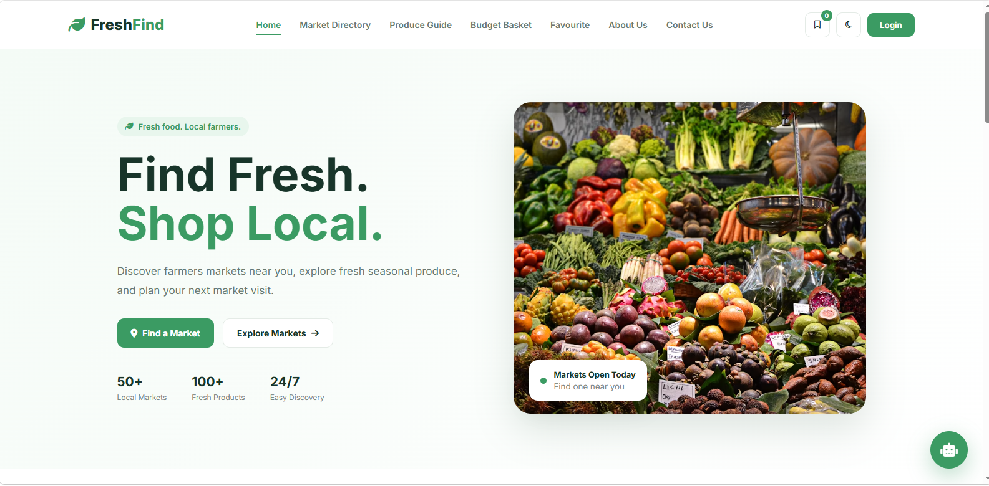
Home Page
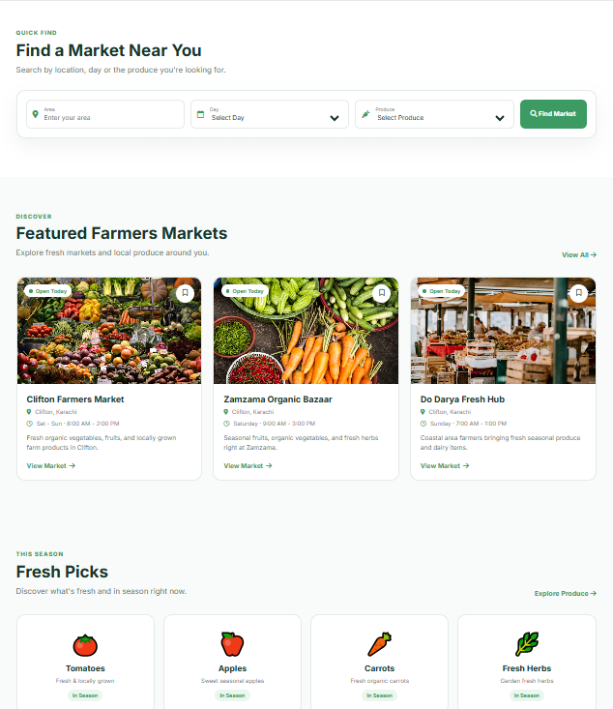

Market Page
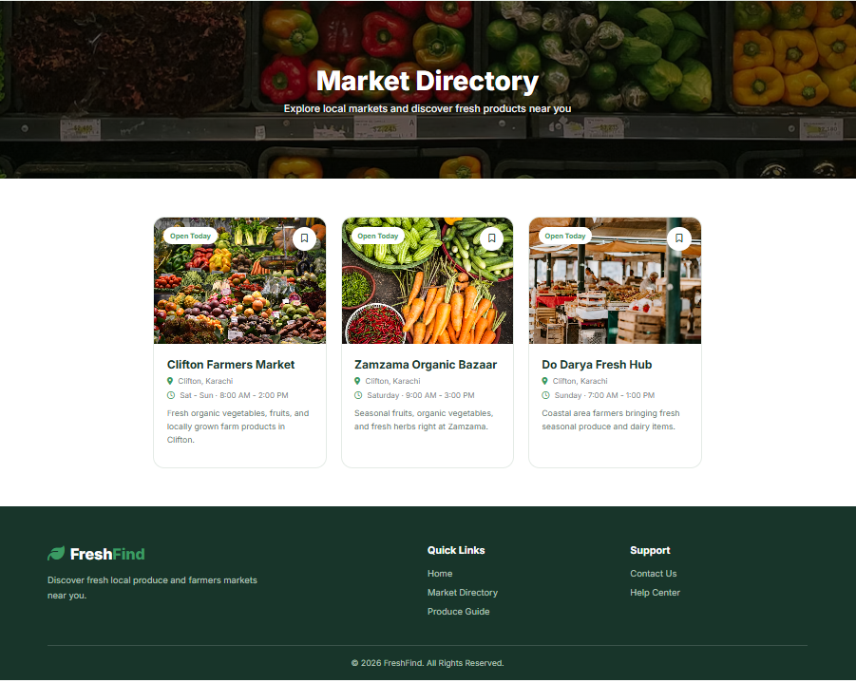

Produce Page
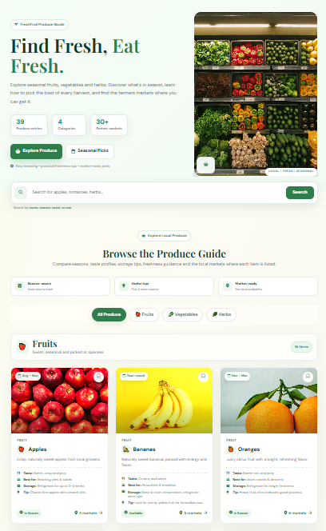

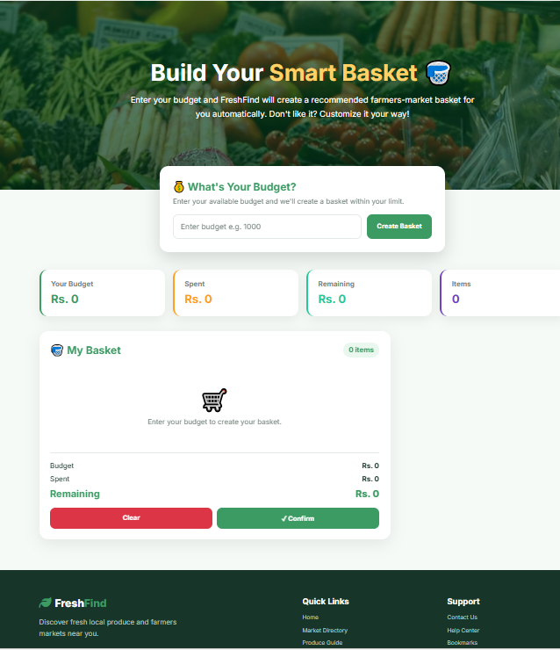
Smart Basket Page

Favourites Page
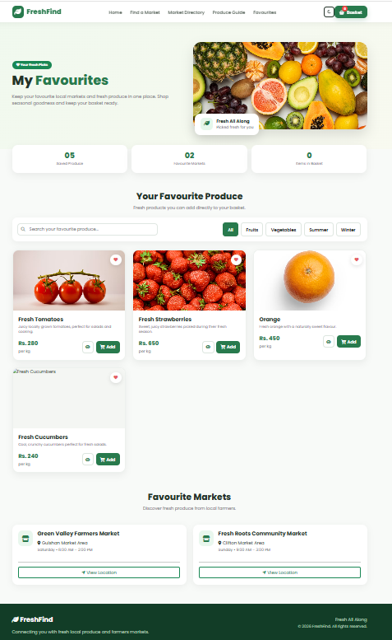

About Page
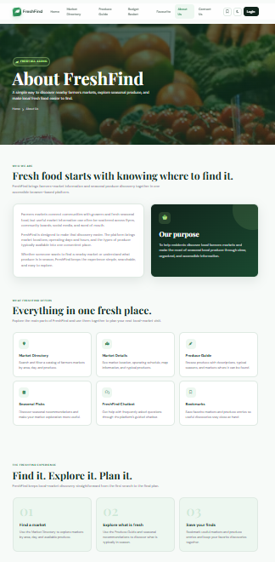

Contact Page

