D-CAKESHOP
The Cake — Premium Confectionery
TECHNICAL MANUAL
Complete Developer & Architecture Reference
Version 1.0 | 2026 | For Internal / Developer Use
Supervisor. | Ms Maryam Naz
Batch. | 2601C1
Group. | C
Serial No. | Enrollment Number | Student Name
1. | Student1722638 | MUHAMMAD MOOSA
2. | Student1722507 | MUHAMMAD UMAR .
3. | Student1724060 | RAHIM SHAH
4. | Student1722636 | SYED MUHAMMAD MUZAMMIL .
5. | Student1703906 | SYED MURTAZA ABBAS NAQVI

Table of Contents

# | Section | Page
1. | Project Architecture Overview | 4
1.1 | Technology Stack | 4
1.2 | Project File Structure | 5
2. | HTML Pages Reference | 6
2.1 | index.html — Homepage | 6
2.2 | about.html — About Us | 6
2.3 | allProducts.html — All Products | 7
2.4 | cart.html — Shopping Cart | 8
2.5 | checkout.html — Checkout Page | 8
2.6 | Contact.html — Contact & Geolocation | 9
2.7 | Sitemap.html — Site Map | 9
2.8 | login.html & Register.html — Authentication Pages | 9
2.9 | Disclaimer.html — Disclaimer Page | 9
2.10 | thankyou.html — Thank You Page | 10
3. | JavaScript Architecture | 10
3.1 | script.js — Core Logic | 10
3.2 | product_data.js — Product Data Store | 11
3.3 | slider.js — Image Slider | 11
3.4 | All Functions Reference | 11
4. | Product Data Schema | 13
4.1 | Product Object Properties | 13
4.2 | Adding a New Product — Step by Step | 14
5. | Cart & Order System — Technical Details | 15
5.1 | localStorage Keys | 15
5.2 | Price Parsing Logic | 15
5.3 | Cart & Order Flow Diagram | 15
6. | CSS & Styling Guide | 16
6.1 | Design Tokens & Custom Classes | 16
6.2 | Adding a New Event Category | 17
7. | Troubleshooting & Known Limitations | 18
8. | Future Development Recommendations | 19
9. | Glossary | 21

1. Project Architecture Overview
D-CAKESHOP (branded as "The Cake") is a fully static, front-end web application with no backend server, database, or server-side rendering. All logic is implemented in plain HTML5, CSS3, and vanilla JavaScript. Data persistence for the cart is handled exclusively through the browser's localStorage API and session interactions via form submissions.
The application follows a single-file-per-page architecture where each HTML page is self-contained, sharing four CSS files (css/style.css, css/theme.css, css/nav.css, css/slider.css) and three JavaScript files (js/script.js, js/product_data.js, js/slider.js).

1.1 Technology Stack
Technology | Purpose
HTML5 | Semantic page structure and markup for all pages including forms, navigation, and product listings
CSS3 — css/style.css | Custom pink-themed styling, animations, hover effects, and layout for the main site
CSS3 — css/theme.css | Theme-level overrides for consistent color branding across the application
CSS3 — css/nav.css | Dedicated navbar styles — sticky nav, dropdown menus, and mobile responsiveness
CSS3 — css/slider.css | Image slider / carousel styles for the homepage hero banner
Vanilla JavaScript — js/script.js | Core interactivity: cart logic, page navigation, product rendering, form handling
Vanilla JavaScript — js/product_data.js | Centralized product data store — all cake products as a JavaScript array
Vanilla JavaScript — js/slider.js | Slider/carousel initialization and controls for the homepage hero section
localStorage (Browser API) | Cart data and total price persistence across page navigations
Geolocation API | Display company address on the Contact Us page via browser geolocation or Google Maps embed
NOTE: Because all CDN libraries (if any) are loaded from external URLs, an internet connection may be required for any third-party assets to render correctly. The core application logic in script.js and product_data.js does not require internet access.

1.2 Project File Structure
File / Folder | Location | Purpose
index.html | Root | Main homepage — entry point with hero slider and site overview
about.html | Root | About Us page — Foundation, Mission, and Vision in three sections
allProducts.html | Root | All Products listing page with thumbnails, prices, and order buttons
birthday.html | Root | Birthday Cakes — event-filtered product page
aniversary.html | Root | Anniversary Cakes — event-filtered product page
engagement.html | Root | Engagement Cakes — event-filtered product page
Marriage.html | Root | Marriage / Wedding Cakes — event-filtered product page
eid.html | Root | Eid Special Cakes — event-filtered product page
FathersDay.html | Root | Father's Day Cakes — event-filtered product page
cart.html | Root | Shopping cart page — displays all added items and totals
checkout.html | Root | Checkout flow — order summary and payment simulation
order.html | Root | Purchase form — captures Name, Address, Contact, Item Code, Quantity, Delivery info
Contact.html | Root | Contact Us page — company address and Geolocation/Google Maps embed
Sitemap.html | Root | Visual site map with hyperlinked page names for all sections
login.html | Root | User login form — username and password inputs
Register.html | Root | User registration form — account creation
Disclaimer.html | Root | Legal disclaimer for the website
thankyou.html | Root | Thank You confirmation page shown after order/checkout
css/style.css | css/ | Main custom CSS — layout, pink theme, product cards, animations
css/theme.css | css/ | Theme-level color and typography overrides
css/nav.css | css/ | Navbar-specific styles — sticky, dropdowns, responsive
css/slider.css | css/ | Homepage hero image slider / carousel CSS
js/script.js | js/ | Core JavaScript — products rendering, cart, compare, form handlers
js/product_data.js | js/ | Product data array — all cake products with full properties
js/slider.js | js/ | Hero image slider initialization and controls
Images/Slider/ | Images/ | 5 slider/hero banner images (webp, jpg) — SLider 1–5
Images/Product Images/Products/Anniversary_Cakes/ | Images/ | Anniversary cake product images
Images/Product Images/Products/Birthday_Cakes/ | Images/ | Birthday cake product images
Images/Product Images/Products/Eid_Cakes/ | Images/ | Eid special cake product images
Images/Product Images/Products/Engagement_Cakes/ | Images/ | Engagement cake product images
Images/Product Images/Products/Fathers_Cakes/ | Images/ | Father's Day cake product images
Images/Product Images/Products/Marriage_Cakes/ | Images/ | Marriage / Wedding cake product images
Images/umer.jpg | Images/ | Team/staff or about-page image
Images/download.jpg | Images/ | General-purpose image asset
logo/ | logo/ | Logo image(s) for the site header and branding
Documentation/ | Documentation/ | Project documentation including the 40-page Final Report PDF
.vscode/settings.json | .vscode/ | VS Code workspace settings (e.g. Live Server port configuration)

2. HTML Pages Reference

2.1 index.html — Homepage
The main entry point of the application. Contains:
- Sticky top navbar with dropdown menus for Products by Event, About, Contact, and Login/Register links
- Hero section with a 5-image auto-advancing slider (js/slider.js + css/slider.css) cycling through 5 banner images
- A brief introduction / overview section with a short history of cake and welcome text
- Navigation shortcuts / links to all major sections of the site

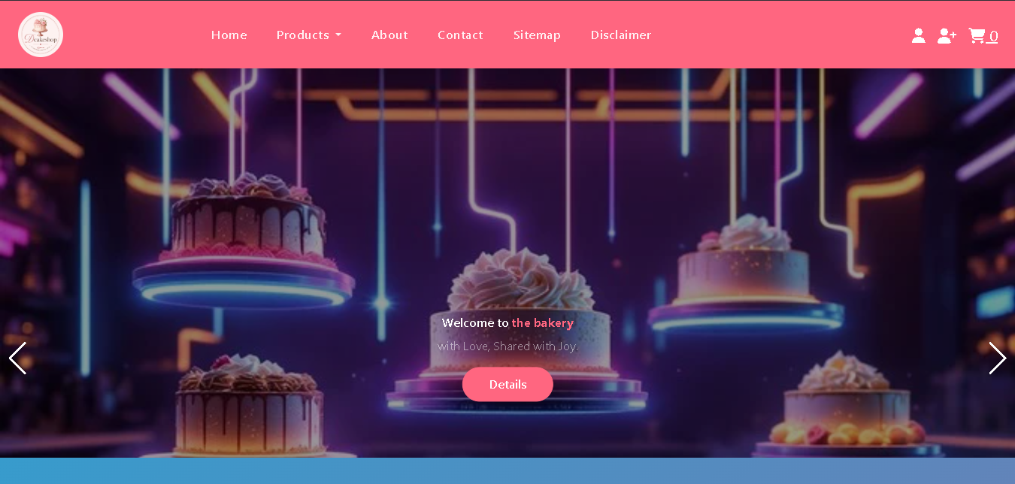

2.2 about.html — About Us
The About Us page is divided into three equal vertical sections:
- Foundation — origin story and founding details of "The Cake" brand
- Mission — brand mission statement and commitment to customers
- Vision — future goals and aspirational statement
Each section is rendered as a styled card or column using CSS grid or flexbox layout defined in style.css.

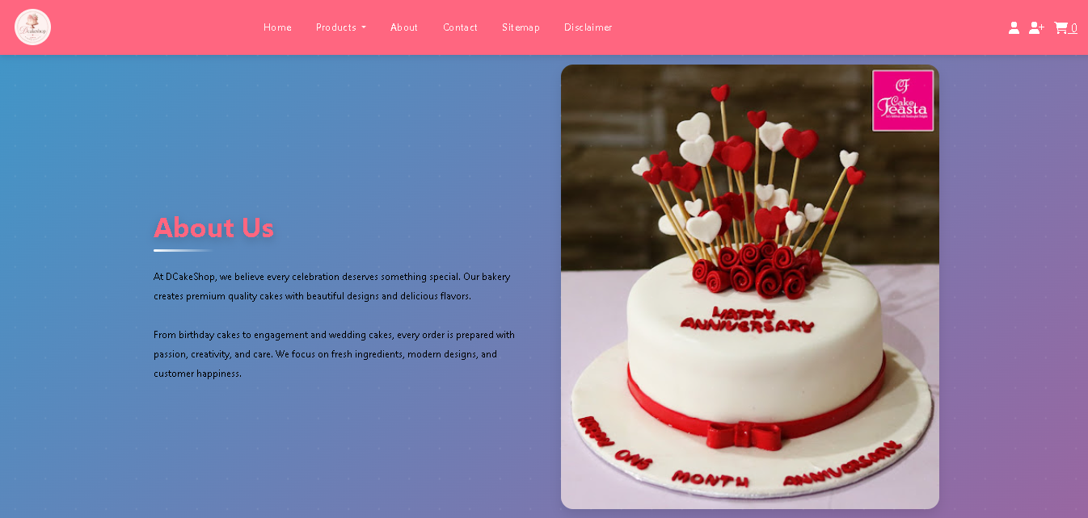

2.3 allProducts.html — All Products
The all-products listing page. Contains:
- A product grid dynamically populated (or statically rendered) from product_data.js
- Each product card shows: product thumbnail image, Item Code, Price (PKR), Egg/Eggless status, a Zoom Button (opens enlarged image in new window), and an Order Button (opens order.html in a new window)
- The Order button passes the item code as a URL parameter or opens order.html pre-filled with the selected product details
NOTE: On click of the Zoom button, the enlarged product image opens in a new browser tab/window via window.open() with only the image URL.
Six individual category pages, each showing cakes filtered by occasion. All follow the same structure as allProducts.html:
File | Event Category & Contents
birthday.html | Birthday Cakes — themed cakes including Cocomelon, balloon designs, character cakes
aniversary.html | Anniversary Cakes — romantic and milestone anniversary cake designs
engagement.html | Engagement Cakes — ring ceremony and engagement-themed cake options
Marriage.html | Marriage / Wedding Cakes — tiered wedding cakes, crown cakes, white & peach designs
eid.html | Eid Special Cakes — Eid-themed cakes and seasonal designs
FathersDay.html | Father's Day Cakes — custom cakes for Father's Day celebrations
Each page includes: event-specific product thumbnails, item codes, prices, Egg/Eggless labels, Zoom button (enlarges image in new window), and Order button (opens order.html in new window).

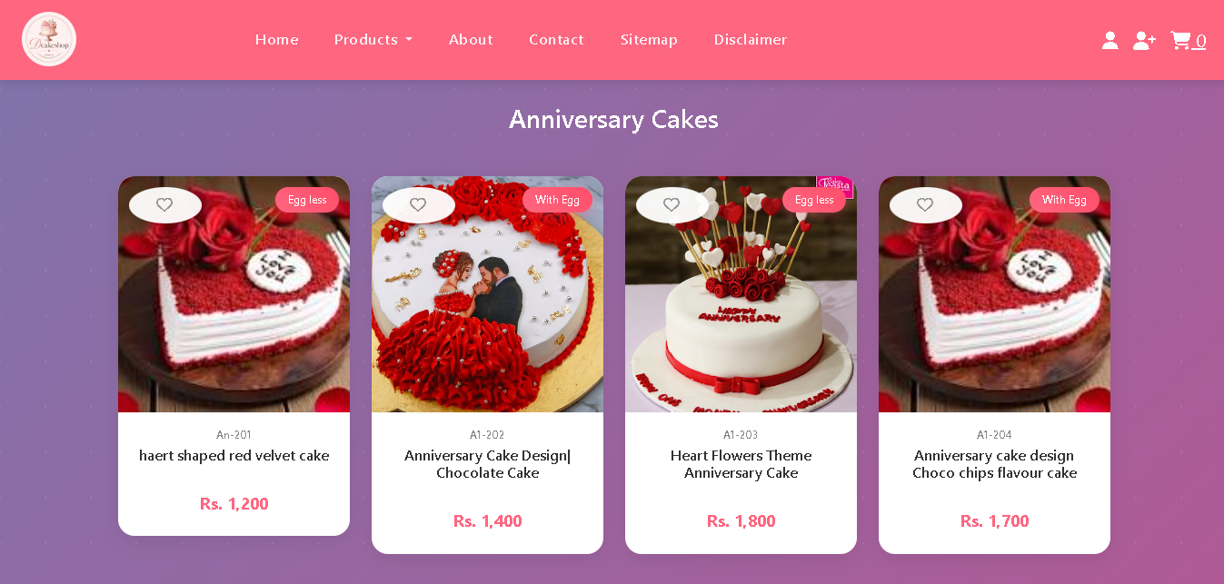

2.4 cart.html — Shopping Cart
Displays all items added to the cart. Key HTML element IDs:
- #cart-table-body — <tbody> where cart row items are injected by renderCart() in script.js
- #cart-page-total — <span> or element displaying the running total in PKR
- #empty-msg — shown when the cart array is empty
- #cart-content — hidden/shown based on whether the cart has items

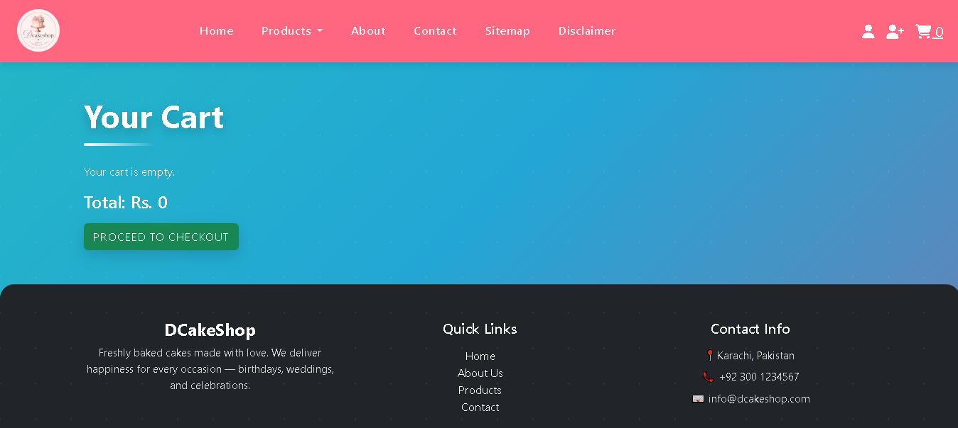

2.5 checkout.html — Checkout Page
Provides the final order review and payment simulation step. Contains:
- Order summary showing cart items, quantities, and total
- A dummy payment simulation — no real payment gateway is integrated
NOTE: Checkout is a front-end simulation only. No real payment processing occurs. For production, integrate a Pakistani gateway (Easypaisa, JazzCash, PayFast) or international option (Stripe).
A standalone purchase form that opens in a new browser window when the Order button is clicked. Contains the following form fields:
- Name — text input for customer full name
- Address — text input or textarea for billing/collection address
- Contact Number — tel/number input for customer phone
- Item Code — text input (pre-filled from the selected product if URL parameter passed)
- Quantity — number input for number of units
- Delivery Address — textarea for delivery destination
- Delivery Date — date input for requested delivery date
The form is purely front-end. On submit, it shows a confirmation or redirects to thankyou.html.

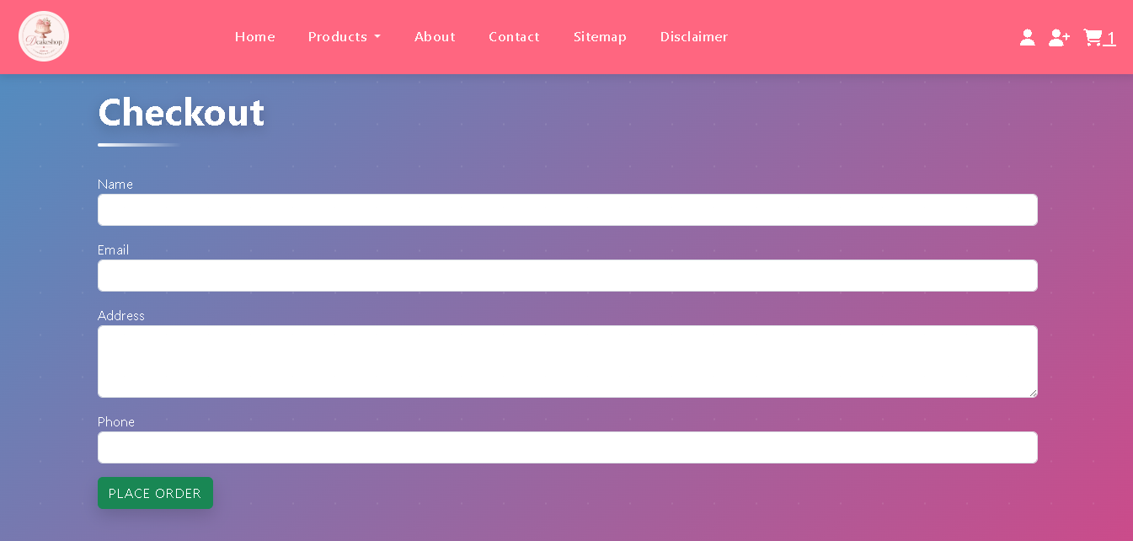

2.6 Contact.html — Contact & Geolocation
Static contact page containing:
- Company address displayed using the Geolocation API or an embedded Google Maps iframe
- Email address rendered as a mailto: link — clicking opens the local mail client
- About Us summary, Contact Us form fields, and Disclaimer link
NOTE: The Geolocation API (navigator.geolocation) requires user permission in the browser. The page should gracefully degrade to a static address display if the user denies permission.

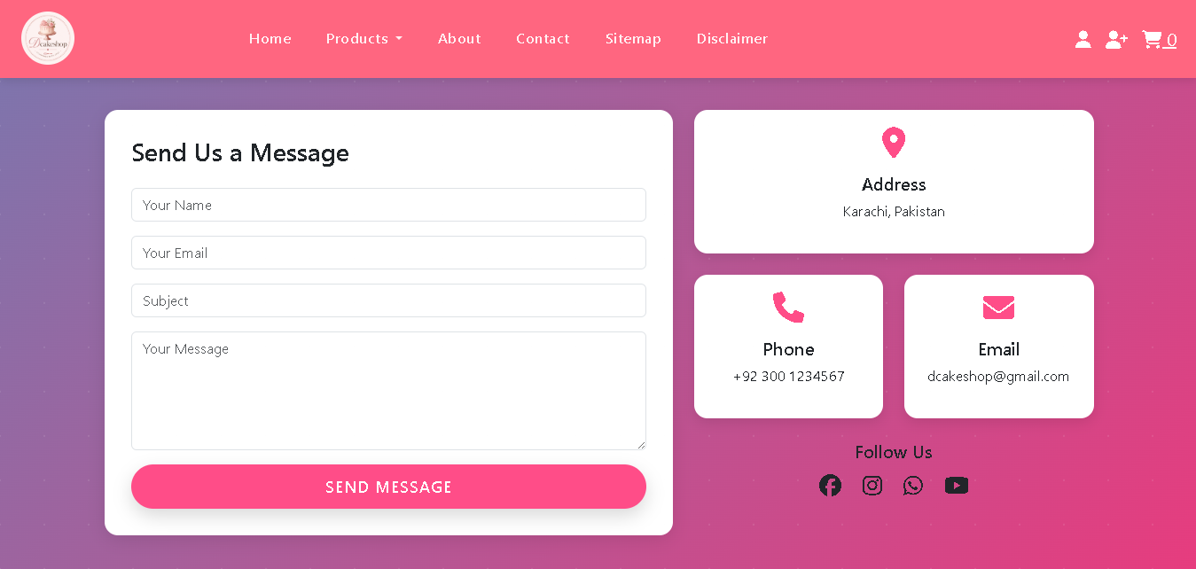

2.7 Sitemap.html — Site Map
Displays the complete navigational structure of the site in a visual diagram or list format. All page names shown in the site map are hyperlinked to their corresponding HTML files. Includes links to: Home, About Us, All Products, Products by Event (all 6 sub-pages), Cart, Checkout, Contact Us, Disclaimer, Login, Register.

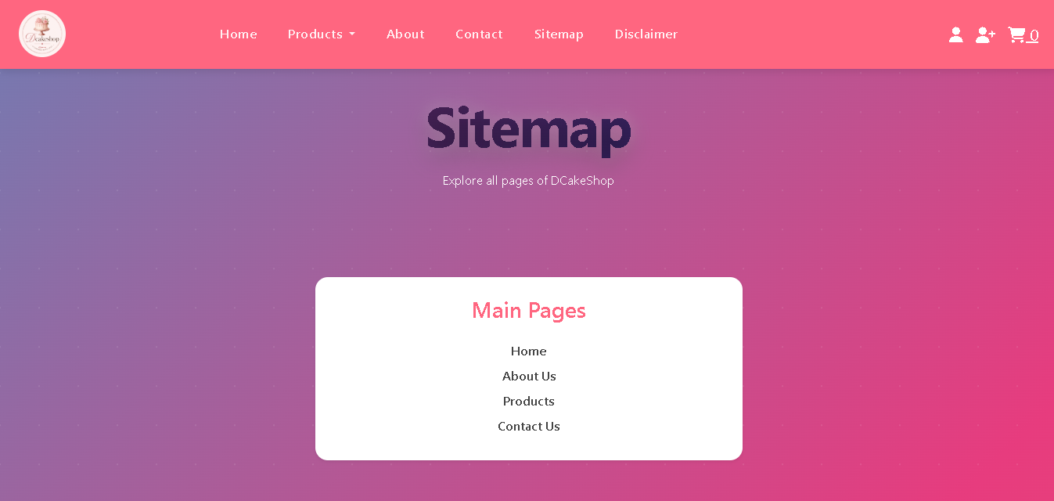

2.8 login.html & Register.html — Authentication Pages
Front-end only authentication pages:
- login.html — Username and Password fields with a Login button. No backend authentication is connected.
- Register.html — Account creation form. Fields for name, email, password, and confirm password. No backend persistence.
NOTE: Authentication is for UI/demo purposes only. No session management, JWT, or database connection is implemented.

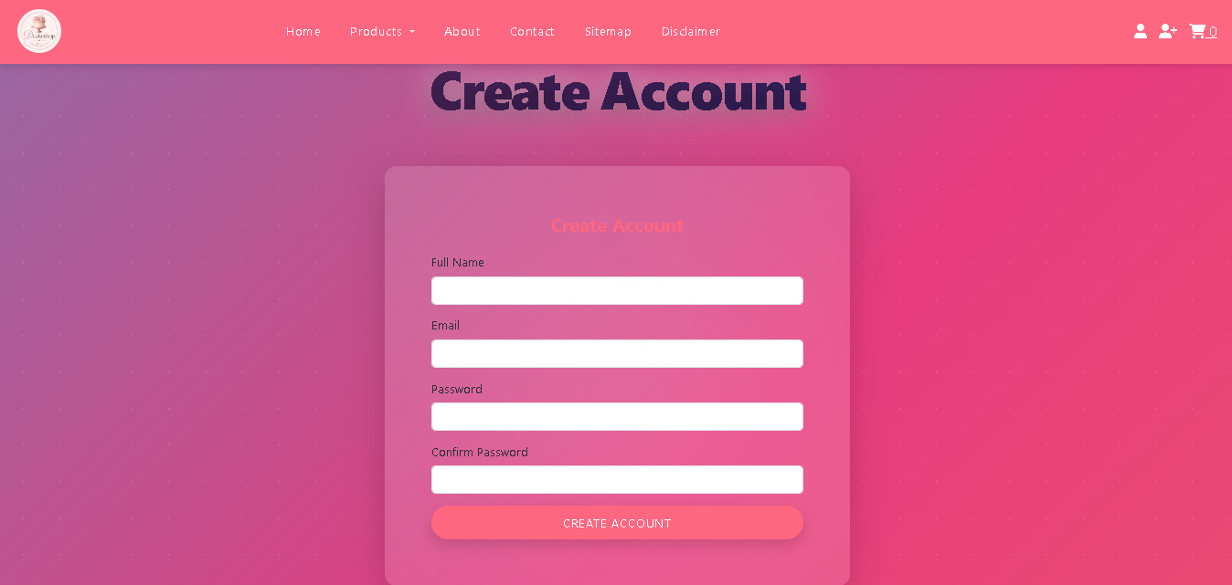

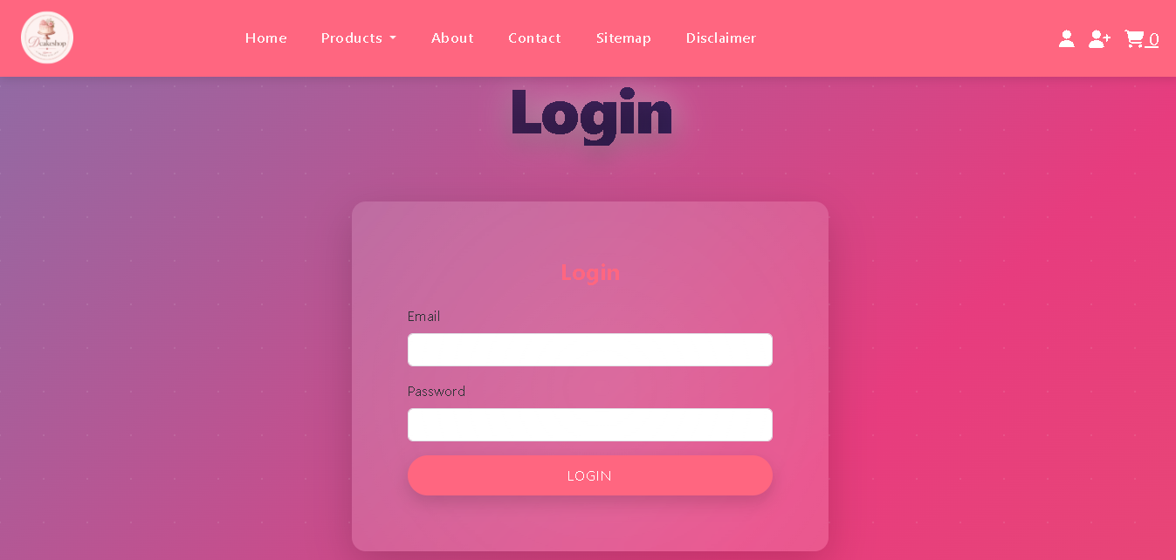

2.9 Disclaimer.html — Disclaimer Page
A static legal/informational disclaimer page for the DCakeShop website. Contains standard e-commerce disclaimer text regarding pricing, availability, images for representation purposes, and liability limitations.
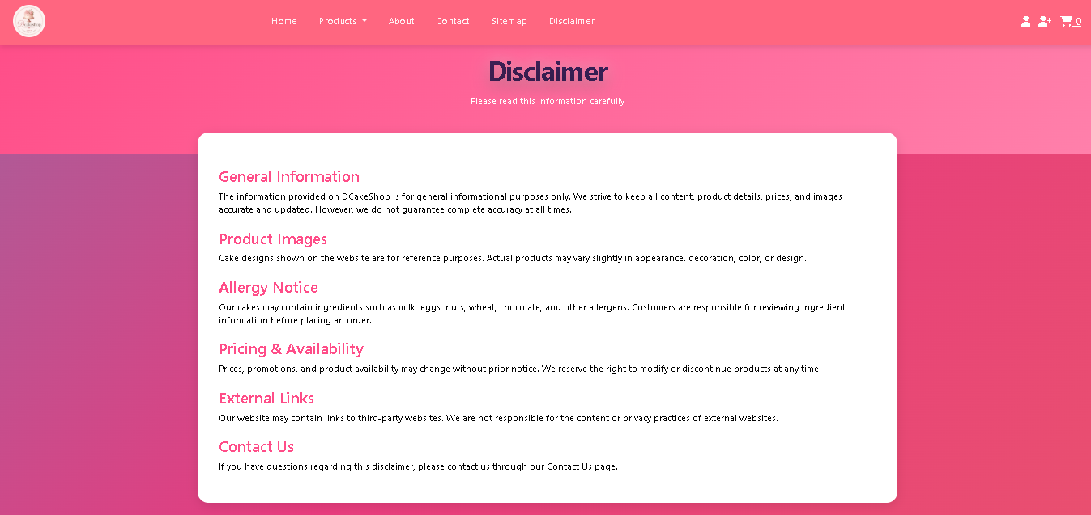

2.10 thankyou.html — Thank You Page
Confirmation page displayed after a successful order form submission or checkout completion. Displays a success message and optionally a summary of the order. Provides a link back to the homepage.

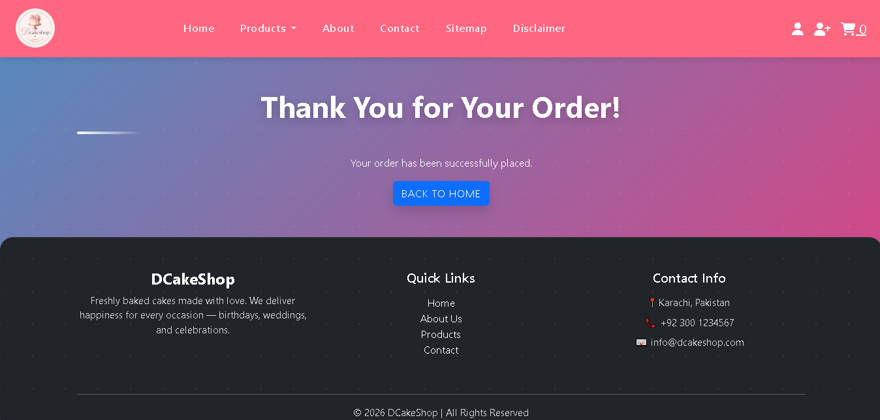

3. JavaScript Architecture
All application logic is split across three JavaScript files loaded at the bottom of the <body> tag in relevant HTML pages, ensuring the DOM is fully parsed before any script executes.

3.1 script.js — Core Logic
The primary JavaScript file handling cart operations, product rendering calls, order form interactions, and contact page geolocation. The initialization flow on page load is:
- Attempt to read userCart and cartTotal from localStorage into the cart array and total variable
- On DOMContentLoaded — renderCart() is called to update the navbar cart count and render the cart table on cart.html
- Conditionally call initSlider(), initNavbar(), initScrollReveal() if their target DOM elements exist on the current page
- If #productGrid or a products container exists in the DOM, displayProducts() is called to inject product cards
- On Contact.html — initGeolocation() is called to embed the map or show the address via the Geolocation API

3.2 product_data.js — Product Data Store
Contains a single exported JavaScript array named products (or similar) storing all cake product objects. This file is the single source of truth for all product information across the site. It is loaded before script.js so the products array is available when displayProducts() is called.

3.3 slider.js — Image Slider
Handles the homepage hero banner image slider. Manages auto-advance timing, previous/next button click events, and active-slide CSS class toggling. Works in conjunction with css/slider.css for animation and transition styles. The 5 slider images are located in Images/Slider/ (SLider 1.webp through Slider 5.jpg).

3.4 All Functions Reference
Function | Detailed Description
displayProducts(category) | Generates and injects HTML product cards into the #productGrid or target container. Accepts an optional category/event filter parameter to show only relevant products on event pages.
initSlider() | Initializes the homepage hero image slider — sets up auto-advance interval, binds previous/next controls, and manages active slide state via CSS classes.
addToCart(productId) | Finds the product object by ID from the products array, increments quantity if already in cart or pushes a new cart entry, then calls updateStorage() and renderCart().
removeItem(index) | Decrements quantity by 1 or removes the item entirely (Array.splice) at the given index. Calls updateStorage() and renderCart() to sync state and UI.
renderCart() | Reads the current cart array from memory, updates the navbar cart count badge, and on cart.html renders all rows into #cart-table-body and updates #cart-page-total.
updateStorage() | Serializes the current cart array (JSON.stringify) and total integer to localStorage under the keys userCart and cartTotal.
processPurchase() | Simulates checkout — clears the cart array and localStorage, resets total to 0, and redirects to or renders thankyou.html.
openOrderForm(productId) | Opens order.html in a new browser window (window.open) with the selected product's item code passed as a URL query parameter for pre-filling the form.
zoomImage(imageSrc) | Opens a new browser window containing only the enlarged product image for the selected item.
sendMsg() | Simulates contact form submission — validates fields client-side and shows a success confirmation banner for 5 seconds.
initGeolocation() | Calls navigator.geolocation.getCurrentPosition() to get the user's coordinates and embeds a Google Maps iframe or displays the company address on the Contact page.
initNavbar() | Binds scroll listener to the navbar — adjusts background opacity or applies a scrolled CSS class when window.scrollY exceeds a threshold.
initScrollReveal() | Uses IntersectionObserver to add a visible CSS class to product cards and sections when they scroll into the viewport, triggering fade-in animations.
filterProducts(brand) | Filters the visible product cards on allProducts.html or event pages by comparing the product's category/event attribute to the filter value.

4. Product Data Schema
All product data is stored as a JavaScript array named products at the top of js/product_data.js. Products are organized across six event categories. Each product object must contain all the properties listed below.

4.1 Product Object Properties
Property | Type | Description & Notes
id | String | Unique slug ID (e.g., 'birthday-cocomelon'). Used as the primary key for cart and order lookups.
name | String | Display name shown on product cards, the order form, and the comparison table.
category | String | Event category — must match the page/filter name: 'birthday', 'anniversary', 'engagement', 'marriage', 'eid', 'fathers'. Used for filtering on event pages.
image | String | Relative path to the product image file (e.g., 'Images/Product Images/Products/Birthday_Cakes/Cocomelon 1st Birthday Fresh Cake.webp').
itemCode | String | Unique product item code displayed on the product card and pre-filled in order.html (e.g., 'CAKE-BD-001').
price | String | Full price string including currency prefix (e.g., 'PKR 2,500'). Parsed to integer for cart arithmetic.
eggStatus | String | 'Eggless' or 'With Egg' — dietary label displayed on the product card.
weight | String | Cake weight/size descriptor (e.g., '1 Kg', '2 Lbs') displayed as a product spec.
flavour | String | Flavour description (e.g., 'Chocolate', 'Vanilla', 'Red Velvet') shown on the product card.
description | String | Short marketing description (1-2 sentences) displayed below the product name on the card.
deliveryDays | String | Standard delivery time (e.g., '2-3 Days', 'Same Day') shown as a product badge or spec.
inStock | Boolean | true/false — whether the product is currently available for ordering.

4.2 Adding a New Product — Step by Step
Follow these exact steps to add a new cake product to the website:
- Open js/product_data.js in a code editor
- Locate the products array (near the top of the file)
- Add a new product object following the schema above — ensure all 12 properties are present
- Place the product image in: Images/Product Images/Products/<CategoryFolder>/<filename>.webp (or .jpg/.png)
- Set the image property to the correct relative path from the root folder
- Set the category property to match one of the six event page filter values exactly
- If the product appears on an event page, no HTML edits are required — displayProducts(category) handles rendering
- Save all files and hard-refresh the browser (Ctrl+Shift+R / Cmd+Shift+R)
TIP: Use a descriptive, lowercase, hyphenated ID (e.g., 'engagement-floral-ring-2kg'). The ID is used as the cart key and order form reference.
WARNING: The category property must exactly match the filter value used on event pages (comparison may use .toLowerCase()). A mismatch means the product will not appear on the relevant event page.

5. Cart & Order System — Technical Details

5.1 localStorage Keys
The cart system uses two localStorage keys to persist state across page navigations within the same browser session:
localStorage Key | Value Type | Contents
userCart | JSON String | Serialized array of cart item objects: [{ id, name, itemCode, price, quantity }]
cartTotal | String (Integer) | Cumulative total price as an integer (non-formatted). Recalculated on every add/remove operation.

5.2 Price Parsing Logic
Product prices are stored as formatted strings in the products array in product_data.js (e.g., 'PKR 2,500'). When a product is added to the cart, the numeric value is extracted using a regex replace:
numericPrice = parseInt(numericPrice.replace(/[^\d]/g, '')) || 0;
This strips all non-digit characters (letters, commas, spaces), leaving only the integer value (e.g., 2500). This integer is stored in the cart item's price property and used for all arithmetic totalling operations.
NOTE: If a price string contains a decimal value (e.g., 'PKR 2,500.50'), the decimal portion will be truncated because parseInt is used. Always use whole-number prices in product_data.js to avoid precision loss.

5.3 Cart & Order State Flow
The complete lifecycle of a cart and order operation in D-CakeShop:
- Page Load — localStorage.getItem('userCart') is parsed into the cart array; cartTotal is read into the total variable
- Add Item — product found by ID in products array; quantity incremented if already in cart, or new entry pushed; updateStorage() and renderCart() called
- Remove Item — item found by index; quantity decremented or Array.splice called; updateStorage() and renderCart() called
- Order Button Click — openOrderForm(productId) called; order.html opened in new window with itemCode as URL parameter
- Order Form Submit — form data captured; thank you message shown; redirects to thankyou.html
- Checkout — processPurchase() called; localStorage.clear(); cart = []; total = 0; page replaces with success confirmation or redirects
- Subsequent Page Load — cart re-read from localStorage (empty after checkout completion)

6. CSS & Styling Guide

6.1 Design Tokens & Custom Classes
The project uses a consistent set of CSS design decisions encoded across four CSS files. The key design tokens and custom utility classes are:
Token / Class | Value | Usage
Accent / Brand Color | #E91E8C (Pink) | Primary brand color used for buttons, borders, headings, icons, and highlights
Darker Accent | #C2185B (Deep Pink) | Hover states, active elements, and secondary headings
Light Background Tint | #FFF8F0 (Warm Cream) | Card backgrounds, section alternating tones, and subtle fills
Heading Font | As defined in theme.css | Primary font for product names, section headings, and navigation labels
Body Font | As defined in style.css | Body text, product descriptions, form labels, and specifications
.btn-order | Custom class | Pink call-to-action order button with hover effect on product cards
.btn-zoom | Custom class | Secondary zoom/enlarge button — smaller variant used on product cards
.product-card | Custom class | Card container with border, shadow, hover lift, and image thumbnail
.section-pink / .section-light | Custom class | Section background variants for alternating content areas
.nav-sticky | Custom class (nav.css) | Navbar remains fixed at top of page on scroll
.slider-wrapper | Custom class (slider.css) | Hero banner slider container with overflow hidden and transition timing
.event-badge | Custom class | Colored badge label showing egg/eggless status or event category on cards
.price-tag | Custom class | Styled price display element in PKR on product cards
.form-input-pink | Custom class | Form inputs with pink border focus effect on order and contact pages
TIP: To rebrand the accent color: open all four CSS files and search for #E91E8C, replacing all occurrences with your new hex color. Also update the darker variant #C2185B and any light tint variants.

6.2 Adding a New Event Category
To extend the website with an additional cake event category (e.g., "Valentine's Day" or "Baby Shower"), the following files must all be updated:

Step 1 — product_data.js
- Add all new products to the products array with the correct category property value matching the new event slug

Step 2 — Create the Event HTML Page
- Create a new file in the root directory (e.g., valentine.html)
- Copy the structure of an existing event page (e.g., birthday.html) and update the page title, heading, and category filter value

Step 3 — index.html & All Navigation Files
- Add a new navigation link in the "Products by Event" dropdown in the navbar across all HTML pages
- Add a new event category card or button on the homepage if a visual showcase section exists

Step 4 — Sitemap.html
- Add the new event page link to the visual site map

Step 5 — Images
- Create a new folder: Images/Product Images/Products/<NewEvent_Cakes>/
- Add all product images for the new event category to this folder
TIP: Ensure the new event page's filter calls displayProducts('valentine') with the exact category value matching the products' category property in product_data.js.

7. Troubleshooting & Known Limitations
Issue | Root Cause | Solution
Product images not showing | Wrong image path in product_data.js or missing file in Images/ folder | Verify image file exists at the exact path specified in product_data.js. Note that folder names and filenames are case-sensitive on Linux/Mac servers.
Slider images not loading | Incorrect paths in slider.js or missing files in Images/Slider/ | Confirm Images/Slider/SLider 1.webp through Slider 5.jpg exist and filenames match exactly — note the capital 'L' in SLider 1.
Cart count not updating | JavaScript disabled or localStorage blocked by browser settings | Enable JavaScript in browser settings. Check browser console for errors. Ensure script.js loads correctly.
Cart items lost on reload | localStorage manually cleared or private/incognito browsing mode | Use a normal browser session. D-CakeShop cart relies entirely on localStorage for persistence.
Order form not pre-filling | URL parameter not being parsed correctly in order.html | Verify openOrderForm() passes the itemCode as a URL query param and order.html reads it with URLSearchParams on load.
Zoom window not opening | Browser popup blocker active | Allow popups for this site in browser settings. window.open() is blocked by default in many browsers without user interaction.
Geolocation not working on Contact page | User denied location permission or HTTP context (Geolocation requires HTTPS) | Host the site over HTTPS. Provide a static fallback address if permission is denied. Check console for GeolocationPositionError.
Event page shows no products | category value in product_data.js does not match the filter passed to displayProducts() | Ensure category strings match exactly (case-insensitive comparison recommended). Check for typos in 'aniversary' (single 'n' — matches filename).
Navbar dropdown not working | Missing script reference or nav.css not linked on the page | Ensure nav.css and script.js are included in every HTML file's <head> and <body> respectively.
Contact form not emailing | Form is front-end demo only — no backend email integration | Integrate EmailJS or FormSpree for real email delivery, or a server-side endpoint (PHP/Node.js mailer).
Checkout doesn't process payment | Checkout is a UI simulation — no payment gateway integrated | Integrate a real gateway: Easypaisa, JazzCash, PayFast (Pakistani), or Stripe (international).
Login/Register has no effect | No backend or localStorage-based authentication implemented | Implement JWT-based auth with a backend (Node.js/PHP) or use Firebase Authentication for a no-backend option.
Layout broken on mobile | Missing viewport meta tag in an HTML file | Add <meta name='viewport' content='width=device-width, initial-scale=1.0'> to every <head> section.
New product not appearing on page | product_data.js not saved, or displayProducts() not called with correct category | Save product_data.js, hard-refresh (Ctrl+Shift+R), and verify the category matches the event page's filter argument.

7.1 Known Limitations
- No form validation — the order form, contact form, login, and register pages have no client-side validation logic
- No authentication — login and registration pages are UI-only with no session management or protected routes
- No backend — no server, no database, no API. All product data is hardcoded in product_data.js
- No real payment — checkout and order flow are purely UI simulations
- localStorage limitations — cart data is lost if the user clears browser data, uses private/incognito mode, or switches devices
- Single currency — all prices are fixed in PKR with no currency conversion support
- No search functionality — users cannot search for products by name, flavour, or price range
- No stock management — the inStock property has no backend verification; products may show available when out of stock
- Zoom uses popup — modern browsers block window.open() popups unless triggered by direct user interaction

8. Future Development Recommendations
The following enhancements are recommended for future iterations of the D-CakeShop platform:

8.1 Backend Integration
- Replace the static products array in product_data.js with a REST API or Headless CMS (e.g., Strapi, Sanity, or a custom Node.js/PHP backend)
- Move product and slider images to a cloud storage service (AWS S3, Cloudinary, or Firebase Storage) for scalability and CDN delivery
- Implement a real database (MySQL / MongoDB / Firebase Firestore) for order management, customer records, and inventory tracking

8.2 Authentication & User Accounts
- Implement full user registration and login (JWT-based authentication or OAuth via Google/Facebook)
- Enable order history, saved addresses, and wishlists per user account
- Add role-based access control: customer vs. admin (for order management dashboard)

8.3 Payment Integration
- Integrate a Pakistani payment gateway such as Easypaisa, JazzCash, or PayFast for domestic transactions
- Consider international options like Stripe or PayPal for cross-border customers
- Implement proper checkout flow with order confirmation emails and invoice generation

8.4 Order & Delivery Management
- Build an admin dashboard for managing incoming orders, tracking delivery status, and updating inventory
- Add SMS/WhatsApp order confirmation notifications using Twilio or a Pakistani SMS gateway
- Implement a real-time delivery tracking feature using Google Maps Directions API

8.5 Contact Form & Geolocation
- Integrate EmailJS or FormSpree for real email delivery from the contact form without a backend
- Add client-side form validation (HTML5 constraints or a library like Parsley.js) for all required fields
- Improve the Geolocation feature with a proper Google Maps JavaScript API embed showing The Cake's branch locations

8.6 UX & Feature Improvements
- Add a real-time product search bar with instant filtering by name, flavour, event, or price range
- Implement a product customization feature — allow customers to add text, choose flavour, size, and decoration before ordering
- Add product ratings and customer reviews with star ratings
- Add a wishlist / save-for-later feature persisted via localStorage or user accounts
- Implement multi-step checkout with address confirmation, delivery slot selection, and payment
- Add filter and sort capabilities on allProducts.html: filter by event, eggless/egg, price range, and weight

8.7 Performance & Technical Improvements
- Convert to a modern framework (React, Vue.js, or Next.js) for component reuse, better state management, and SSR/SSG capabilities
- Implement lazy loading for all product images using the loading='lazy' attribute or IntersectionObserver
- Bundle and minify CSS and JavaScript files using Webpack, Vite, or Parcel for production deployment
- Implement a Service Worker for offline capability and faster repeat visits (Progressive Web App)
- Add Open Graph and Twitter Card meta tags for better social media sharing previews
- Ensure full WCAG 2.1 AA accessibility compliance — add ARIA labels, keyboard navigation, and sufficient color contrast

9. Glossary
Term | Definition
Static Website | A website with no server-side processing — all content is pre-written HTML/CSS/JS files served directly to the browser without any dynamic generation.
Vanilla JavaScript | Plain JavaScript with no frameworks or libraries — no React, Vue, Angular, or jQuery. Uses only built-in browser APIs.
DOM | Document Object Model — the browser's live tree representation of the HTML page that JavaScript reads and manipulates to update the UI dynamically.
localStorage | A browser-native key-value storage API that persists string data with no expiry across sessions on the same domain and browser. Used for cart persistence.
product_data.js | The centralized data file for D-CakeShop — contains all cake product objects in a JavaScript array as the single source of truth.
Geolocation API | A browser API (navigator.geolocation) that provides the user's geographic coordinates — used on the Contact page to display The Cake's location on a map.
window.open() | A JavaScript method that opens a new browser window or tab — used to open the enlarged product image (zoom) and the order form (order.html) in new windows.
IntersectionObserver | A browser API that fires a callback when a target element enters or exits the viewport — used in initScrollReveal() for fade-in card animations on scroll.
localStorage.clear() | A JavaScript method that removes all key-value pairs from localStorage — called by processPurchase() to empty the cart after a successful checkout.
URL Query Parameter | Data appended to a URL after a '?' (e.g., order.html?itemCode=CAKE-BD-001) — used to pass the selected product's item code to the order form on page load.
URLSearchParams | A built-in browser API for reading URL query parameters in JavaScript — used in order.html to extract and pre-fill the passed item code.
Array.find() | JavaScript method returning the first array element satisfying the test function — used in addToCart() and openOrderForm() to locate products by ID.
Array.splice() | JavaScript method that removes or replaces array elements in-place — used in removeItem() to delete cart entries.
JSON.stringify / parse | JavaScript methods to serialize an object to a JSON string for localStorage storage (stringify) and deserialize it back to a JavaScript object (parse).
Regex replace | A string manipulation technique using regular expressions — used in price parsing to strip non-digit characters from PKR price strings.
Eggless Cake | A cake baked without eggs — an important dietary and religious preference for many customers in Pakistan. Shown as a badge on each product card.
PKR | Pakistani Rupee — the currency used for all product pricing in D-CakeShop.
DOMContentLoaded | A browser event that fires when the HTML document is fully parsed and the DOM tree is built, before external resources (images, CSS) finish loading.
setInterval | A JavaScript function that repeatedly executes a callback at a fixed time interval — used in the hero slider for auto-advancing between images.
CDN | Content Delivery Network — a globally distributed server network delivering static assets (CSS, JS, fonts) faster by serving from geographically close edge servers.

TASK SHEET REVIEW
Project Ref. No.: eP/Advertisement Portal Management System/01 |  | Project title | Date of Preparation of Activity Plan
No | Task |  | Actual Start Date | Actual Days | Names | Status
1 | Script.js (Index & About) | D-Cake Shop | 29-Apr | 2 | Muhammad Moosa | Completed
2 | Cart & Checkout Implementation |  | 1-May | 2 | Muhammad Moosa | Completed
3 | Order & Login |  | 3-May | 2 | Muhammad Moosa | Completed
4 | Register & Navigation (Nav.css) |  | 5-May | 2 | Muhammad Moosa | Completed
5 | Style.css adjustments |  | 7-May | 2 | Muhammad Moosa | Completed
6 | Script.js (Index & About) |  | 29-Apr | 2 | Muhammad Umar | Completed
7 | Cart & Checkout Implementation |  | 1-May | 2 | Muhammad Umar | Completed
8 | Order & Login |  | 3-May | 2 | Muhammad Umar | Completed
9 | Register & Navigation (Nav.css) |  | 5-May | 2 | Muhammad Umar | Completed
10 | Style.css adjustments |  | 7-May | 2 | Muhammad Umar | Completed
11 | Project Documentation |  | 29-Apr | 5 | Rahim Shah | Completed
12 | Product_data.js |  | 12-May | 2 | Syed Muhammad Muzammil | Completed
13 | Eid Engagement page |  | 14-May | 2 | Syed Muhammad Muzammil | Completed
14 | Fathersday page |  | 16-May | 2 | Syed Muhammad Muzammil | Completed
15 | Related images/design assets |  | 18-May | 2 | Syed Muhammad Muzammil | Completed
16 | Content creation |  | 12-May | 3 | Syed Murtaza Abbas Naqvi | Completed
17 | Assets organization |  | 15-May | 3 | Syed Murtaza Abbas Naqvi | Completed

End of Technical Manual — D-CakeShop v1.0 | © 2026 | For Developer Use Only

