Flask

Variable Rules
- You can add variable sections to a URL by marking sections with <variable_name>. Your function then receives the <variable_name> as a keyword argument.
@app.route('/user/<username>')
def show_user_profile(username):
# show the user profile for that user
return f'User {escape(username)}'

Rendering Templates
- To render a template you can use the render_template() method. All you have to do is provide the name of the template and the variables you want to pass to the template engine as keyword arguments
from flask import render_template
@app.route('/hello/')
@app.route('/hello/<name>')
def hello(name=None):
return render_template('hello.html', name=name)

Accessing Request Data

The Request Object
HTTP methods---
- GET – Requests using GET should only retrieve data.
- POST- Used to insert the data to the server/database.
- PUT- Used to replace and existing record
- DELETE- Used to delete a record record
- PATCH- is used to to apply partial modifications to a resource

Session and Cookie

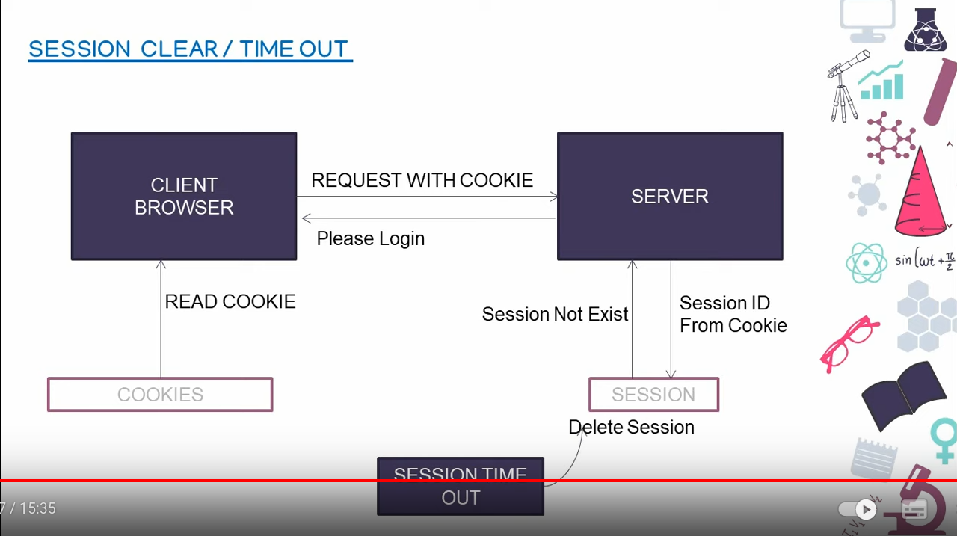

Creating a database
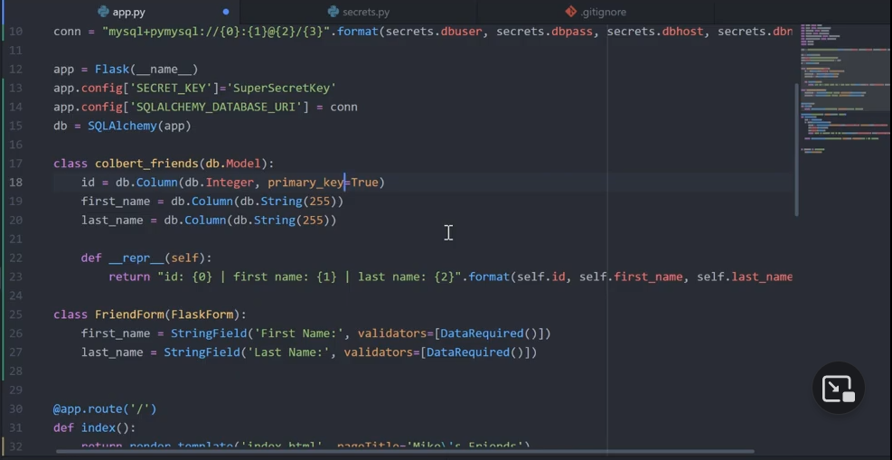
Adding data to the database
