STEP 1 — Check Existing Control Files
Login as SYSDBA:
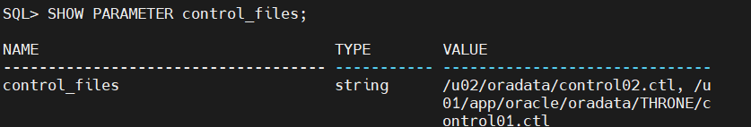

STEP 2 — Shutdown Database
STEP 3 — Create New Location(or use any existing path)
STEP 4 — Copy Existing Control File
Copy original control file to new location:
STEP 5 — Start Database in NOMOUNT Mode
STEP 6 — Update Control File Parameter
(here showing 3 because I already have 2 controlfiles before)
STEP 7 — Shutdown Database Again
STEP 8 — Start Database Normally
STEP 9 — Verify Multiplexing
