Config Spring – IDE

Eclipse Java EE IDE for Web Developers. Version: Luna Service Release 2 (4.4.2)

Maven:

xsi:schemaLocation=*"http://maven.apache.org/POM/4.0.0*

<**modelVersion**>4.0.0</**modelVersion**>

Tomcat v7.0 Server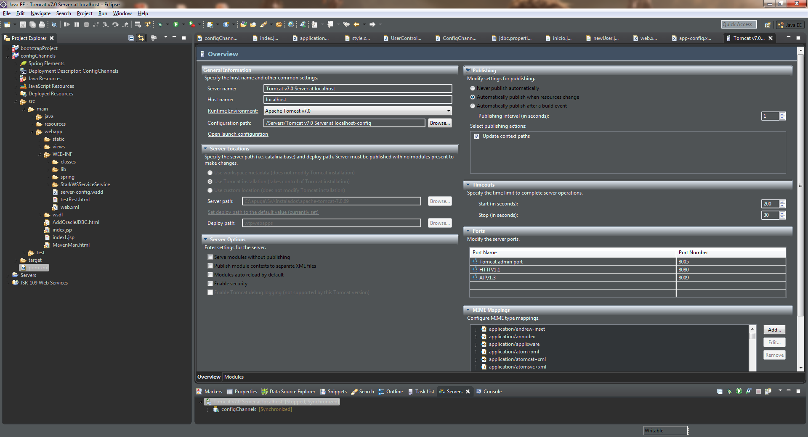

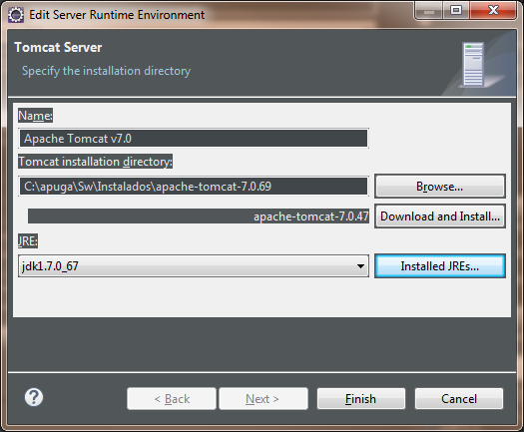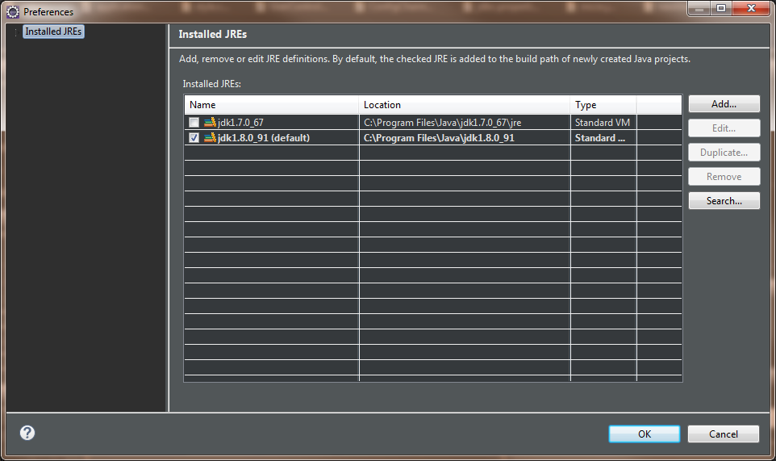

Server Locations:

*Use Tomcat installation (takes control of Tomcat installation)

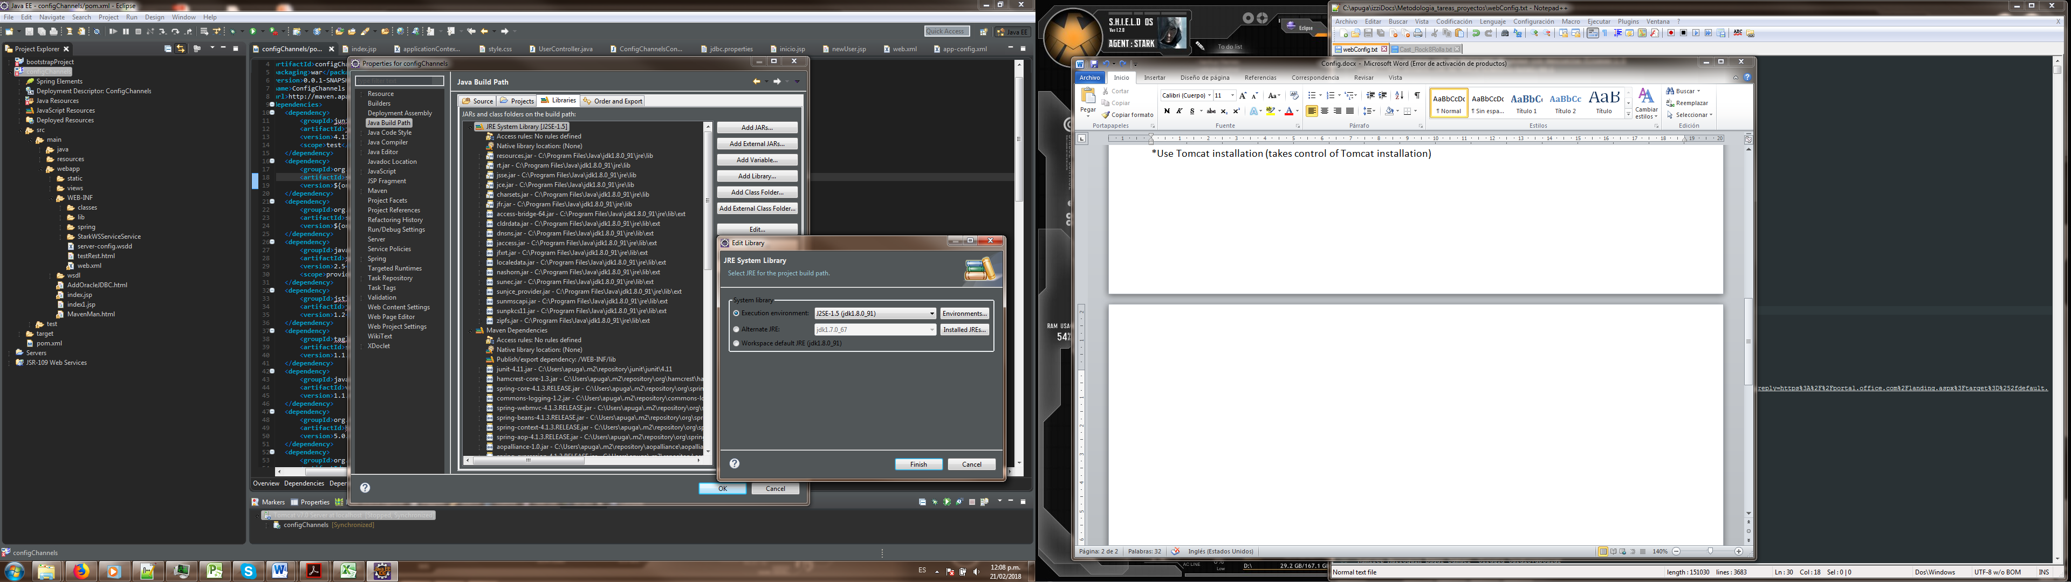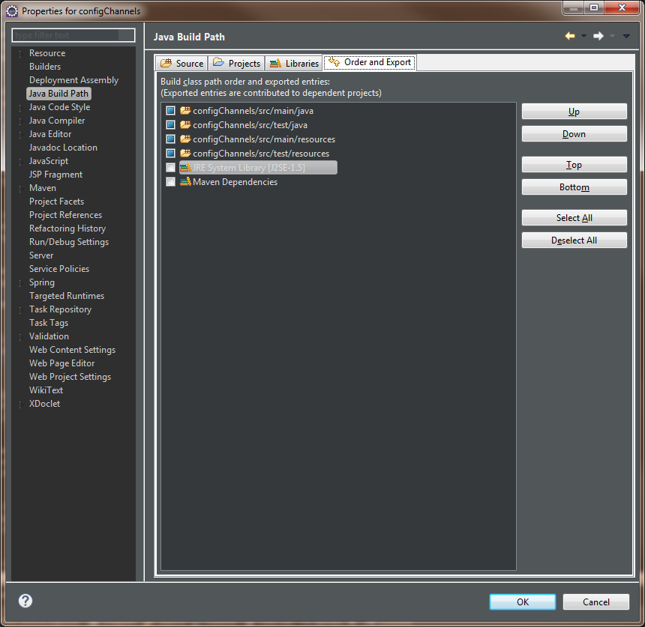

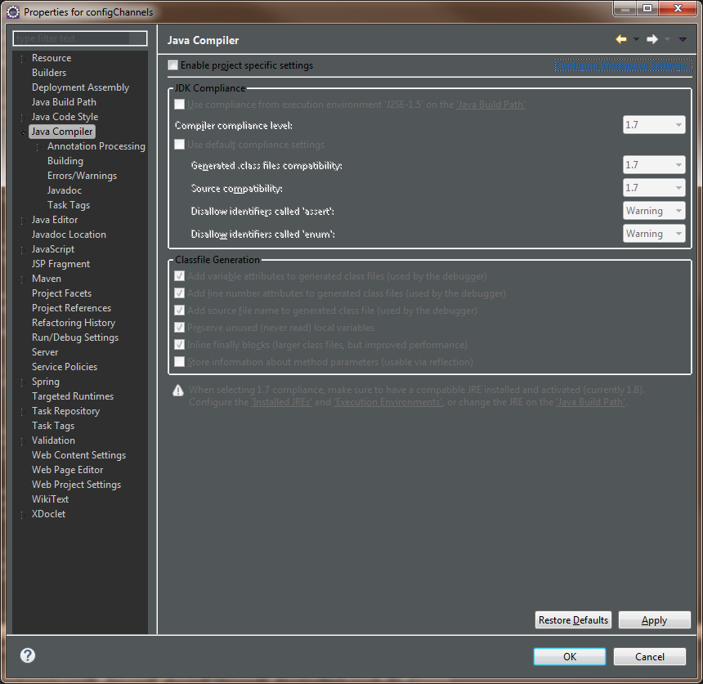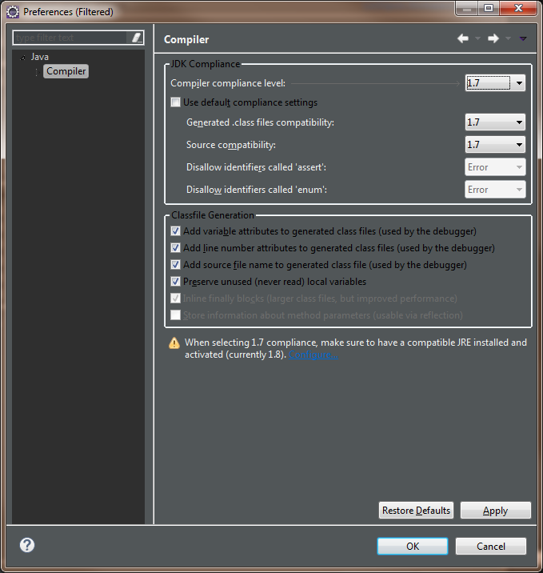

Clic en : Configure Workspace Settings

FINALLY: *** app-config.xml

<!-- Filtrar contenido estatico -->

<**mvc:resources** mapping=*"/static/**"* location=*"/static/"* />