# ElasticSearch & Kibana SetUp using Docker

* Install Docker Toolbox on Windows
  + Download and Execute DockerToolBox.exe. (https://docs.docker.com/toolbox/toolbox_install_windows/)
  + Select a custom directory for Docker installation. (for the scope of this document it is c:\work\Docker Toolbox)

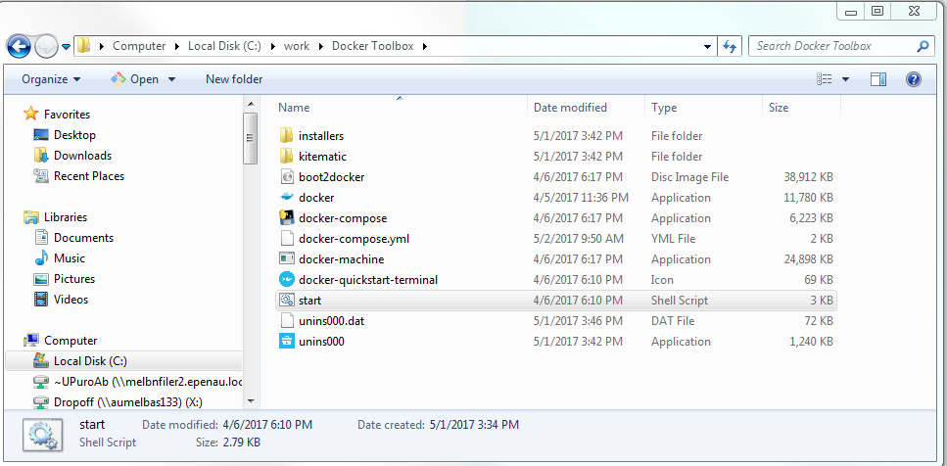

* Start Up Docker
  + Open the Git Bash in administrator mode (if Git is not installed then it can be installed from (https://git-scm.com/downloads)
  + Go to the directory where docker is installed(/c/work/D*) and type ./start.sh. Please Note the ip address of the docker machine (in this instance 192.168.99.100)

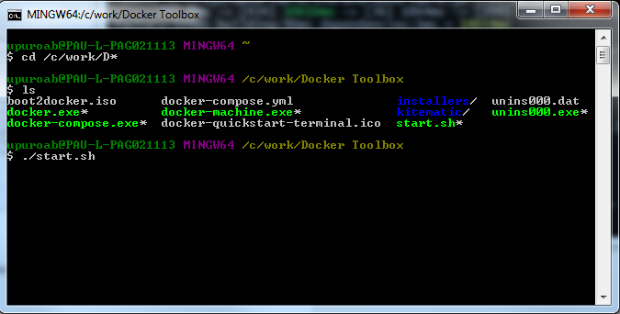

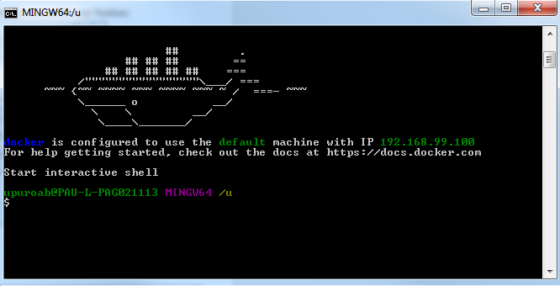

* Pull the ElasticSearch and Kibana images (<https://www.elastic.co/guide/en/elasticsearch/reference/current/docker.html> and <https://www.elastic.co/guide/en/kibana/5.3/_pulling_the_image.html> )
  + Run the following commands to pull the docker images for elasticsearch and kibana
    - docker pull docker.elastic.co/elasticsearch/elasticsearch:5.3.2
    - docker pull docker.elastic.co/kibana/kibana:5.3.2

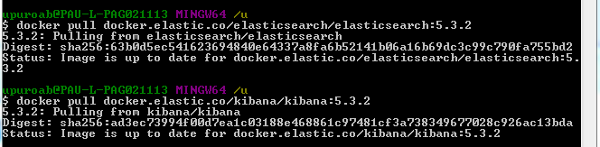

* Start the ElasticSearch in docker container
  + Run the command ‘docker run -p 9200:9200 -e "http.host=0.0.0.0" -e "transport.host=127.0.0.1" -e ES_JAVA_OPTS="-Xms512m -Xmx512m" docker.elastic.co/elasticsearch/elasticsearch:5.3.2’
  + To run elasticsearch without X-Pack security run the command ‘docker run -p 9200:9200 -e "http.host=0.0.0.0" -e "transport.host=127.0.0.1" -e "xpack.security.enabled=false" -e ES_JAVA_OPTS="-Xms512m -Xmx512m" docker.elastic.co/elasticsearch/elasticsearch:5.3.2’
  + To run elasticsearch to bypass the CORS problem run the command ‘docker run -p 9200:9200 -e "http.host=0.0.0.0" -e "transport.host=127.0.0.1" -e "xpack.security.enabled=false" -e "http.cors.enabled=true" -e http.cors.allow-origin="http://local.test.pearsonplaces.com.au:4200" -e http.cors.allow-headers="*" -e "http.cors.allow-credentials=true" -e ES_JAVA_OPTS="-Xms512m -Xmx512m" docker.elastic.co/elasticsearch/elasticsearch:5.3.2’
  + Open the url <http://192.168.99.100:9200/> with user id/password - elastic/changeme

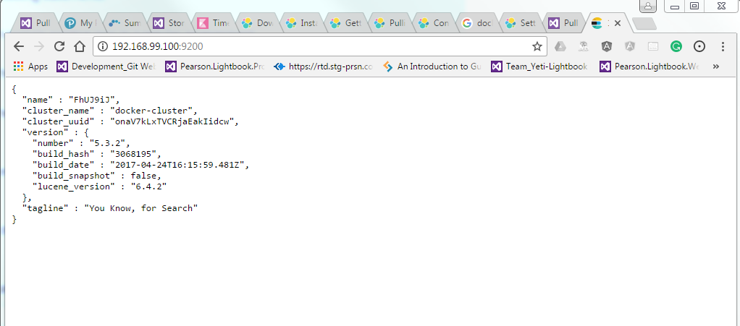

* Start the Kibana to monitor ElasticSearch
  + Run the command ‘docker run -p 5601:5601 -e "http.host=0.0.0.0" -e "transport.host=127.0.0.1" -e "ELASTICSEARCH_URL=http://192.168.99.100:9200" -e "ELASTICSEARCH_USERNAME=elastic" -e "ELASTICSEARCH_PASSWORD=changeme" docker.elastic.co/kibana/kibana:5.3.2’
  + Open the url http://192.168.99.100:5601/ with user id/password - elastic/changeme

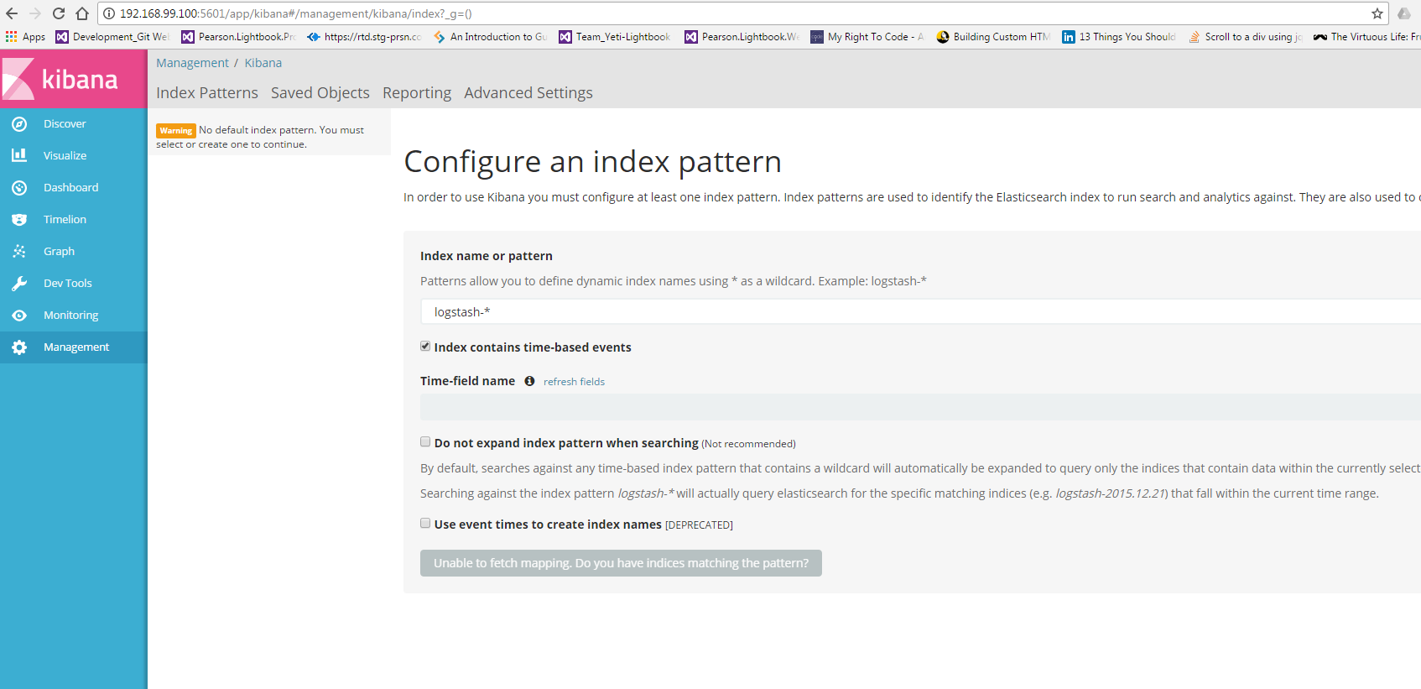

* Use the Dev tools on Kibana to test and build indexes on ElasticSearch

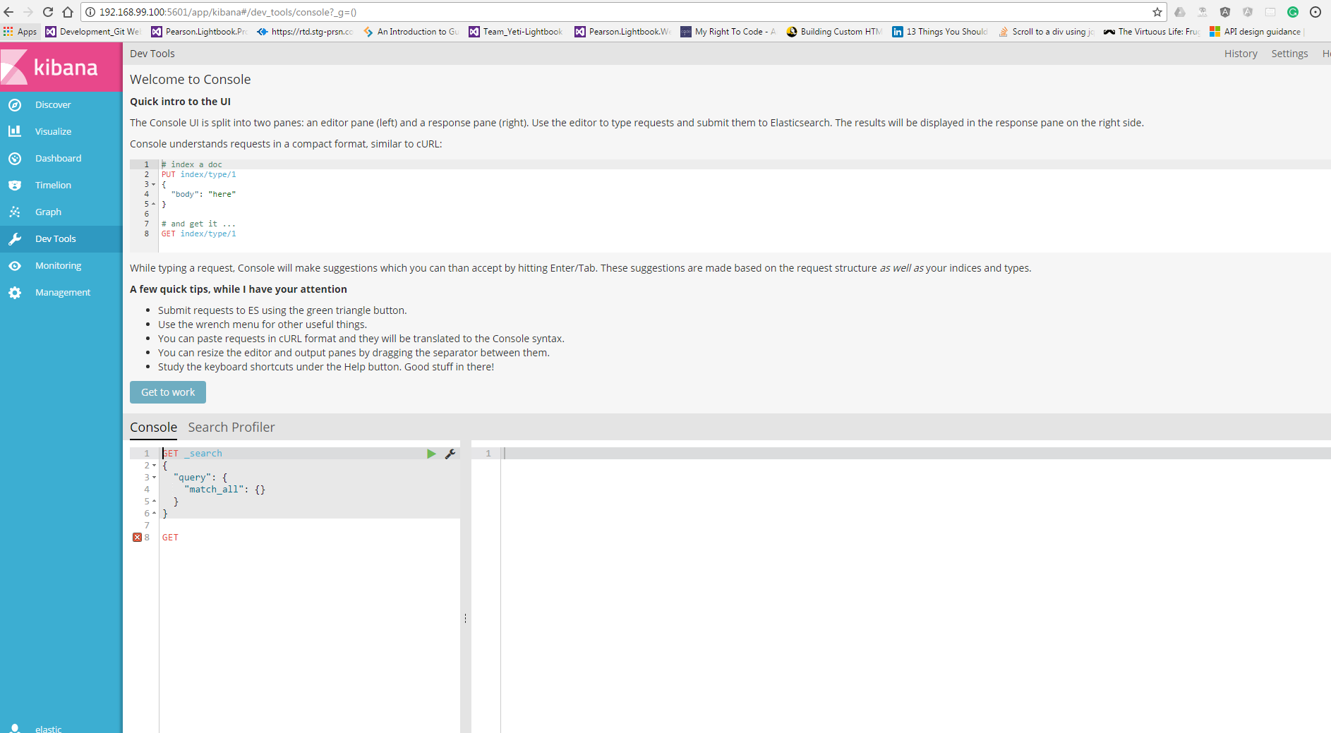

**Sample Code to create and add Data to index using Dot Net core and NEST**

**The following code creates and populates the index - lightbook at Course, Chapter, Module and Topic level. This data is a subset from course - Chemistry Western Australia 11**

Added the routing at course level for efficient search

using System;

using Nest;

namespace ConsoleApp1

{

public class CourseContent

{

public string Type { get; set; }

public DateTime CreatedOn { get; set; }

[Text(Fielddata = true)]

public string Text { get; set; }

public string Url { get; set; }

public string CourseId { get; set; }

public string Location { get; set; }

public string Title { get; set; }

}

class Program

{

public static Uri node;

public static ConnectionSettings settings;

public static ElasticClient client;

public static string COURSE = "Course";

public static string CHAPTER = "Chapter";

public static string MODULE = "Module";

public static string TOPIC = "Topic";

public static string CONTENT = "Content";

static void Main(string[] args)

{

node = new Uri("http://192.168.99.100:9200");

settings = new ConnectionSettings(node).DefaultIndex("lightbook");

//settings.EnableHttpCompression();

//settings.BasicAuthentication("elastic", "changeme");

client = new ElasticClient(settings);

var indexSettings = new IndexSettings();

indexSettings.NumberOfReplicas = 100;

//Number of shards kept at 100 so that data for each course is segregated in separate shards for efficient search

indexSettings.NumberOfShards = 100;

var indexConfig = new IndexState

{

Settings = indexSettings

};

if (!client.IndexExists("lightbook").Exists)

{

client.CreateIndex("lightbook", c => c

.InitializeUsing(indexConfig)

.Mappings(m => m.Map<CourseContent>(mp => mp

.RoutingField (routing => routing.Required(true)) // So that routing is required.

.AutoMap())));

}

InsertData(CHAPTER, "Unit 1 Chemical Fundamentals: Structure, properties and reactions", "/CH11_WA/units/CH11_WA-U01/chapters/CH11_WA-U01-00", "CH11_WA", "CH11_WA | Unit 1 Chemical Fundamentals:", "Unit 1 Chemical Fundamentals: Structure, properties and reactions");

InsertData(CHAPTER, "Materials", "/CH11_WA/units/CH11_WA-U01/chapters/CH11_WA-U01-01", "CH11_WA", "CH11_WA", "Materials");

InsertData(CHAPTER, "Atoms: Structure and mass", "/CH11_WA/units/CH11_WA-U01/chapters/CH11_WA-U01-02", "CH11_WA", "CH11_WA", "Atoms: Structure and mass");

InsertData(CHAPTER, "Electron arrangements and the periodic table", "/CH11_WA/units/CH11_WA-U01/chapters/CH11_WA-U01-03", "CH11_WA", "CH11_WA", "Electron arrangements and the periodic table");

InsertData(CHAPTER, "Metals", "/CH11_WA/units/CH11_WA-U01/chapters/CH11_WA-U01-04", "CH11_WA", "CH11_WA", "Metals");

InsertData(CHAPTER, "Ionic compounds", "/CH11_WA/units/CH11_WA-U01/chapters/CH11_WA-U01-05", "CH11_WA", "CH11_WA", "Ionic compounds");

InsertData(MODULE, "Before you begin", "/CH11_WA/units/CH11_WA-U01/chapters/CH11_WA-U01-01/modules/CH11_WA-U01-01-CO", "CH11_WA", "CH11_WA | 1 Materials", "Before you begin");

InsertData(MODULE, "Materials science", "/CH11_WA/units/CH11_WA-U01/chapters/CH11_WA-U01-01/modules/CH11_WA-U01-01-01", "CH11_WA", "CH11_WA | 1 Materials", "Materials science");

InsertData(MODULE, "Nanomaterials", "/CH11_WA/units/CH11_WA-U01/chapters/CH11_WA-U01-01/modules/CH11_WA-U01-01-02", "CH11_WA", "CH11_WA | 1 Materials", "Nanomaterials");

InsertData(MODULE, "Purifying materials", "/CH11_WA/units/CH11_WA-U01/chapters/CH11_WA-U01-01/modules/CH11_WA-U01-01-03", "CH11_WA", "CH11_WA | 1 Materials", "Purifying materials");

InsertData(TOPIC, "Chemical Materials", "/CH11_WA/units/CH11_WA-U01/chapters/CH11_WA-U01-01/modules/CH11_WA-U01-01-01/pages/Psec05192014210059280334/topics/Tsec09172014115242645226", "CH11_WA", "CH11_WA | 1.1 Materials science", "Properties of Materials");

InsertData(CONTENT, "Materials GO67 The term material usually describes substances that are components of other objects.For example, wood, paper and nylon are all classified as materials because they can be used to create houses, books and clothes, respectively.Substances that are not considered materials include chemicals such as hydrochloric acid, chlorophyll or carbon dioxide.While these are all extremely useful substances, other objects are not made out of these substances.Therefore these substances are not usually classified as materials. Materials are often mixtures of many substances – for example cement or bitumen.However, materials can also be pure elements or compounds. Elements are substances that are made up of just one type of atom.Therefore they consist of atoms with the same atomic number(the number of protons in the nucleus).Pure metals such as gold or silver are examples of elements that are also materials.Carbon is an example of a non - metallic element that forms a variety of materials such as charcoal, graphite, diamond and even nanotubes. Compounds also make up a huge variety of materials.Compounds are pure substances made of more than one type of atom.They consist of more than one element in fixed proportions. The formula of a compound indicates the relative numbers of atoms of each element in the compound. Silica, SiO2SiO2, is a compound made up of silicon and oxygen atoms and is the main component of beach sand. The compound contains twice as many oxygen atoms as silicon atoms.Silica is used to make glass, quartz and gemstones. Calcium carbonate, CaCO3CaCO3, is another compound that makes up several different materials. These materials include chalk, limestone and marble. For example, the marble statue shown in the figure below is made of calcium carbonate. A marble statue of an angel in front of a blue sky. 1.1.2 This marble statue is made of the compound calcium carbonate, CaCO3CaCO3. Properties and uses of materials The way in which a material is used is determined by the material's physical and chemical properties. These properties are special features of the material such as its colour, hardness, melting and boiling points, whether it conducts electricity or heat and how easily the material reacts with other chemicals.", "/CH11_WA/units/CH11_WA-U01/chapters/CH11_WA-U01-01/modules/CH11_WA-U01-01-01/pages/Psec05192014210059280334/topics/Tsec09172014115242645226", "CH11_WA", "CH11_WA | 1.1 Materials science", "Properties of Materials");

InsertData(CONTENT, "Over the last century, the number of useful materials has expanded dramatically.The rapid development in materials technology has come from scientists' increased understanding of chemistry and materials at the atomic level. One of the most important technological advancements was the discovery of synthetic polymers. The first polymer was synthesized in 1907 by Leo Baekeland. Since then, synthetic polymers have been used to create a range of different materials, including resins, rubbers, glues, foams and, most importantly, plastics. Plastics are now an important part of our everyday life because they are strong, flexible, weatherproof and can be made into almost any shape. Today, plastics are used in 3D printers like the one shown in the figure below. 3D printing allows the production of one-off plastic objects that would otherwise need to be produced in a factory. 0:00 1.1.19 This 3D printer uses a plastic wire filament to print objects in 3D. Semiconductors are another class of materials that have revolutionised society. The semiconductor industry is most commonly associated with the production of the microchips that are used in our computers, phones and telecommunications networks. Semiconductors are also used in the production of devices such as lasers and light emitting diodes (LEDs). Originally, LEDs came in a limited range of colours – mostly red.However, materials technology has developed LEDs that can emit all types of coloured light.By combining red, green and blue LEDs it is now possible to create huge screens for stadiums and billboards.More recently, scientists have discovered how to make white LEDs that can be used as energy efficient lighting in cars and in the home.", " /CH11_WA/units/CH11_WA-U01/chapters/CH11_WA-U01-01/modules/CH11_WA-U01-01-01/pages/Psec05192014210059280334/topics/Tsec09172014115352645226", "CH11_WA", "CH11_WA | 1.1 Materials science", "Properties of Materials");

//for (int i = 1; i <= 25; i++)

//{

//InsertData(i.ToString(), i);

//}

/*

Console.WriteLine(PerformTermQuery());

Console.Read();

Console.WriteLine(PerformMatchQuery());

Console.Read();

Console.WriteLine(PerformMatchPhraseQuery("Post from NEST"));

Console.Read();

Console.WriteLine(PerformFilter("Post from NEST by abhi"));

Console.Read();

*/

}

public static void InsertData(string type, string text, string url, string courseId, string location, string title)

{

var newBlogPost = new CourseContent

{

Type = type,

CreatedOn = DateTime.Now,

Text = text,

Url = url,

CourseId = courseId,

Location = location,

Title = title

};

client.Index(newBlogPost, i => i

.Index("lightbook")

.Type("courseContent")

.Routing(newBlogPost.CourseId)

);

}

public static Object PerformMatchQuery()

{

var result = client.Search<CourseContent>(s => s

.From(0)

.Size(10000)

.Index("lightbook")

.Type("courseContent")

.Query(q =>

q.Match(mq => mq.Field(f => f.Text).Query("abhi"))

)

);

return result;

}

public static Object PerformMatchPhraseQuery(string phrase)

{

var result = client.Search<CourseContent>(s => s

.From(0)

.Size(10000)

.Index("lightbook")

.Type("courseContent")

.Query(q =>

q.MatchPhrase(mq => mq.Field(f => f.Text).Query(phrase))

)

);

return result;

}

public static Object PerformTermQuery()

{

var query = " ";

var result = client.Search<CourseContent>(s => s

.From(0)

.Size(10000)

.Index("lightbook")

.Type("courseContent")

.Query(q =>

q.Term(t => t.Text, query)

)

);

return result;

}

}

}

**Steps to re-run the NEST file**

1. **Run the command ‘docker ps -a’ to see all the docker containers running. Please note the first 4 letter of container id , it is 327f in case of elasticSearch instance and b881 in case of kibana**

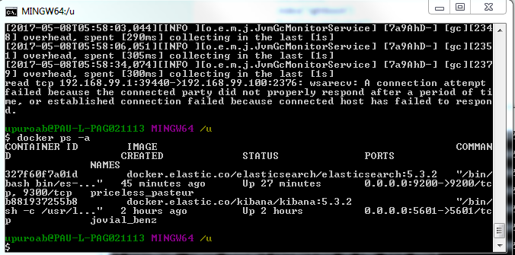

1. **Run the command ‘docker container stop <first 4 letter container id>’ For e.g. docker container stop 327f for elastic**



1. **Run the command ‘docker rm <first 4 letter of container id>’ For e.g docker rm 327f**



1. **The idea is when ‘docker ps -a’ is run again there should be no docker containers**



1. **Re run the docker command to start docker container for elasticsearch and kibana**
   1. docker run -p 80:9200 -e "http.host=0.0.0.0" -e "transport.host=127.0.0.1" -e "xpack.security.enabled=false" -e "http.cors.enabled=true" -e http.cors.allow-origin="http://local.test.pearsonplaces.com.au:4200" -e http.cors.allow-headers="*" -e "http.cors.allow-credentials=true" -e ES_JAVA_OPTS="-Xms512m -Xmx512m" docker.elastic.co/elasticsearch/elasticsearch:5.3.2
   2. docker run -p 5601:5601 -e "http.host=0.0.0.0" -e "transport.host=127.0.0.1" -e "ELASTICSEARCH_URL=http://192.168.99.100:9200" -e "ELASTICSEARCH_USERNAME=elastic" -e "ELASTICSEARCH_PASSWORD=changeme" docker.elastic.co/kibana/kibana:5.3.2
2. **Execute the NEST code (from the above section) to create data**
3. **Check if data exist in ES**