TECHNICAL DOCUMENTATION
Identity Verification Flow
Selfie-First Verification: Enrollment, ID Portrait Matching, Document Extraction and Validation
Attribute | Detail
System | Proctoring platform – identity verification
Basis of document | Review of the current implementation (not the README alone)
Document date | October 06, 2026
Classification | Internal – Technical

Table of Contents
1. Introduction 4
1.1 Purpose 4
1.2 Overview 4
1.3 Key Limitation 4
2. System Architecture 4
3. End-to-End Flow 4
3.1 Sequence Summary 5
3.2 Phase 1 – Selfie Enrollment Flow 6
3.3 Phase 2 – ID Verification Flow 7
3.4 Reading the Diagrams 7
4. Phase 1 – Enroll the Reference Selfie 7
4.1 Request 7
4.2 Processing Steps 8
4.3 Storage 8
4.4 Result 8
5. Phase 2 – Submit the ID Document 8
5.1 Request 8
5.2 Request Validation 9
6. Phase 2 – Match the ID Portrait with the Selfie 9
6.1 Load the Reference 9
6.2 Detect and Embed ID Portraits 9
6.3 Match Score 9
6.4 Orientation and Face Selection 9
7. Phase 2 – Extract Document Information 9
7.1 Configuration 10
7.2 Structured Result 10
8. Phase 2 – Validate and Save the Result 10
8.1 Validation Rules 10
8.2 Session Persistence 10
9. API Output and Failure Behavior 11
9.1 Successful Response 11
9.2 HTTP Status Codes 11
10. Interpretation of Success and Known Limitations 11
10.1 Meaning of “Success” 11
10.2 Not Established by a Successful Result 11
10.3 Summary of Observed Gaps 11

1. Introduction

1.1 Purpose
This document describes the identity verification flow as it is currently implemented. It is intended for engineers, reviewers and stakeholders who need an accurate account of what the system does today, including its limitations.

1.2 Overview
The system implements a selfie-first verification flow:
Enroll selfie → Detect portrait on ID → Compare faces → Extract document details → Validate document rules → Save result

1.3 Key Limitation
Important: Selfie enrollment currently does not enforce liveness, because that check is switched off. The present flow therefore establishes a face match against an enrolled image. It does not provide proof that a live person completed enrollment.

2. System Architecture
Component | Responsibility
Verification service | HTTP interface; input decoding; orchestration of enrollment and ID matching
Face detection | Selfie face detection (MediaPipe) and ID portrait detection (YuNet)
Gaze verification | Confirms that the selfie subject is looking at the screen
Face recognition inference | Produces face embeddings through Triton (gRPC)
Reference store | Stores and retrieves the reference selfie embedding
Document analysis | Structured extraction of document fields from the ID image using an OpenAI vision model
Redis | Temporary storage of the selfie reference and the document-analysis session

ID verification runs directly over HTTP. It does not pass through the RabbitMQ streaming frame queue or the shared frame batch processor, although it uses batch inference internally for ID portraits.

3. End-to-End Flow
Verification is performed in two client-initiated phases. Phase 1 enrolls the reference selfie; Phase 2 submits the ID document, which is matched against that selfie, analysed and validated.

3.1 Sequence Summary
# | Actor | Action | Dependency
1 | Client | Submits selfie image and candidate identifier (enrollment request) | —
2 | Service | Decodes image; detects exactly one face; rejects framing warnings; requires gaze toward screen; crops face | —
3 | Service | Generates the face embedding | Triton
4 | Service | Stores the reference embedding (24-hour expiry) | Redis
5 | Service | Returns enrollment result | —
6 | Client | Submits ID image, candidate identifier, selected country and selected ID type | —
7 | Service | Validates the request; loads the stored selfie embedding | Redis
8 | Service | Detects portraits on the ID at 0° and embeds each crop | Triton
9 | Service | Scores each portrait against the selfie; if none passes, retries at 180°, 90° and 270° | Triton
10 | Service | On a passing portrait, sends the full ID image for structured extraction | OpenAI
11 | Service | Applies document rules (readability, ID class, country, type, expiry) | —
12 | Service | Saves the document session (24-hour expiry) | Redis
13 | Service | Returns analysis result with extracted details and face-match evidence | —

3.2 Phase 1 – Selfie Enrollment Flow
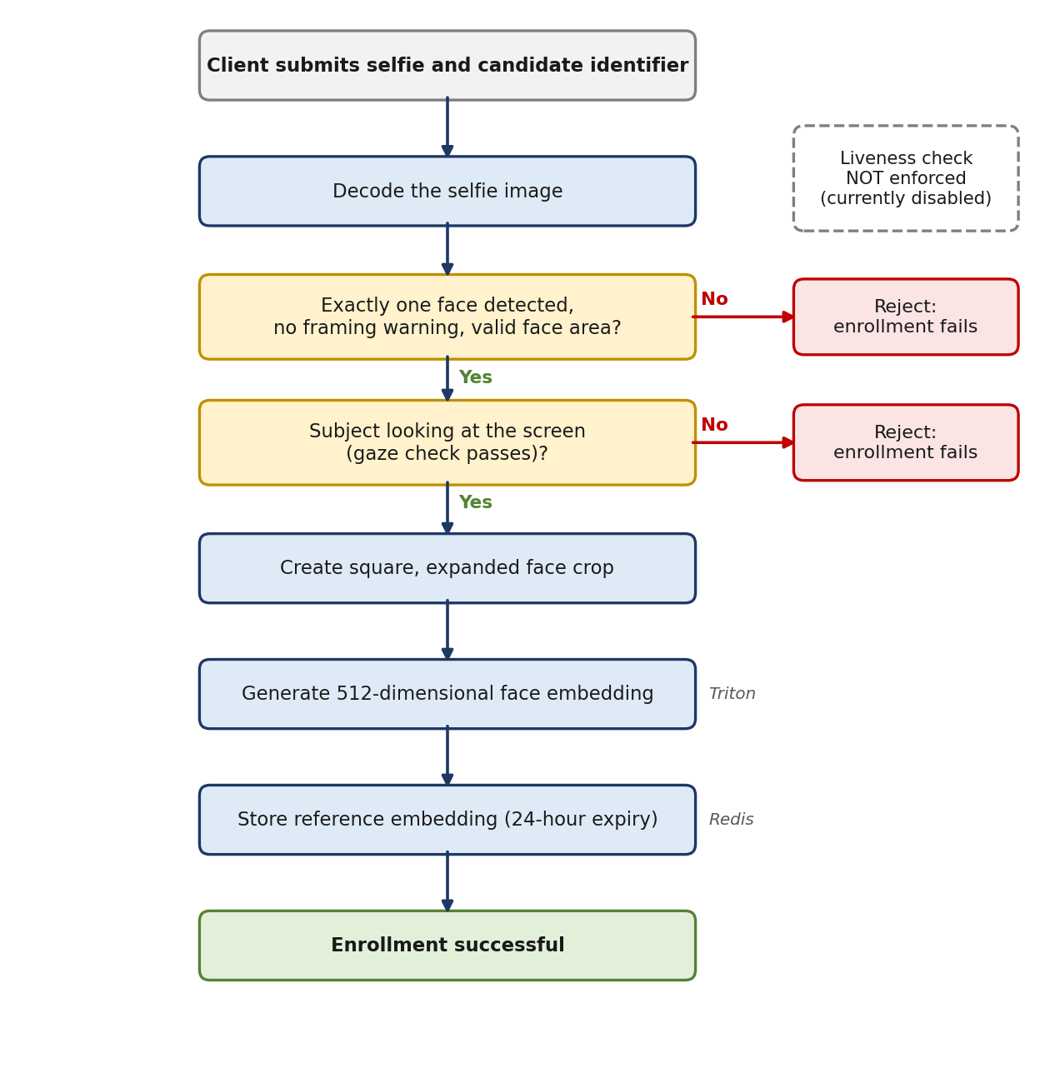
Figure 1. Selfie enrollment flow

3.3 Phase 2 – ID Verification Flow
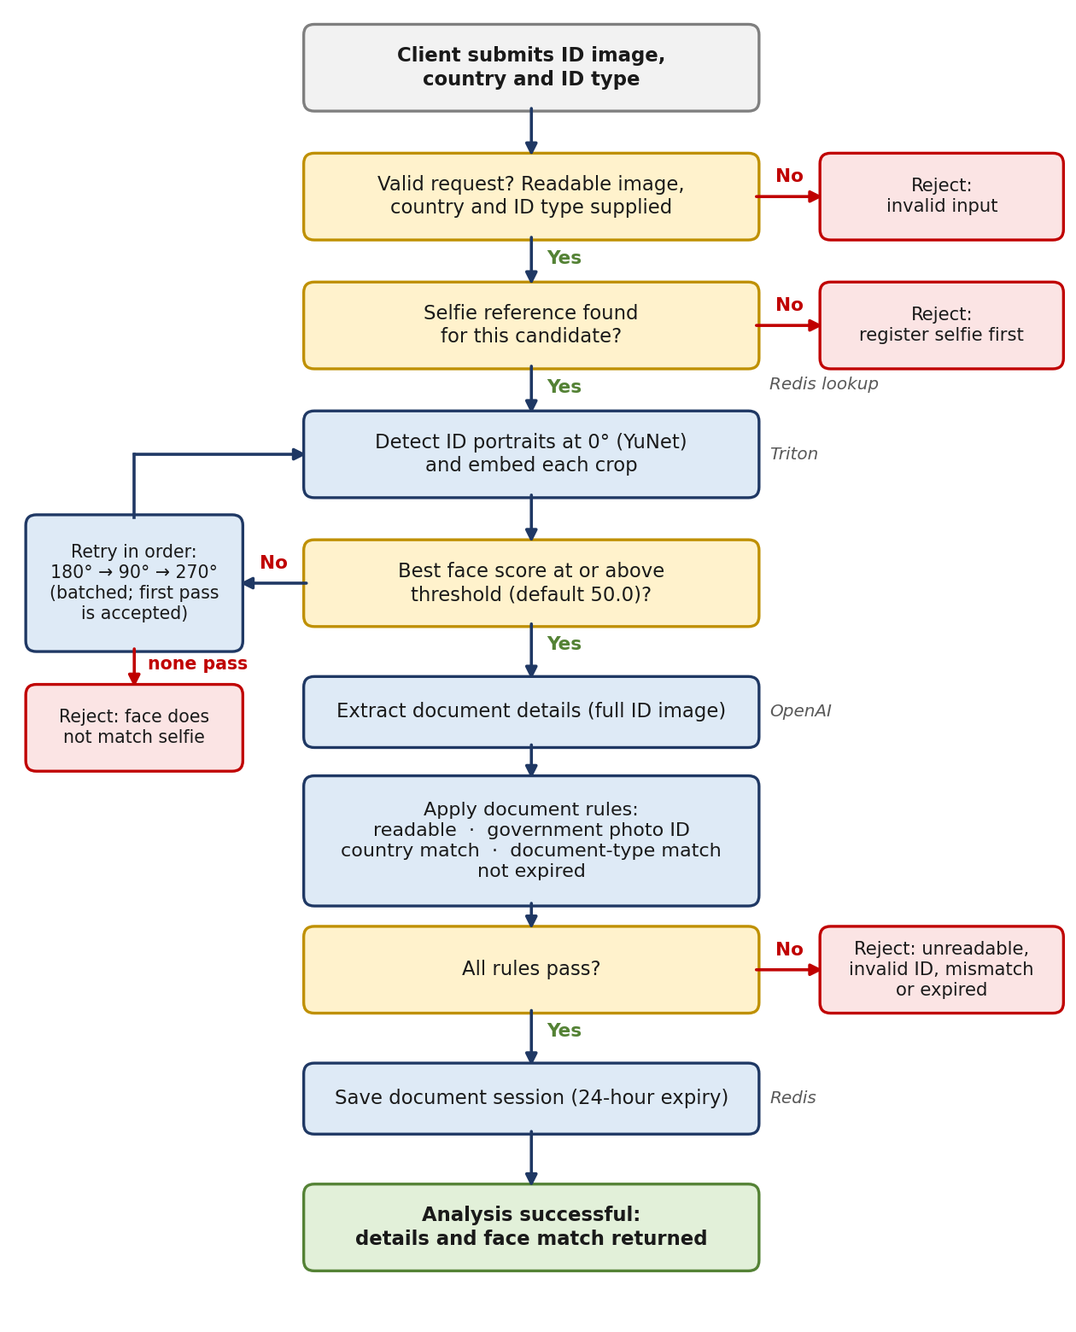
Figure 2. ID verification flow, including orientation retries and rejection outcomes

3.4 Reading the Diagrams
- Amber boxes are decision points; red boxes are rejection outcomes; green boxes are successful completion.
- Labels beside a step (Triton, OpenAI, Redis) identify the external dependency it relies on.
- Any rejection ends the request; no partial result is saved.

4. Phase 1 – Enroll the Reference Selfie

4.1 Request
The client submits an enrollment request containing:
- A candidate identifier.
- The selfie image, Base64-encoded.

4.2 Processing Steps
- Decode the Base64 image into a BGR image using OpenCV.
- Detect faces.
- Reject the request if any of the following apply:
  - No face is detected.
  - More than one face is detected.
  - The detector reports a framing warning.
  - The face bounding box is invalid.
- Run gaze estimation and require the subject to be looking at the screen, with no error.
- Create a square, expanded, top-biased face crop; fall back to the raw bounding-box crop if required.
- Generate the reference embedding using the Triton face-recognition model.
- Save the embedding to Redis.
- …

4.3 Storage
Property | Value
Content | 512-dimensional float32 face embedding, keyed by candidate identifier
Time to live | 24 hours

4.4 Result
A successful enrollment returns a confirmation that enrollment was successful.
Note: Liveness is skipped in the active method. A liveness service is started with the application, but enrollment does not call it.

5. Phase 2 – Submit the ID Document

5.1 Request
Input | Description
Candidate identifier | Must match the identifier used at enrollment
ID image | Base64-encoded image of the identity document
Selected country | Country chosen by the user, used for comparison only
Selected ID type | Document type chosen by the user (for example, Passport), used for comparison only

5.2 Request Validation
The service verifies that the request is JSON, that the image can be decoded, and that the selected country and selected ID type are populated.
Implementation detail: The candidate identifier is not strictly required by the parser. If omitted, it defaults to "unknown".

6. Phase 2 – Match the ID Portrait with the Selfie

6.1 Load the Reference
The service retrieves the stored selfie embedding for the candidate. If none is available, it returns the message “Please register your selfie first.”

6.2 Detect and Embed ID Portraits
- Try the original image at 0°.
- Detect portraits using YuNet.
- Prepare a crop for each detected face.
- Send the crops to Triton for embeddings.
Recognizer preprocessing and inference proceed as follows:
- Resize to 112 × 112.
- Convert to FP16.
- Normalize pixels using (pixel − 127.5) × 0.0078125.
- Convert to channel-first layout.
- Run the face-recognition model.
- L2-normalize the output embeddings.

6.3 Match Score
The implementation uses a custom score rather than a raw cosine-similarity percentage:
Score = clamp( ((1 + dot product) / 2) × 100 − 10 × Euclidean distance, 0, 100 )
A face passes when its score is at least the configured threshold, which defaults to 50.0. This score is not a calibrated probability of identity.

6.4 Orientation and Face Selection
- If the upright image fails, the service batch-processes 180°, 90° and 270°, and accepts the first passing orientation in that order. It does not select the globally strongest orientation.
- Within an orientation, the highest-scoring face is selected.
- Multiple ID faces are currently permitted, because the rejection logic is switched off.

7. Phase 2 – Extract Document Information
The vision-model call occurs only after a portrait has passed face matching. The service JPEG-encodes the full ID image in the accepted orientation, not only the portrait crop, and submits it for structured extraction.

7.1 Configuration
Setting | Default
Vision model | gpt-4o-mini
Request timeout | 60 seconds
API key | Required

7.2 Structured Result
Group | Contents
Document | ID classification, country, country match, ID type, type match, side
Identity | Printed name, ID number
Issue | Issue date
Expiry | Expiry date
Photo | Portrait presence
Image quality | Readability

The prompt instructs the model to detect country and document type from the image, using the user’s selections only for comparison. The model supplies extracted fields and match flags; the application applies the final acceptance rules.

8. Phase 2 – Validate and Save the Result

8.1 Validation Rules
Rules are evaluated in the following order:
# | Check | Failure Result
1 | Image readable | Ask for a clearer photo
2 | Classified as a government-issued photo ID | Reject invalid ID
3 | Country match confirmed | Reject country mismatch
4 | ID-type match confirmed | Reject document-type mismatch
5 | Parseable expiry date is not before today | Reject expired ID

Note: Missing or unparseable expiry dates do not cause rejection. The validators also do not independently require a populated name, document number, front side, or portrait presence.

8.2 Session Persistence
Property | Value
Time to live | 24 hours
Status | Analyzed
Contents | Document type, country, name, number, dates, side and match flags

The saved session does not include face-match evidence or a liveness result. In addition, the outcome of the save operation is not checked, so the API can return success even if session persistence fails.

9. API Output and Failure Behavior

9.1 Successful Response
A successful ID response contains the extracted document groups, an indication that no error occurred, and face-match details: detected faces, threshold, selected face, orientation and per-face scores.

9.2 HTTP Status Codes
Outcome | HTTP Status
Successful analysis | 200
Invalid input or returned verification error | 400
Unhandled exception | 500

Most service-handled failures, including timeouts and generic internal errors, are returned as 400.

10. Interpretation of Success and Known Limitations

10.1 Meaning of “Success”
A successful result means that a detected ID portrait matched the enrolled selfie, and that the extracted document data passed the implemented rules.

10.2 Not Established by a Successful Result
- Live-person enrollment.
- Authoritative document authenticity.
- Issuing-authority lookup (none exists in the active ID path).
- Dedicated tamper or security-feature verification.
- Comparison of the printed name against an external candidate record.

10.3 Summary of Observed Gaps
Area | Observation
Liveness | Not enforced at enrollment
Multiple ID faces | Permitted; no rejection
Orientation selection | First passing orientation (0°, 180°, 90°, 270°), not strongest
Match score | Custom, uncalibrated; default threshold 50.0
Session persistence | Save outcome not checked; success may be returned on failure
Session content | No face-match evidence or liveness result stored
Expiry validation | Missing or unparseable dates do not cause rejection
Field requirements | Name, number, side and portrait presence not independently enforced
Candidate identifier (ID step) | Defaults to "unknown" if omitted

