*East West University*

Project : MarketPlace - Buy & Sell

**Course Title         :** Mobile Application Development

**Course Code       :** CSE489

**Section                :** 01

**Semester       :** Spring 2022

**Submitted To**

**Md Mostofa Kamal Rasel, PhD**

**Assistant Professor**

**Department of Computer Science and Engineering**

**Submitted By**

**Jamil Ahmmed Tushar (2018-3-60-121) 55%**

**Apurba Roy Ajay (2018-3-60-063) 45%**

**Project Description:**

Online Marketplace provides a platform where registered user can buy and sell products or items online. The system has four type of users: Administrator and Buyer. The Administrator is responsible for the authentication of the user and the product both. Every component on the website is under the control of the Administrator. The Administrator has full authority to insert, update or delete any user or product from the website. It contains online payment service which enables trade on only local. Marketplace is developed for complete selling and buying of any product uploaded on the site. Every type of user having authenticated Email and password can access this system.

The features we have used for our application :

* **Sign Up As Shop Owner/Admin or Buyer/Customer**
* **Add or delete product**
* **Buying a product**
* **Search by product title and price**
* **Update Data Realtime on Firebase.**

Objective

The purpose of Marketplace system is to take advantage of the Internet and World Wide Web to improve the way private individuals and companies buy and sell the items. The overarching goal of the MARKETPLACE project is to design, create and maintain a sustainable web-based platform providing a central access point to all needed tangible and intangible modeling components and making them available to the entire materials modeling community. These include activities on databases, modeling, integrated open simulation platforms, and translation and knowledge services.

**The goal of our project :**

* **Provide the buyers with huge amount of categories**
* **Easy search of items they want to buy.**
* **Makes buying convenient by allowing to buy items anywhere and anytime.**
* **Provides sellers with a huge customer base.**
* **Increased sales**
* **Online sales infrastructure**
* **Smooth Customer Experience**
* **Brand awareness**

**Features:**

**All xmls were done by Apurba Roy.**

**Feature 1:**

This is the home Page and Signup page. At first user have to signup with their information. And all of the data store in Firebase Database.

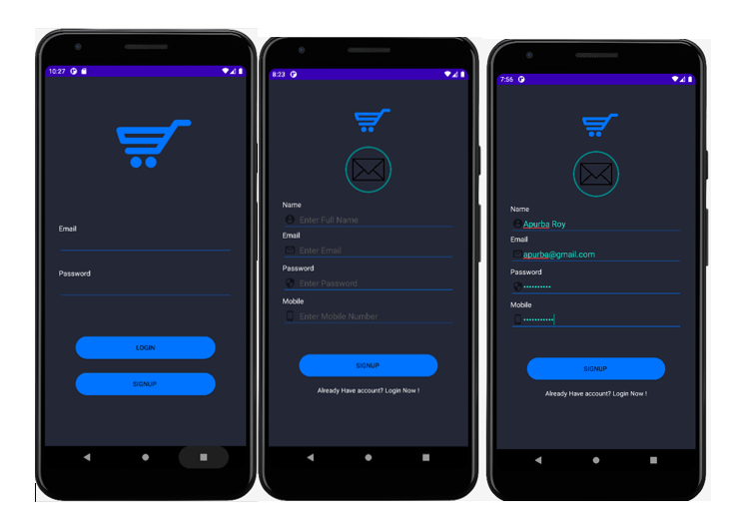

**Feature 2:**

After the successfully Registration user can login with user Email and Password.

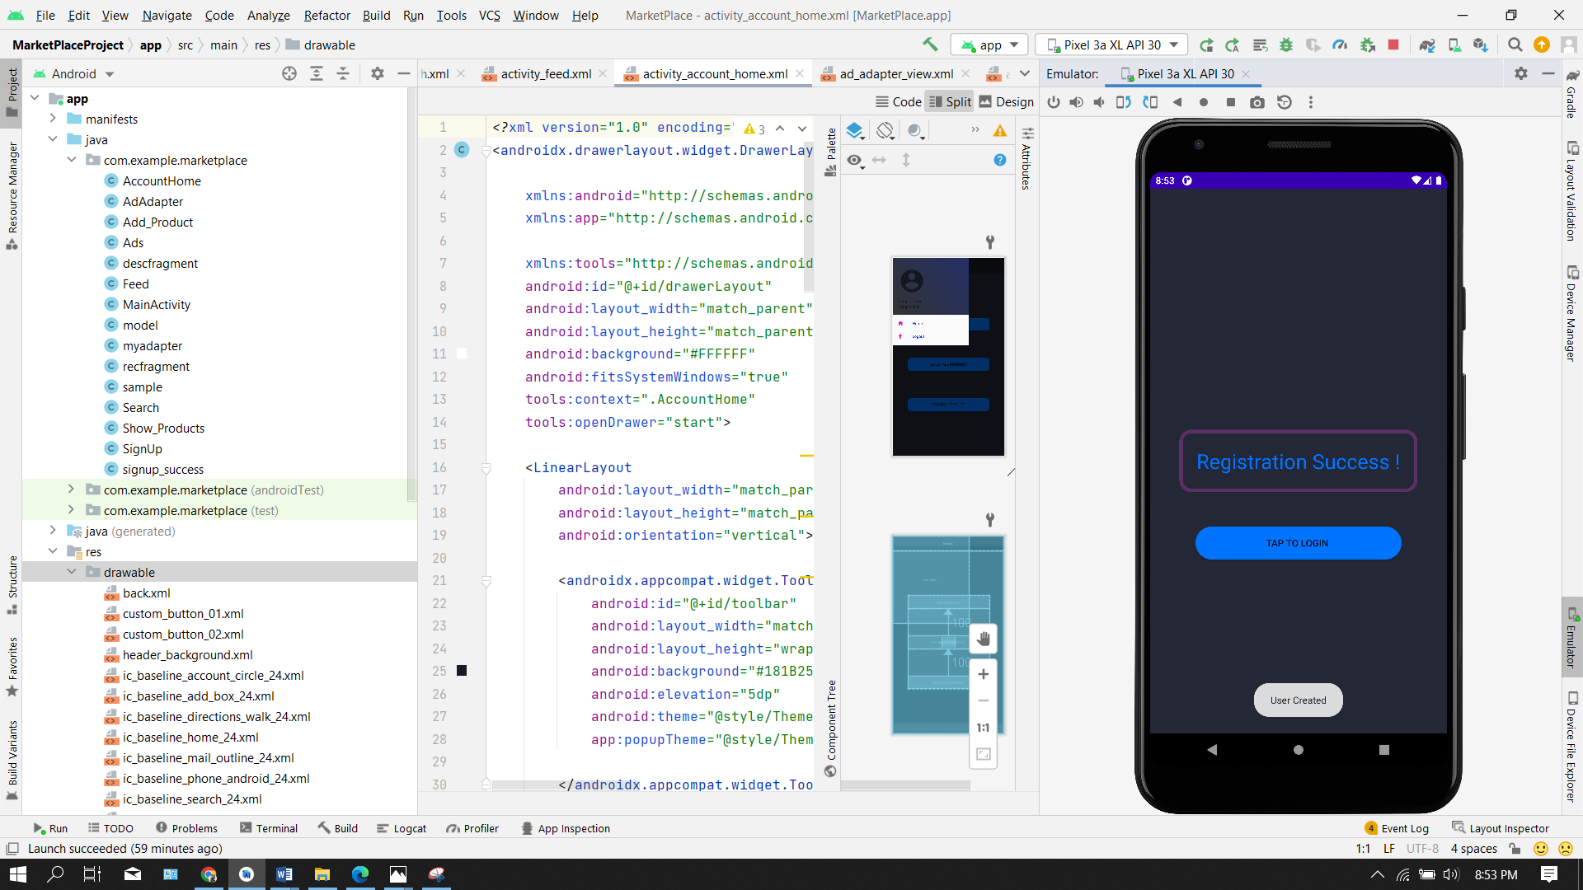 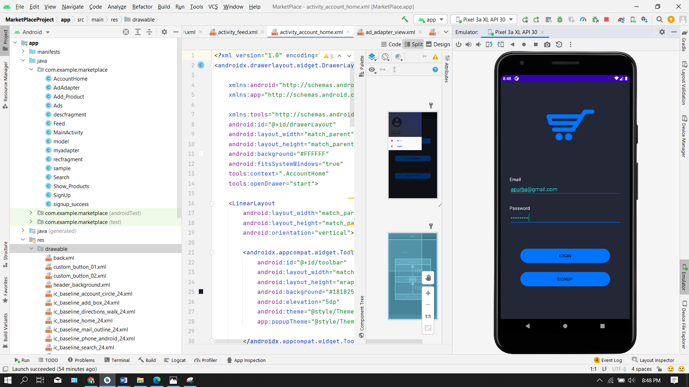

**Feature 3:**

This is the homepage when admin logs in to the app. In the "add" option, the admin/shop owner can add their product with the details. Then all of the data is stored in Firebase.

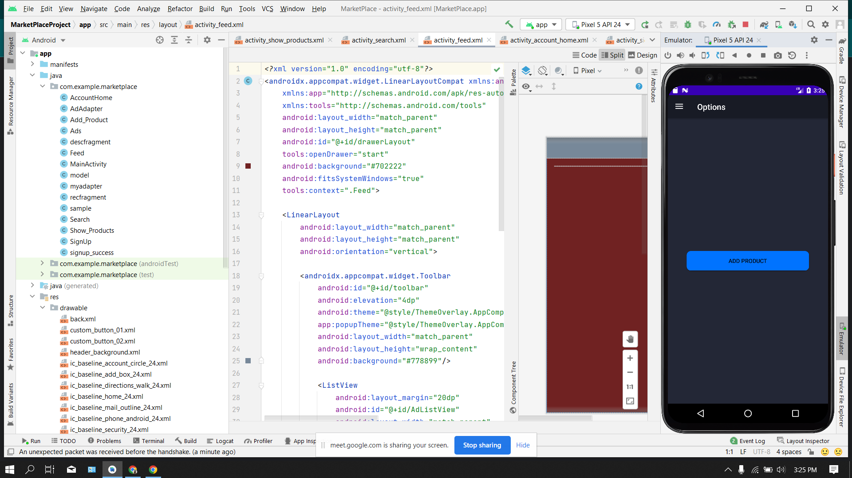 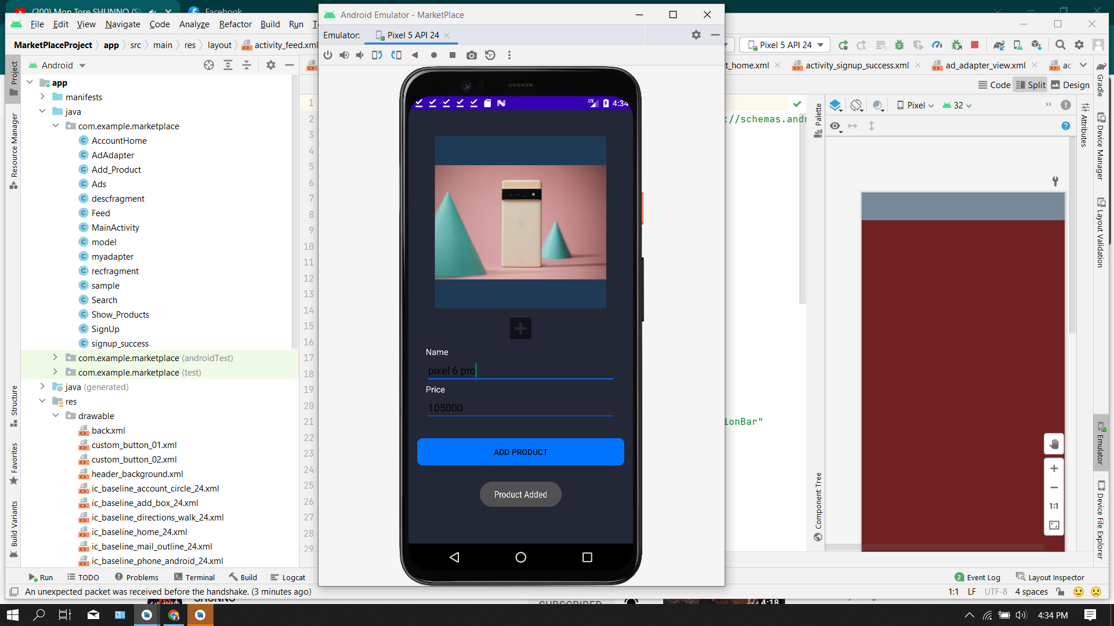

**Feature 4:**

In search option buyers can find their product and search the product which one they want to purchase.

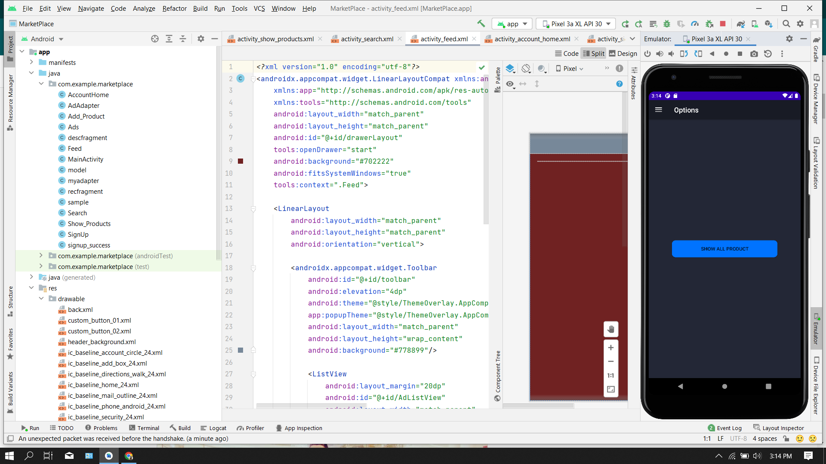 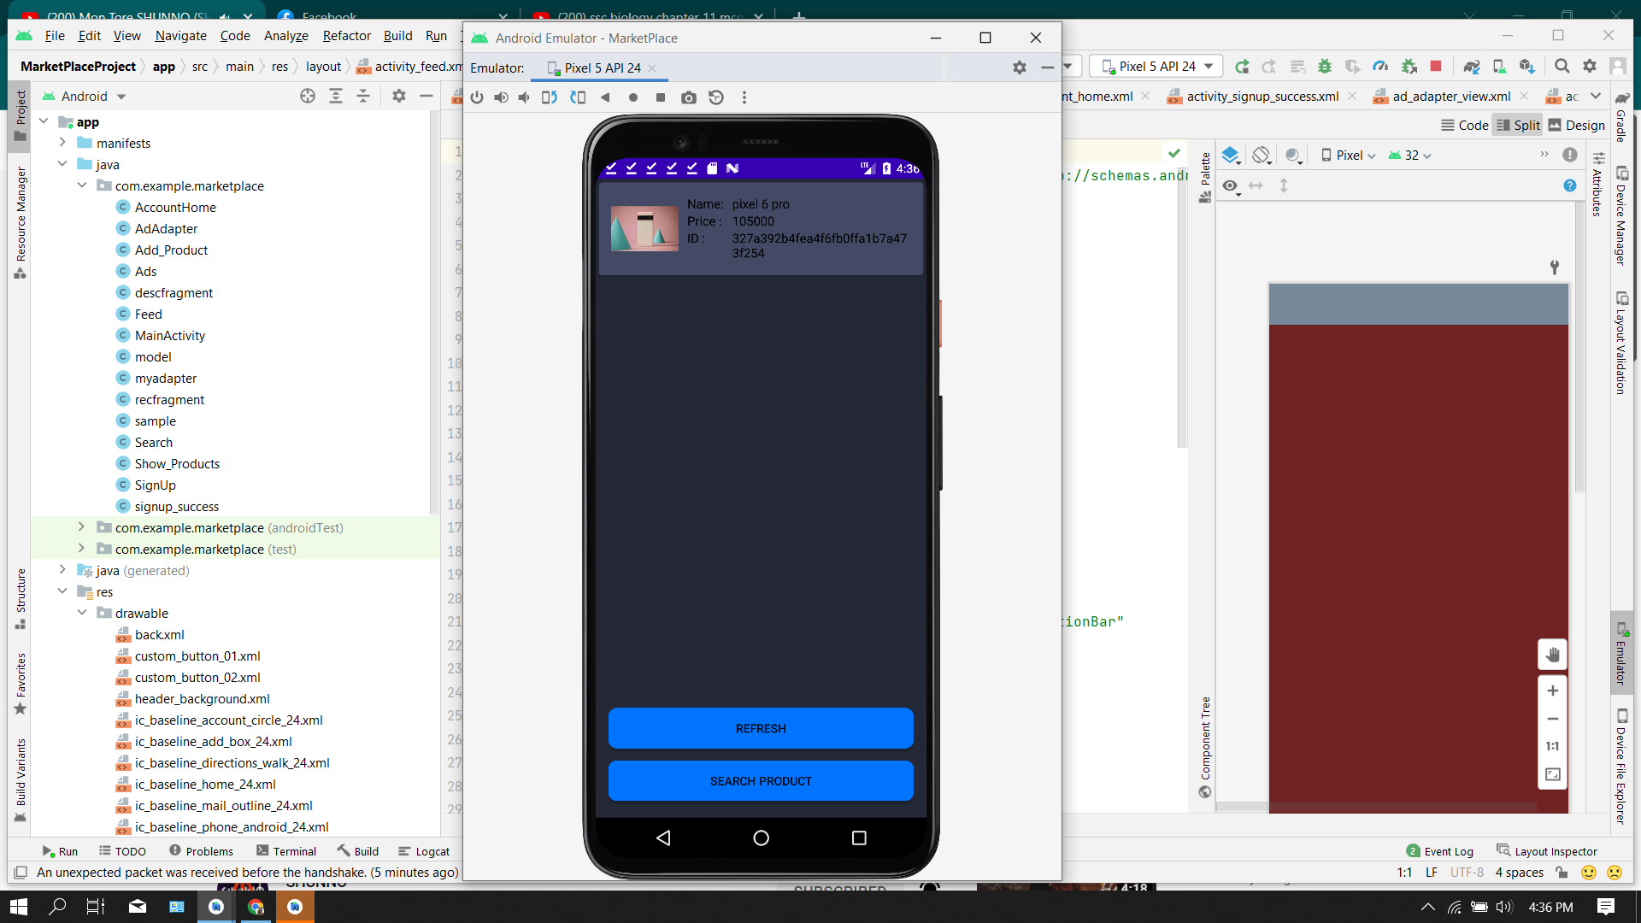 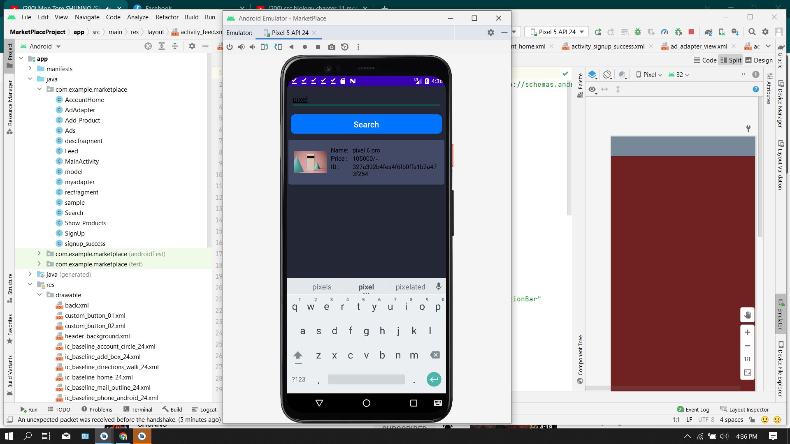

**Prepare by : Jamil Ahmmed Tushar**

**Feature 5:**

Buyers can easily buy any product after clicking the buy option. Then admin can connect with buyers by phone number, which one buyer uses to signup.

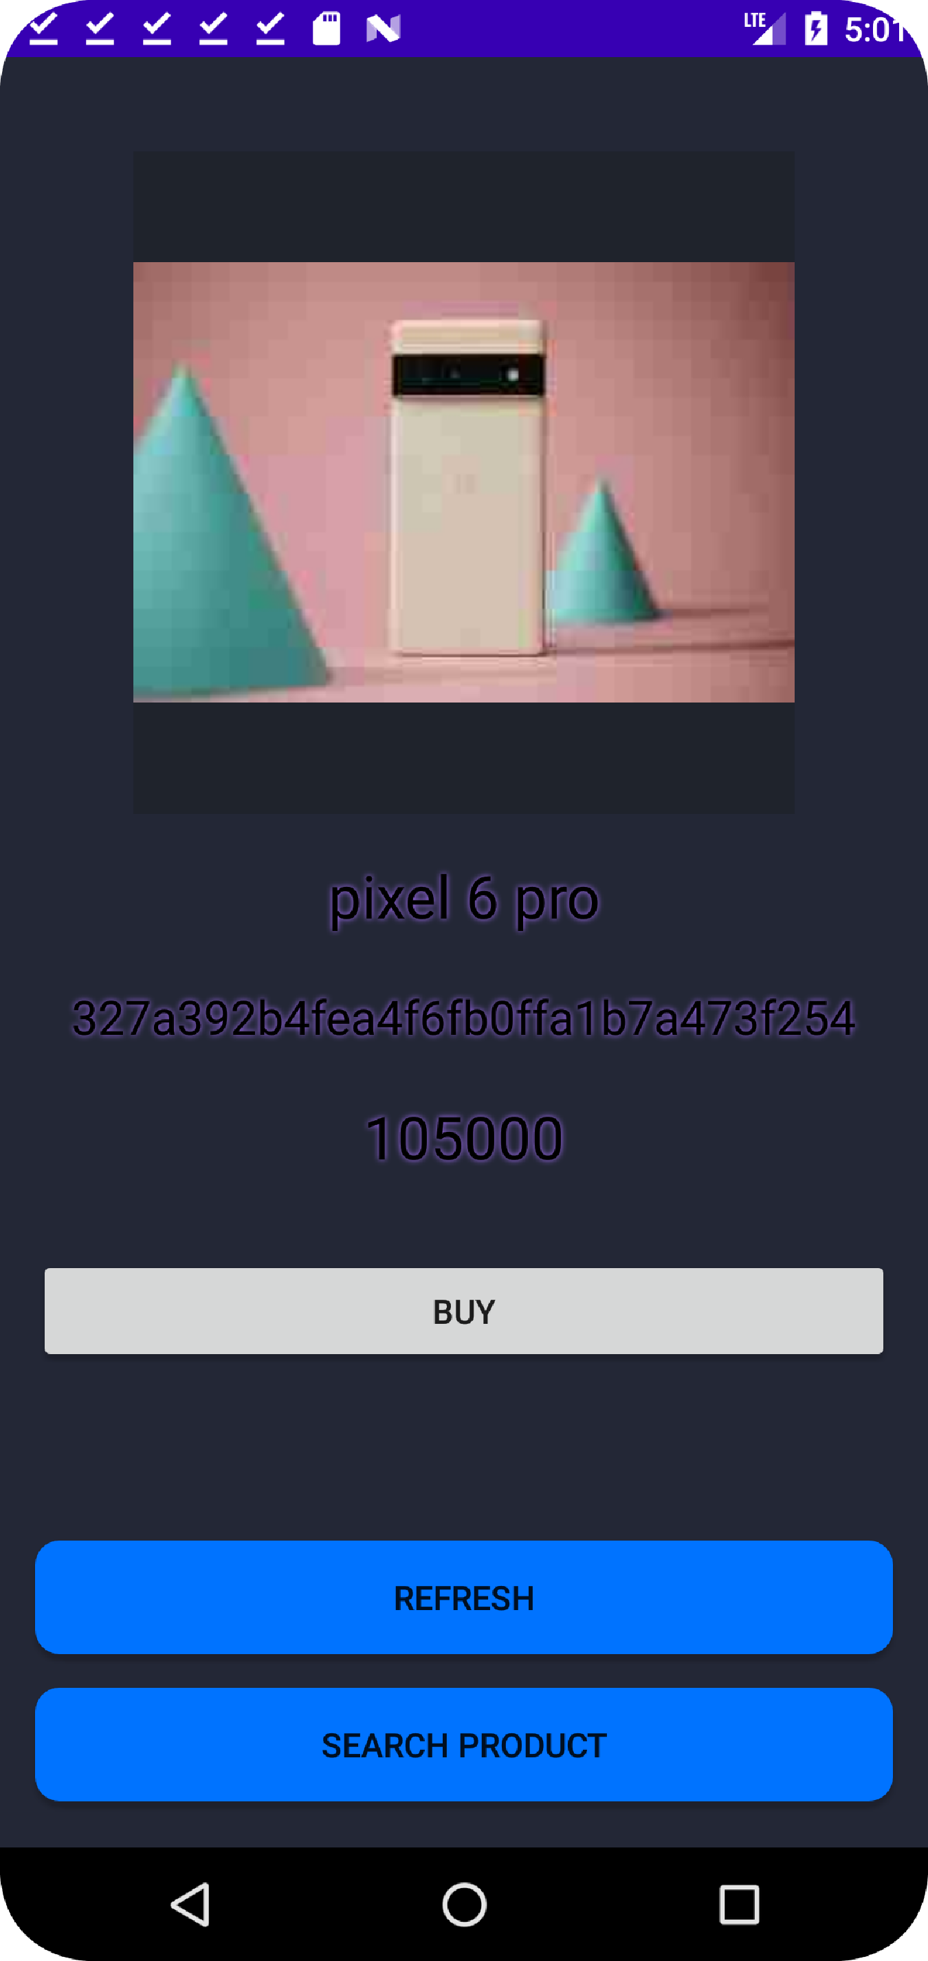

**Firebase Connection of Our project:**

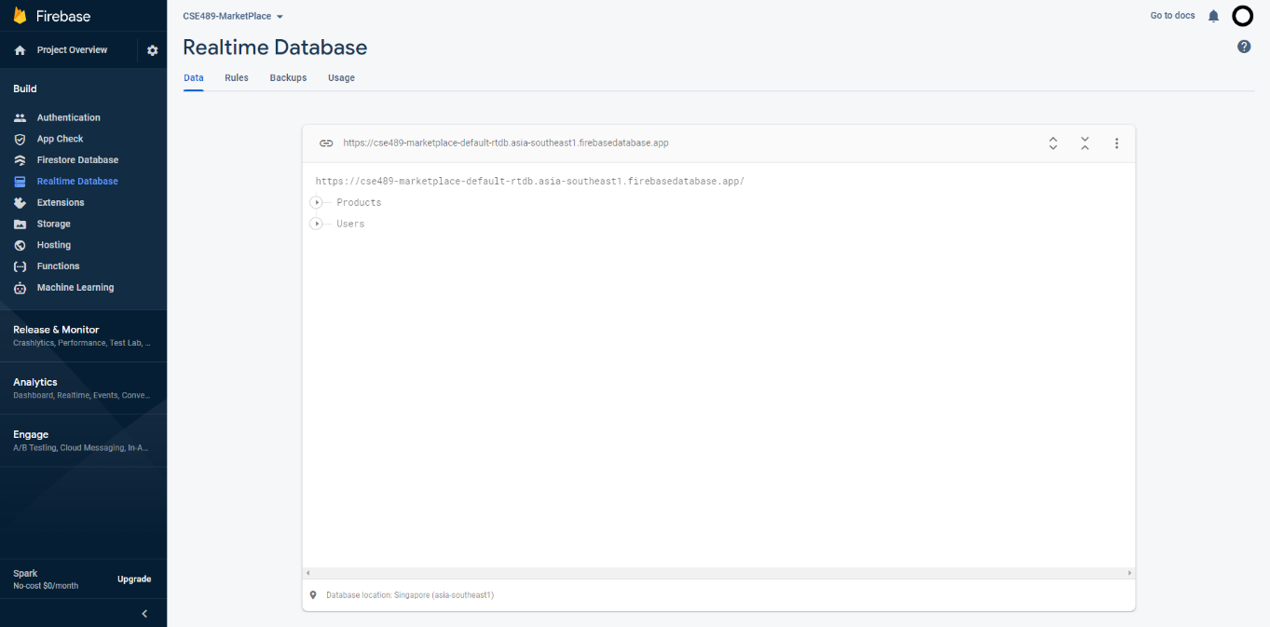

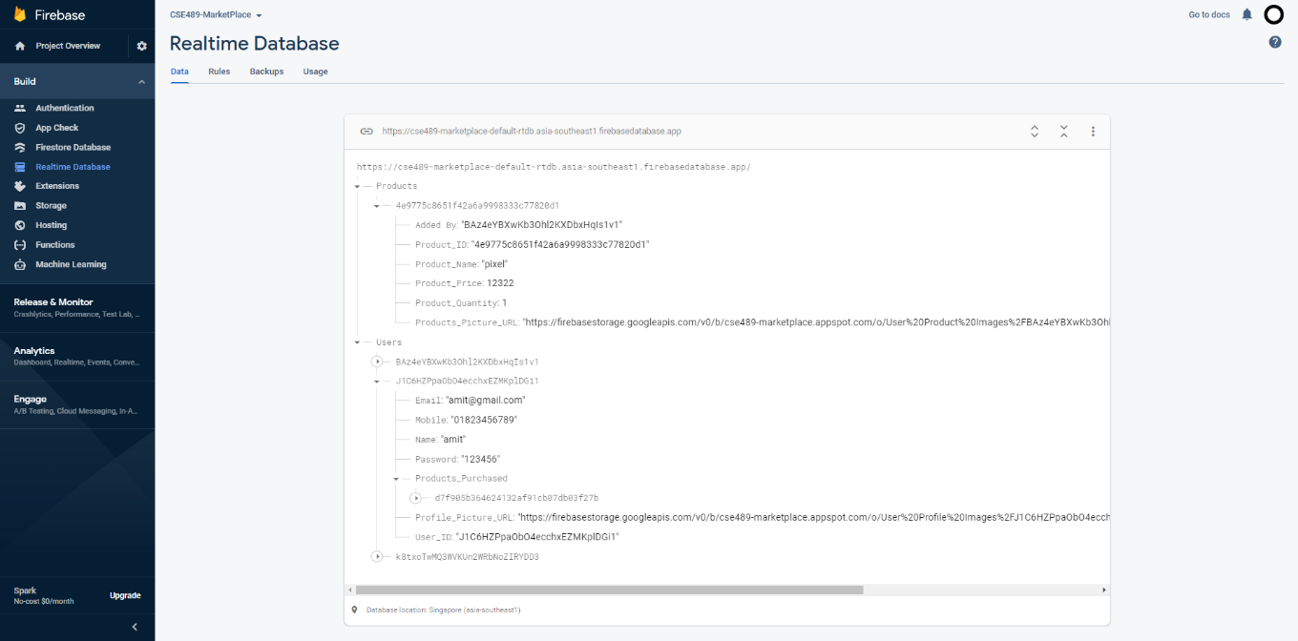

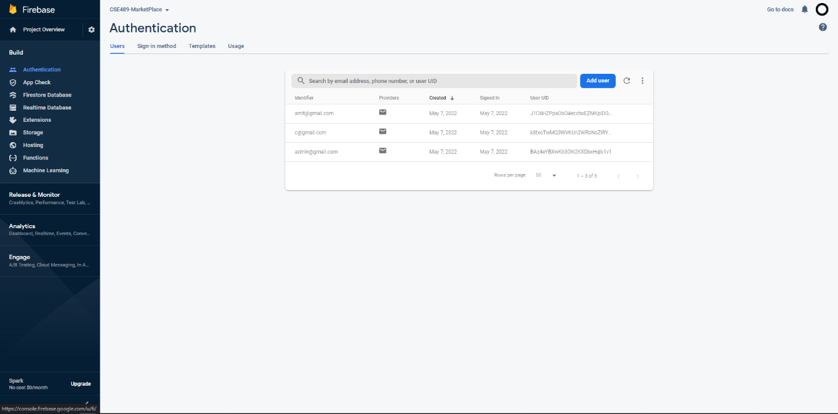

**Challenges:**

* Had to learn Firebase extensively.
* Had to learn on adding Attractive UI
* Keep it simple and user friendly
* Focus on first time experience

**Opportunities:**

* Improve customer Engagement
* Provide more value to your customers
* Product Information is stored in firebase Realtime Database, Firebase Storage.
* Connect with your customer more fast and easy.
* Buyers can choose their product depend on their money
* Buyers can click on product from list and it will open another container showing its description.
* Marketplace has lots of effective ways to generate revenue.

**Future Improvement:**

We are unable to add some required configuration due to time and manpower constraints. In the future, we can add some figures:

* Online payment like bkash, nagad.
* Add google map Api
* In app chatting feature
* Search by price
* Add balance info of buyers
* Assure Security and Trustworthiness

**Conclusion :**

In the past few years mobile app development has become a booming industry. Currently, it is estimated that there are 2.3 million mobile app developers who are devoted to keeping up with the industry demand.

In fact, according to Apple, in 2013 1.25 million apps were registered in the Apple app store and accounted for 50 billion downloads and $5 billion paid to developers. With these types of industry numbers, it soon becomes clear that mobile app development is a key factor for business success.

By developing a mobile app, we will get access to almost every type of online platform. App development assists in reaching marketplaces via Blackberry, Google Play, Apple App Store, and other internet marketplaces also through social media sites. Additionally, apps hold the caliber to mail data to clients, evaluation of functions, coupon codes, and force announcements. Mobile apps help businesses reach a vast target audience and promote building an efficient app marketing strategy.

And finally CSE489 is a course on mobile application development. From this course, we learned how to create a mobile app. The goal of this course was to provide students with information on mobile application development, including an overview of the Android platform and its architecture, application building blocks, and development tools. After completing this course, we can construct a user interface and convert a design into a functional Android application using Java and XML. In this course, we will learn how to create a mobile application using Android Studio.