**east west university**

**Lab Report - 02**

**Department:** **Computer Science and Engineering**

**Course Title:** Digital Image Processing

**Course Code:** CSE438

**Section No:** 02

**Submitted To**:

Dr. Ahmed Wasif Reza

Professor, Department of CSE

Additional Director, Institutional Quality Assurance

Cell (IQAC)

**Submitted By**:

Name: Apurba Roy Ajay

ID: 2018-3-60-063

**1. Adjust the histogram of the following image to match the reference image using**

**histogram matching. Show the histogram of original, reference, and output images.**

**Codes:**

im1 = imread("tree.jpg");

im2 = imread("tree_reference.png");

M = zeros(256, 1, 'uint8');

hist1 = imhist(im1);

hist2 = imhist(im2);

cdf1 = cumsum(hist1) / numel(im1);

cdf2 = cumsum(hist2) / numel(im2);

for idx = 1 : 256

diff = abs(cdf1(idx) - cdf2);

[~, ind] = min(diff);

M(idx) = ind - 1;

end

out = M(double(im1) + 1);

subplot(2, 3, 1), imshow(im1);

title('Tree');

subplot(2, 3, 2), imshow(im2);

title('Tree Reference');

subplot(2, 3, 3), imshow(out);

title('Output Image');

subplot(2, 3, 4), imhist(im1);

title('Tree Histogram');

subplot(2, 3, 5), imhist(im2);

title('Reference Histogram');

subplot(2, 3, 6), imhist(out);

title('Output Image Histogram');

**Output:**

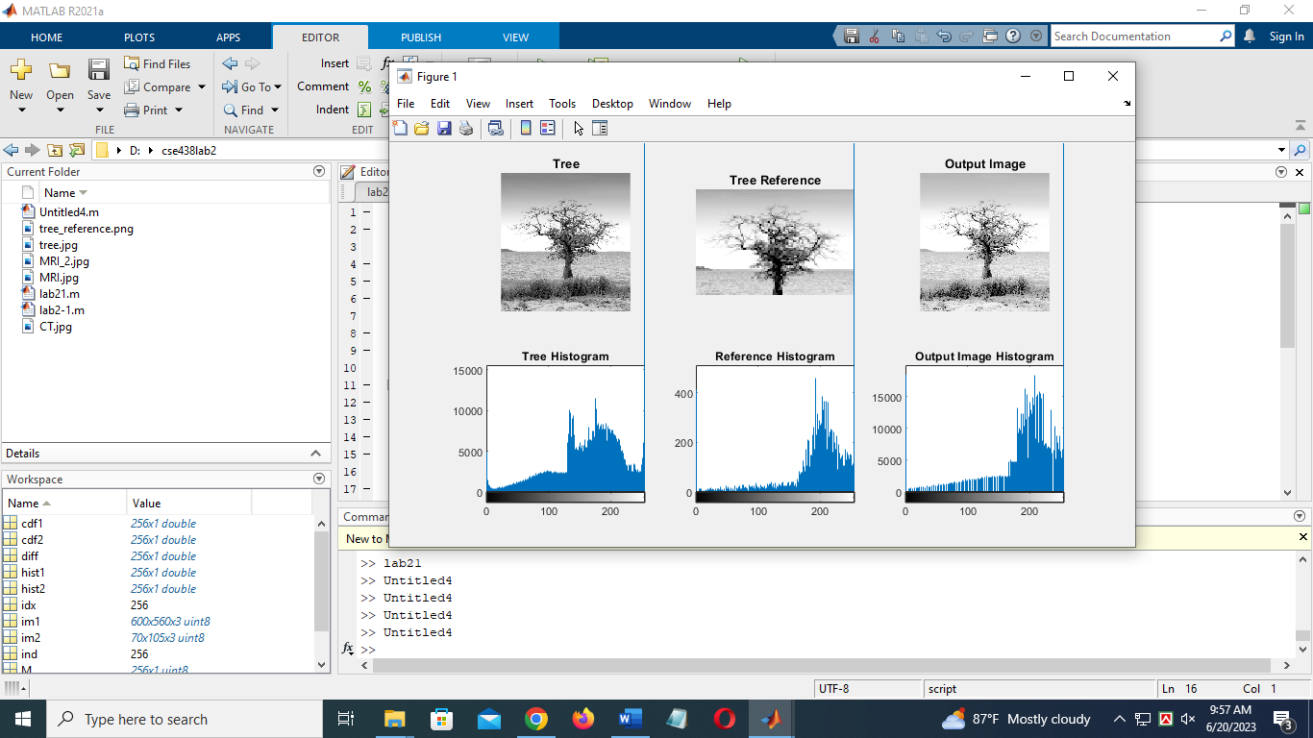

**2.Change the contrast of the image using histogram equalization. Show the histogram of both input and output images.**

**Codes:**

im1 = imread("CT.jpg");

figure;

subplot(1,2,1),imshow(im1);

subplot(1,2,2),imshow(im1);

imh = imadjust(im1,[0.3,0.6],[0.0,1.0]);

imh1 = histeq(im1);

figure;

subplot(2,2,1),imshow(imh);title('Streched');

subplot(2,2,2),imshow(imh);

subplot(2,2,2),imhist(imh);

subplot(2,2,1);imshow(im1);

subplot(2,2,2); imhist(im1);

subplot(2,2,3);imshow(im1);

subplot(2,2,3);imshow(imh1);title('Hist. Equ.');

subplot(2,2,4);imhist(imh1);

**Output:**

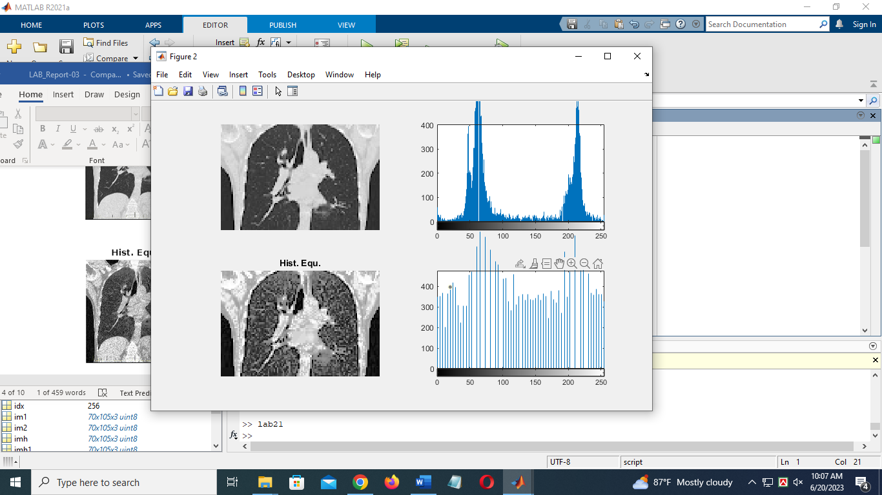

**3. Adjust the contrast of the following image.**

**Codes:**

image= imread('nature.png');

G3 = rgb2gray(image);

adj1 = imadjust(G3);

figure,imshow(adj1)

**Output:**

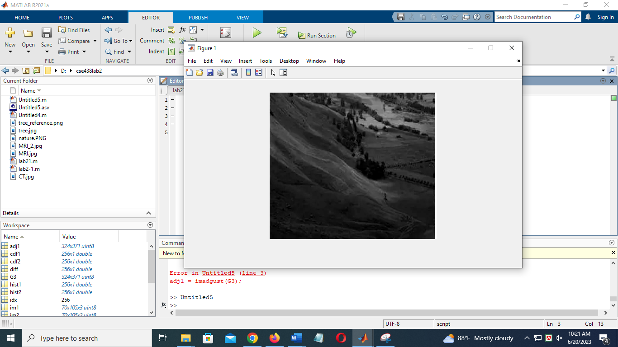

**4.Brighten the following image**

**Codes:**

image= imread('nature1.png');

imshow (image)

bright1=imlocalbrighten(image);

imshowpair(image,bright1,'montage')

**output:**

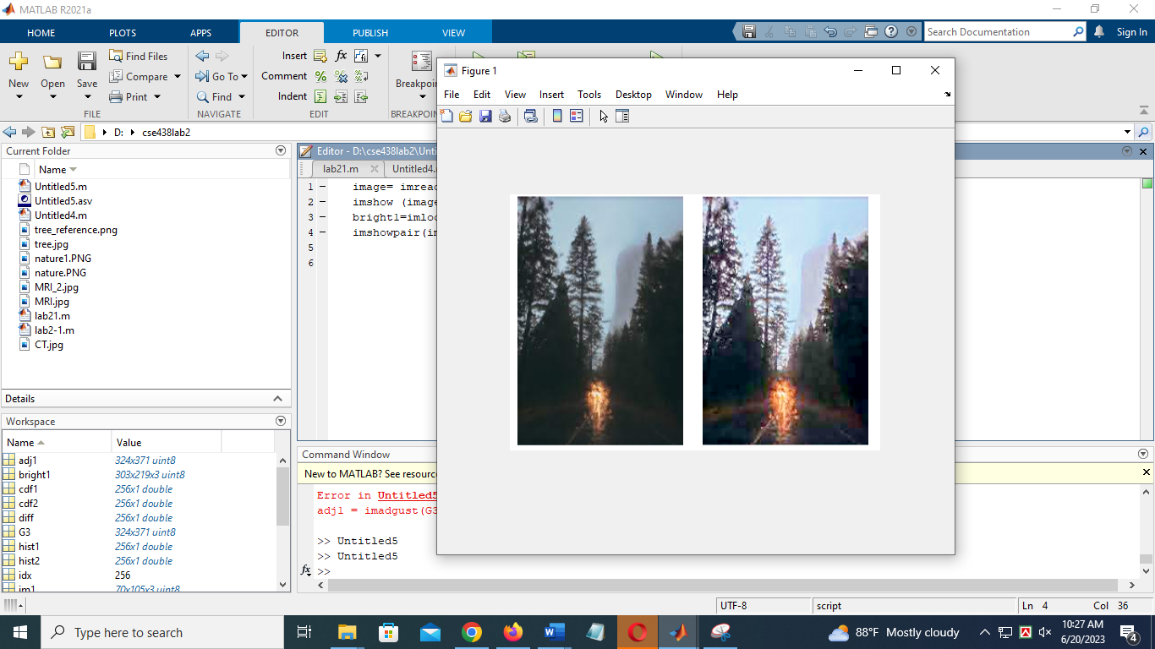

**5. Quantize the Grayscale image by 8 levels.**

**Codes:**

image=imread('coin.png');

i = imshow(image)

thresh = multithresh(image,7);

valuemax = [thresh max(image(:))]

[quant8,index]= imquantize(image,thresh,valuemax);

figure,imshow(quant8)

**Output:**

