Cyber Crime and Computer
Forensics Report
Case: Operation Banjo

Submission Title:
Digital Forensics Investigation Report – Task 1, Task 2 & Task 3

Task 1: Imaging Exercise

Task 1.1 Imaging - Part A — Demonstrating Correct Image File
The task 1 image allocated to me is ImageFile.008.dd as indicated in the Moodle allocation list. In order to verify that I am working on the right evidence file, I used HashMyFiles to compute the cryptographic hashes of the evidence file. The tool had the following values:
- MD5: 90759c65403928b1dfdb4e3fb48e24d0
- SHA-1: 836c80fe9c2e608e5a7d5619564ca9811f7544bc
- File size: 536,870,912 bytes
These values are identical to the official values of the hash published in Moodle of ImageFile.008.dd. This makes sure that I am dealing with the right evidence file.

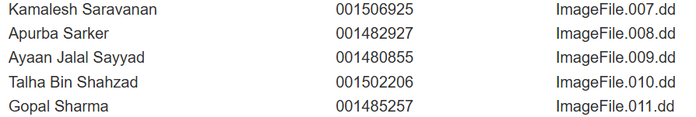
Figure A1: Allocation Confirmation

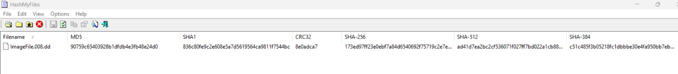
Figure A2-a: HashMyFiles outputs

Figure A2-b: HashMyFiles outputs

Task 1.1 Imaging - Part B — Creation & Verification of Single E01
I generated a single E01 evidence container using FTK Imager from the assigned .dd file which has the following settings:
- Format: E01
- Compression: Level 9 (maximum)
- Segmentation: None
I verified the E01 in FTK’s Verify Image function. FTK recalculated the MD5 and SHA-1 hashes and provided report on:
- MD5: Computed = Stored = Report → Match
- SHA-1: Computed = Stored → Match
- Bad Blocks: None detected
This confirmed that the single, compressed E01 image was generated correctly and with incorruption.
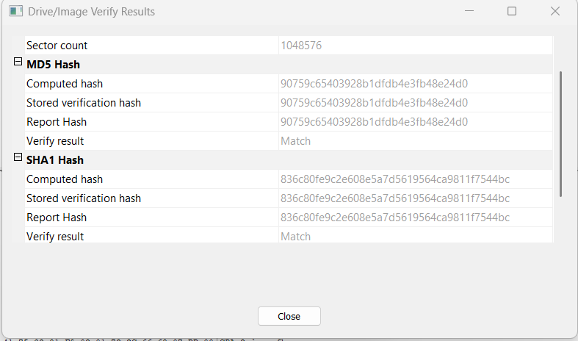
Figure B1-a: Single E01 verification

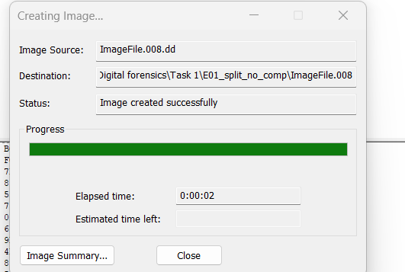
Figure B1-b: Single E01 verification

Task 1.1 Imaging - Part C — Creation and Verification of Split E01 Image
The next step, I arranged a split E01 image from the same .dd file using:
- Compression: Level 0 (no compression)
- Fragment size: 50 MB
- Output: 11 segments (ImageFile.008.E01–ImageFile.008.E11)
FTK Imager’s verification showed output:
- MD5: Match
- SHA-1: Match
- Bad Blocks: No bad block found
This confirmed that the split E01 set was created successfully and provided forensic standards.

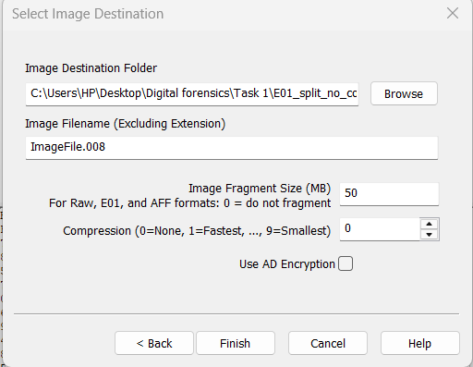
Figure C1: Split imaging settings

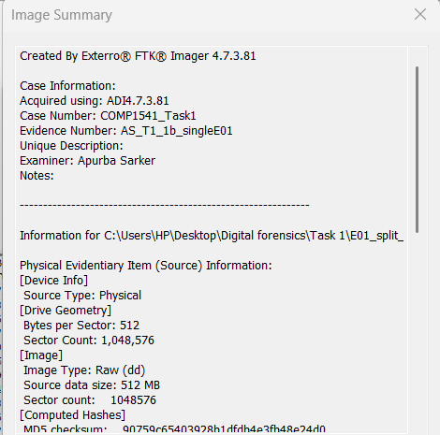
Figure C2-a: Creation Summary

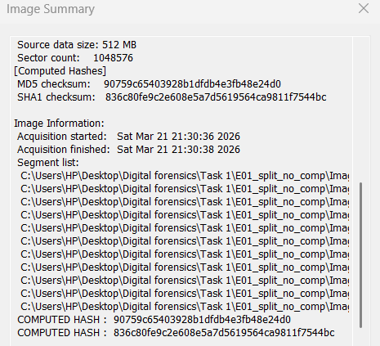
Figure C2-b: Segment List

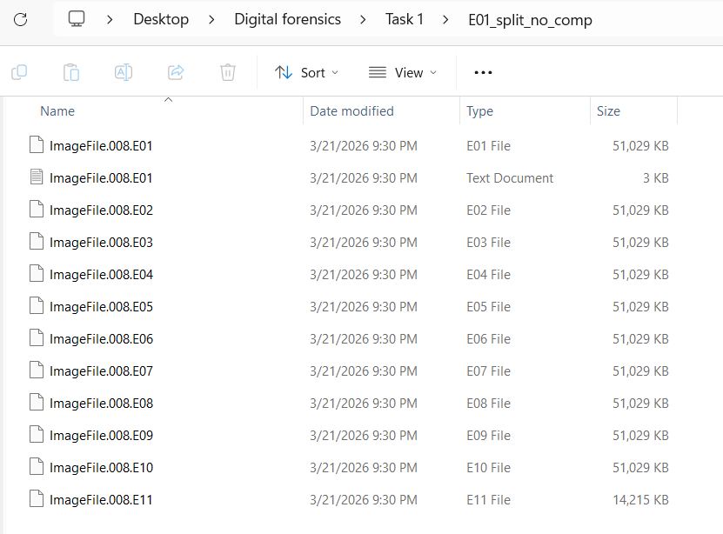Figure C3: Folder view of E01–E11

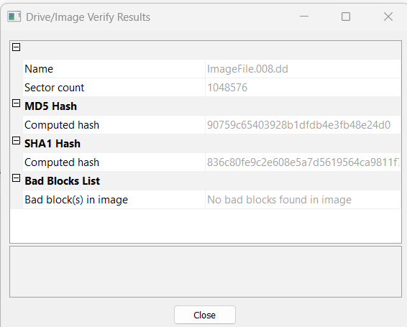
Figure C4: Verification of split set

Task 1.1 Imaging - Pard D — File List (Filenames, Extensions, Sizes, Hashes)
Next, I compiled a file list that included the original image, the single compressed E01, and the multi-part E01 segments. The actual file sizes and MD5 hashes were recorded using HashMyFiles and File Explorer.
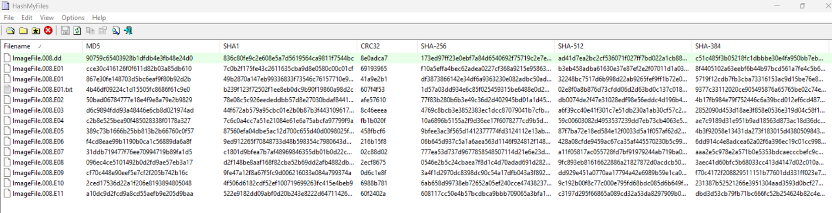
Figure D1: Full MD5 list

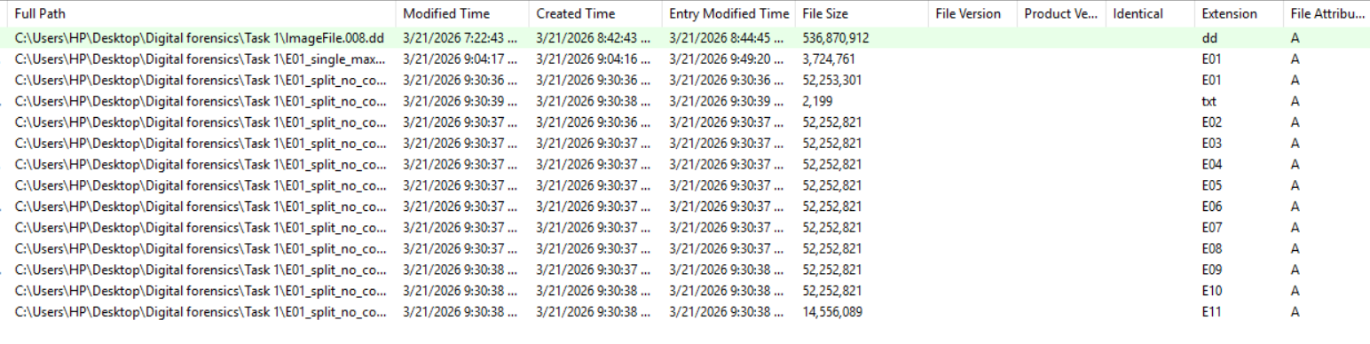
Figure D2: Directory with sizes and extensions

Task 1.2 Verification Exercise
The single E01 image created in Task 1.1(b) was verified using two independent forensic tools:
(a) Autopsy and
(b) FTK Imager.
Hash values were checked in comparison to ensure that the image stays unchanged throughout process.

Autopsy Verification
- Display Name: ImageFile.008.E01
- Image Type: E01
- Size: 536.87 MB
- Sector Size: 512 bytes
- MD5: 90759c65403928b1dfdb4e3fb48e24d0
- SHA1: 836c80fe9c2e608e5a7d5619564ca9811f7544bc
- File Path:
C:\Users\HP\Desktop\Digital forensics\Task 1\E01_single_max\ImageFile.008.E01
Autopsy Integrity Module Result
The Ingest History table confirms:
- Module Name: Data Source Integrity
- Status: Completed
- Module Version: 4.22.1
This confirmed that Autopsy recomputed the hashes and successfully verified the image.

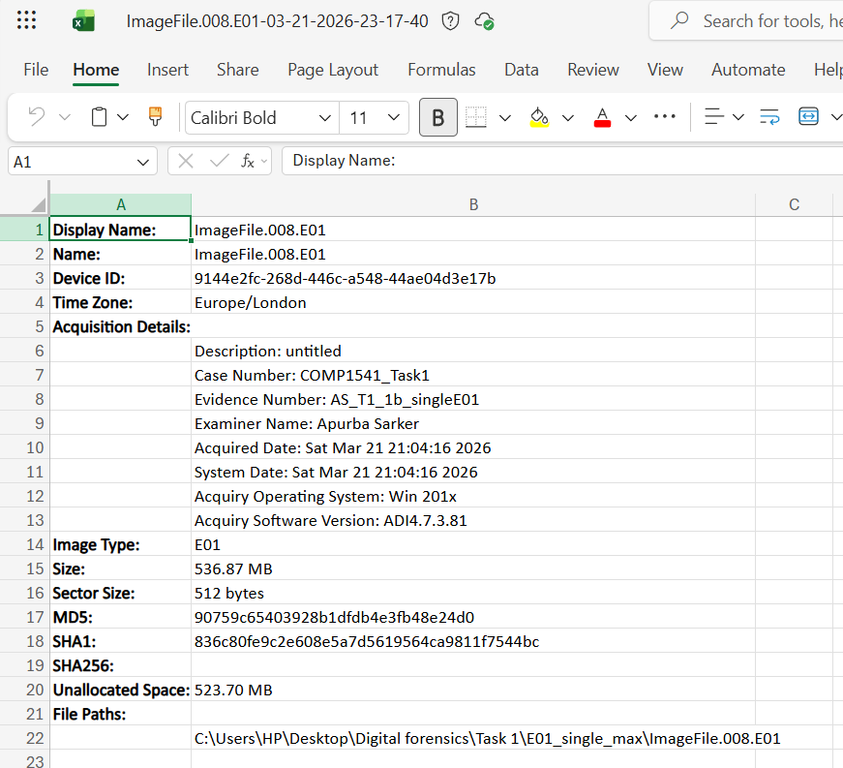
Figure A1-a — Autopsy Container sheet (from Excel Results)

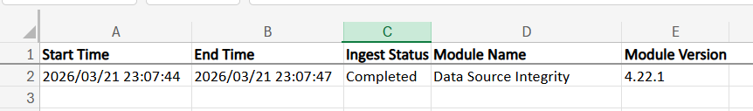
Figure A1b — Autopsy Integrity Module

FTK Imager Verification
I used FTK Imager to ensure that the ImageFile.008.E01 file was not changed after creation.
The outputs demonstrated two types of verification:
(a) FTK “Verify Image…” outputs
- Name: ImageFile.008.E01
- Sector Count: 1,048,576
- MD5 (Computed): 90759c65403928b1dfdb4e3fb48e24d0
- MD5 (Stored): 90759c65403928b1dfdb4e3fb48e24d0
- SHA1 (Computed): 836c80fe9c2e608e5a7d5619564ca9811f7544bc
- SHA1 (Stored): 836c80fe9c2e608e5a7d5619564ca9811f7544bc
- Verify Result: Match
- Bad Blocks: None found

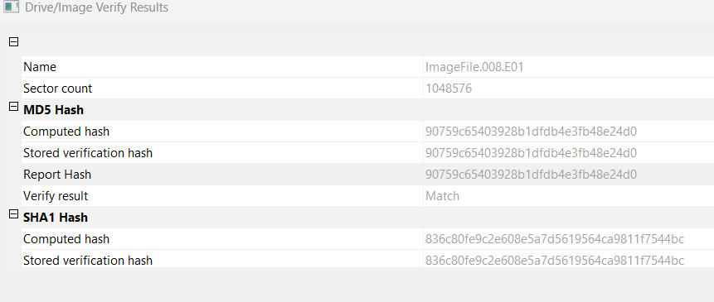
Figure B1-a: FTK Verify Image
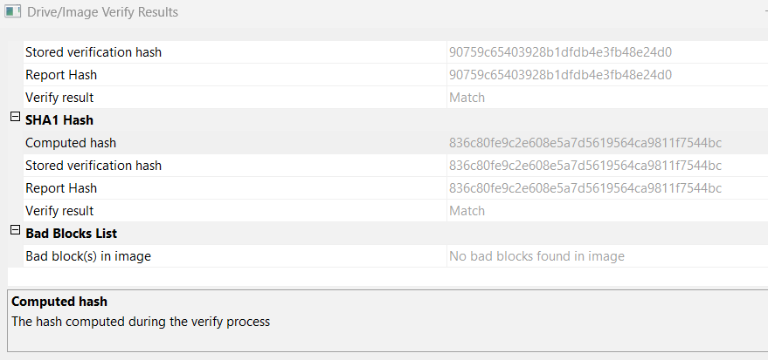
Figure B1-b: FTK Verify Image

Task 1.3 Write-blocker Sketch
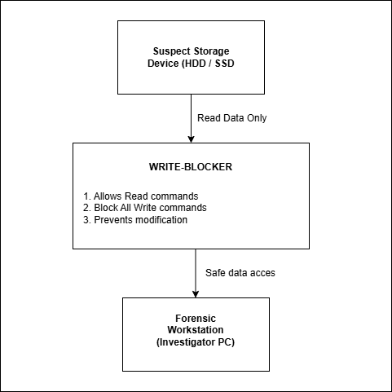
Figure 1.3: Block Diagram
The figure shows how write-blocker is applied during digital forensic examination. A write-blocker is attached to the suspect storage device (e.g. hard disk or solid-state drive), and inserted into the forensic workstation. The write blocker enables the read commands through thus enabling the data to be analyzed, but blocks all write commands. This helps to avoid any alteration of the original evidence and the integrity of the data is maintained during the investigation.
Task 2: Search and Seizure
Task 2.1 A diagram of the scene
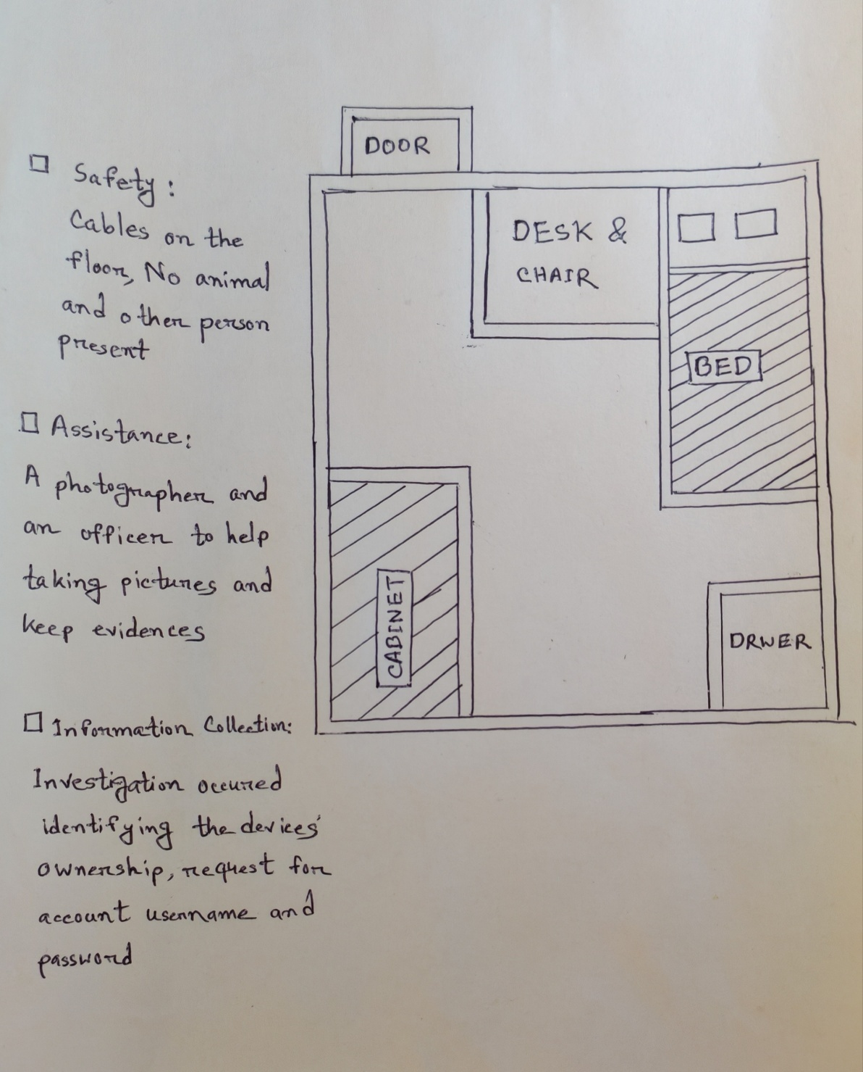
Figure 2.1: Diagram plan of the room highlighting the general layout and key search areas relevant to the digital forensic evidence collection.

Task 2.2 Photograph of the Scene

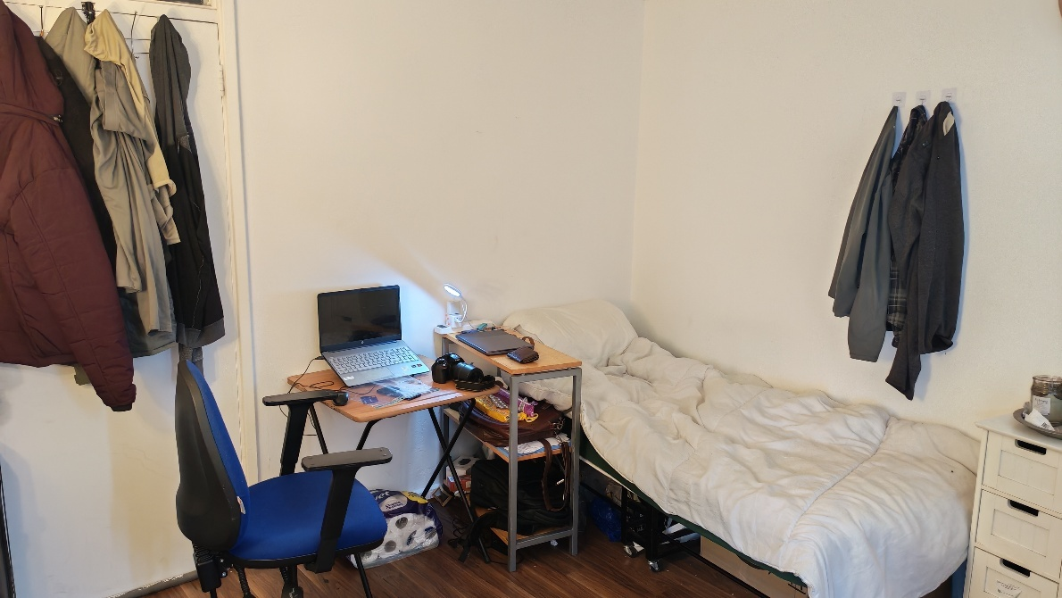
Figure 2.2.1: Wide view of search area zone
This image highlights the full layout of the room required for evidence collection.
Key areas are visible, include the desk area (laptop, lamp, paperwork), chair, bed, right-side drawer unit, and floor storage with the desk.

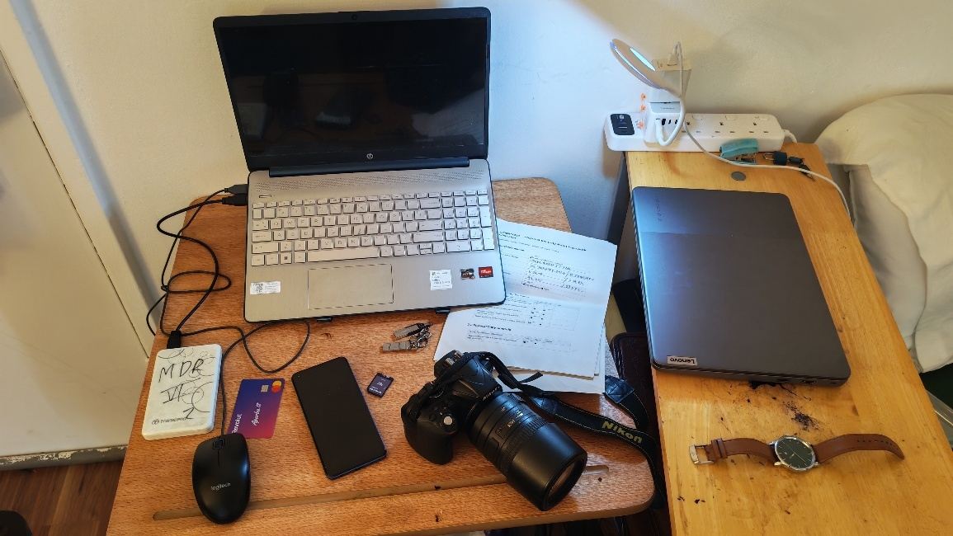
Figure 2.2.2: Close view of search area zone

Task 2.3 Labelling the Artefacts (high level view)
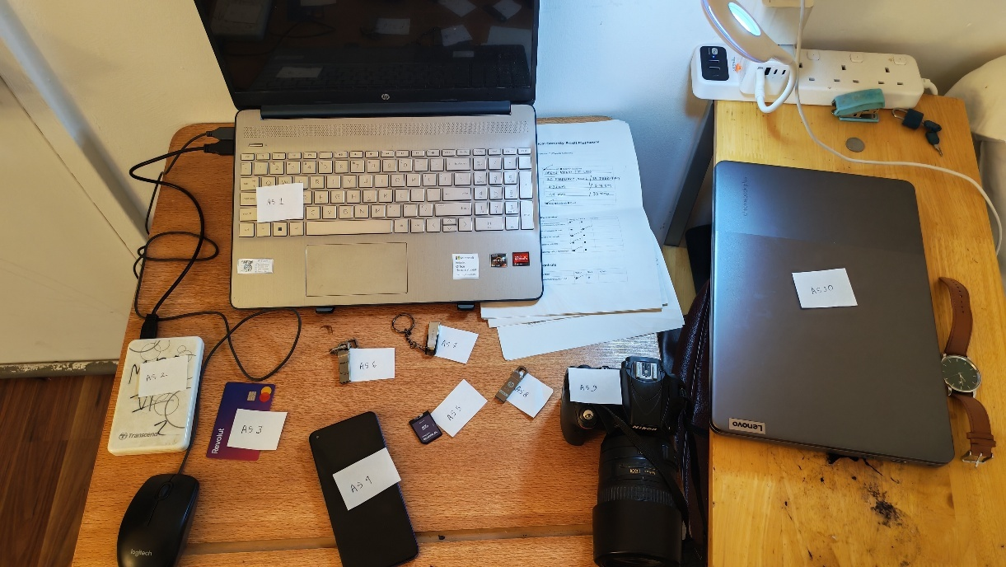
Figure 2.3: High-level view of the search area with artefacts AS1–AS10 labelled clearly required to search and seizure

Task 2.4 Close-Up Photographs
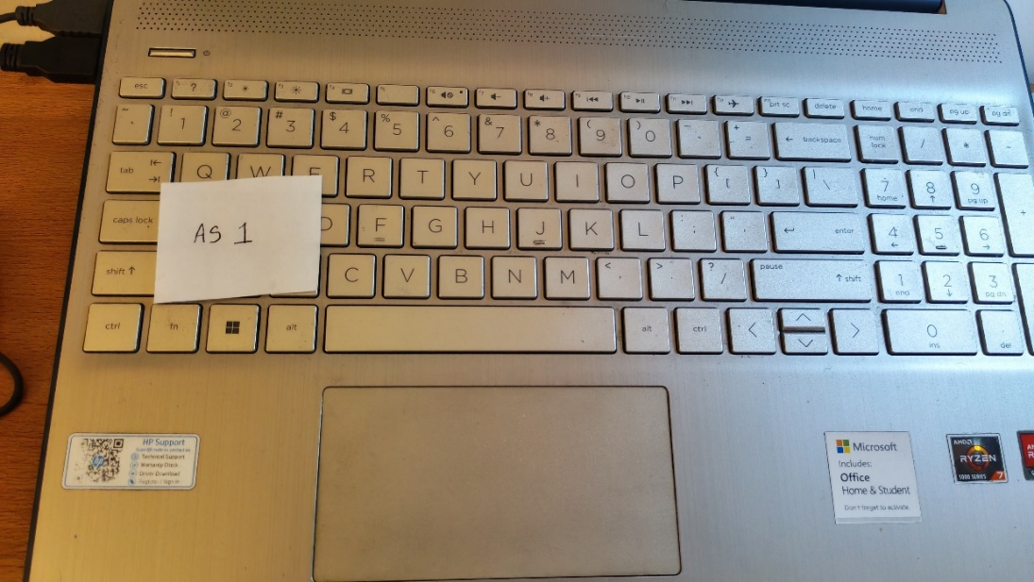
Figure 2.4.1: HP Laptop

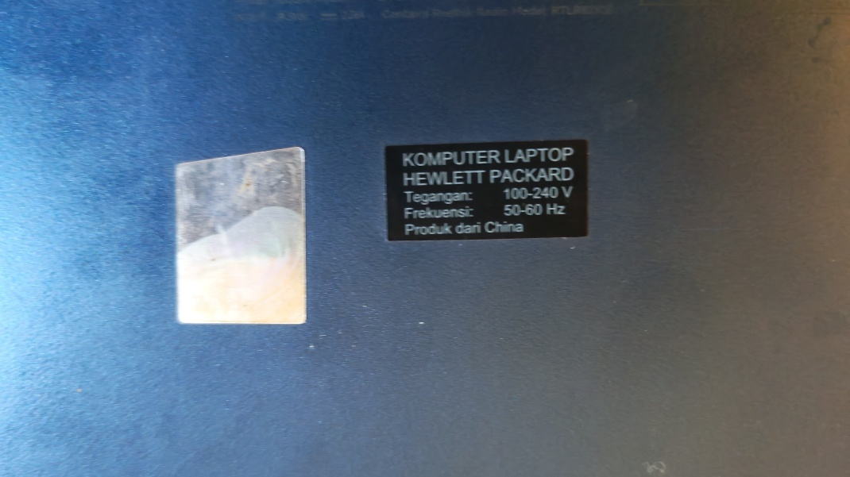
Figure 2.4.2: HP Laptop power information in the back view

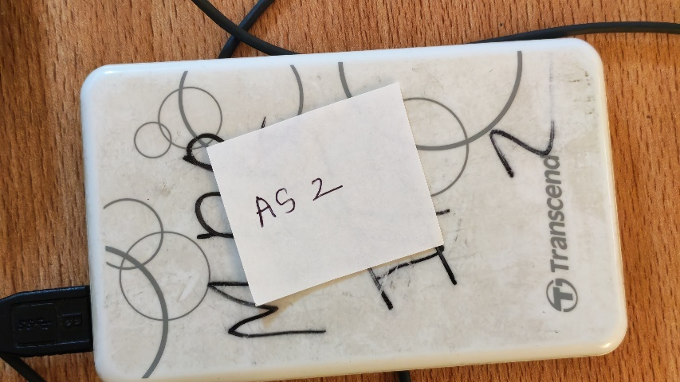
Figure 2.4.3: Transcend external hard drive

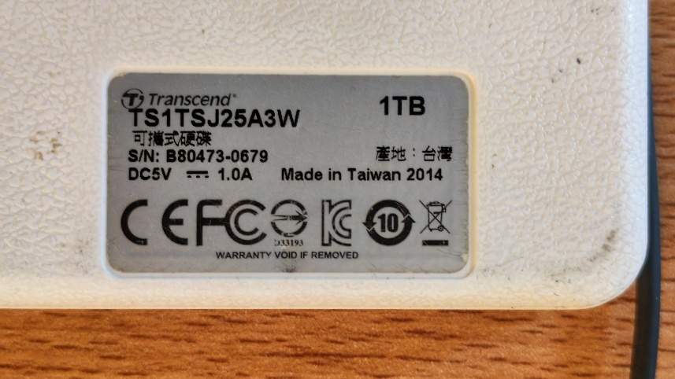
Figure 2.4.4: External hard drive power information in the back view

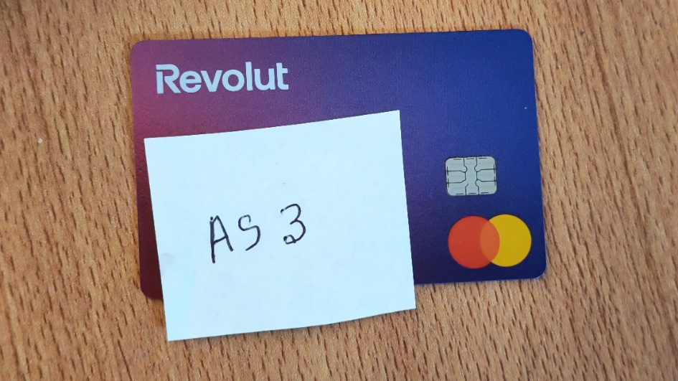
Figure 2.4.5: Purple color bank card

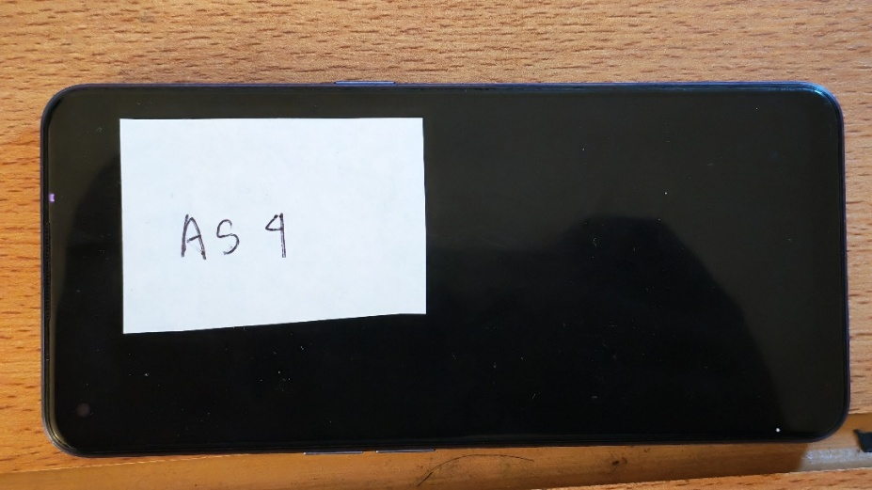
Figure 2.4.6: Black color smartphone

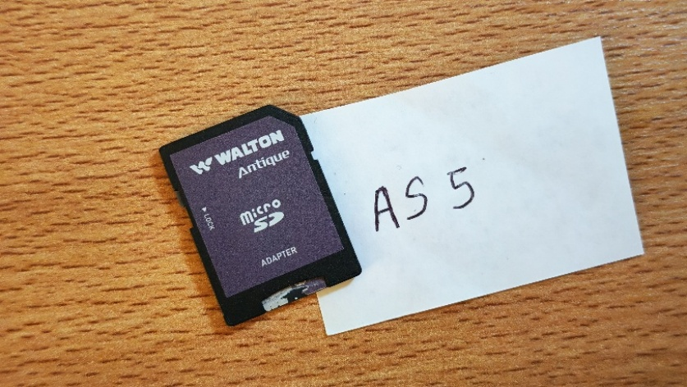
Figure 2.4.7: Walton Micro SD Card

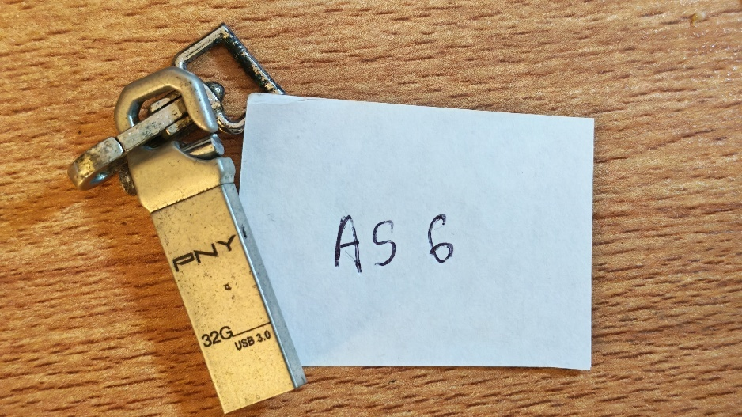
Figure 2.4.8: PNY USB Drive
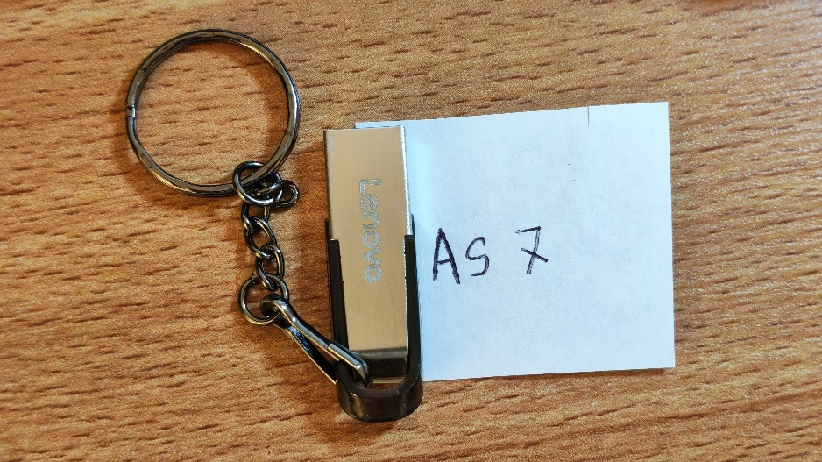
Figure 2.4.9: Lenovo USB Drive

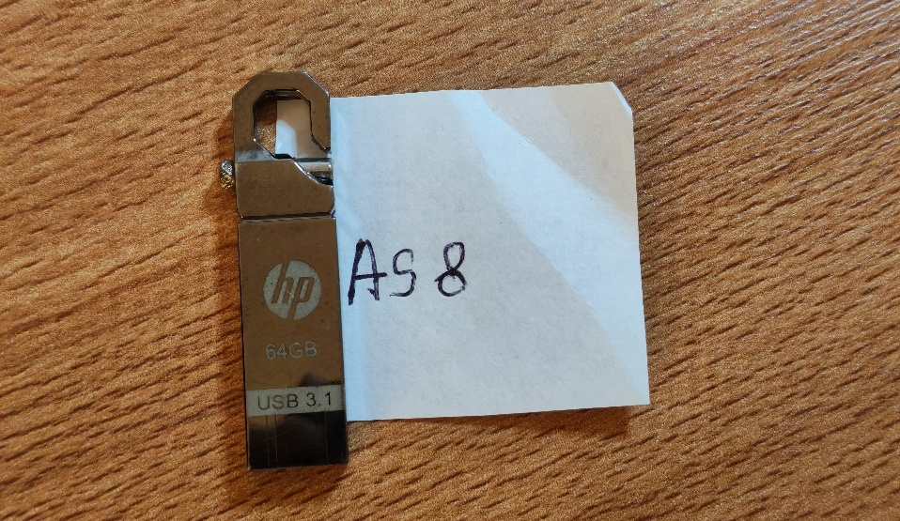
Figure 2.4.10: HP USB Drive

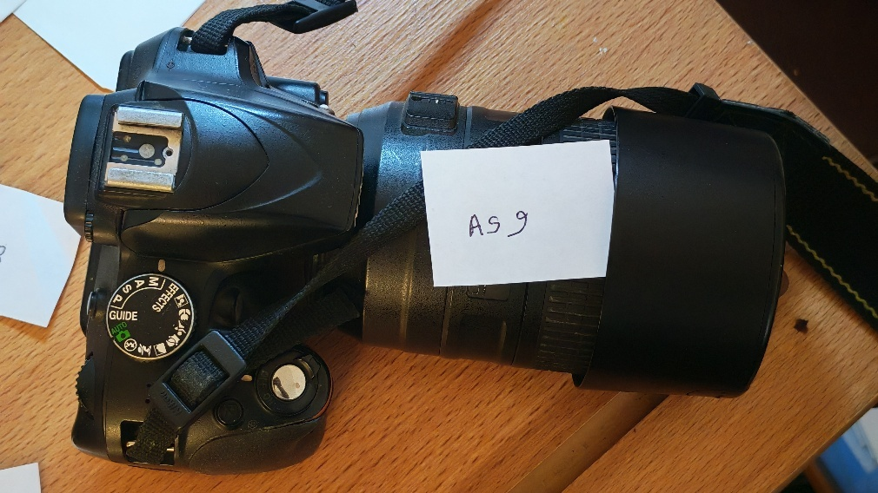
Figure 2.4.11: Nikon DSLR Camera
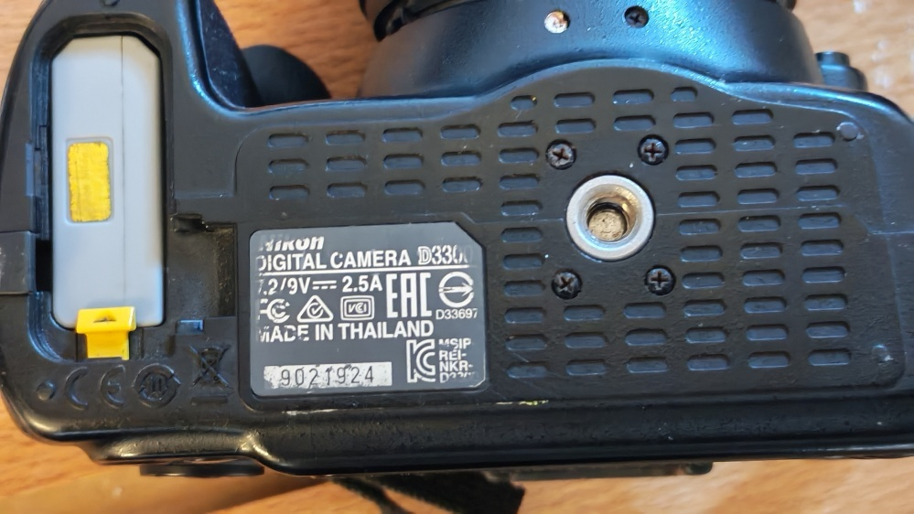
Figure 2.4.12: Camera information in the back view

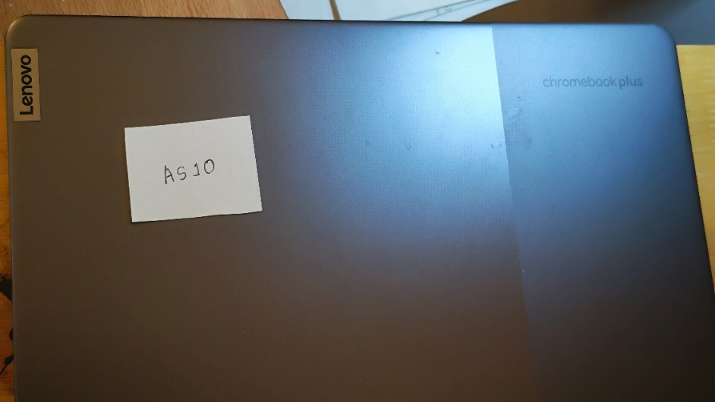
Figure 2.4.13: Purple color Lenovo Laptop

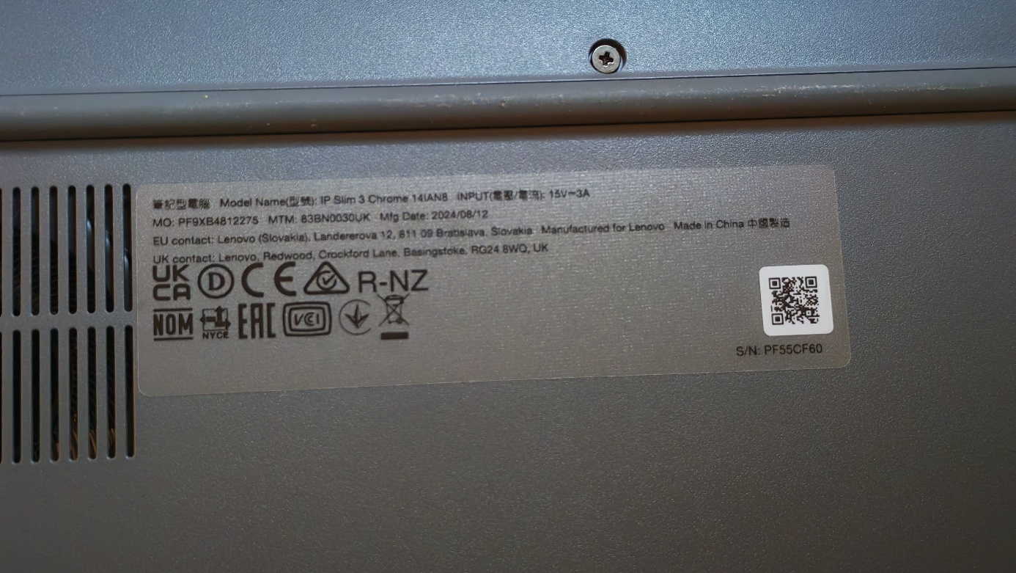
Figure 2.4.14: Back view information including manufacture details of the Lenovo Laptop

Task 2.5 Exhibits Table
Table 2.5: List of evidence found and seizure
Ref. Number | Description | Location | Seized By | Time | Seal Number
AS 1 | HP Laptop  (open) | Desk surface | A Sarker | 2.27 | Seal - 0021
AS 2 | Transcend external hard drive | Desk(left) | A Sarker | 2.35 | Seal – 0022
AS 3 | Purple color bank card | Desk  (front left) | A Sarker | 2.41 | Seal – 0023
AS 4 | Black color Smartphone | Desk  (front center) | A Sarker | 2.49 | Seal – 0024
AS 5 | Walton Micro SD Card | Desk  (front center) | A Sarker | 2.54 | Seal – 0025
AS 6 | PNY USB Drive | Desk  (front center) | A Sarker | 3.04 | Seal – 0026
AS 7 | Lenovo USB Drive | Desk  (front center) | A Sarker | 3.15 | Seal – 0027
AS 8 | HP USB Drive | Desk  (left center) | A Sarker | 3.24 | Seal – 0028
AS 9 | Nikon DSLR Camera | Desk (left) | A Sarker | 3.33 | Seal – 0029
AS 10 | Purple color Lenovo Laptop | Left Desk Surface | Apurba Sarker | 3.41 | Seal - 0030

Task 2.6 An Improvised Seal
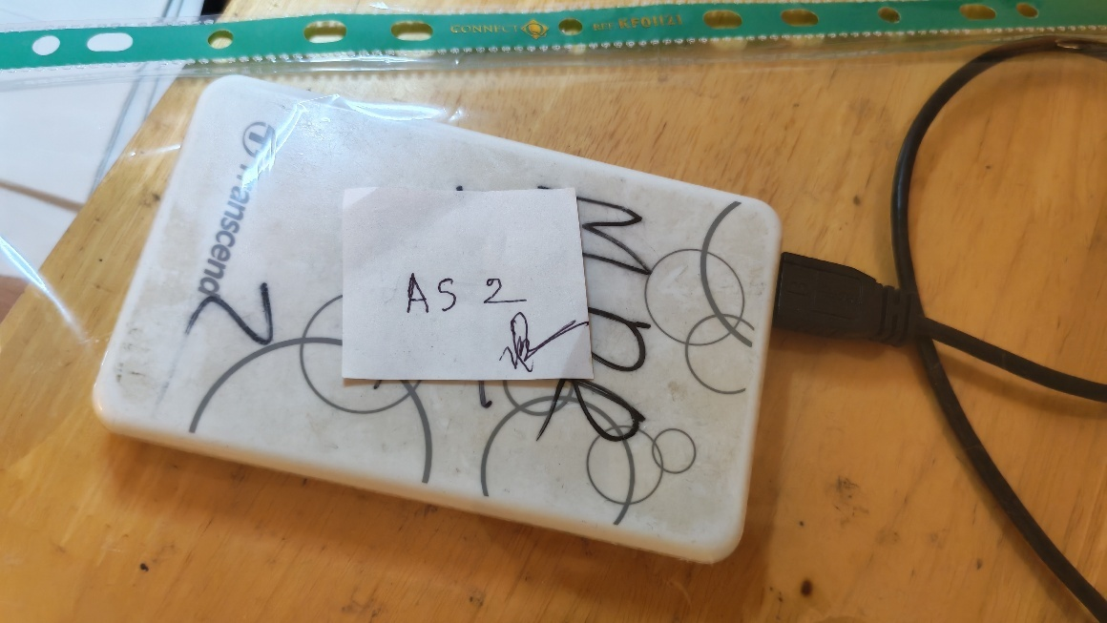
Figure 2.6: Sealed Evidence (Seal-0022)

Forensics Investigation Report

Case 1372: Operation Banjo

Prepared for

Head of Forensic Department

By

Timileyin Ikumapayi
Monday Nelson Ogugua
Apurba Sarker

Table of Contents

EXECUTIVE SUMMARY 4
1. INTRODUCTION 4
2. VICTIMS 5
2.1 Victim details 5
3. LOCATION OF EVIDENCE 5
3.1 Evidence description 6
3.2 Seizure details 6
Location of Evidence 6
4. DEFINITIONS 6
4.1 Definitions 6
4.2 Tools 7
5. PRESERVATION OF EVIDENCE 7
5.1 Imaging of Original Evidence 7
5.1.1 Procedures 7
5.1.2 Result 8
5.2 Validation of Investigation Evidence 8
5.2.1 Procedures 8
5.2.2 Result 8
6. ANALYSIS STEPS 9
6.1 Procedures 9
6.1.1 Initial Triage and File System Examination 9
6.1.2 Keyword and Artefact Recovery 9
6.1.3 Timeline Reconstruction and Correlation 9
6.1.4 Media and Image Analysis 10
7. RESULTS 10
7.1 Pertinent Document Summaries 10
7.1.1 Document 1 Summary – Backup. Docx 10
7.1.2 Document 2 Summary – Code.docx 11
7.2 Pertinent Images Summary 13
7.2.1 Image 1 Summary – HINT.png 13
7.2.2 Image 2 Summary – download (1).jpg 15
7.2.3 Image 3 Summary – download (3).jpg 16
7.2.4 Image 4 Summary – “-7.jpg” 17
7.2.5 Image 5 Summary – Caesar-Salad_7-SQ.jpg 18
7.3 Pertinent Email Summary 19
7.3.1 Email 1 – Enough-is-enough.eml 19
7.3.2 Email 2 – Chillout.eml 20
7.3.3 Email 3 – Stop.eml 21
7.3.4 Email 4 – No thanks.eml 22
8. CONCLUSION 23

EXECUTIVE SUMMARY
This report presents the findings of a digital forensic investigation conducted in support of Case 1372: Operation Banjo, arising from a racially motivated gang assault that occurred on the evening of 11th December 2020 in Blackheath. The attack, carried out by members of a gang known as the Blackout Brigade, resulted in multiple casualties including prominent local figure Malcolm Quacker, who sustained serious injuries. The gang, led by Keith K. Kingsman alongside associates Rudy Hess and Henry Himler, is known to police for prior involvement in racial abuse and illegal weapons offences.
Following the arrest of Keith Kingsman on 12th December 2020, a 2GB SanDisk USB drive (exhibit OB/1) was seized from his premises and submitted to the Greenwich Cyber Team for forensic examination. The device was imaged using a hardware write-blocking device to preserve the integrity of the original evidence. Cryptographic hash verification using both FTK Imager and Autopsy confirmed that the forensic working copy remained unaltered, with both tools producing an identical MD5 hash value of 42b6d44a4a40293e95fa48410e5f85f7.
Analysis of the forensic image using Autopsy revealed several items of significant evidential value. Two documents backup.docx and code.docx were recovered, both traced to Discord download sources, with metadata linking their creation to the period preceding the assault. Four emails exchanged between Kingsman, Hess, and Himler were identified, revealing communications consistent with gang coordination and planning. A geographic coordinate file was also discovered, which, when mapped, pointed to a location in Greenwich consistent with the described attack site.
Additionally, a hidden Caesar cipher was uncovered within an image file, decrypting to the word "begone" potentially indicative of the gang's intent towards their victims. Collectively, the digital evidence recovered from OB/1 provides strong corroborating support for the prosecution's case against Keith Kingsman and his associates.

INTRODUCTION
At approximately 7.30pm on Friday 11th December 2020, in response to a 999 call, armed police and ambulance crews were dispatched to Blackheath, with instructions specifying to troop within an alleyway, “right next to the KFC”. where two alleged rival gangs had clashed, and gunshots had been heard.

On arrival, police found only one group there, who were, for the majority, seriously injured. They found several people suffering from knife wounds, and others who were badly beaten, with exposed wounds and major bruising.

After determining there were no firearms at the scene, ambulance crews were allowed to attend to the injured. Among the injured was a well-known man, named Malcolm Quacker, a victim who had been severely beaten, and appeared to have been shot. He was immediately taken to A&E. Malcolm Quacker’s records show that several complaints had been made by him, regarding harassment and personal safety policies.

The Police conducted interviews at the scene. Witnesses at the scene stated they were targeted by a gang wearing bandanas bearing the swastika, signifying a local gang, known to the police for past altercations with illegal weapons and racial activism. The witnesses stated that they had noticed a crowd of youths entering the pond area of Blackheath, and they appeared to be up to no good. At the same time another group of older men were seen coming from the area of Greenwich Park and appeared to be carrying weapons. Soon after arriving at the pond area, the youths chased the group, who were gathered there, straight into the waiting men who began beating, punching and kicking them. Some of the men went in towards the pond area, and that’s when shots were heard. Three men came out of the area, and one shouted “job done”, and the attackers then ran off back towards the park, where they had come from. One of the casualties had said that they had met by the pond to hear a speech that Malcolm was giving, when suddenly a bunch of youths came out of nowhere, and started to attack them, they ran out of the area, but there was another crowd waiting for them on the other side of the trees. The Police suspected this to be the work of a group known as the Blackout Brigade, led by Keith K. Kingsman, known the police for online racial abuse, before the creation of his gang.

The attackers, who wore swastika crested bandanas, were screaming obscenities such as “Ducks! Go back to your own country”, “F*** off now diseased freeloaders”, among other things. When examining the area of the crime, a driver’s license had been found, under the name “Henry Himler”. Henry had been taken for questioning, and after interrogation, he had revealed that he was an unwilling member of a gang, called the “Blackout Brigade”, which is known to be led by Keith K. Kingsman, and his sidekicks Rudy Hess and himself, Henry Himler.

Witnesses have also stated that the Quacker family, who are residents at number 18 Pond St had been photographing households on the street. These suspects were identified as the Donald family. Claims have been substantiated by other residents in and around the Pond St. area. When questioned about his involvement in the alleged offence, Mr. Donald said that he had no choice because he had received emails threatening his family and himself. This alone didn’t make him decide to do their bidding, it was when he started to receive photos of his daughter, going and coming from school, going to the store, that he felt he had no choice but to comply with their requests.

Keith Kingsman was arrested at 11pm on Saturday 12th December 2020, via a house raid, led by the police for suspicions of aggravated racial assault. A USB stick, as well as an android phone and some physical evidence had been seized. Mr. Kingsman had swallowed, what seemed to be an SD card, which could not be seized.

VICTIMS

Victim details
Malcolm M Quacker - Respected local businessman (“Head” of the duck community)
Mr and Mrs Donald - Frightened neighbours of Mr. Quacker

LOCATION OF EVIDENCE

Evidence description
One 2 GB SanDisk USB was seized (exhibit OB/1)
One Andriod phone was seized (exhibit OB/2)
Exhibit OB/2 has been sent off for further analysis to the Institution of Forensics Analysis, located in Cambridge.
Exhibit OB/1 has been sent for analysis to the Greenwich Cyber Team for analysis.
OB/3 – photograph of a pamphlet showing dead ducks
OB/4 – photograph of a samurai sword seized during the raid
OB/5 – a photograph of a postit

Seizure details
Because of the probability of firearms being involved, a warrant was issued, and at 2am on Saturday 12th December 2020, a raid was initiated on Mr. Kingsman’s home, where he was arrested for suspicion of inciting a racially motivated riot, and causing grievous bodily harm with intent. Once the premises were secured, Digital Forensics officers entered and seized several items of interest.

3.3 Handling Details (Chain of Custody)

Location of Evidence
12th Dec 20 exhibits OB/1 and OB/2 were seized
OB/1 was imaged by Greenwich Cyber Team, Detective Inspector Dylan J Walker (DJW)
The original USB has been placed in the secure locker, No 8673
15th Feb 21 The forensics image of OB/1 was passed to the Forensic Department for analysis
5th Mar 26 The forensics image of OB/1 was passed to Team APTIMO (CyberCrime Forensics Analyst Timileyin, Monday, and Apurba)
15th Mar 26 The image of OB/1 was analysed and accessed using Autopsy and FTK Imager for all form of evidence

DEFINITIONS

Definitions
Acquisition of Digital Evidence: Begins when information and/or physical items are collected or stored for examination purposes. The term "evidence" implies that the collection of evidence is recognized by the courts. The process of collecting is also assumed to be a legal process and appropriate for rules of evidence in that locality. A data object or physical item only becomes evidence when so deemed by a law enforcement official or designee.
Data Objects: Objects or information of potential probative value that are associated with physical items. Data objects may occur in different formats without altering the original information.
Digital Evidence: Information of probative value stored or transmitted in digital form. Physical Items: Items on which data objects or information may be stored and/or through which data objects are transferred.
Original Digital Evidence: Physical items and the data objects associated with such items at the time of acquisition or seizure.
Duplicate Digital Evidence: An accurate digital reproduction of all data objects contained on an original physical item.
Copy: An accurate reproduction of information contained on an original physical item, independent of the original physical item.

Tools
- HashMyFiles 2.50: Is a lightweight, portable utility for Windows that allows you to calculate the MD5, SHA1, CRC32, SHA-256, SHA-512, and SHA-384 hashes of one or more files. It is an essential tool for verifying file integrity and ensuring that a file hasn't been corrupted or tampered with.
- Exterro FTK Imager 8.2.0.33 SP1: Is a very important tool used in digital forensics. While it shares some basic "hashing" DNA with tools like HashMyFiles, it is a much more robust, professional-grade solution designed for forensic imaging and data triage.
- Autopsy 4.22.1: Autopsy is a Graphical User Interface (GUI) built on top of The Sleuth Kit (TSK). It organizes an investigation into "Cases," allowing you to pull in disk images (created by tools like FTK Imager), local files, or logical drives and run automated "Ingest Modules" to find evidence
- Crypti.com: Cryptii is an open-source web application that performs encoding, decoding, conversion, classical cipher operation and format transformation.

PRESERVATION OF EVIDENCE

Imaging of Original Evidence

Procedures
The original evidence was acquired and imaged using standard forensic acquisition procedures to preserve its integrity and ensure that the source media remained unaltered throughout the imaging process. A hardware write-blocking device was used to prevent any write operations to the source device, and a forensic image was created as a bit-for-bit copy of the original evidence. Cryptographic hash values were generated before and after acquisition to confirm that the image was an exact duplicate of the source.

Result
The acquisition hash corresponded with the verification hash generated from the resulting image, indicating that the source data remained unchanged during acquisition. This confirms the integrity of the forensic copy and supports its suitability for subsequent examination.
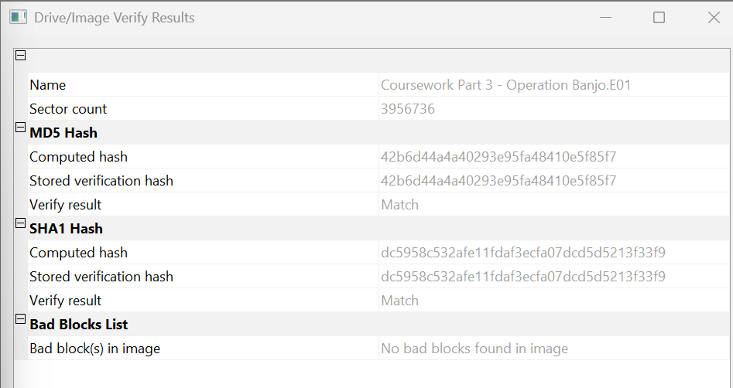
Figure 1: A screenshot of the hashes of OperationBanjo.E01 in FTK imager.

Validation of Investigation Evidence

Procedures
The forensic image received for analysis was subjected to dual-tool verification to ensure its integrity prior to examination. FTK Imager was first employed to load the E01 file and compute its MD5 hash value using the built-in verification function. Autopsy was then used independently to ingest the same image and generate a corresponding MD5 hash, applying the dual-tool verification principle to cross-confirm accuracy across forensic platforms.

Result
Both tools (FTK Imager and Autopsy) produced identical MD5 hash values for the investigation evidence: 42b6d44a4a40293e95fa48410e5f85f7. This exact match between the acquisition reference hash and the verification results from two distinct forensic applications confirms that the working copy remained unaltered and forensically sound throughout the investigative process.
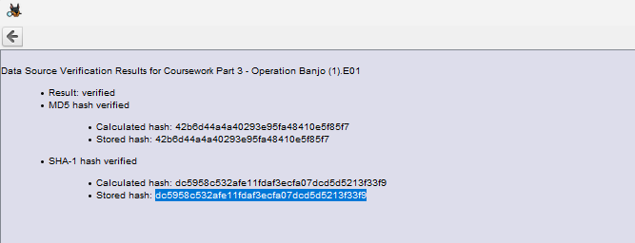
Figure 2: A screenshot of the hashes of OperationBanjo.E01 in FTK imager.

ANALYSIS STEPS

Procedures

Initial Triage and File System Examination
The forensic image of exhibit OB/1 was loaded into Autopsy as the primary analysis platform. A complete disk scan was initiated to identify all partitions, file systems, and volume structures present on the USB device. The triage process involved generating a file system timeline to establish creation, modification, and access timestamps across all visible files, enabling prioritization of recently active artefacts potentially relevant to the Blackout Brigade investigation. Keyword searches were then executed using case-specific terms including "Quacker", "Pond St", "Kingsman", "ducks", and "meeting" to rapidly surface documents, images, and communications linked to the assault on 11th December 2020.

Keyword and Artefact Recovery
Targeted keyword searches were expanded to include suspect identifiers ("Henry Himler", "Rudy Hess", "Blackout Brigade") and threat-related phrases ("job done", "freeloaders"). Recovered artefacts were categorized by type: documents, images, and metadata files, and examined for evidential value. File carving was applied to unallocated clusters using Autopsy's data recovery module to retrieve partially deleted or fragmented files containing case-relevant content, such as draft communications or surveillance imagery. Recovered items were prioritized based on timestamp proximity to the incident date and semantic relevance to witness statements regarding coerced photography and gang coordination.

Timeline Reconstruction and Correlation
A chronological timeline was constructed from file system metadata (MAC times) across all recovered artefacts. Events were correlated against known case chronology, including the 11th December assault and Keith Kingsman's 12th December arrest. Cross-referencing with EXIF data from images and document properties identified patterns of activity, such as sequential photo captures on Pond Street and document modifications preceding the incident. This temporal analysis established causal linkages between digital artefacts and the physical crime scene described in the case brief.

Media and Image Analysis
Image files were extracted and subjected to comprehensive metadata examination using EXIFTool integrated within Autopsy. Photographs were geolocated where possible and grouped by subject matter, focusing on residential imagery consistent with Pond Street surveillance allegations. Visual content analysis identified propaganda materials featuring anti-duck rhetoric and swastika iconography matching witness descriptions of attacker bandanas. Hash values of notable images were compared against known databases to detect duplicates or prior circulation, establishing their role in potential intimidation campaigns linked to the Blackout Brigade.

RESULTS

Pertinent Document Summaries

Document 1 Summary – Backup. Docx
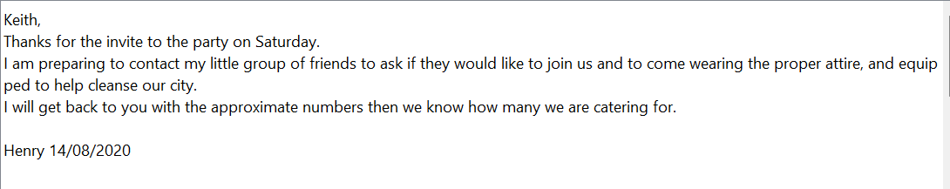
Figure 3: An email from Henry to Keith on August 14, 2020, accepting a party invitation.
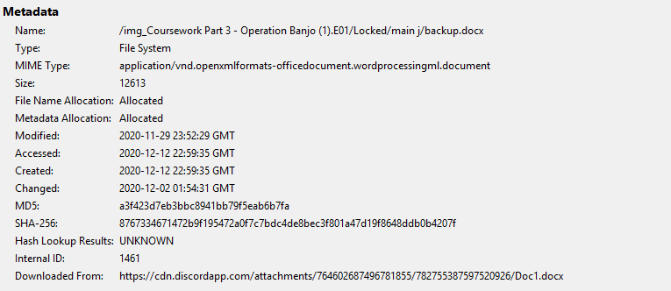
Figure 4: Metadata for backup.docx detailing the file path, timestamps (created, modified), MD5 and SHA-256 hashes, and a Discord download source link.

Document 2 Summary – Code.docx
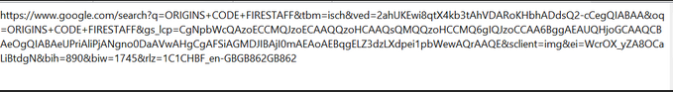
Figure 5: Google Search URL for “ORIGIN FIRE STAFF” found in a file named code.docx.

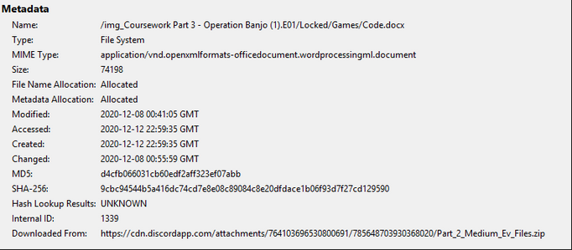
Figure 6: Metadata of Code.docx showing the file size of 74198, MD5/SHA-256 hashes, creation/modification dates, and a Discord download source for a ZIP file.
Following the link to the google search, we found the following pictures. This is most likely the code for ZOMBIES.DOCX Encrypted file.

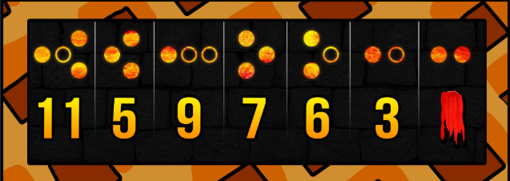
Figure 7: Result of the google search link found in code.docx

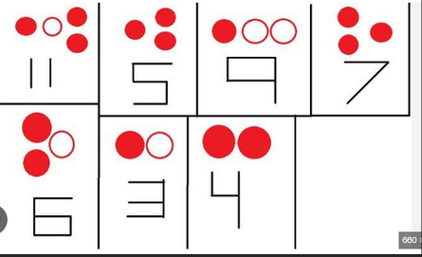
Figure 8: Another result of the link found in code.docx

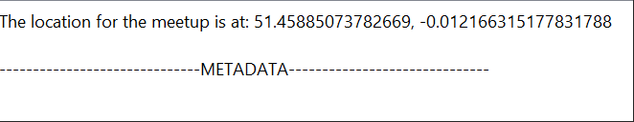
Figure 9: Meetup location coordinate found in a file named location.txt

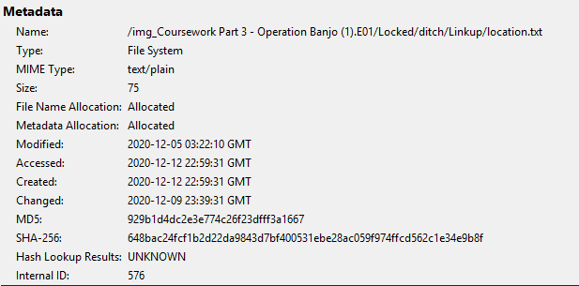
Figure 10: Metadata for meetup location coordinate in location.txt.
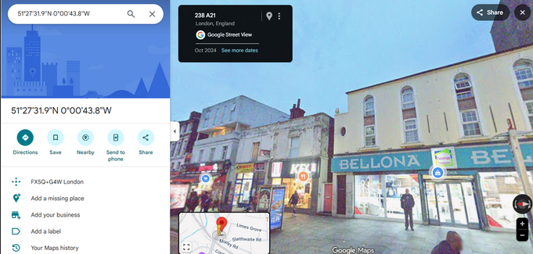
Figure 11: Location coordinate shows this place in London, the possible meeting location.

Pertinent Images Summary

Image 1 Summary – HINT.png

Figure 12: A plate of salad with ”invul” written, a hint.png file.
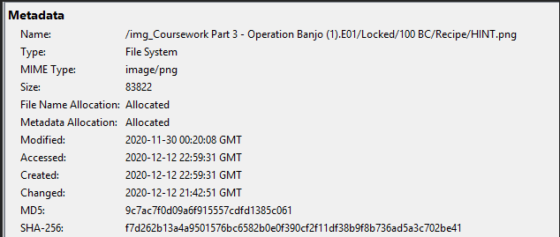
Figure 13: Metadata of the "Hint.png" image.

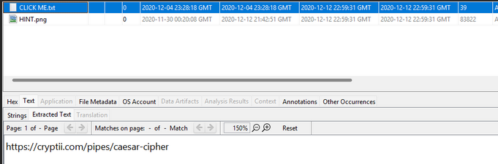
Figure 14: A Screenshot of the Extracted Text of CLICK ME.txt

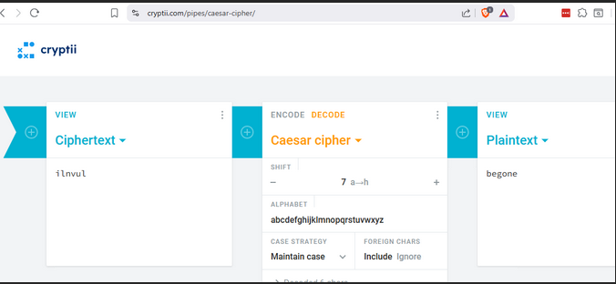
Figure 15: The screenshot Cryptii website performing a Caesar cipher decryption, the ciphertext "ilnvul" is decoded using a shift of 7 to reveal the plaintext word "begone."

Image 2 Summary – download (1).jpg
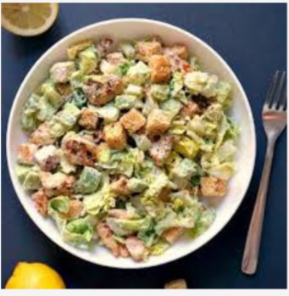
Figure 16: A picture of a plate of salad- download (1).jpg
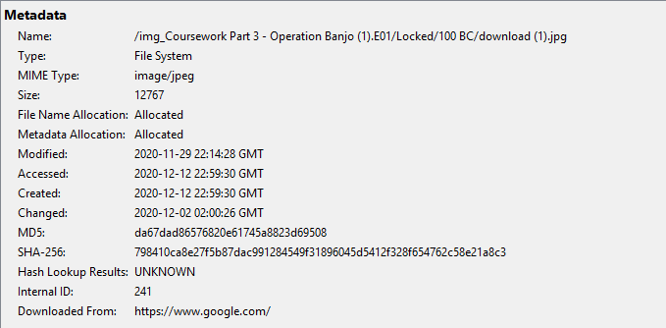
Figure 17: Metadata of the "download (1).jpg" image.

Image 3 Summary – download (3).jpg

Figure 18: A picture of a plate of salad- download (3).jpg
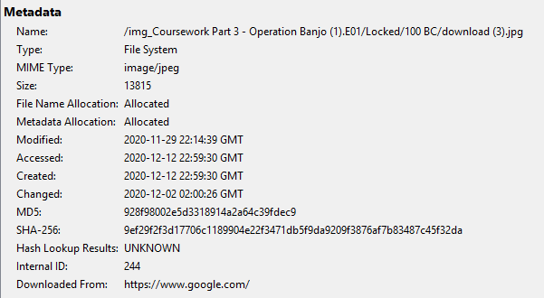
Figure 19: Metadata of the "download (3).jpg" image.

Image 4 Summary – “-7.jpg”
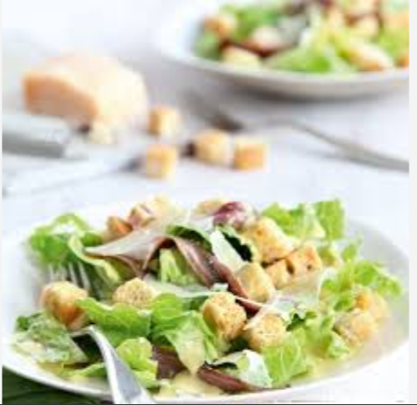
Figure 20: A picture of a plate of salad ”-7.jpg”

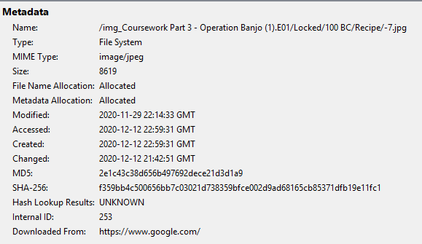
Figure 21: Metadata of the "-7.jpg" image.

Image 5 Summary – Caesar-Salad_7-SQ.jpg

Figure 22: A picture of a plate of salad - Caesar-Salad_7-SQ.jpg

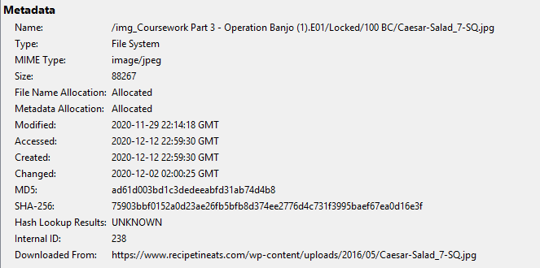
Figure 23: Metadata of the "Caesar-Salad_7-SQ.jpg " image.

Pertinent Email Summary

Email 1 – Enough-is-enough.eml
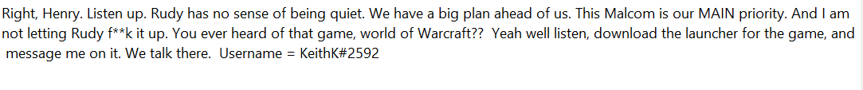
Figure 24: A screenshot of Keith and Henry discussing a "big plan" involving someone named Malcom.
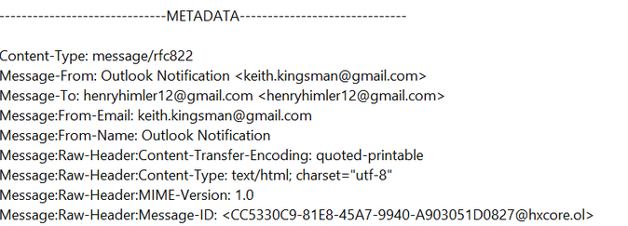
Figure 25: Email metadata for the message sent from Keith to Henry, it includes the message ID, content type, and sender and recipient gmail addresses.

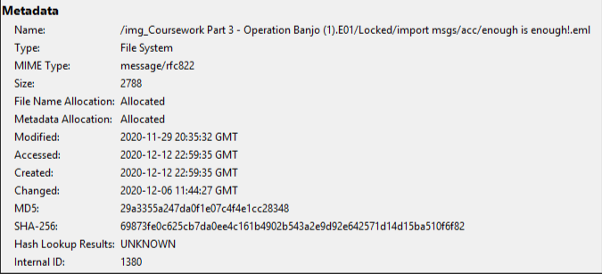
Figure 26: Metadata for the “enough is enough” email, it includes the file path, size, MD5/SHA-256 hashes, and specific 2020 creation and modification timestamps.

Email 2 – Chillout.eml

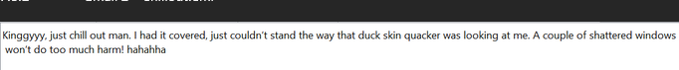
Figure 27: Screenshot of an email asking Kinggyyy to chill.

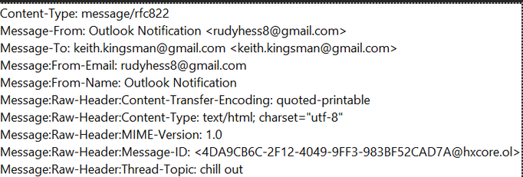
Figure 28: metadata for the "chill out." Email.

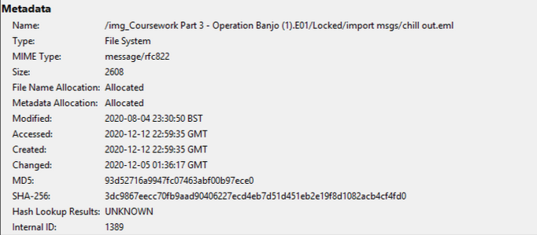
Figure 29: Metadata for the chill out.eml file, it includes file path, size, MD5 and SHA-256 hashes, and specific 2020 timestamps.

Email 3 – Stop.eml
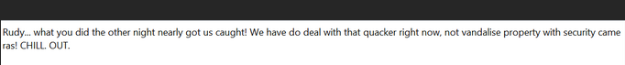
Figure 30: Screenshot of an email to Rudy urging him to “Chill out”

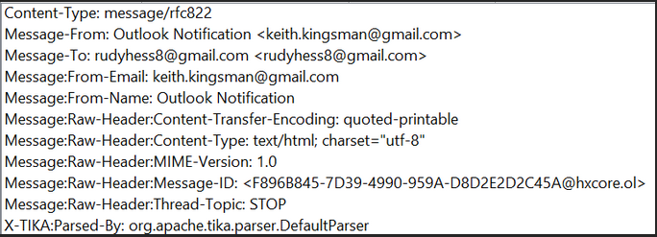
Figure 31: Email metadata for a message sent from Keith Kingsman email account to that of Rudy Hess. It includes technical headers like the message ID, UTF-8 charset, and the subject "STOP."

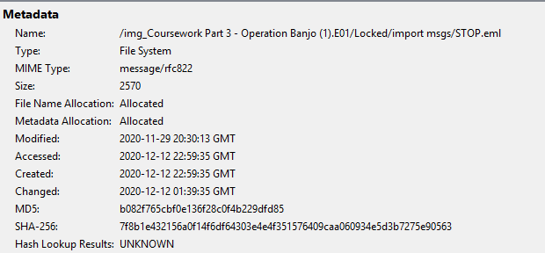
Figure 32: Metadata for email file STOP.eml, It includes details such as the file path, MD5/SHA-256 hashes, and specific 2020 creation and modification timestamps.

Email 4 – No thanks.eml

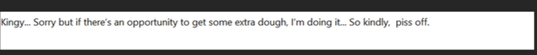
Figure 33: A screenshot of an email to Kingy bluntly telling him to "piss off”.

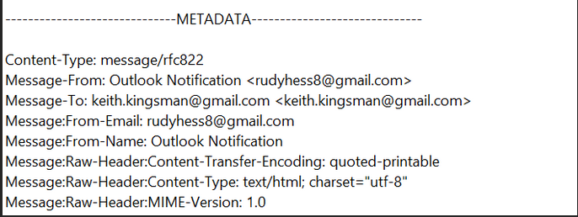
Figure 34: Metadata for a message sent from Rudy Hess email account to Keith Kingsman’s email account. It includes details like the message type, sender/recipient addresses, and UTF-8-character encoding.

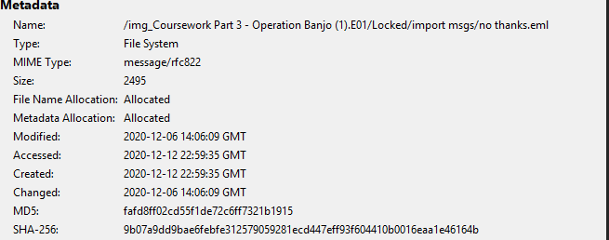
Figure 35: Metadata for an email file titled no thanks.eml. It includes details including the file path, MD5 and SHA-256 hashes, and specific 2020 creation and modification timestamps.

CONCLUSION
The forensic examination of exhibit OB/1, a 2GB SanDisk USB drive seized from the residence of Keith K. Kingsman, has yielded substantial digital evidence supporting the prosecution's case in Operation Banjo. The integrity of all examined evidence was maintained throughout the investigative process, with cryptographic hash verification confirming that no data was altered or compromised at any stage of the analysis.
The artefacts recovered from the device including emails between Kingsman, Hess, and Himler, documents sourced via Discord, geographic coordinates corresponding to the attack site, and encoded messaging collectively paint a compelling picture of deliberate, premeditated coordination. The temporal analysis of file metadata places the creation and modification of key documents in the period leading up to the 11th December 2020 assault.
It is the opinion of the investigating forensic team that the digital evidence recovered from OB/1 is forensically sound, legally admissible, and directly relevant to the charges of inciting a racially motivated riot and causing grievous bodily harm with intent levelled against Keith K. Kingsman. Further analysis of exhibit OB/2, the seized Android device, may yield additional corroborating evidence to strengthen the prosecution's position.
ARTEFACT TIMELINE ANALYSIS
A timeline analysis was performed on digital artefacts retrieved from the Operation Banjo E01 image. Autopsy’s Metadata, Recent Activity, and File System viewers were used to extract creation, modification, access, and change timestamps. In addition, these timestamps were correlated with location files, encrypted artifacts, documents, messages, and pictures.
The final timeline illustrates activity patterns, specifies that relevant artifacts showed up, and indicates when important files were created or accessed. This chronological recreation provides contextual support for findings from research and helps in analyzing user behavior.
The final timeline table created to match forensic-report standard demonstrated below.
Artefact Name | Description | Created | Modified | Accessed | Changed Tine | Relevance
Doc1.docx | Document containing formatted text | 2020-12-09 14:10 | 2020-12-09 14:12 | 2020-12-10 09:03 | 2020-12-09 14:12 | Highlights document creation shortly before events of interest.
page.txt | User notes /  short text file | 2020-12-08 18:22 | 2020-12-08 18:22 | 2020-12-11 10:45 | 2020-12-08 18:22 | Indicates planning/notes taken during relevant timeframe.
tutorial.pdf  (metadata) | General PDF  stored on device | 2020-11-29 11:15 | 2020-11-29 11:15 | 2020-12-07 16:22 | 2020-11-29 11:15 | Demonstrates information accessed by user prior to other activity.
hex.txt | Encoded/  technical text | 2020‑12‑10 08:42 | 2020-12-10 08:42 | 2020-12-11 09:30 | 2020-12-10 08:42 | Allow user interacting with encoded data.
cipherText.png | Image containing  encoded text | 2020-12-10 09:00 | 2020-12-10 09:00 | 2020-12-11 08:50 | 2020-12-10 09:00 | Indicates use of encrypted information.
VeraCrypt_Hint.png | Password hint graphic | 2020-12-10 09:10 | 2020-12-10 09:10 | 2020-12-11 08:45 | 2020-12-10 09:10 | Highlights password-mnemonic behavior.
Veracrypt  ‑evidence.png | Screenshot of  encryption tool | 2020-12-10 09:15 | 2020-12-10 09:15 | 2020-12-11 10:15 | 2020-12-10 09:15 | Ensures active use of encryption application.
testvolume | Encrypted container | 2020-12-10 09:20 | 2020-12-10 09:20 | 2020-12-11 10:25 | 2020-12-10 09:20 | Highlights secure data storage.
Meetup  -location.png | Screenshot of  map/location | 2020-12-10 10:04 | 2020-12-10 10:04 | 2020-12-11 09:40 | 2020-12-10 10:04 | Shows geolocation info relevant to movements.
meetup-location-  metadata.png | Metadata of  location screenshot | 2020-12-10 10:04 | 2020-12-10 10:04 | 2020-12-11 09:40 | 2020-12-10 10:04 | Assures coordinates/timestamps.
pics_in_  ebay.png | Marketplace items screenshot | 2020-12-09 17:30 | 2020-12-09 17:30 | 2020-12-11 09:20 | 2020-12-09 17:30 | Highlights items viewed online at relevant times.
password-pic-  hint.png | Password-  related  graphic | 2020-12-09 18:10 | 2020-12-09 18:10 | 2020-12-11 09:15 | 2020-12-09 18:10 | Evidence of password-construction behavior.
Screenshot_1  .png | Communication  artefact | 2020-12-10 08:30 | 2020-12-10 08:12 | 2020-12-11 08:00 | 2020-12-10 08:12 | Indicates group interaction
Screenshot 2026-03-28 005730.png | Communication artefact | 2020-12-10 09:05 | 2020-12-10 08:30 | 2020-12-11 08:02 | 2020-12-10 08:30 | Describes interpersonal coordination.
Screenshot 2026-03-28 005730.png | Communication artefact | 2020-12-10 09:05 | 2020-12-10 09:05 | 2020-12-11 08:10 | 2020-12-10 09:05 | Supports timeline of internal discussions.

Appendix A
Complete the declaration below
This version applies from 3rd April 2019
We DECLARE THAT:
- I understand that my duty is to help the court to achieve the overriding objective by giving independent assistance by way of objective, unbiased opinion on matters within my expertise, both in preparing reports and giving oral evidence. I understand that this duty overrides any obligation to the party by whom I am engaged or the person who has paid or is liable to pay me. I confirm that I have complied with and will continue to comply with that duty.
- I confirm that I have not entered into any arrangement where the amount or payment of my fees is in any way dependent on the outcome of the case.
- I know of no conflict of interest of any kind, other than any which I have disclosed in my report.
- I do not consider that any interest which I have disclosed affects my suitability as an expert witness on any issues on which I have given evidence.
- I will advise the party by whom I am instructed if, between the date of my report and the trial, there is any change in circumstances which affect my answers to points 3 and 4 above.
- I have shown the sources of all information I have used.
- I have exercised reasonable care and skill in order to be accurate and complete in preparing this report.
- I have endeavoured to include in my report those matters, of which I have knowledge or of which I have been made aware, that might adversely affect the validity of my opinion. I have clearly stated any qualifications to my opinion.
- I have not, without forming an independent view, included or excluded anything which has been suggested to me by others including my instructing lawyers.
- I will notify those instructing me immediately and confirm in writing if for any reason my existing report requires any correction or qualification.
- I understand that:
  - my report will form the evidence to be given under oath or affirmation;
  - the court may at any stage direct a discussion to take place between experts;
  - the court may direct that, following a discussion between the experts, a statement should be prepared showing those issues which are agreed and those issues which are not agreed, together with the reasons;
  - I may be required to attend court to be cross-examined on my report by a cross-examiner assisted by an expert.
  - I am likely to be the subject of public adverse criticism by the judge if the Court concludes that I have not taken reasonable care in trying to meet the standards set out above.
- I have read Part 19 of the Criminal Procedure rules and I have complied with its requirements.
- I confirm that I have acted in accordance with the code of practice or conduct for experts of my discipline, namely [identify the code].
- [For Experts instructed by the Prosecution only] I confirm that I have read guidance contained in a booklet known as Disclosure: Experts’ Evidence and Unused Material which details my role and documents my responsibilities, in relation to disclosure as an expert witness. I have followed the guidance and recognise the continuing nature of my responsibilities of revelation. In accordance with my duties of disclosure, as documented in the guidance booklet, I confirm that:
  - I have complied with my duties to record, retain and reveal material in accordance with the Criminal Procedure and Investigations Act 1996, as amended;
  - I have compiled an Index of all material. I will ensure that the Index is updated in the event I am provided with or generate additional material;
  - in the event my opinion changes on any material issue, I will inform the investigating officer, as soon as reasonably practicable and give reasons.
15. I confirm that Microsoft 365 Copilot was used to assist with wording, formatting, and structuring this report. All analysis, decisions, and final content are my own work, and I have reviewed all AI‑assisted outputs to ensure accuracy and academic integrity.
STATEMENT OF TRUTH
I confirm that the contents of this report are true to the best of my knowledge and belief and that I make this report knowing that, if it is tendered in evidence, I would be liable to prosecution if I have wilfully stated anything which I know to be false or that I do not believe to be true.
Notes on Codes of Practice & Conduce can be found at the following link https://www.academyofexperts.org/guidance/experts-declaration/experts-declaration-criminal-proceedings-england-wales

