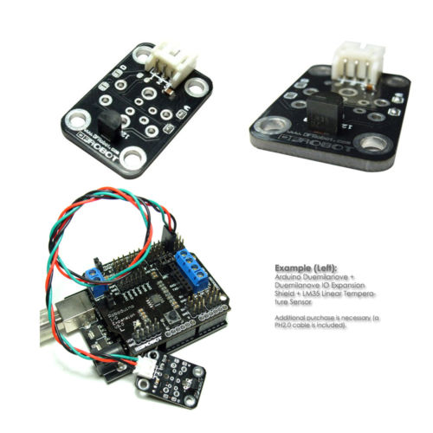Greenhouse window actuator control unit, concept specification

Control board: Arduino Mega

**Inputs:**

1. Two temperature sensors, spaced ~30cm from one-another
2. Up to four actuator position inputs (voltage signal from 10K pot. on actuator)
3. Two potentiometers for user sensitivity input (one to set minimum responsive temperature, one to set maximum)
4. 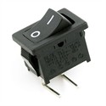One ‘on/off’ switch input which on one side (0) will retract all actuators until switched again (1) for return to normal operation

**Outputs:**

1. Up to eight outputs for motor switching, controlling up to four actuators forwards and backwards (reversing polarity as needed). Either relays or solid state FETs

Degree of control accuracy is 5 stages from closed to full open

1. 16 x 2 LCD screen with temperature and sensitivity setting display:

|  |  |  |  |  |  |  |  |  |  |  |  |  |  |  |  |
| --- | --- | --- | --- | --- | --- | --- | --- | --- | --- | --- | --- | --- | --- | --- | --- |
| **T** | **E** | **M** | **P** | **:** | **2** | **4** | **°** | **C** |  |  | **E** | **X** | **T** | **:** | **3** |
| **M** | **I** | **N** | **-** | **1** | **5** |  | **M** | **A** | **X** | **-** | **3** | **0** |  |  |  |

[**EXT:**] – Degree of actuator extension, from 0 for closed to 5 for fully extended

[**MIN-**] Temperature at which actuator will begin to extend to first position and pot. resistance will be 2K (EXT: 1)

[**MAX-**] Temperature at which actuator will be fully extended and pot. resistance will be 10K (EXT: 5)

**Other:** Control circuitry should include a regulator for powering off 24V DC