1. Deploy a 2-Node K8S Cluster Using Kops
2. Clone or Fork the repo <https://github.com/mavrick202/argocdtesting.git>
3. Visit following URL for step-by-step deployment of ArgoCD

<https://www.eksworkshop.com/intermediate/290_argocd/install/>

ArgoCD Documentation:

<https://argoproj.github.io/argo-cd/getting_started/>

<https://luktom.net/en/e1683-argocd-vs-flux>

Deploying ArgoCD and Deploying application

kubectl create namespace argocd

kubectl apply -n argocd -f https://raw.githubusercontent.com/argoproj/argo-cd/stable/manifests/install.yaml

VERSION=$(curl --silent "https://api.github.com/repos/argoproj/argo-cd/releases/latest" | grep '"tag_name"' | sed -E 's/.*"([^"]+)".*/\1/')

sudo curl --silent --location -o /usr/local/bin/argocd <https://github.com/argoproj/argo-cd/releases/download/$VERSION/argocd-linux-amd64>

sudo chmod +x /usr/local/bin/argocd

kubectl patch svc argocd-server -n argocd -p '{"spec": {"type": "LoadBalancer"}}'

export ARGOCD_SERVER=`kubectl get svc argocd-server -n argocd -o json | jq --raw-output .status.loadBalancer.ingress[0].hostname`

--------OLD MEATHOD BEFORE 1.8 VERSION---------

ARGO_PWD=`kubectl get pods -n argocd -l app.kubernetes.io/name=argocd-server -o name | cut -d'/' -f 2`

--------------------------------------------------------------

-----FROM VERSION 1.9 & Later--------------------------------

kubectl -n argocd get secret argocd-initial-admin-secret -o jsonpath="{.data.password}" | base64 -d

------------------------------------------------------------

argocd login $ARGOCD_SERVER --username admin --password <Password> --insecure

CONTEXT_NAME=`kubectl config view -o jsonpath='{.contexts[].name}'`

argocd cluster add $CONTEXT_NAME

argocd app create rollingupdate --repo https://github.com/mavrick202/argocdtesting.git --path deploy --dest-server https://api.trainingk8s.xyz(Replace-with-ur-cluster) --dest-namespace default

argocd app create votingapp --repo https://github.com/mavrick202/argocdtesting.git --path votingapp --dest-server https://api.trainingk8s.xyz --dest-namespace default

argocd app get rollingupdate (or) Can be done fom the GUI

argocd app sync rollingupdate (or) Can be done fom the GUI

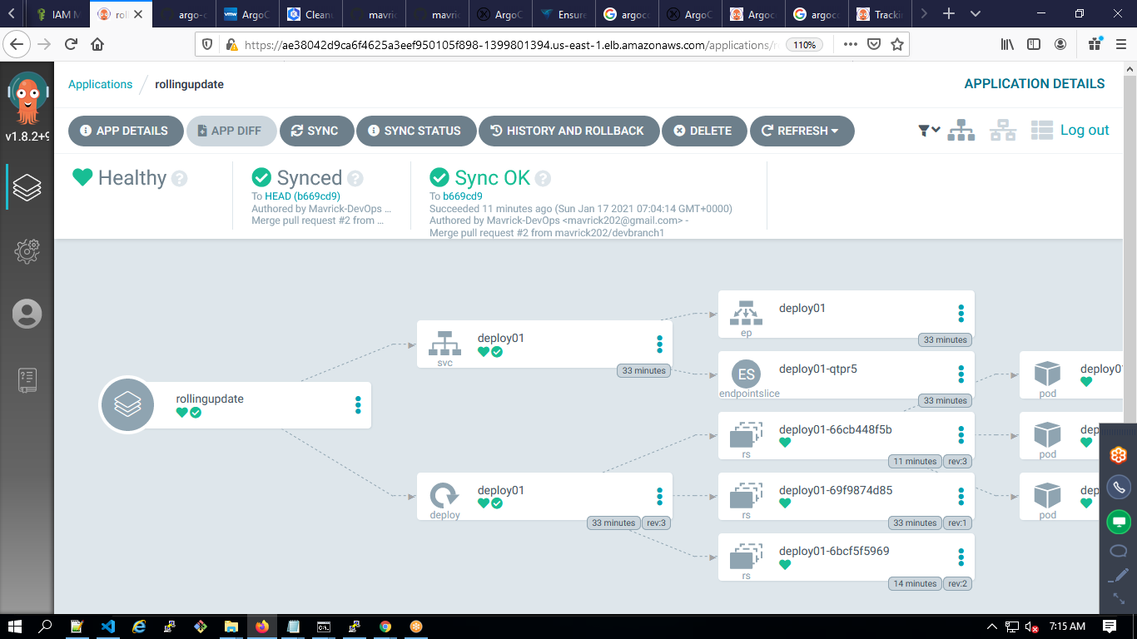

Using Azure Devops:

1. Create SP using Kubeconfig.
2. Use the repo with a folder deploy and inside create deployment.yaml
3. Kubectl apply -f ./_azureb13terraformaws/deploy/

<https://medium.com/hootsuite-engineering/using-gitops-argocd-to-ship-kubernetes-changes-faster-at-hootsuite-4d35628a3fb7>

<https://www.dataversity.net/openshift-vs-kubernetes-the-seven-most-critical-differences/>