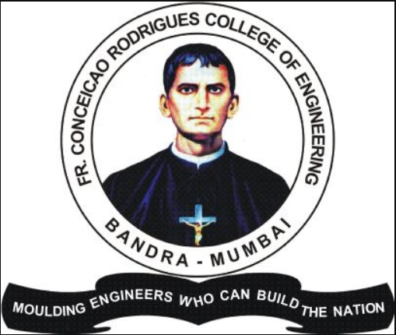 Fr. Conceicao Rodrigues College of Engineering

-----------------------------------------------------------------------------------------------------------------------------------------------------------------------------------------------------------------------------------------------------------------------------------------------------------

Apurva Jadhav

Laxmi Narayan Apt,R.no 01,Poona Link Road

Kalyan,Maharashtra,421306

apurvajadhav011@gmail.com

9321662801

## Objective

Dynamic and passionate software engineering student with a strong foundation in programming languages and algorithm design. Seeking an internship opportunity to leverage my skills in software development and contribute to innovative projects.

## Education

Fr. Conceicao Rodrigues College of Engineering  
Bachelor of Engineering in Electronics and Computer Science  
Expected Graduation: [2027]

## Skills

- Programming Languages: Java, Python, React (beginner)  
- Web Development: HTML, CSS, JavaScript  
- Methodologies: Agile, Problem Solving, Algorithm Design

## Projects

1. NGO Website Development with React  
 - Developed a responsive website for an NGO to enhance visibility and outreach.  
2. Tata Campaign for Interfaith Harmony  
 - Collaborated on a campaign project aimed at promoting social harmony and inclusion.  
3. Corporate Engagement Program for Fr Angel Ashram & School  
 - Designed and implemented a program to enhance community engagement and support.

## Experience

Relevant internships, part-time jobs, or volunteer experiences can be listed here if applicable.

## Achievements

- Achieved [any relevant achievements, awards, or recognitions].  
- Participated in [hackathons, coding competitions, etc.].

## Find Me Online

- HackerRank: [HackerRank Profile](https://www.hackerrank.com/profile/jadhavapurva623)  
- LinkedIn: [LinkedIn Profile](https://www.linkedin.com/in/apurva-j-777948284/)