Objectives

Project Brief

You work for Spark Funds, an asset management company. Spark Funds wants to make investments in a few companies. The CEO of Spark Funds wants to understand the global trends in investments so that she can take the investment decisions effectively.

Business and Data Understanding

Spark Funds has two minor constraints for investments:

* It wants to invest between 5 to 15 million USD per round of investment
* It wants to invest only in English-speaking countries because of the ease of communication with the companies it would invest in

For your analysis, consider a country to be English speaking only if English is one of the official languages in that country (Refer to the downloaded PDF file: Click here for a list of countries where English is an official language.)

These conditions will give you sufficient information for your initial analysis. Before getting to specific questions, let’s understand the problem and the data first.

1. What is the strategy?

Spark Funds wants to invest where most other investors are investing. This pattern is often observed among early stage startup investors.

2. Where did we get the data from?

We have taken real investment data from crunchbase.com, so the insights you get may be incredibly useful. For this group project, we have divided the data into the following files:

You have to use three main data tables for the entire analysis (refer downloaded files)

3. What is Spark Funds’ business objective?

The business objectives and goals of data analysis are pretty straightforward.

Business objective: The objective is to identify the best sectors, countries, and a suitable investment type for making investments. The overall strategy is to invest where others are investing, implying that the 'best' sectors and countries are the ones 'where most investors are investing'.

Goals of data analysis: Your goals are divided into three sub-goals:

Investment type analysis: Comparing the typical investment amounts in the venture, seed, angel, private equity etc. so that Spark Funds can choose the type that is best suited for their strategy.

Country analysis: Identifying the countries which have been the most heavily invested in the past. These will be Spark Funds’ favourites as well.

Sector analysis: Understanding the distribution of investments across the eight main sectors. (Note that we are interested in the eight 'main sectors' provided in the mapping file. The two files — companies and rounds2 — have numerous sub-sector names; hence, you will need to map each sub-sector to its main sector.)

4. How do you approach the case study? What are the deliverables?

The entire case study is divided into checkpoints to help you navigate. For each checkpoint, you are advised to fill in the tables into the spreadsheet provided in the download segment. The tables are also mentioned under the 'Results Expected' section after each checkpoint. Since this is the first case study, you have been provided with some additional guidance. Going forward you will be expected to structure and solve the problem by yourself, just like you would be solving problems in real life scenarios.

Important Note: All your code has to be submitted in one Jupyter notebook. For every checkpoint, keep writing code in one well-commented Jupyter notebook which you can submit at the end.

**Checkpoints - Part 1**

**Checkpoint 1: Data Cleaning 1**

1. Load the companies and rounds data (provided on the previous page) into two data frames and name them**companies**and**rounds2** respectively.
2. Table 1.1: The table below is just for reference — you need to fill out the spreadsheet which is attached in the download section. This holds true for all the tables.

**Results Expected: Table 1.1**

**Table 1.1: Understand the Data Set**

|  |  |
| --- | --- |
| How many **unique companies** are present in **rounds2**? |  |
| How many**unique companies** are present in **companies**? |  |
| In the **companies** data frame, which column can be used as the unique key for each company? Write the **name of the column**. |  |
| Are there any companies in the rounds2 file which are not present in companies? Answer yes or no: **Y/N** |  |
| Merge the two data frames so that all variables (columns) in the **companies**frame are added to the **rounds2** data frame. Name the merged frame **master_frame***.*How many observations are present in master_frame? |  |

After this, you will need to work only with the **master frame.**

**Note:** When you load the dataset, you might notice that in the ‘permalink’ column of the ‘Company’ dataframe and in the ‘company_permalink’ column of the ‘rounds2’ dataframe, there are some encoding issues. We have attached a screenshot below:

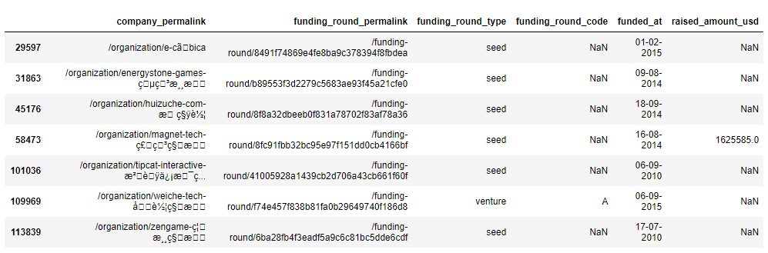

**Encoding issue in some rows**

It is extremely essential that you handle this encoding issue as simply deleting this cell might cause you to lose important data which in turn will affect your whole analysis. For this, you need to specify a different coding type for the ‘company_permalink’ column. Here’s a list of various encoding types that Python can handle:

* [Standard Encodings](https://docs.python.org/2/library/codecs.html#standard-encodings)

The best conclusion that can be drawn is that this file is encoded using multiple encoding types (maybe because the ‘company_permalink’ column contains names of companies in various countries, and hence various languages).

We have provided a StackOverflow answer below which might serve as an intelligent way to tackle this problem:

* [Removing Special Characters in a Pandas DataFrame - StackOverflow](https://stackoverflow.com/questions/45871731/removing-special-characters-in-a-pandas-dataframe)

**Checkpoint 2: Funding Type Analysis**

This is the first of the three goals of data analysis – investment type analysis.

The funding types such as seed, venture, angel, etc. depend on the type of the company (startup, corporate, etc.), its stage (early stage startup, funded startup, etc.), the amount of funding (a few million USD to a billion USD), and so on. For example, seed, angel and venture are three common stages of startup funding.

* Seed/angel funding refers to early-stage startups whereas venture funding occurs after seed or angel stage/s and involves a relatively higher amount of investment.
* Private equity type investments are associated with much larger companies and involve much higher investments than venture type. Startups which have grown in scale may also receive private equity funding. This means that if a company has reached the venture stage, it would have already passed through the angel or seed stage/s.

**Spark Funds wants to choose one of these four investment types for each potential investment they will make.**

Considering the constraints of Spark Funds, you have to decide one funding type which is most suitable for them.

1. Calculate the average investment amount for each of the four funding types (venture, angel, seed, and private equity) and report the answers in **Table 2.1**
2. Based on the average investment amount calculated above, which investment type do you think is the most suitable for Spark Funds?

**Results Expected: Table 2.1**

**Table 2.1**: Average Values of Investments for Each of these Funding Types

|  |  |
| --- | --- |
| Average funding amount of **venture type** |  |
| Average funding amount of **angel type** |  |
| Average funding amount of **seed type** |  |
| Average funding amount of **private equity type** |  |
| Considering that Spark Funds wants to invest between **5 to 15 million USD**per investment round, which investment type is the most suitable for it? |  |