HW 3

Apurva Sharma

GTID 902490301
asharma70@gatech.edu

1.

Attached as kd.py

The parameter h can be varied to get different kernel density estimations.

2.

The results can be seen as:

h = 0.7

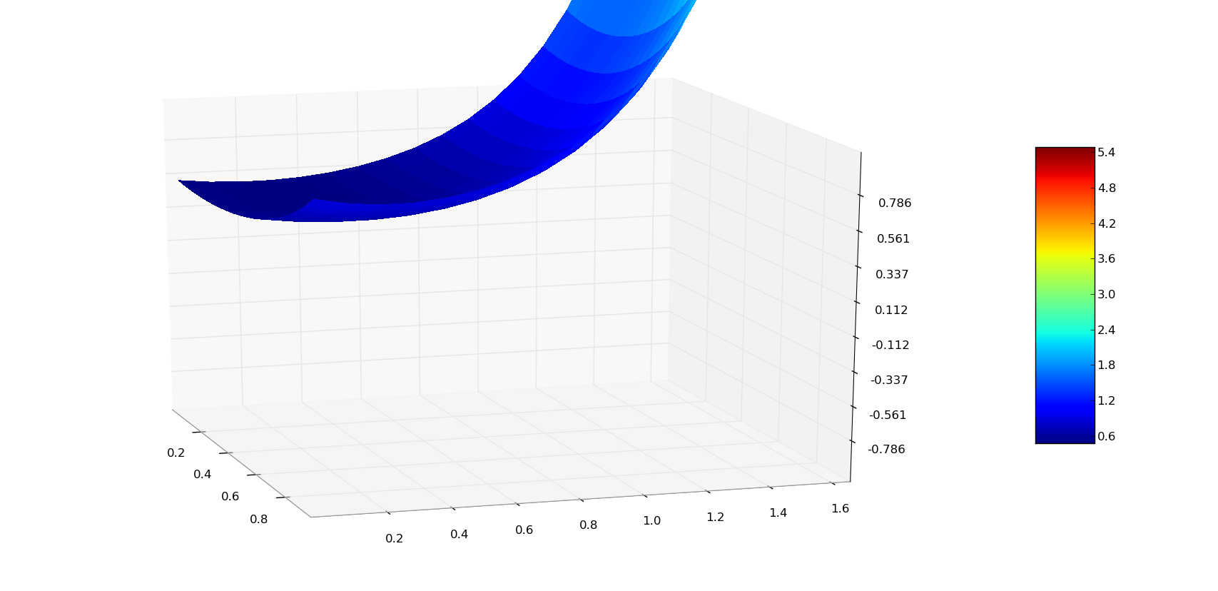

h=0.8

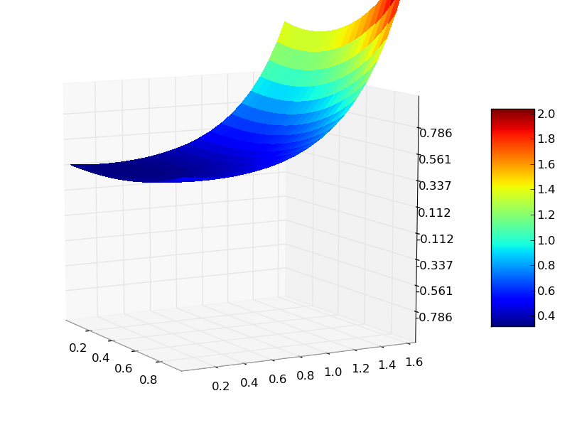

h = 2

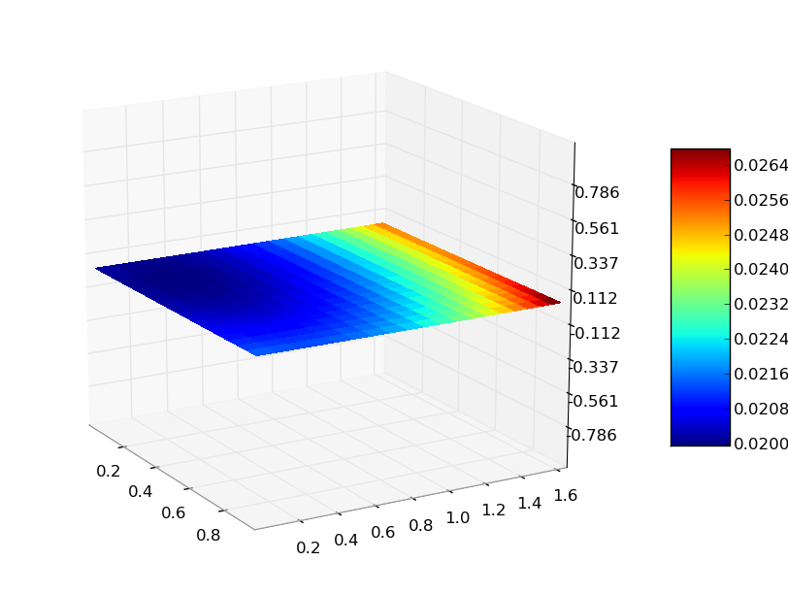

h = 10
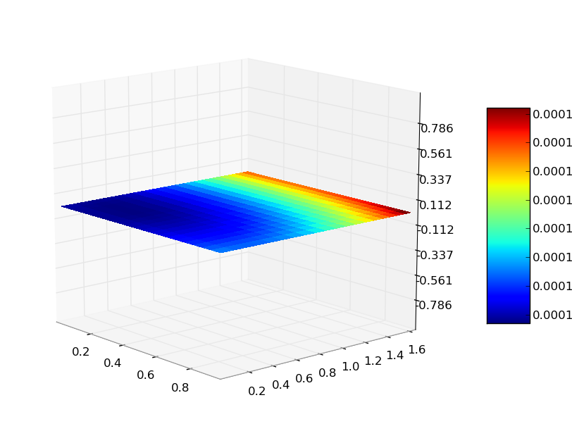

We can see that as h increases, the density begins to oversmooth. For higher values, the density almost looks like a flat plane because of this.
For much lower values, the curve was way too steep to be captured properly, how ever you can run the program which generates the 3d model which can be moved around for seeing what the density looks like.

3.
Attached as nw.py

4.

You can run it with either sp500.csv or sp500_small.csv

Models can be prepared with sp500.csv as long as prediction is to be made over fewer points.
However, if predictions are to be made for all the slots, then the process takes too long (~1hr) as the data points are too many.

For this, a truncated version with 100 days can be used. (sp500_small.csv).

Sample comparison of predictions with h = 30 look like:

If h is too large, then oversmoothing is again visible as:

when h = 50

