Architect a Blockchain Supply Chain Solution

**Add step-by-step instructions on how to run and test your project in the Project_Readme file.**

Contract Address

<https://sepolia.etherscan.io/address/0x7ba684354599a30c30b3a8c33e29bfc58c3bd939>

Transaction ID

<https://sepolia.etherscan.io/tx/0x1f34d64b2a11ba0d7d4c224385eec207856b0c689f515881c3b1b15b49b7f299>

in order to run the project

1. Clone this repo
2. Navigate to : nd1309-Project-6b-Example-Template/project-6
3. Run command : npm install
4. In a separate terminal
   1. truffle compile
   2. truffle migrate –-reset
   3. truffle test
   4. truffle develop
   5. truffle migrate --network sepolia
5. in a separate terminal npm run dev (will start the UI project)

Libraries:

**Explain why libraries listed in the Project_Readme file were adopted in your project**

Node v10.24.1 - Node.js is a JavaScript runtime environment that allows developers to run JavaScript code on the server side.

NPM 6.14.12 - NPM simplifies the process of installing, managing, and sharing third-party libraries and tools in Node.js project

Truffle v4.1.14 (core: 4.1.14) - Truffle helps compile/test/deploy smart contracts

Solidity v0.4.24 (solc-js) - Solidity is specifically designed for writing smart contracts.

Ganache : Version 2.5.4 (2.5.4.1367) - Ganache enables to run a private Ethereum blockchain on local machine

"@truffle/hdwallet-provider": "^2.1.11" - is a convenient way to provide Ethereum address and private key for development purposes.

"lite-server": "2.4.0" - development server used to run web applications on browser

Submit Contract Address:

Sequence Diagram

Activity Diagram

State Daigram

Class Diagram

**Provide a screenshot of the Classes (Data Model) UML diagram in your report.**

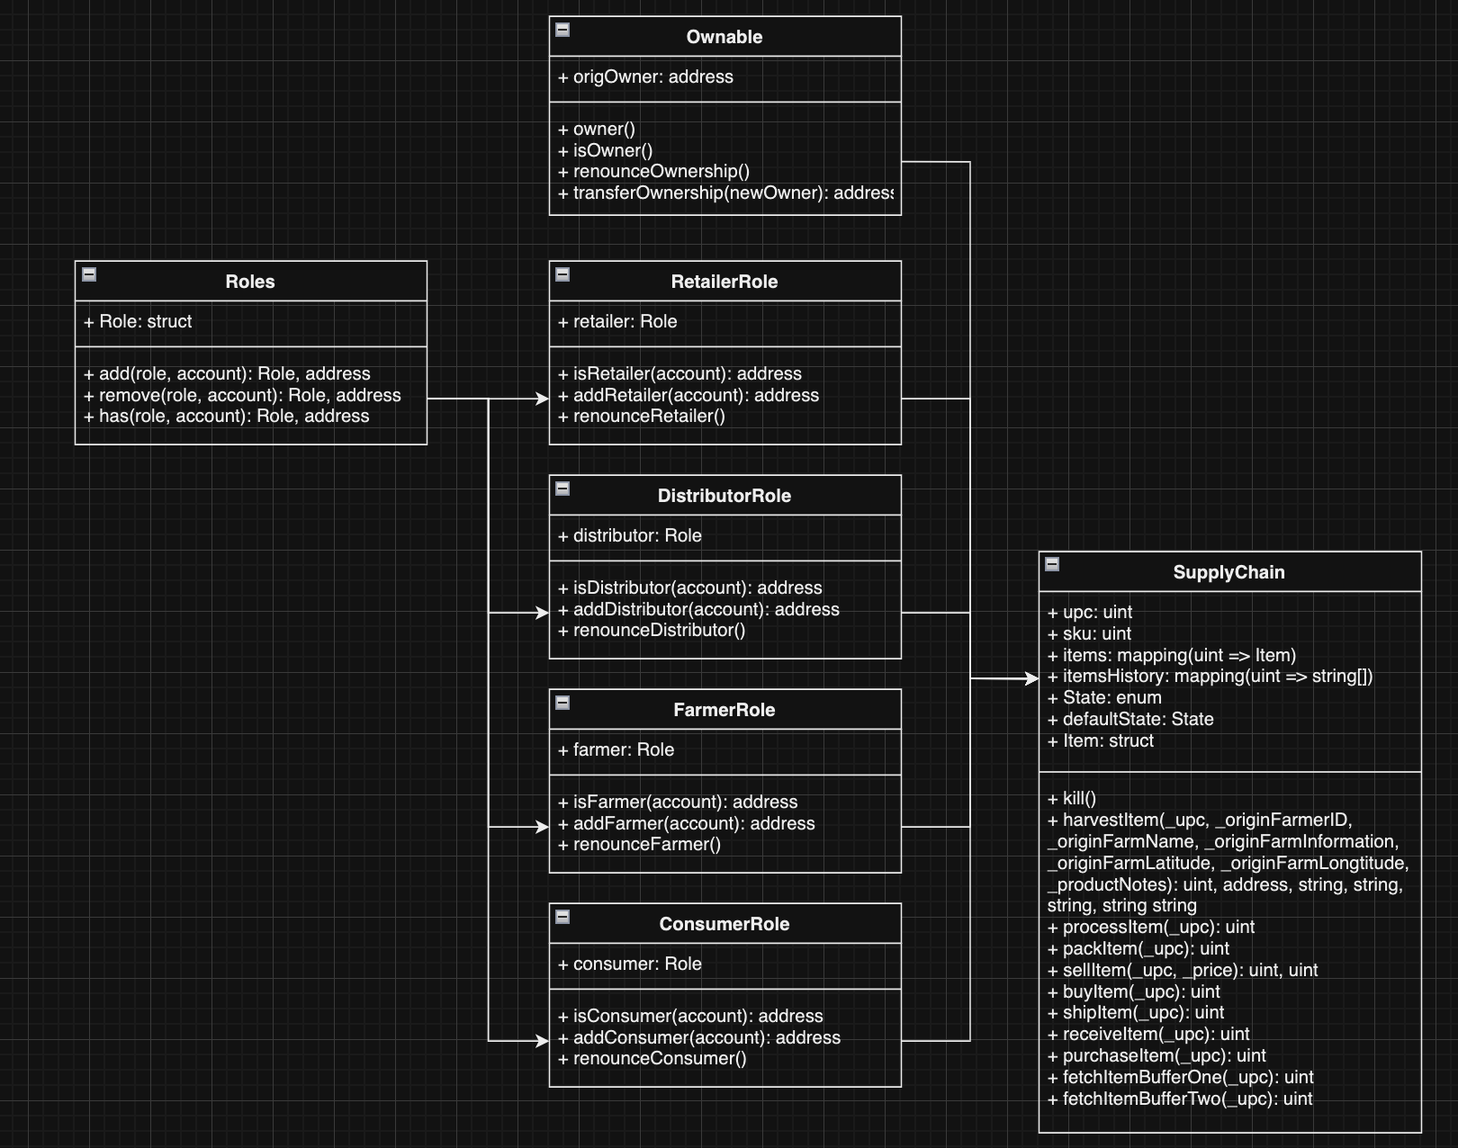

**Provide a screenshot that confirms the contract passes all test cases successfully.**

Front end

