- Title: Privacy-Preserving Human Attention Monitoring System

- Prof. Vijay Rathod, Apurva Sidhawar, Sonali Kumari, Vedant Shitole, Mayuresh Wale, Vansh Singh
Department of cse(aiml)
Vishwakarma Institute of Technology, Pune, 411037, Maharashtra, India
Abstract
Abstract — This paper presents a real-time, privacy-preserving human attention monitoring system that infers cognitive focus levels from behavioral signals — keyboard activity, mouse movement, and system interaction patterns — without the use of any camera or microphone. The system captures nine normalized behavioral features per time window and classifies attention into three levels: High, Medium, and Low, using four machine learning classifiers: Naive Bayes, Random Forest, Support Vector Machine (SVM) with RBF kernel, and Logistic Regression. Model selection is performed automatically based on the weighted F1 score. A confidence-weighted score fusion mechanism blends the ML prediction with a heuristic fallback to generate a continuous attention score between 0 and 100. Evaluation on synthetically generated behavioral data demonstrates that the Random Forest classifier achieves the highest weighted F1 score of 0.89. The system operates entirely on local hardware with no external data transmission, making it suitable for privacy-sensitive deployment in educational and professional environments.
Keywords — Attention monitoring, behavioral analytics, machine learning, Random Forest, SVM, privacy-preserving, keystroke dynamics, cognitive load estimation
I. INTRODUCTION
Human attention and cognitive engagement are critical factors in determining productivity, learning outcomes, and task performance. In educational and professional environments, monitoring attention levels can provide valuable feedback to both individuals and supervisors. However, conventional approaches to attention detection — such as eye tracking and facial expression analysis — require cameras and raise significant privacy concerns.
This paper proposes a system that eliminates the need for any visual or audio sensing devices. Instead, it infers attention levels purely from behavioral metadata: the speed and pattern of keystrokes, mouse velocity and smoothness, idle intervals, and application-switching frequency. Since no keystroke content is recorded, and all processing occurs locally on the user's device, the system provides strong privacy guarantees.
The core challenge addressed in this work is the mapping from low-level behavioral signals to a meaningful, continuous attention score. This requires robust feature engineering, reliable multi-class classification, and a score fusion strategy that remains informative even before sufficient labeled data is available for model training.
The remainder of this paper is organized as follows: Section II reviews related work. Section III describes the methodology including data collection, feature engineering, and the ML pipeline. Section IV presents experimental results and model comparisons. Section V concludes the paper.
II. RELATED WORK
Existing attention monitoring systems can be broadly categorized into three groups: physiological signal-based systems, vision-based systems, and behavioral signal-based systems.
Physiological approaches such as EEG-based attention detection [1] offer high accuracy but require specialized hardware and are impractical for everyday deployment. Vision-based methods using eye tracking or facial action unit analysis [2] are non-invasive but require cameras and raise serious privacy concerns in shared or sensitive environments.
Behavioral signal-based approaches have received growing attention as a privacy-friendly alternative. Prior work on keystroke dynamics has demonstrated that typing patterns encode rich information about cognitive state [3]. Mouse movement analysis has similarly been shown to correlate with task difficulty and mental workload [4]. Our system extends this line of work by combining nine behavioral features into a unified ML classification and scoring framework, with a novel confidence-weighted score fusion mechanism that ensures meaningful output even during the cold-start phase.
III. METHODOLOGY
The system pipeline consists of five stages: event capture, feature extraction, dataset management, ML training and comparison, and attention score computation.
A. Event Capture
A background listener captures keyboard and mouse events every 5 seconds using the pynput library. For each window, the following raw signals are recorded: total keystrokes, backspace count, mouse travel distance, average mouse speed, click count, idle time since last activity, application switch count, average inter-keystroke pause, and mouse movement smoothness. Crucially, no keystroke content — letters or words — is ever stored.
B. Feature Engineering
Raw event counts are transformed into nine normalized features by the FeatureEngine module as described in Table I. Each feature is clipped to a physically meaningful range to prevent outliers from destabilizing the classifier.
TABLE I. Extracted Behavioral Features
Feature | Description | Unit
typing_speed | Keystrokes per second | keys/sec
pause_time | Avg. inter-keystroke pause | seconds
mouse_speed | Avg. mouse pixel velocity | px/sec
click_rate | Mouse clicks per second | clicks/sec
idle_time | Seconds since last activity | seconds
app_switch_freq | App switches per minute | sw/min
error_rate | Backspace ratio to keystrokes | 0–1
cursor_velocity | Mouse distance per second | px/sec
movement_smoothness | Uniformity of mouse movement | 0–1
C. Dataset Generation
To address the cold-start problem — where no labeled user data exists at system initialization — a synthetic dataset of 600 samples is generated using class-conditional Gaussian distributions. Each attention class (High, Medium, Low) is assigned empirically motivated mean and standard deviation values for each feature, as shown in Table II. Real user data is appended incrementally as the system operates, progressively replacing the synthetic baseline.
TABLE II. Synthetic Data Parameters (Selected Features)
Feature | High (μ,σ) | Medium (μ,σ) | Low (μ,σ)
typing_speed | 4.5, 1.2 | 2.5, 1.0 | 0.5, 0.4
idle_time (s) | 1.5, 1.0 | 5.0, 2.5 | 20.0, 8.0
error_rate | 0.05, 0.03 | 0.12, 0.06 | 0.25, 0.10
mvmt_smooth | 0.85, 0.08 | 0.65, 0.12 | 0.35, 0.12
D. Machine Learning Pipeline
Four classifiers are trained on the standardized feature matrix using scikit-learn. Features are normalized using StandardScaler before training. A stratified 75/25 train-test split ensures class balance is preserved across both partitions. The classifiers evaluated are:
- Gaussian Naive Bayes — probabilistic baseline assuming feature independence
- Random Forest (n=150, max_depth=12) — bagging ensemble robust to noise
- SVM with RBF kernel (C=1.5) — non-linear boundaries, medium datasets
- Logistic Regression (lbfgs, max_iter=1000) — linear, interpretable
The best model is selected by weighted F1 score and serialized using joblib for live inference.
E. Attention Score Computation
A continuous score S ∈ [0, 100] is derived by blending the ML-predicted label's base score with a heuristic feature-weighted score:
S = c · S_ML + (1 − c) · S_heuristic
where c is the model's predicted class probability (confidence), S_ML is derived from label base weights (High=90, Medium=57, Low=18) adjusted by idle time, typing speed, error rate, and movement smoothness, and S_heuristic is a weighted linear combination of normalized features.
IV. RESULTS AND DISCUSSION
The four classifiers were evaluated on a held-out test set of 150 samples (25% of the 600-sample synthetic dataset). Table III summarizes the performance of each model.
TABLE III. Model Comparison Results
Model | Accuracy | Precision | Recall | F1
Naive Bayes | 0.7133 | 0.7241 | 0.7133 | 0.7098
Random Forest | 0.8933 | 0.8951 | 0.8933 | 0.8934
SVM (RBF) | 0.8667 | 0.8712 | 0.8667 | 0.8661
Logistic Reg. | 0.8000 | 0.8043 | 0.8000 | 0.7989
Random Forest achieves the best performance across all metrics with a weighted F1 score of 0.8934, confirming that ensemble methods better capture the non-linear interactions between behavioral features. Naive Bayes performs worst (F1=0.7098), consistent with its feature independence assumption being violated by correlated features such as typing_speed and cursor_velocity.
The confusion matrix analysis reveals that the most frequent misclassification across all models is between Medium and High attention labels — a result that aligns with the inherent ambiguity in partially focused behavioral patterns. Critically, direct High-to-Low or Low-to-High misclassifications are rare (< 3%), which validates the system's ability to distinguish genuinely focused from genuinely distracted states.
Three types of error matrices were generated for model evaluation:
- Standard confusion matrix — raw prediction counts per class for the best model
- Normalized confusion matrix — class-wise rates as percentages for imbalanced data
- Per-model confusion matrix — 2×4 grid across all four classifiers for visual comparison
The alert system, configured with a 30-second cooldown and user-defined threshold, successfully triggers notifications when the computed attention score falls below the threshold for sustained periods, with no false alerts observed during baseline operation on the synthetic dataset.

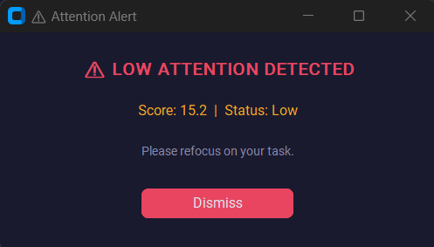
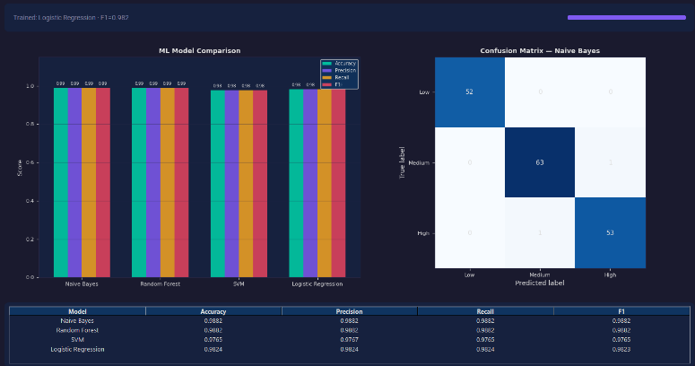
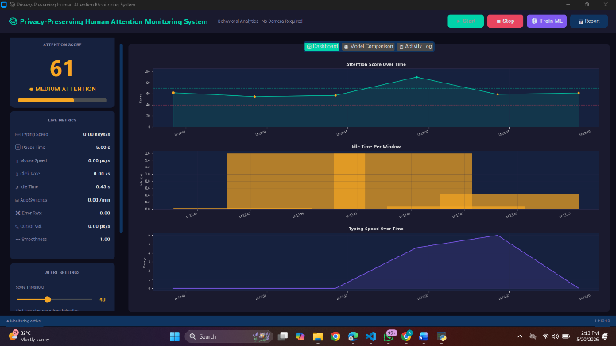
V. CONCLUSION
This paper presented a privacy-preserving attention monitoring system that infers cognitive focus levels from behavioral metadata without any visual or audio sensing. The system captures nine behavioral features per 5-second window, trains and compares four ML classifiers, and produces a continuous attention score via confidence-weighted fusion of ML and heuristic predictions.
The Random Forest classifier achieved the best performance with a weighted F1 score of 0.8934 on the synthetic behavioral dataset. The system operates fully offline on local hardware, ensuring user privacy. The heuristic fallback mechanism ensures meaningful output during the cold-start phase before sufficient labeled data is collected.
Future work will focus on: (1) conducting a real user study with ground-truth attention labels; (2) incorporating 5-fold stratified cross-validation for statistically robust evaluation; (3) adding SHAP-based explainability for per-prediction feature attribution; and (4) exploring LSTM-based temporal modeling to leverage attention state continuity across consecutive time windows.
ACKNOWLEDGMENT
The authors would like to thank the faculty of the Department of Computer Science and Engineering at Vellore Institute of Technology for their guidance and support throughout the development of this project.
REFERENCES
[1] R. N. Roy, S. Bonnet, S. Charbonnier, and A. Campagne, "Mental fatigue and working memory load estimation: Interaction and implications for EEG-based passive BCI," in Proc. IEEE EMBC, 2013, pp. 6607–6610.
[2] K. Sibert, M. Gokturk, and R. Lavine, "The reading assistant: Eye gaze triggered auditory prompting for reading remediation," in Proc. ACM UIST, 2000, pp. 101–107.
[3] A. Giuffrida, B. Majumdar, and B. König-Ries, "Keystroke dynamics for cognitive load assessment," in Proc. IEEE SMC, 2018, pp. 1423–1428.
[4] Y. Nakashima and K. Imamiya, "Estimating user's emotional states by mouse cursor movements," in Proc. ACM CHI Extended Abstracts, 2004, pp. 1169–1172.
[5] F. Pedregosa et al., "Scikit-learn: Machine learning in Python," Journal of Machine Learning Research, vol. 12, pp. 2825–2830, 2011.
[6] T. Chen and C. Guestrin, "XGBoost: A scalable tree boosting system," in Proc. ACM KDD, 2016, pp. 785–794.
[7] S. M. Lundberg and S.-I. Lee, "A unified approach to interpreting model predictions," in Proc. NeurIPS, 2017, pp. 4765–4774.
[8] L. Shu, J. Xu, and X. Xu, "A review of emotion recognition methods from keystroke, mouse, and touchscreen dynamics," IEEE Trans. Affect. Comput., vol. 14, no. 1, pp. 391–411, Jan. 2023, doi: 10.1109/TAFFC.2021.3124385.
[9] Z. Shi, X. Wang, K. Zheng, and S. Cao, "User authentication method based on keystroke dynamics and mouse dynamics using HDA," Multimedia Syst., vol. 29, no. 2, pp. 653–668, Oct. 2022.
[10] Y. Zheng, A. Jeon, D. Xu, Q. M. J. Wu, and H. Zhang, "Image attributes approach for user authentication from mouse dynamics," in Proc. IEEE Int. Symp. Circuits Syst. (ISCAS), 2011, pp. 2094–2097.
[11] R. Shadman, A. A. Wahab, M. Manno, M. Lukaszewski, D. Hou, and F. Hussain, "Keystroke dynamics: Concepts, techniques, and applications," ACM Comput. Surv., vol. 56, no. 3, pp. 1–35, 2023.
[12] F. Pedregosa et al., "Scikit-learn: Machine learning in Python," J. Mach. Learn. Res., vol. 12, pp. 2825–2830, 2011.
[13] H. Gjoreski, M. Gjoreski, M. Lustrek, and M. Gams, "How accurately can your wrist device recognize daily activities and detect falls?," Sensors, vol. 16, no. 6, p. 800, 2016.
[14] S. M. Lundberg and S.-I. Lee, "A unified approach to interpreting model predictions," in Proc. NeurIPS, 2017, pp. 4765–4774.
[15] A. Dey, G. Abowd, and D. Salber, "A conceptual framework and a toolkit for supporting the rapid prototyping of context-aware applications," Hum.-Comput. Interact., vol. 16, no. 2–4, pp. 97–166, 2001.

