UniqueEmailID-Springboot Application

# 1.Purpose:

This document explains how to run the application uniqueEmail. It explains how to add an email application to a server and steps to run the application.

# 2.Importing Project

1. The application is a spring boot application which accepts HTTP rest request and return an integer as a response.
2. Some of the prerequisites required to run this application are:

a. JAVA-jdk - 1.8 (Either oracle or openJDK should work)

b. Apache-Maven-3.6.3

c. Tomcat - V9.0

d. Eclipse or any IDE to configure the project (following instructions are assuming Eclipse as an IDE)

e. Standard Browser (Chrome)

1. Go to location where you have downloaded the project- It would be referred as base-dir.
2. Open the Eclipse environment, Go to File-Import -> Import existing project into eclipse. 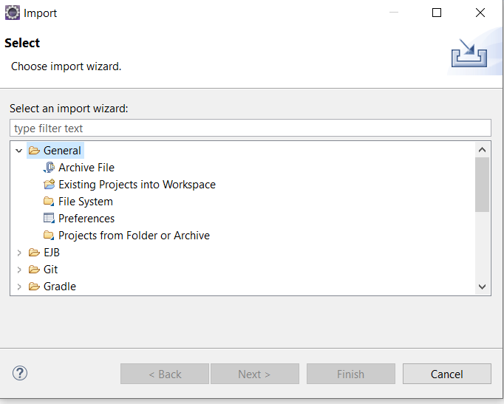

5. Browse to base-dir->source_code -> select-UniqueEmail project and select Finish.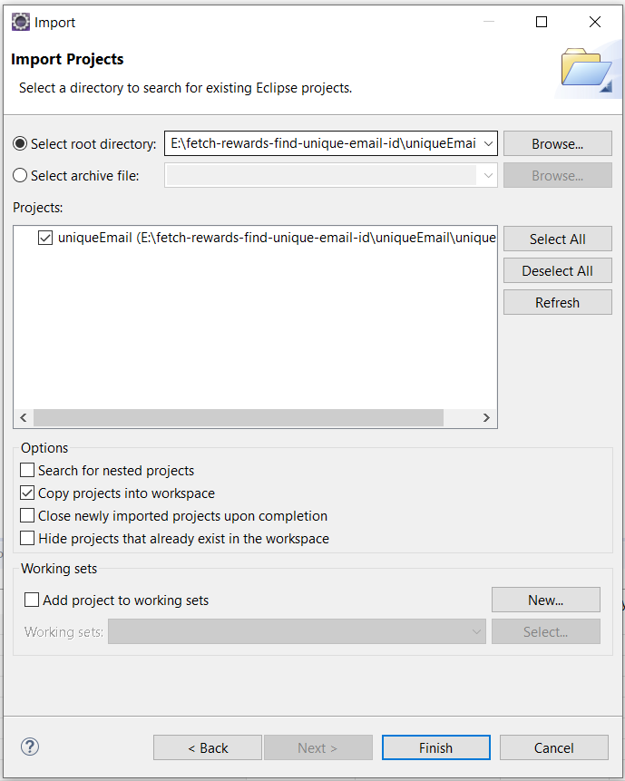

6. Project will be imported, and project will start to build automatically.

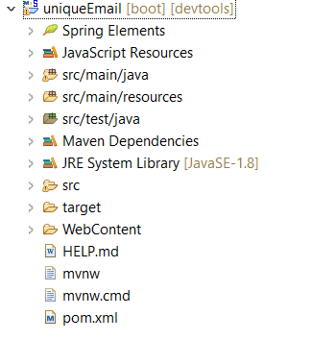

# 3.Hosting application on Server

I have chosen tomcat server, but the application can run with any server. The application needs to be hosted on server so that It can create a unique URL and accept http request.

1. Install tomcat from following website according to user environment:

<https://tomcat.apache.org/download-90.cgi>

1. Select the servers perspective in Eclipse:

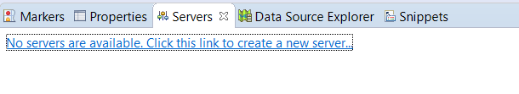

1. Click on the link to create new server. Select Apache tomcat server v9 and click next

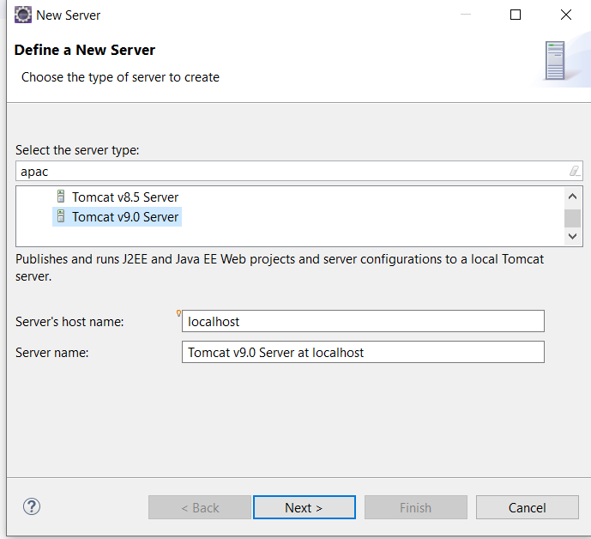

1. Provide tomcat installation directory

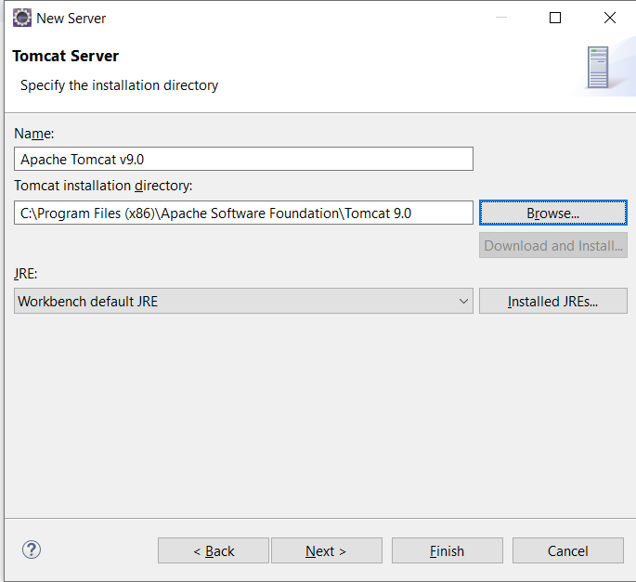

1. Add the service project to the tomcat server and click finish.

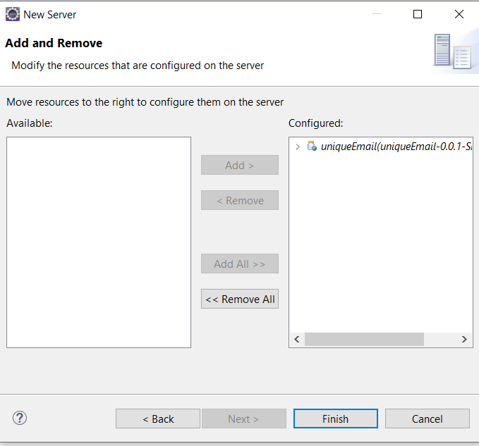

1. Adjust the ports where you want to run tomcat and tomcat admin on. (I have used **8080** for tomcat and **8090** for tomcat admin port)
2. Right click on tomcat server and start the server.

# 4. Running the application

The application can be run in two ways.

## Adding email ids as a parameter while sending the http request

1. Open any browser and send Http URL where you can send the request is:

[**http://localhost:8080/uniqueEmail/index/**](http://localhost:8080/uniqueEmail/index/)

**now you can send the email id list as parameters as:**

<http://localhost:8080/uniqueEmail/index/?emailIds=example@gmail.com,example.1@gmail.com,example1@gmail.com,example.spam@gmail.com,example2@gmail.com>

where the parameters are added as a part of url with a comma separated list.

**Note:** ”+”is considered as special character in http request , so when “+ ”sign is involved it needs to be replaced by “**2%2B**”

The response would be number of unique emails.

## Giving email id list in an input file

1. If there are large number of email ids involved, the list can be given in an input file.

***Note: The email ids must be separated by “,”. The name and path of the input file must be specified in application.properties file as a value for property “****emailListPath”*

1. If the email ids are not given in URL submitted and “emailListPath” property is specified, the emails in those input file will be considered as input and the number of unique emails would be displayed as an output.
2. Open any browser and go to URL <http://localhost:8080/uniqueEmail/index/> to submit a request.