**Project Title: Mediswift - Hyperlocal Medicine Delivery CRM**

* **Problem Statement:**

The online pharmacy market is growing rapidly, yet most existing providers primarily cater to bulk medicine orders and operate on a delivery model that takes several days to fulfil. This creates a critical gap for customers who need urgent, small, and time-sensitive medicine orders fulfilled within minutes.

Currently, customers lack a seamless way to:

* Check real-time inventory of nearby pharmacies
* Place immediate orders
* Get fast delivery with live tracking

This gap leads to:

* Missed sales opportunities for pharmacies
* Poor customer experience
* Potential delays in treatment for patients
* **Proposed Solution:**

A Salesforce-powered CRM platform designed to streamline the urgent medicine delivery process by providing:

* Real-time pharmacy inventory visibility for customers and staff
* Intelligent order allocation to the nearest available pharmacy
* Delivery partner assignment
* Automated notifications to keep customers updated at every stage
* Analytics and dashboards to optimize pharmacy operations and demand forecasting

Such a solution would help pharmacies maximize sales, enhance customer satisfaction, and meet the growing demand for hyperlocal medicine delivery.

* **Industry:**

For Mediswift: Hyperlocal Medicine Delivery CRM, the most appropriate industry would be: Healthcare & Life Sciences

This is because:

* It deals with medicine delivery → falls under pharma & healthcare
* The CRM aspect + real-time inventory & logistics → makes it a HealthTech / PharmaTech solution
* **Target Users:**

Target Users will be as follows:

1. Pharmacy Owners & Staff–

* To manage real-time inventory
* Accept and fulfil incoming orders quickly
* Track delivery performance and sales

1. Customers / Patients –

* To search for medicines
* Place urgent orders
* Track delivery status

1. Delivery Partners –

* To receive delivery assignments
* Update order status (picked up, delivered)
* **Use Cases:**

Use cases will be as follows:

1. Real-Time Inventory Management (Pharmacy Staff / Admins)

* Add, update, and track medicine stock levels.
* Receive alerts for low stock or expiring medicines.

1. Order Placement & Management (Customers & Pharmacies)

* Customers search for medicines and place urgent orders.
* Pharmacies receive, confirm, and process orders efficiently.

1. Intelligent Order Allocation (System / CRM)

* Automatically assign orders to the nearest pharmacy with available stock
* Optimize order fulfilment to reduce delivery time.

1. Delivery Partner Assignment & Tracking (Delivery Staff / System)

* Assign delivery partners based on proximity and availability.
* Enable live tracking of delivery progress for customers and pharmacies.

1. Automated Notifications & Alerts (Customers & Pharmacies)

* Notify customers about order confirmation, dispatch, and delivery.
* Alert pharmacies and delivery partners of new orders and updates.

1. Analytics & Reporting (Pharmacy Admins)

* Track sales trends, order volumes, and customer demand.
* Generate reports to improve inventory management and operational efficiency.

1. Customer Feedback & Refill Reminders (Customers)

* Collect customer ratings and reviews.
* Send automated reminders for recurring medicine refills.

1. Prescription Management (Optional / Future Scope)

* Upload and validate prescriptions for prescription-only medicines.
* Ensure regulatory compliance.
* **Functional Requirements:**

**For Customers:**

* Search for medicines by name, composition, or prescription.
* View real-time stock availability at nearby pharmacies.
* Place urgent orders and select delivery options.
* Track order status in real time (confirmation, dispatch, delivery).
* Receive automated notifications and alerts.
* Rate the delivery and provide feedback.

**For Pharmacies Staff:**

* Add, update, and manage medicine inventory.
* Receive and confirm orders assigned by the system.
* Assign orders to delivery partners manually or automatically.
* View order history and generate daily/weekly reports.
* Receive alerts for low stock, expiring medicines, and urgent orders.

**For Delivery Partners:**

* Receive delivery assignments from the system.
* Update order status (picked up, in transit, delivered).
* Use GPS navigation to optimize delivery routes.

**System / CRM Requirements:**

* Real-time inventory synchronization across pharmacies.
* Intelligent order allocation based on proximity and stock availability.
* Automated notifications via email, SMS, or app push notifications.
* Analytics dashboard for sales trends, demand forecasting, and performance metrics.
* User authentication and role-based access control.
* Optional: Prescription validation for regulated medicines.
* **Stakeholder Analysis:**

|  |  |  |  |
| --- | --- | --- | --- |
| **Stakeholder** | **Role** | **Key Interest** | **Impact** |
| **Customers / Patients** | Place medicine orders | Fast delivery, accurate stock info, smooth app experience | High |
| **Pharmacy Owners / Staff** | Manage inventory & orders | Efficient operations, more sales, fewer stock-outs | High |
| **Delivery Partners** | Deliver medicines | Clear assignments, optimized routes, timely payments | Medium |

* **AppExchange Exploration:**

1. Salesforce Maps (formerly MapAnything)**:** Geolocation, route optimization, and live tracking of deliveries.
2. Twilio for Salesforce / SMS Magic: Automates SMS notifications and alerts.
3. Salesforce Inventory & Order Management (Salesforce Labs): Real-time inventory tracking, order capture, and fulfilment automation.
4. Einstein Analytics / Tableau CRM (Optional, Advanced): Advanced analytics and dashboards.

* **Salesforce Editions:**

Edition Used: Salesforce Developer Edition (Free)

The **Developer Edition** provides a fully functional Salesforce environment with:

* Access to **Salesforce CRM Core features** (Leads, Accounts, Contacts, Opportunities, etc.).
* **Customization tools** like Objects, Fields, Flows, Validation Rules, and Reports.
* **Apex** and **Lightning Components** development capability.
* **API access** for integrations.
* **Lightning App Creation – MediSwift**

Objective: To create a dedicated **Lightning App** named *MediSwift* for managing medicines, pharmacies, orders, and deliveries efficiently within Salesforce.

Steps to Create the Lightning App:

1. Step 1: From Setup, search and open App Manager.
2. Step 2: Click New Lightning App button.

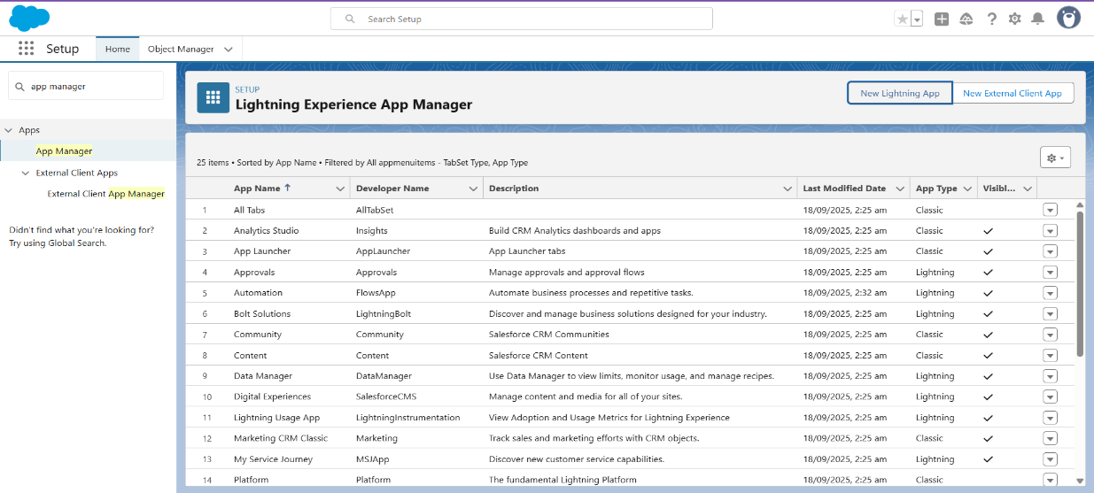

1. Step 3: Enter app details.

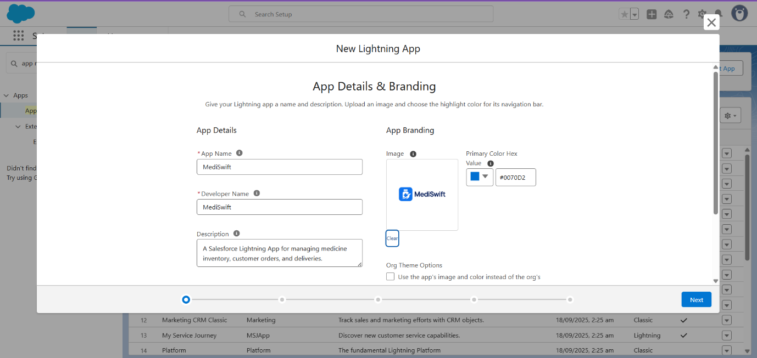

1. Step 4: Select Standard Navigation for CRM-like experience.

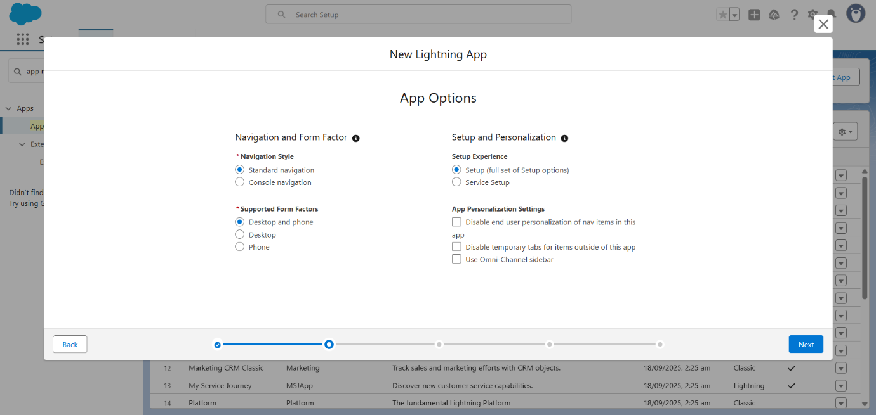

1. Step 5: Add standard objects like Accounts, Contacts, Products, Orders, Reports, Dashboards.

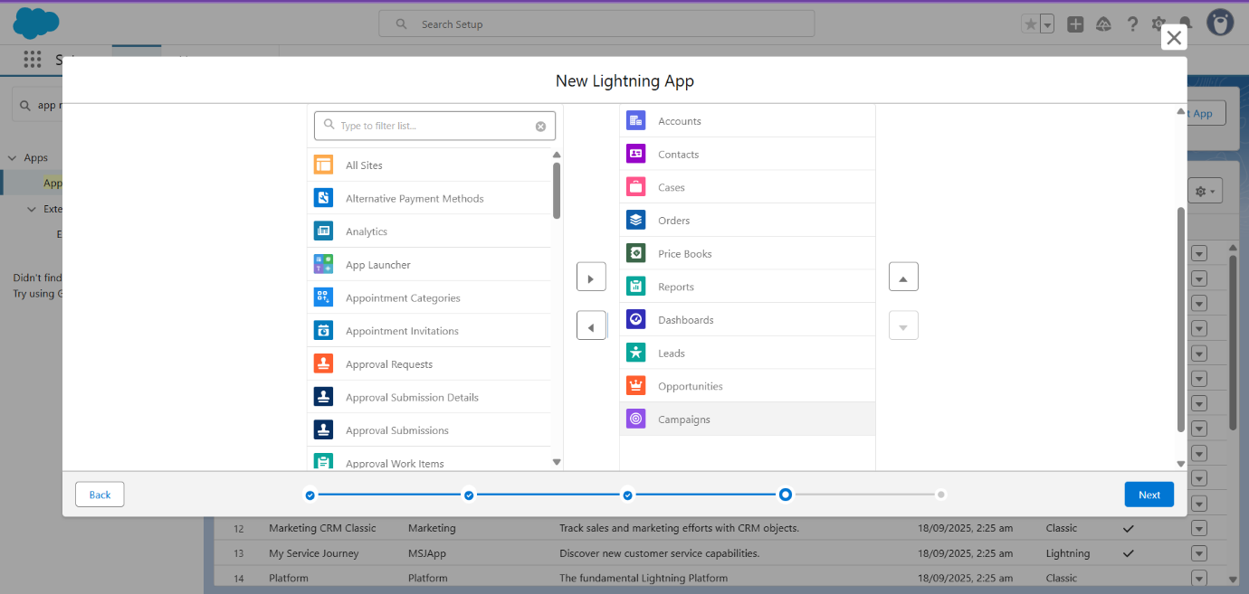

1. Step 6: Assign System Administrator profile for access.

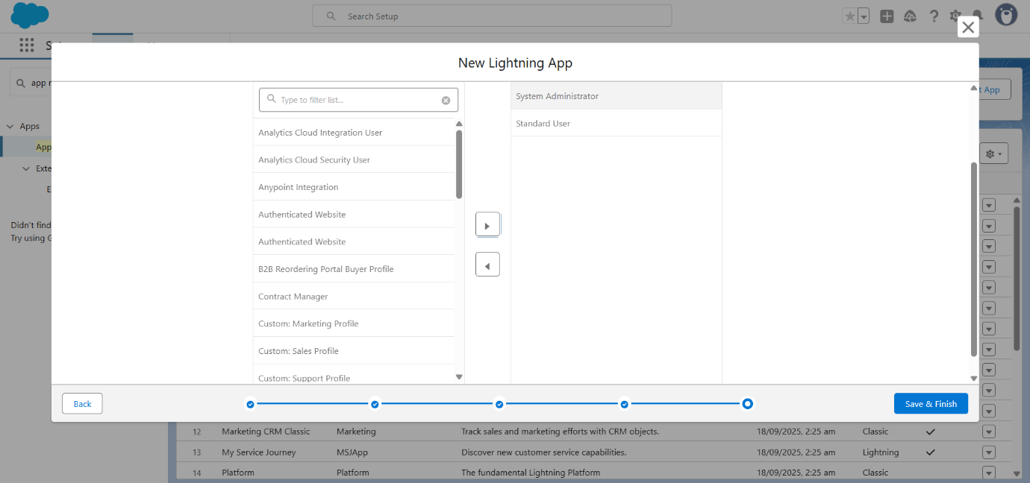

1. Step 6: click Save & Finish. Launch the app from App Launcher.

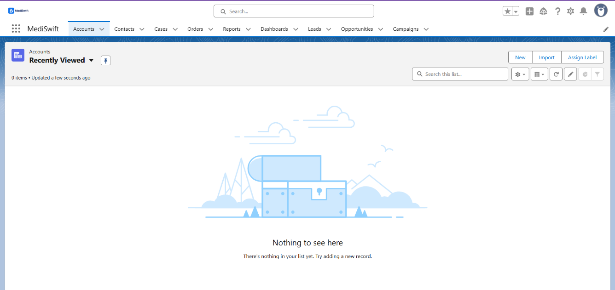

* **Company Profile Setup**

Objective: To configure the organization details in Salesforce to align with MediSwift’s business information.

Steps:

* Step 1: Go to Setup → Search for Company Information.
* Step 2: Click Edit on the Company Information page. Fill the following details.
* Organization Name: MediSwift
* Primary Contact: Apurva Dolas
* Street: Sai Nagar, Amravati
* City: Amravati
* Zip/Postal Code: 444607
* State/Province: Maharashtra
* Country: India
* Step 3: Set Locale Settings
* Default Locale: English (India)
* Default Language: English
* Default Time Zone: (GMT+05:30) India Standard Time
* Step 4: Set Currency Settings
* Currency Locale: English (India) – INR
* Step 5: Click **Save** to apply organization settings.

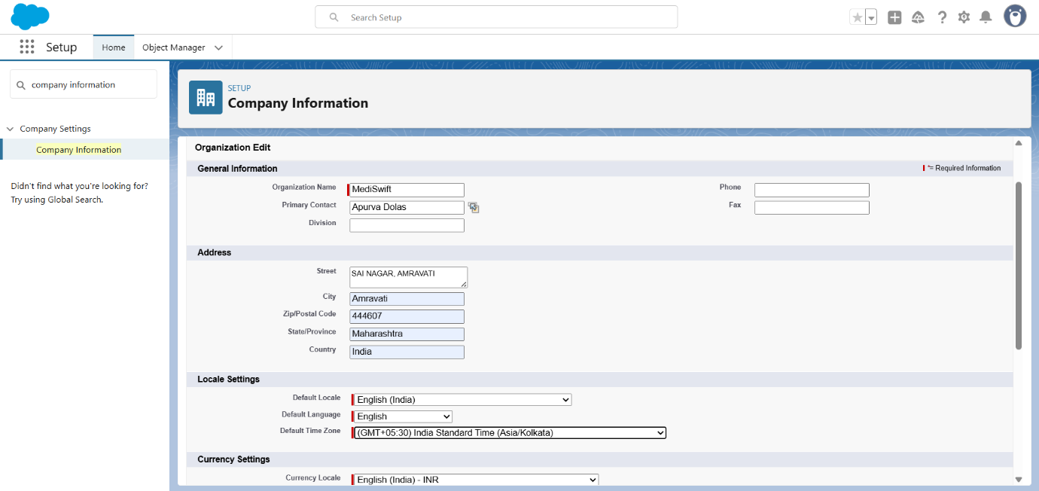

* **Business Hours and Holidays**

Objective: To configure MediSwift’s standard business hours and holidays in Salesforce.

Business Hours Setup:

* Step 1: Go to **Setup** → search for **Business Hours**.
* Step 2: Click **New Business Hours**.

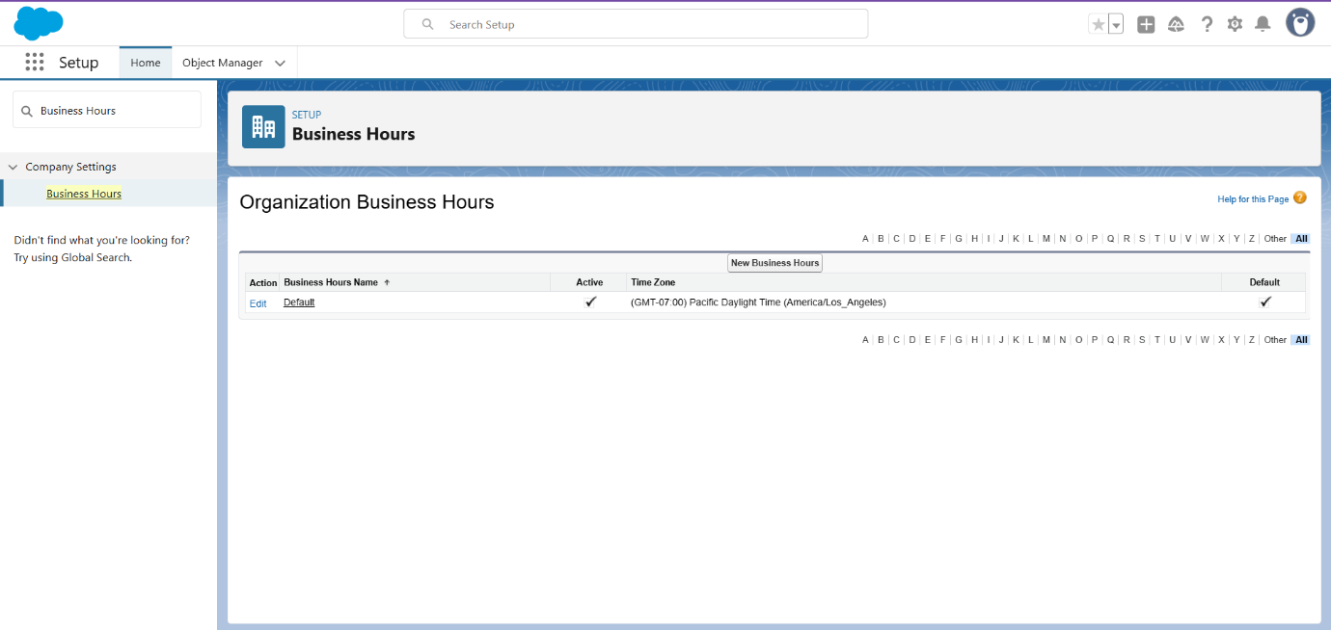

* Step 3: Fill in the details:
* Name: MediSwift Business Hours
* Default: ✔ (Check to make these default hours)
* Time Zone: (GMT+05:30) India Standard Time
* Business Days & Hours:
* Monday – Saturday: 09:00 AM to 09:00 PM
* Sunday: Close
* Step 4: Click Save.

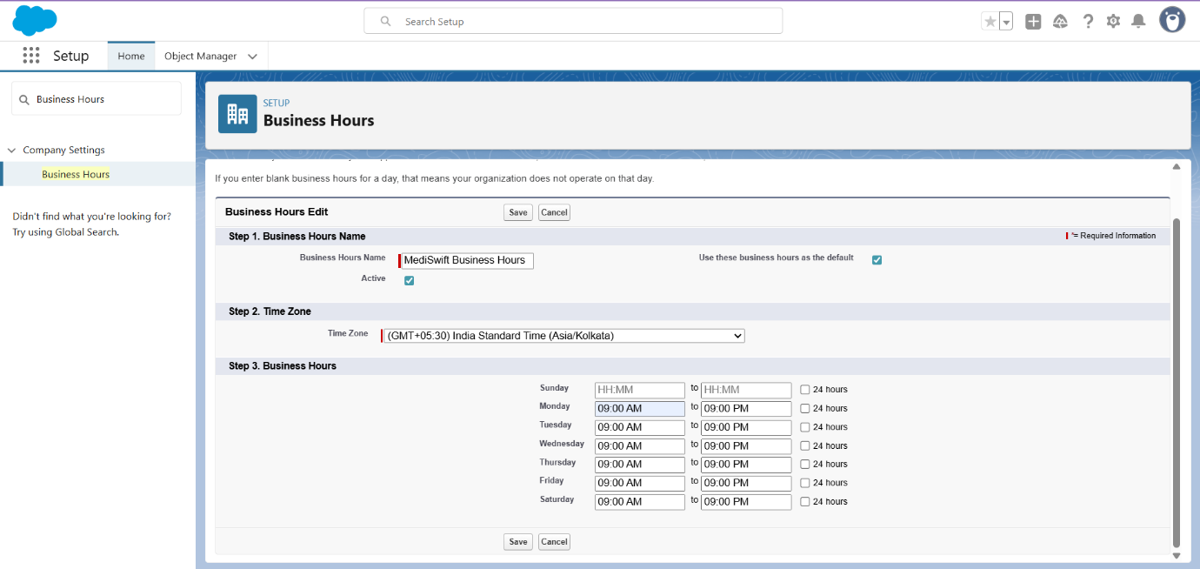

Holiday Setup:

* Step 1: Go to Setup → search for Holidays.
* Step 2: Click New Holiday

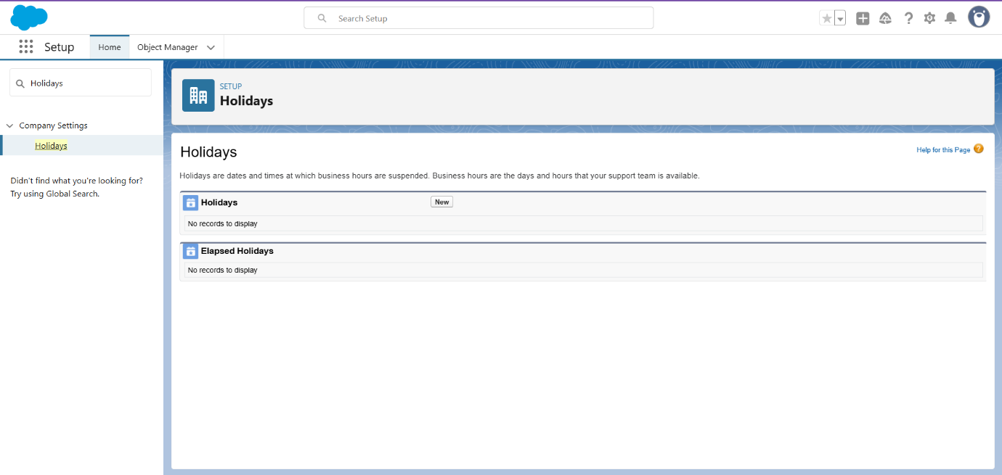

* Step 3: Enter details:
* Holiday Name: Diwali
* Date: 18/10/25
* Step 4: Repeat for all company holidays.
* Step 5: Click Save.

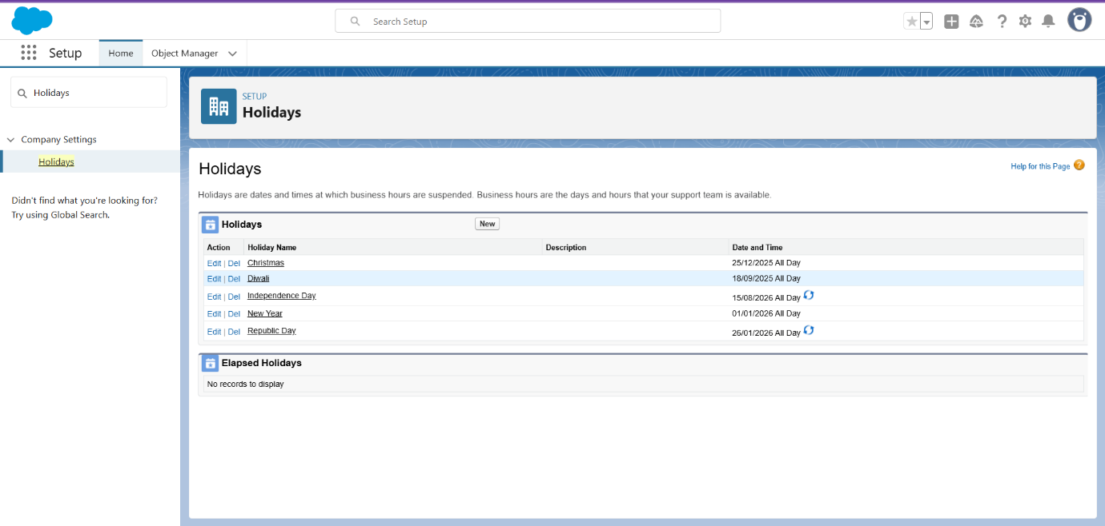

* **Fiscal Year Setting:**

Objective: To configure MediSwift’s fiscal year in Salesforce for accurate forecasting, reporting, and quota management.

Steps:

* Step 1: Go to Setup → search for Fiscal Year.
* Step 2: Select Standard Fiscal Year (recommended for most organizations).

(If a unique cycle is needed, select Custom Fiscal Year — but this is not required for MediSwift.)

* Step 3: Configure Fiscal Year Period
* Name: MediSwift
* Fiscal Year Start Month: January
* Fiscal Year is Based On: The Ending Month
* Step 4: Click Save to apply fiscal year settings.

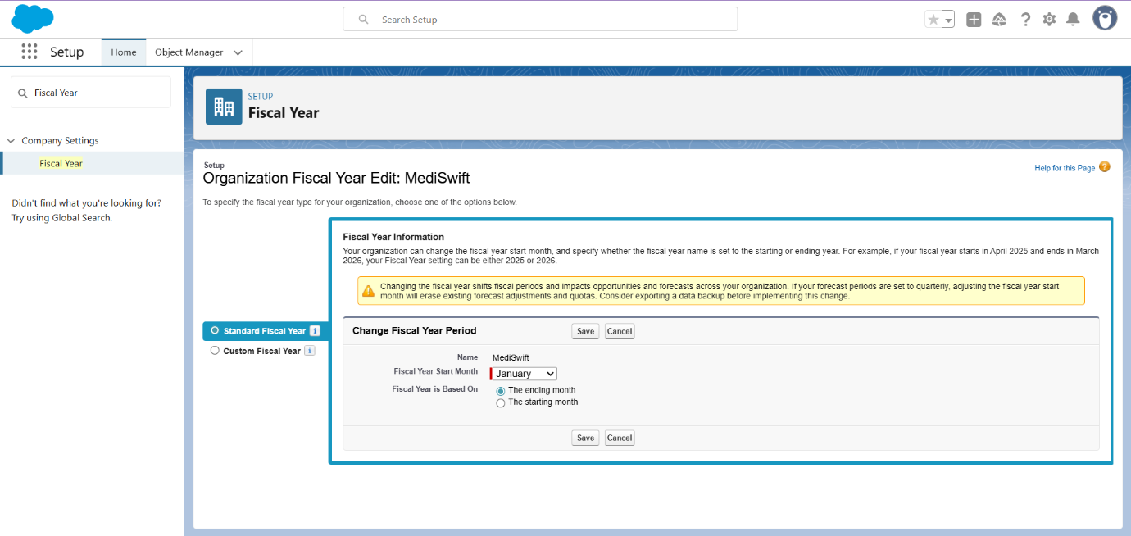

* **User Setup & Licenses**

Objective: To create dedicated Salesforce users for key MediSwift stakeholders to enable secure access and role-based functionality.

* Step 1: Go to **Setup** → search for **Users**.
* Step 2: Click **New User**.

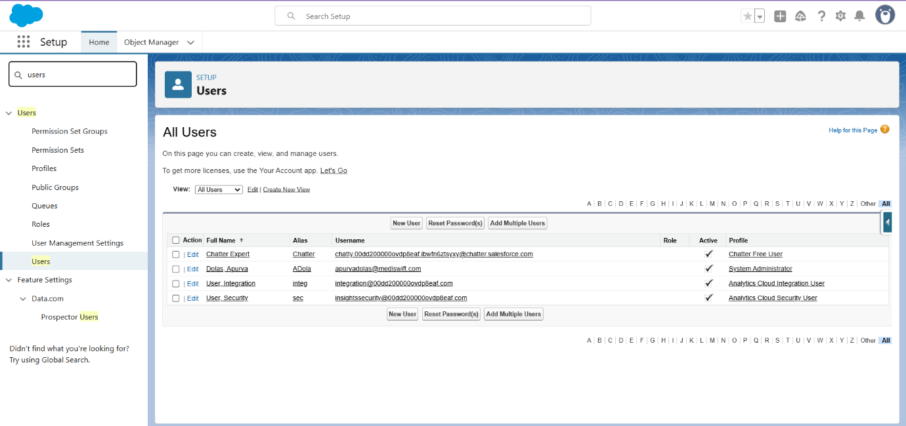

* Step 3: Create Users.
* Fill in First Name, Last Name, Email, Username, Alias, Nickname.
* Assign Salesforce Platform License
* Select appropriate Profile
* Set Active checkbox.

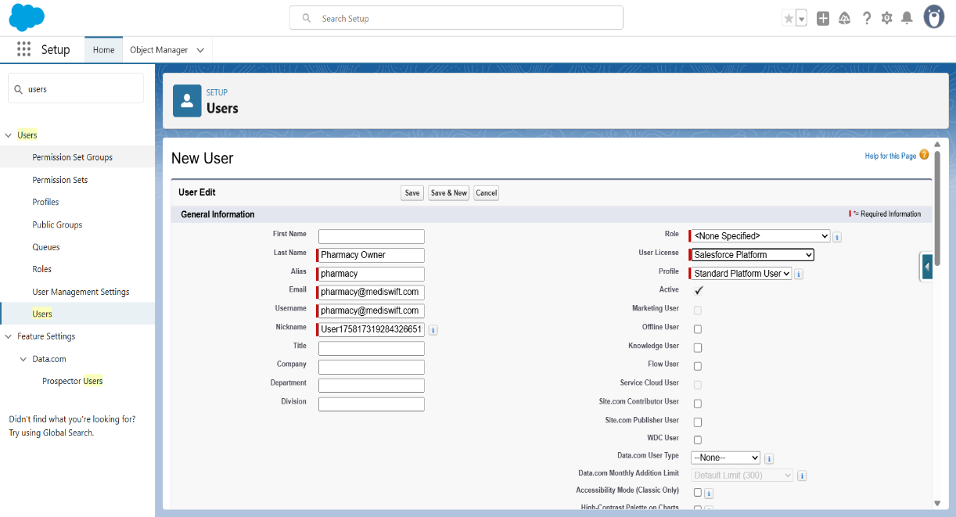

* Step 4: Save. Repeat the process for each stakeholder type.

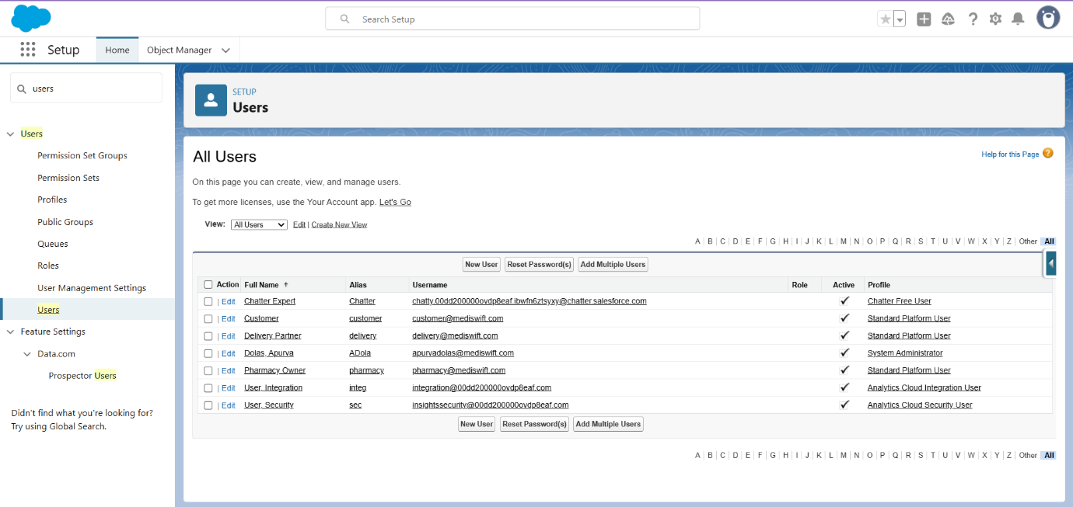

* **Profiles**

To control data access and permissions for different user types, three **custom profiles** were created by cloning the **Standard Platform User** profile. Each profile is tailored to match the responsibilities of the respective user group.

|  |  |
| --- | --- |
| **Profile Name** | **Purpose** |
| **Pharmacy Owner Profile** | For pharmacy owners and staff who manage inventory and fulfil customer orders. |
| **Delivery Partner Profile** | For delivery partners who pick up and deliver medicines. |
| **Customer Profile** | For end users (patients) placing medicine orders through the platform. |

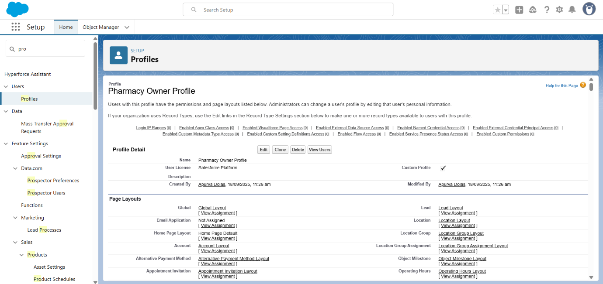

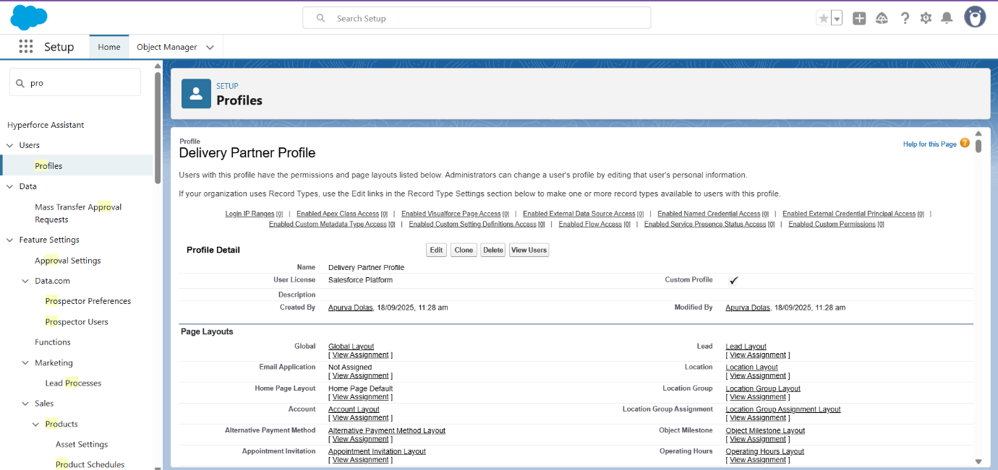

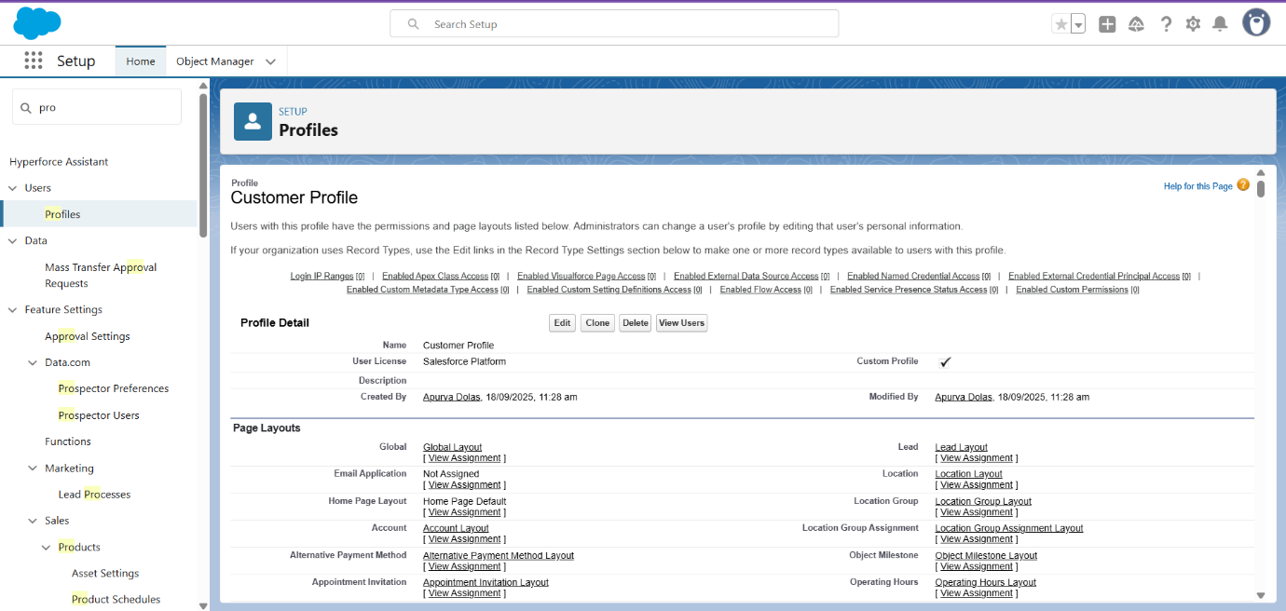

* **Roles**

Objectives: To define a role hierarchy in Salesforce that controls data visibility between users while supporting MediSwift’s business model.

Role Hierarchy Example:

MediSwift Admin

├── Pharmacy Owner Role

│ └── Delivery Partner Role

└── Customer Role