**Major- To pull Ubuntu image from Docker registry:**

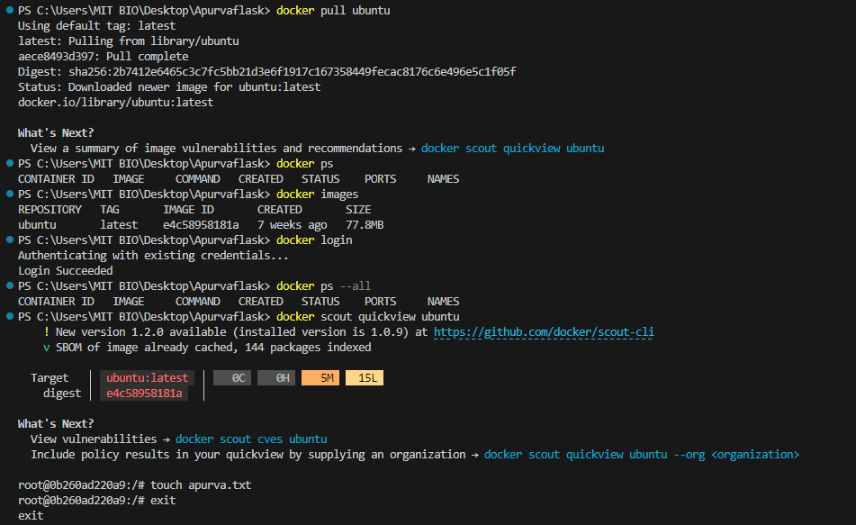

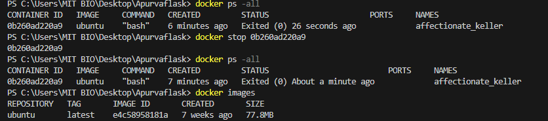

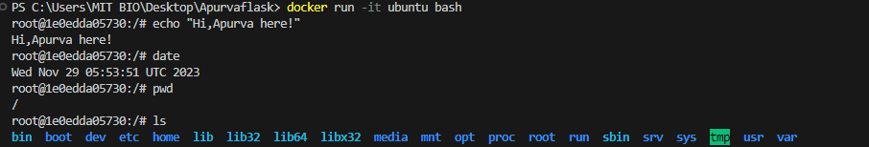

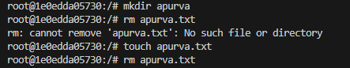





Docker desktop:

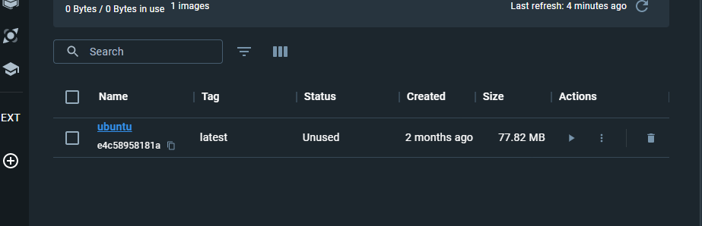

**Minor- FLASK minimal app:**

App python code:

#hello.py

from flask import Flask

app = Flask(__name__)

@app.route("/")

def hello_world():

    return "Hello, Apurva!"

app.run()

VS Code terminal:

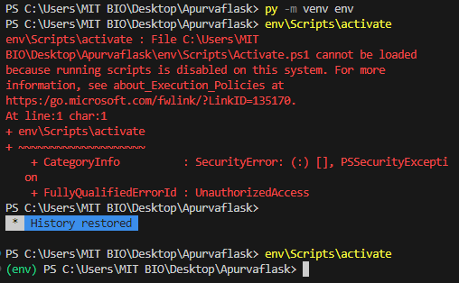

Activated through Windows PowerShell Administrator mode:

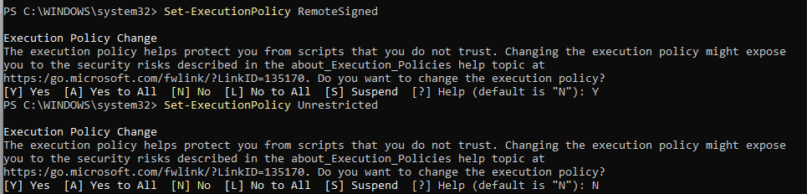

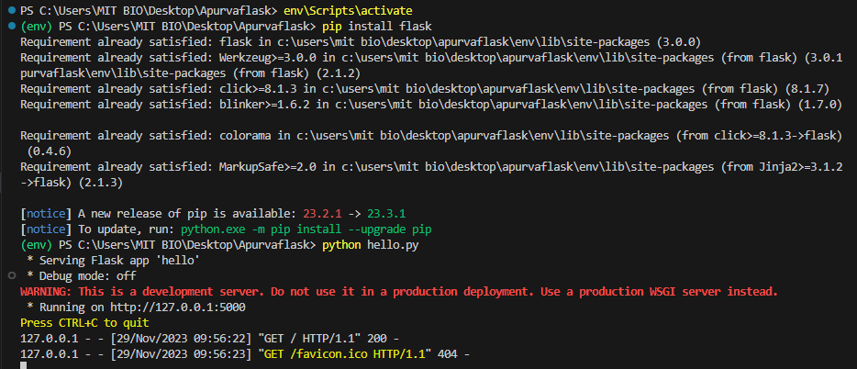

**Output:**

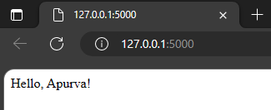

Port change:

