**LAB4_Part1**

Q1.

index.html

<!DOCTYPE html>

<html lang="en">

<head>

<title>Income Tax Calculator</title>

<link rel="stylesheet" href="style.css">

</head>

<body>

<div class="container">

<h1>Income Tax Calculator</h1>

<p>Revised Income tax slabs under new tax regime for FY 2023-24 (AY 2024-25)</p>

<table>

<tr>

<th>Income tax slabs under new tax regime</th>

<th>Income tax rates under new tax regime</th>

</tr>

<tr>

<td>0 to Rs 3 lakh</td>

<td>0%</td>

</tr>

<tr>

<td>Rs 3 lakh to Rs 6 lakh</td>

<td>5%</td>

</tr>

<tr>

<td>Rs 6 lakh to Rs 9 lakh</td>

<td>10%</td>

</tr>

<tr>

<td>Rs 9 lakh to Rs 12 lakh</td>

<td>15%</td>

</tr>

<tr>

<td>Rs 12 lakh to Rs 15 lakh</td>

<td>20%</td>

</tr>

<tr>

<td>Income above Rs 15 lakh</td>

<td>30%</td>

</tr>

</table>

<label for="income">Annual Income: New Slab</label>

<input type="number" id="income" placeholder="Enter your annual income">

<button onclick="calculateTax()">Calculate Tax</button>

<div id="result"></div>

</div>

<script src="script.js"></script>

</body>

</html>

**style.css**

body {

font-family: Arial, sans-serif;

background-color: #f8f8f8;

display: flex;

justify-content: center;

align-items: center;

height: 100vh;

margin: 0;

}

.container {

background-color: #ffffff;

padding: 20px;

border-radius: 10px;

box-shadow: 0 0 10px rgba(0, 0, 0, 0.1);

text-align: center;

}

h1 {

color: #0000FF; /* Blue color for the heading */

}

table {

width: 100%;

margin-bottom: 20px;

border-collapse: collapse;

}

th, td {

padding: 10px;

border: 1px solid #dddddd;

text-align: center;

}

.input-section {

margin-bottom: 20px;

}

input {

padding: 10px;

width: calc(100% - 22px);

margin-top: 10px;

border: 1px solid #dddddd;

border-radius: 5px;

}

button {

padding: 10px 20px;

background-color: #1a73e8;

color: #ffffff;

border: none;

border-radius: 5px;

cursor: pointer;

}

button:hover {

background-color: #155ab6;

}

#result {

margin-top: 20px;

font-size: 1.2em;

color: #333333;

}

**script.js**

function calculateTax() {

var income = document.getElementById('income').value;

var tax = 0;

if (income <= 300000) {

tax = 0;

} else if (income <= 600000) {

tax = (income - 300000) * 0.05;

} else if (income <= 900000) {

tax = (300000 * 0.05) + (income - 600000) * 0.10;

} else if (income <= 1200000) {

tax = (300000 * 0.05) + (300000 * 0.10) + (income - 900000) * 0.15;

} else if (income <= 1500000) {

tax = (300000 * 0.05) + (300000 * 0.10) + (300000 * 0.15) + (income - 1200000) * 0.20;

} else {

tax = (300000 * 0.05) + (300000 * 0.10) + (300000 * 0.15) + (300000 * 0.20) + (income - 1500000) * 0.30;

}

alert(`The income tax of an income of ${income} is: ${tax}`);

}

**Output:**

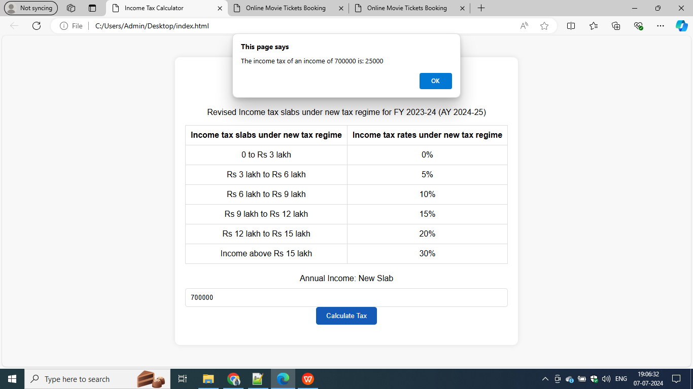

**Q2**

**index1.html**

<!DOCTYPE html>

<html lang="en">

<head>

<title>Online Movie Tickets Booking</title>

<link rel="stylesheet" href="styles1.css">

</head>

<body>

<h1>Online Movie Tickets Booking</h1>

<div class="movie-container">

<label>Pick a movie: </label>

<select id="movie">

<option value="120">Animal (Rs120)</option>

<option value="150">Pathaan (Rs150)</option>

<option value="100">Pushpa (Rs100)</option>

<option value="200">KGF (Rs200)</option>

</select>

</div>

<ul class="showcase">

<li>

<div class="seat"></div>

<small>N/A</small>

</li>

<li>

<div class="seat selected"></div>

<small>Selected</small>

</li>

<li>

<div class="seat occupied"></div>

<small>Occupied</small>

</li>

</ul>

<div class="container">

<div class="screen"></div>

<div class="row">

<div class="seat"></div>

<div class="seat"></div>

<div class="seat"></div>

<div class="seat"></div>

<div class="seat"></div>

<div class="seat"></div>

<div class="seat"></div>

<div class="seat"></div>

</div>

<div class="row">

<div class="seat"></div>

<div class="seat"></div>

<div class="seat"></div>

<div class="seat"></div>

<div class="seat"></div>

<div class="seat"></div>

<div class="seat"></div>

<div class="seat"></div>

</div>

<div class="row">

<div class="seat"></div>

<div class="seat"></div>

<div class="seat"></div>

<div class="seat"></div>

<div class="seat"></div>

<div class="seat"></div>

<div class="seat"></div>

<div class="seat"></div>

</div>

<div class="row">

<div class="seat"></div>

<div class="seat"></div>

<div class="seat"></div>

<div class="seat"></div>

<div class="seat"></div>

<div class="seat"></div>

<div class="seat"></div>

<div class="seat"></div>

</div>

</div>

<p class="text">

You have selected <span id="count">0</span> seats for a price of Rs<span id="total">0</span>

</p>

<script src="scripts.js"></script>

</body>

</html>

**style1.css**

body {

font-family: 'Arial', sans-serif;

background-color: #1c1b29;

margin: 0;

padding: 0;

color: #fff;

display: flex;

flex-direction: column;

align-items: center;

justify-content: center;

height: 100vh;

}

h1 {

margin: 20px 0;

font-size: 24px;

color: #e8a87c;

}

.movie-container {

margin-bottom: 20px;

}

.movie-container select {

background-color: #fff;

border: 0;

border-radius: 5px;

font-size: 14px;

margin-left: 10px;

padding: 5px 15px;

appearance: none;

}

.showcase {

display: flex;

justify-content: center;

list-style-type: none;

background: rgba(0, 0, 0, 0.1);

padding: 5px 10px;

border-radius: 5px;

color: #777;

width: 80%;

margin-bottom: 20px;

}

.showcase li {

display: flex;

align-items: center;

justify-content: center;

margin: 0 5px;

}

.showcase .seat {

display: inline-block;

width: 18px; /* Updated width */

height: 18px; /* Updated height */

background-color: #444451;

margin-right: 5px;

border-radius: 5px;

}

.showcase .seat.selected {

background-color: #6feaf6;

}

.showcase .seat.occupied {

background-color: #fff;

}

.container {

perspective: 1000px;

margin-bottom: 20px;

}

.container .screen {

background-color: #fff;

height: 70px;

width: 100%;

margin: 15px 0;

transform: rotateX(-45deg);

box-shadow: 0 3px 10px rgba(255, 255, 255, 0.7);

}

.row {

display: flex;

justify-content: center;

}

.seat {

background-color: #444451;

height: 25px;

width: 30px;

margin: 5px;

border-radius: 5px;

cursor: pointer;

transition: 0.3s;

}

.seat.selected {

background-color: #6feaf6;

}

.seat.occupied {

background-color: #fff;

cursor: not-allowed;

}

.seat:not(.occupied):hover {

background-color: #555;

}

.text {

margin-top: 20px;

font-size: 16px;

}

script.js

const container = document.querySelector('.container');

const seats = document.querySelectorAll('.row .seat:not(.occupied)');

const count = document.getElementById('count');

const total = document.getElementById('total');

const movieSelect = document.getElementById('movie');

populateUI();

let ticketPrice = +movieSelect.value;

function setMovieData(movieIndex, moviePrice) {

localStorage.setItem('selectedMovieIndex', movieIndex);

localStorage.setItem('selectedMoviePrice', moviePrice);

}

function updateSelectedCountAndTotal() {

const selectedSeats = document.querySelectorAll('.row .seat.selected');

const seatsIndex = [...selectedSeats].map(seat => [...seats].indexOf(seat));

localStorage.setItem('selectedSeats', JSON.stringify(seatsIndex));

const selectedSeatsCount = selectedSeats.length;

count.innerText = selectedSeatsCount;

total.innerText = selectedSeatsCount * ticketPrice;

}

function populateUI() {

const selectedSeats = JSON.parse(localStorage.getItem('selectedSeats'));

if (selectedSeats !== null && selectedSeats.length > 0) {

seats.forEach((seat, index) => {

if (selectedSeats.indexOf(index) > -1) {

seat.classList.add('selected');

}

});

}

const selectedMovieIndex = localStorage.getItem('selectedMovieIndex');

if (selectedMovieIndex !== null) {

movieSelect.selectedIndex = selectedMovieIndex;

}

}

movieSelect.addEventListener('change', e => {

ticketPrice = +e.target.value;

setMovieData(e.target.selectedIndex, e.target.value);

updateSelectedCountAndTotal();

});

container.addEventListener('click', e => {

if (

e.target.classList.contains('seat') &&

!e.target.classList.contains('occupied')

) {

e.target.classList.toggle('selected');

updateSelectedCountAndTotal();

}

});

updateSelectedCountAndTotal();

**Output:**

