**LAB4_Part2**

**Q1**

**index2.html**

<!DOCTYPE html>

<html lang="en">

<head>

<title>Photo Gallery</title>

<link rel="stylesheet" href="styles.css">

</head>

<body>

<div class="container">

<h1>Photo Gallery</h1>

<button id="loadImagesBtn">Load Random Images</button>

<div class="gallery" id="gallery"></div>

</div>

<script src="script.js"></script>

</body>

</html>

**style2.css**

body {

font-family: Arial, sans-serif;

display: flex;

justify-content: center;

align-items: center;

height: 100vh;

margin: 0;

background-color: #f4f4f4;

}

.container {

width: 90%;

max-width: 1200px;

text-align: center;

}

h1 {

margin-bottom: 20px;

}

button {

padding: 10px 20px;

font-size: 16px;

cursor: pointer;

}

.gallery {

display: grid;

grid-template-columns: repeat(6, 1fr);

grid-template-rows: repeat(3, 1fr);

gap: 20px;

margin-top: 20px;

}

.card {

border-radius: 8px;

overflow: hidden;

box-shadow: 0 4px 8px rgba(0, 0, 0, 0.1);

transition: transform 0.3s;

width: 100%;

height: 200px;

}

.card img {

width: 100%;

height: 100%;

object-fit: cover;

display: block;

}

.card:hover {

transform: translateY(-5px);

}

**script2.js**

document.getElementById('loadImagesBtn').addEventListener('click', loadImages);

function loadImages() {

fetch('https://api.unsplash.com/photos/random?count=18&client_id=Mz68OKWKXa7RSkRSW2kHeW9963Aa6D9FyF3EMhIraL8')

.then(response => response.json())

.then(data => {

const gallery = document.getElementById('gallery');

gallery.innerHTML = '';

data.forEach(image => {

const card = document.createElement('div');

card.classList.add('card');

const img = document.createElement('img');

img.src = image.urls.small;

card.appendChild(img);

gallery.appendChild(card);

});

})

.catch(error => console.error('Error fetching images:', error));

}

**Output:**

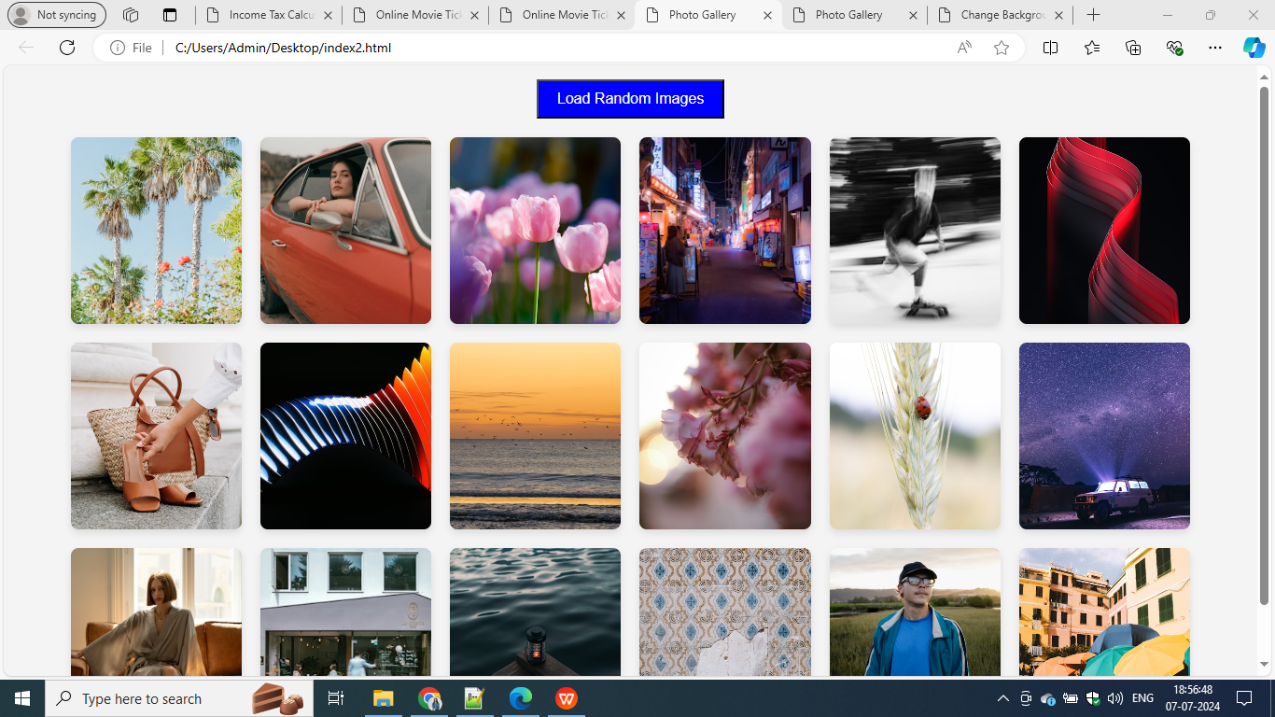

**Q2**

**index3.html**

<!DOCTYPE html>

<html lang="en">

<head>

<title>Change Background Color</title>

<link rel="stylesheet" href="styles1.css">

</head>

<body>

<h1>Change Background Color</h1>

<button id="colorButton">Click Me</button>

<script src="script1.js"></script>

</body>

</html>

**style3.css**

body {

text-align: center;

background-color: #D87093;

font-family: Arial, sans-serif;

}

h1 {

margin-top: 20%;

font-size: 2em;

color: black;

}

button {

padding: 10px 20px;

font-size: 1em;

cursor: pointer;

}

**script3.js**

document.getElementById('colorButton').addEventListener('click', function() {

const randomColor = '#' + Math.floor(Math.random()*16777215).toString(16);

document.body.style.backgroundColor = randomColor;

});

**Output :**

