Title: Analysis of Schema – Contoso Sales
Schema Type: Star Schema
The Contoso Sales data model follows a Star Schema. The Sales table acts as the central fact table, while Calendar, Channel, Geography, Product, Promotion, and Stores act as dimension tables. ProductSubcategory and ProductCategory provide additional product-level information. The tables are connected through relationships, allowing sales to be analyzed by different dimensions such as date, product, store, channel, geography, and promotion.

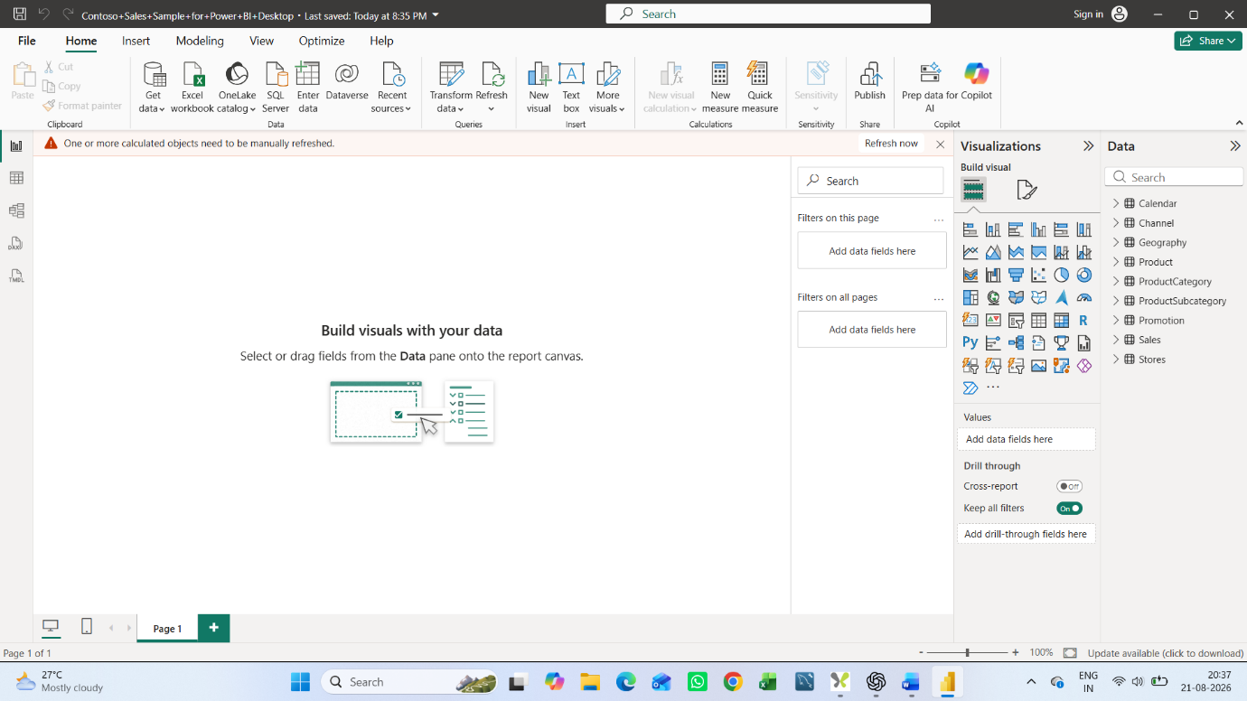

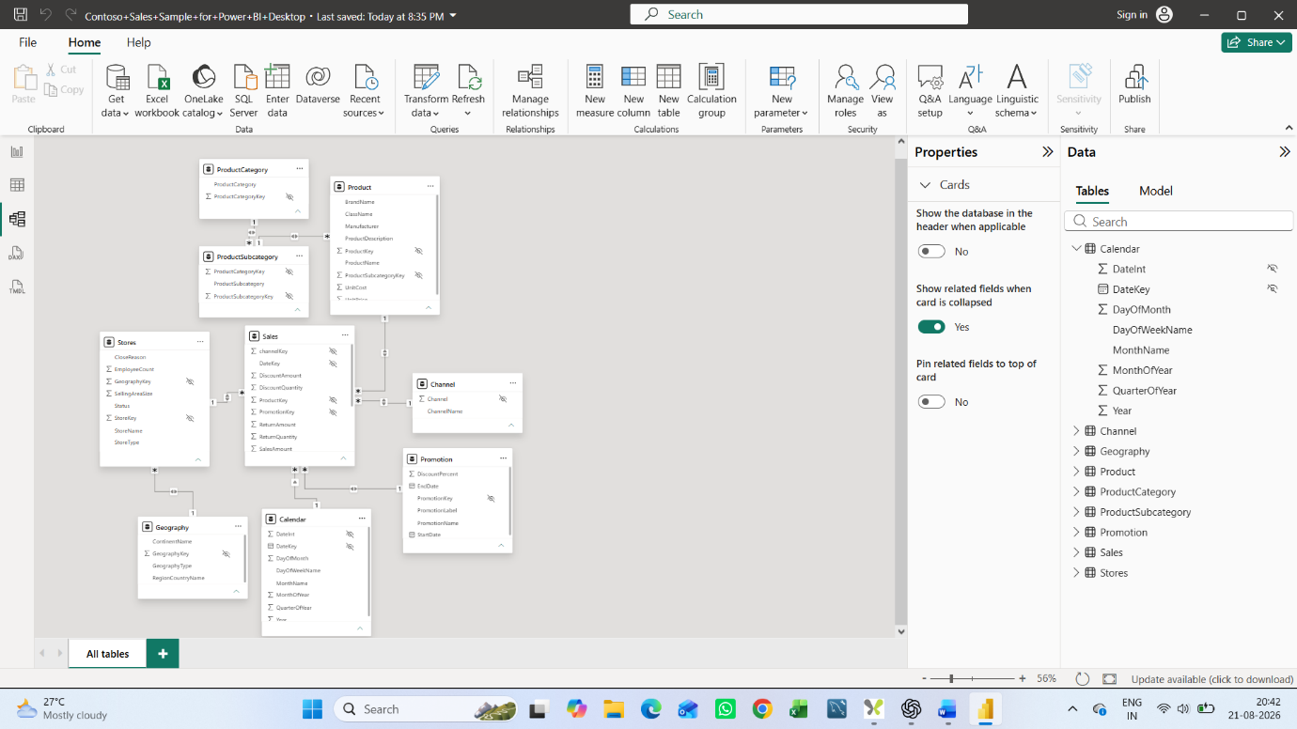
Fact Table: Sales
Dimension Tables: Calendar, Channel, Geography, Product, ProductCategory, ProductSubcategory, Promotion, Stores.

