**Practical No. 5A**

**To design and develop web pages using HTML fundamental and formatting elements**

Name: Apurva Ashwinkumar Patil.

PRN: 2018BTECS00052

**Problem Statement:**

Design a static web page using HTML for Computer Science Department information access it locally and in LAN using web server.

It should have following sections:

1. Only one <h1> tag
2. At least one <h2> to <h6> tag
3. At least one <p> tag
4. HTML5 semantic tags
5. At least one anchor tag
6. At least one <br> tag
7. At least one <img> tag
8. At least one comment tag

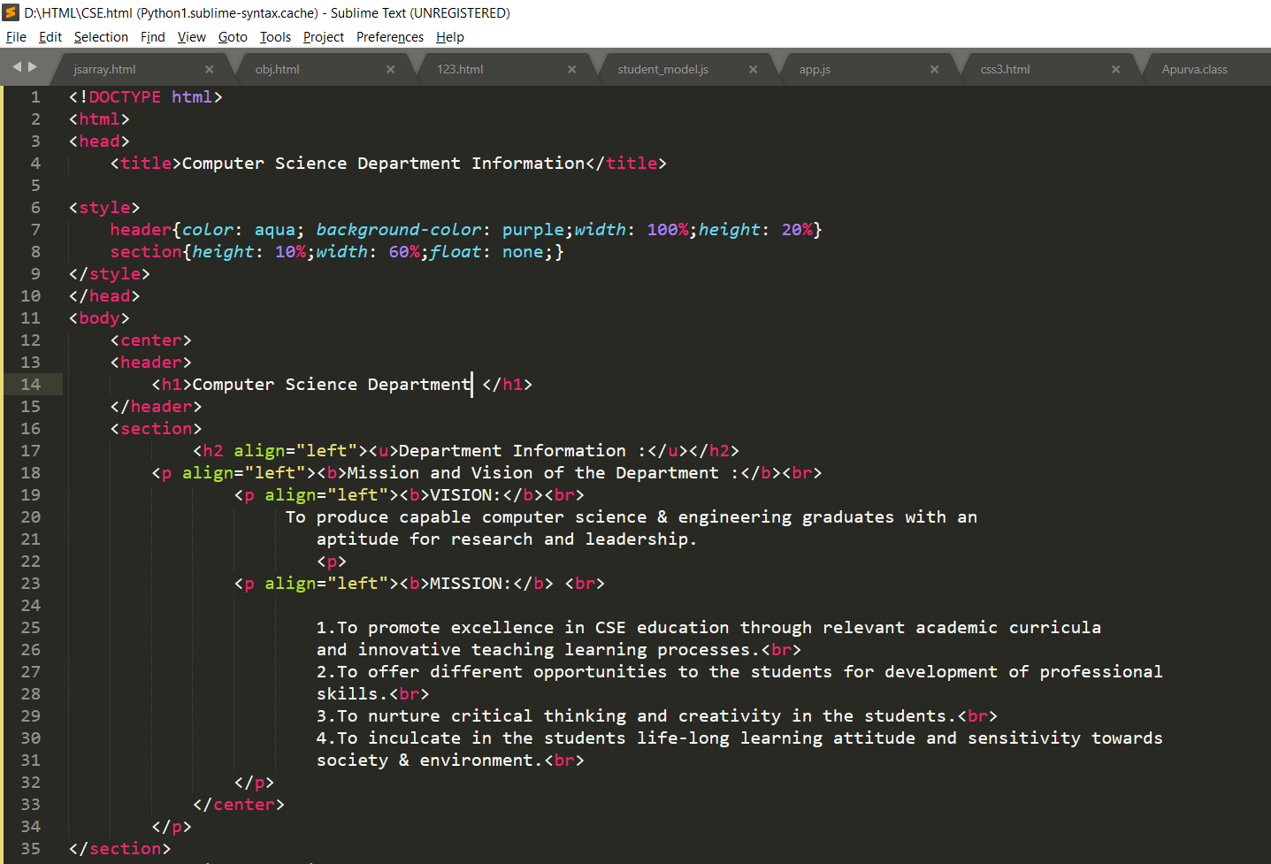

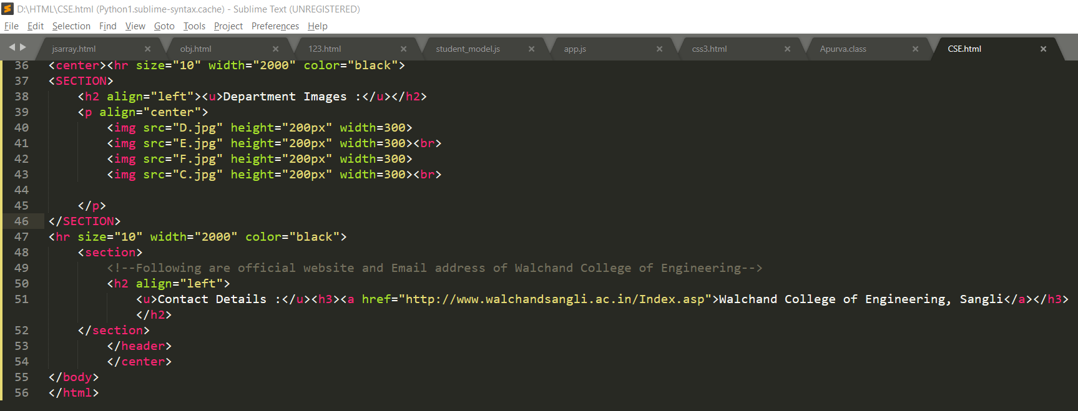

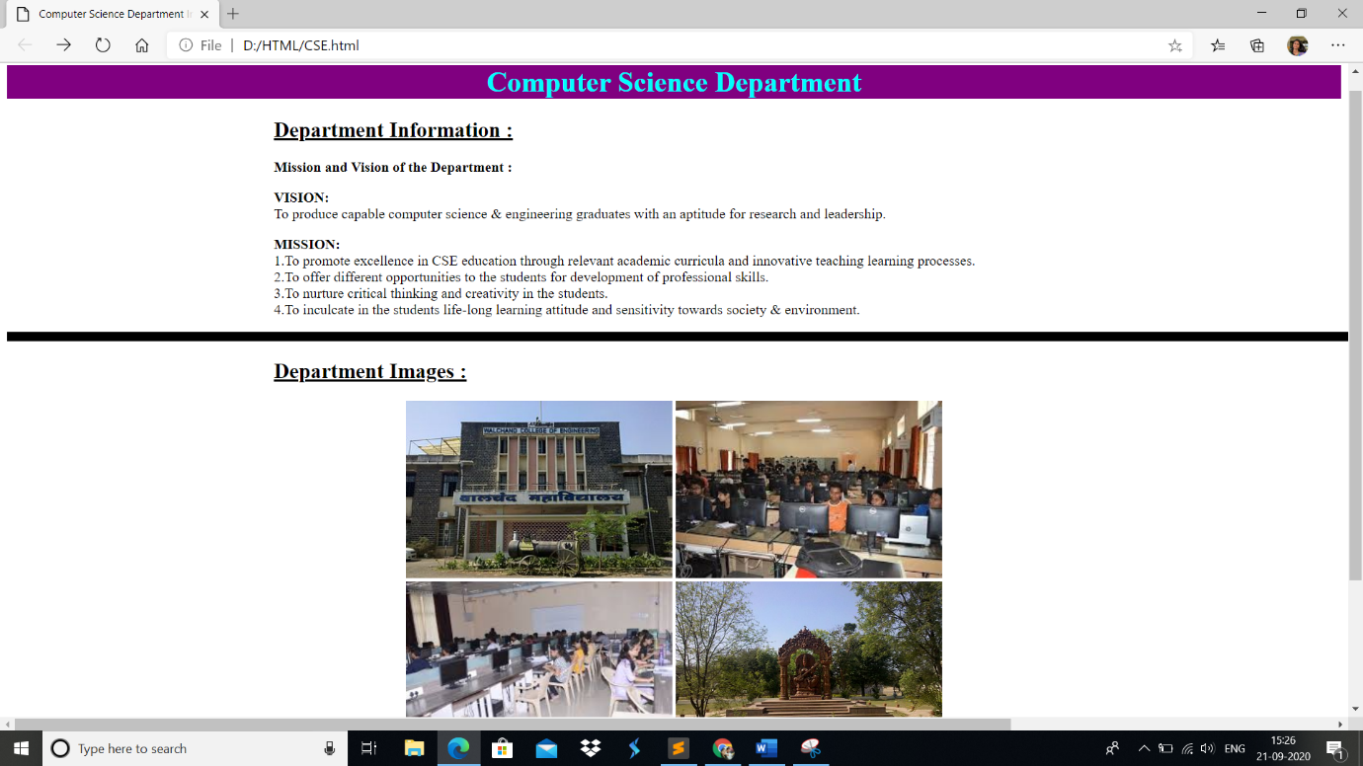



**Accessing web page locally: -**

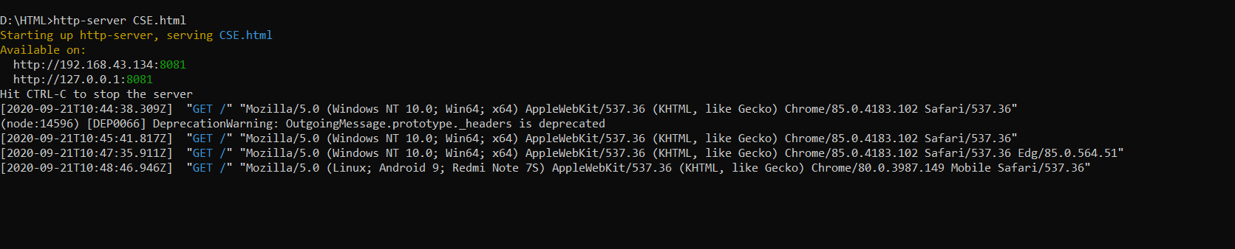

**Web page available on: -**

[**http://192.168.43.134:8081**](http://192.168.43.134:8081)

[**http://127.0.0.1:8081**](http://127.0.0.1:8081)

**GitHub’s Public Repository: -**

[**https://github.com/apurvapatil2000/Programming-Lab.git**](https://github.com/apurvapatil2000/Programming-Lab.git)