Exersice13
- Develop an inventory manager script that stores item names as keys and their current stock counts as values. The system should update the stock count when a sale occurs and print a warning if stock drops to zero.

inventory = {
"Pen": 10,
"Book": 5,
"Pencil": 3
}
item = input("Enter item sold: ")
quantity = int(input("Enter quantity sold: "))
if item in inventory:
inventory[item] -= quantity
if inventory[item] == 0:
print("Warning: Stock is zero!")
elif inventory[item] < 0:
print("Not enough stock!")
inventory[item] += quantity
else:
print("Remaining stock:", inventory[item])
else:
print("Item not found.")
print("Inventory:", inventory)
Output:
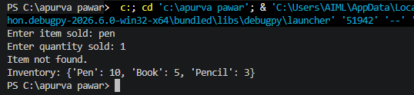

- Create a student contact database that maps student roll numbers to email addresses, allowing administrators to look up contact info instantly by entering a roll ID.
Code:
students = {
101: "student1@gmail.com",
102: "student2@gmail.com",
103: "student3@gmail.com"
}
roll = int(input("Enter roll number: "))
if roll in students:
print("Email:", students[roll])
else:
print("Student not found.")
Output: