Practical no.2
Code:
print("****grocery shop billing calculator")
rice_qty = float(input("enter qty of rice (in kg):"))
rice_price_per_kg = 50
rice_total = rice_qty * rice_price_per_kg

sugar_qty = float(input("enter qty of sugar (in kg):"))
sugar_price_per_kg = 40
sugar_total = sugar_qty * sugar_price_per_kg

dal_qty = float(input("enter qty of dal (in kg):"))
dal_price_per_kg = 30
dal_total = dal_qty * dal_price_per_kg

print("***bill details***")
print("rice :",rice_total)
print("sugar :",sugar_total)
print("dal :",dal_total)

total_bill = sugar_total + rice_total + dal_total
print("total bill :",total_bill)

discount = 0
if total_bill >=1000:
print("discount:",discount)
discount = total_bill * 0.10

elif total_bill >= 500:

discount = total_bill * 0.05
print("discount:",discount)

else:
print("No discount")
final_bill = total_bill - discount
print("final bill:",final_bill)
Output: 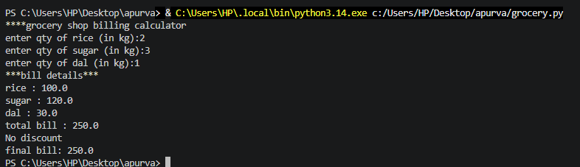

Exercise
Que1: develop a program that accept a student’s marks for three different subject .calculate their total and average , and print a final scorecard with the rounded to two decimal places
Code:
name = (input("enter student name"))
s1 = float(input("enter subject 1 marks :"))
s2 = float(input("enter subject 2 marks:"))
s3 = float(input("enter subject 3 marks :"))

subject = s1 + s2 +s3
average = subject/3

print("_____student score card______")
print("student name:",name)
print("subject1:",s1)
print("subject2:",s2)
print("subject3:",s3)
print("total marks:",subject)
print("average marks:",average)

Output:
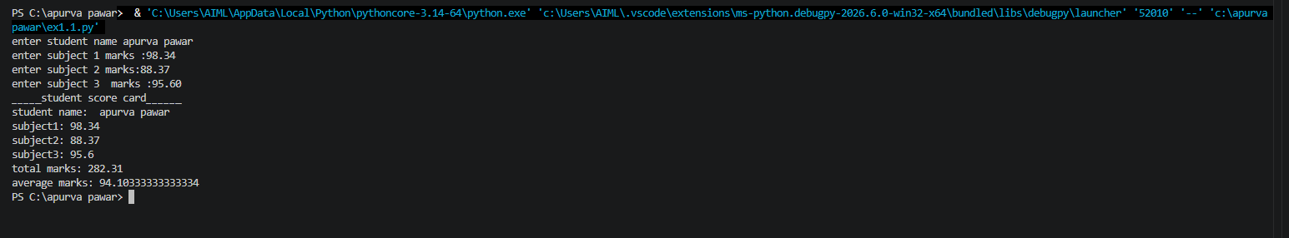

Que 2 : create a simple profile generator that takes an employee name role and monthly salary and prints out a formatted text-based employee identity card.

Code:
name = (input("enter employee name:"))
role = (input("enter emplyee role:"))
salary = int(input("enter emplyee salary:"))

print("____emplyee salary card____")
print("emplyee name",name)
print("emplyee role",role)
print("emplyee salary:",salary)
output:
