Practical NO.3
Code:
print("=========College Admission Eligibility=========")

age =int(input("Enter your age: "))
marks=float(input("Enter your marks: "))
if age>=18 and age <=25:
print("You are eligible for college admission")
if marks>=60:
print("You are eligible for college admission based on marks")
if marks>=85:
print("You are eligible for admission AIML")
elif marks>=75:
print("You are eligible for admission in CSE")
else:
print("You are eligible for other courses")
else:
print("You are not eligible for college admission due to marks")
else:
print("You are not eligible for admission due to your age")
Output:
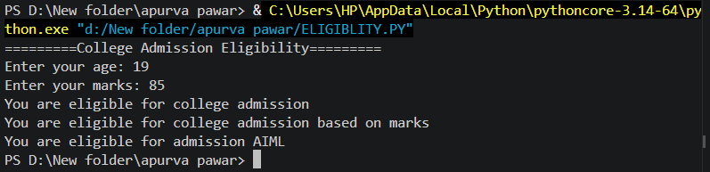

Exercise
Q.01 Develop a screening program that checks a user's age and income status to see if they qualify for a specialized education scholarship scheme. The rules state that the applicant must be under 25 years old and have an annual family income below ₹3,00,000.
Code:
name=input("Enter your name :")
age= int(input("Enter your age :"))
income=float(input("Enter your income :"))
cast=input("Enter your cast ( sc/st/nt/obc):")
if age < 25 and income < 300000 and cast in ["sc","st","nt","obc"]:
print("congratulation! .You are qualified for education scolarship scheme. ")
else:
print("You are not qualified for education scolarship scheme. ")
Output: 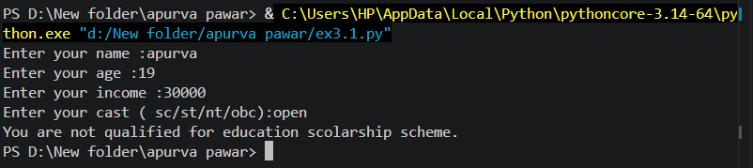

Q02 : Q.02 Create a system validator that evaluates a candidate's placement eligibility by verifying they have a graduation score of 70% or more and no active academic backlogs.

Code:

score=float(input("Enter your scores :"))
backlogs=int(input("Enter your backlogs :"))

if score >= 70 and backlogs == 0:
print("The candidate is eligible for placement ")
else:
print("The candidate is not eligible for placement ")
output: 