**Report: Predicting earthquake prone area in a given location**

A swarm is a large number of homogenous, simple agents interacting locally among themselves, and their environment, with no central control to allow a global interesting behaviour to emerge. These agents (insects or swarm individuals) are relatively unsophisticated with limited capabilities on their own, they are interacting together with certain behavioural patterns to cooperatively achieve tasks necessary for their survival. The social interactions among swarm individuals can be either direct or indirect. The agents follow very simple rules, and although there is no centralized control structure dictating how individual agents should behave, local, and to a certain degree random, interactions between such agents lead to the [emergence](https://en.wikipedia.org/wiki/Emergence) of "intelligent" global behavior, unknown to the individual agents. Swarm Intelligence algorithms in several optimization tasks and research problems. Swarm Intelligence principles have been successfully applied in a variety of problem domains including function optimization problems, finding optimal routes, scheduling, structural optimization. Here this concept is used to perform predictions.

The objective of this project is to find an earthquake prone area in a particular region. A group of agents are randomly allocated in a given area. All the agents know about their position in the space and the value of cost function at that position. The probability values are evaluated by the cost function and each agent has velocities which direct the movement of the agents. The agents move through the problem space by following the current optimum agents. Thus we get the area with optimum value.

Cost function is decided on the basis of factors that can cause earthquake. The earth’s crust is divided into large plates that continually move over, under, alongside or apart from one another atop the partly molten outer layer of the earth’s core. When the pressure to move becomes stronger than the friction holding them together, adjoining blocks of crust can suddenly slip, rupturing the fault and creating an earthquake.

Some of the factors affecting earthquake are:

* **Temperature** - At high temperature molecules and their bonds can stretch and move, thus materials will behave in more ductile manner. At low Temperature, materials are brittle.
* **Confining Pressure** - At high confining pressure materials are less likely to fracture because the pressure of the surroundings tends to hinder the formation of fractures. At low confining stress, material will be brittle and tend to fracture sooner.
* **Strain rate** - Strain rate refers to the rate at which the deformation occurs (strain divided by time). At high strain rates material tends to fracture. At low strain rates more time is available for individual atoms to move and therefore ductile behavior is favored.

Particles are randomly allocated in the problem space. The local best is calculated by comparing the value of cost function of each particle. In the first iteration this value is assigned to the global best variable also. The velocity of the particles is updated according to the global best value of the cost function and the velocity generation function. The location of the particles is further updated on the basis of this newly generated velocity. Thus the particles start to converse towards the particle with the highest value of cost function. After certain iterations, all the articles converse towards the particle with highest value. Thus we get the optimal solution. Screenshots of the problem space are attached below:

Initial position of the particles

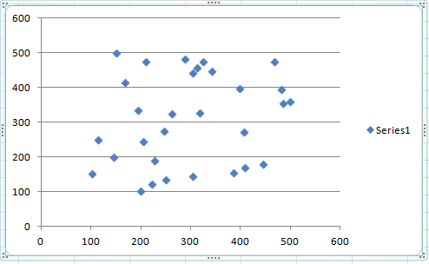

After 100 iterations

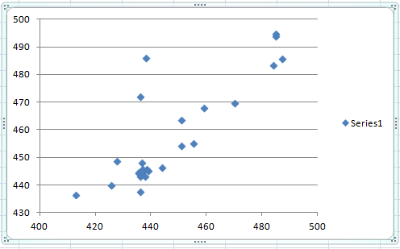

After 300

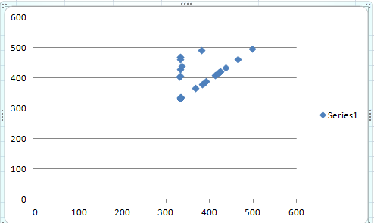

After 400

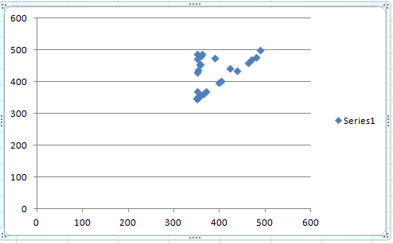

After 500

