Top_song_analysis.R

Apurva Sarode

2020-04-16

library(readr)  
library(dplyr)

library(ggplot2)

library(ggridges)

library(highcharter)

library(plyr)

library(lubridate)

library(fmsb)  
library(gridExtra)

library(cmna)

library(tidyselect)  
library(factoextra)

library(psych)

library(gvlma)  
library(MASS)

library(NbClust)  
library(GGally)

library(car)

#---------------------Data Preparation-------------------------------#

top10s <- read.csv("C:\\Users\\Apurva Sarode\\Desktop\\Spotify_mva.csv",header = TRUE)  
View(top10s)  
Data <- top10s

#-----------------------Data Cleaning--------------------------------#  
#finding missing data  
dim(Data)

## [1] 603 15

any(Data$bpm==0)

## [1] TRUE

any(Data$pop==0)

## [1] TRUE

Data = filter(Data, bpm != 0)  
Data = filter(Data, pop != 0)  
dim(Data)

## [1] 598 15

#reordering columns  
Data <- Data[,c(1,2,3,4,5,6,12,7,8,9,10,11,13,14,15)]  
View(Data)  
  
#speechiness also include podcast and speeches  
#For songs speechiness will be low and inaccurate, hence removing spch  
Data$spch <- NULL  
#Liveness includes lives shows which are also inaccurate to test songs  
#in a recording studio, Hence removing live  
Data$live <- NULL  
  
#Renaming columns to a more readable format  
colnames(Data)[4] <- "Genre"  
colnames(Data)[7] <- "Duration"  
colnames(Data)[8] <- "Energy"  
colnames(Data)[9] <- "Dancebility"  
colnames(Data)[10] <- "Loudness"  
colnames(Data)[11] <- "Valence"  
colnames(Data)[12] <- "Acoustiveness"  
colnames(Data)[13] <- "Popularity"  
  
  
#Normalizing Loudness  
x = Data$Loudness  
normalized = (x-min(x))/(max(x)-min(x))  
loud = normalized * 100  
rounded_loud = round(loud, digits=0)  
Data$Loudness = rounded_loud  
  
#Creating the Dependannt Variable Rating based on the popularity given by Spotify  
y = Data$Popularity  
shapiro.test(y)

##   
## Shapiro-Wilk normality test  
##   
## data: y  
## W = 0.94946, p-value = 1.984e-13

qqnorm(y)  
qqline(y, col=2)

#we dont see normal distribution hence we cannot split the data in quartiles equally  
#Instead we divide by average  
mean(y)

## [1] 67.07692

max(y)

## [1] 99

Rating <- cut(y, breaks = c(0,67,99),  
 labels = c("Below Average", "Above Average"),   
 right = FALSE, include.lowest = TRUE)  
Data['Rating'] <- Rating  
View(Data)  
  
summary(Data)

## X title   
## Min. : 1.0 A Little Party Never Killed Nobody (All We Got): 2   
## 1st Qu.:152.2 All I Ask : 2   
## Median :302.5 Castle Walls (feat. Christina Aguilera) : 2   
## Mean :302.4 Company : 2   
## 3rd Qu.:453.8 First Time : 2   
## Max. :603.0 Here : 2   
## (Other) :586   
## artist Genre year bpm   
## Katy Perry : 17 dance pop :324 Min. :2010 Min. : 43.0   
## Justin Bieber: 16 pop : 60 1st Qu.:2013 1st Qu.:100.0   
## Maroon 5 : 15 canadian pop : 34 Median :2015 Median :120.0   
## Rihanna : 15 barbadian pop: 15 Mean :2015 Mean :118.7   
## Lady Gaga : 14 boy band : 15 3rd Qu.:2017 3rd Qu.:129.0   
## Bruno Mars : 13 electropop : 13 Max. :2019 Max. :206.0   
## (Other) :508 (Other) :137   
## Duration Energy Dancebility Loudness   
## Min. :134.0 Min. : 4.00 Min. :23.00 Min. : 0.00   
## 1st Qu.:202.0 1st Qu.:61.00 1st Qu.:57.00 1st Qu.: 69.00   
## Median :220.5 Median :74.00 Median :66.00 Median : 77.00   
## Mean :224.7 Mean :70.59 Mean :64.53 Mean : 73.23   
## 3rd Qu.:239.0 3rd Qu.:82.00 3rd Qu.:73.75 3rd Qu.: 85.00   
## Max. :424.0 Max. :98.00 Max. :97.00 Max. :100.00   
##   
## Valence Acoustiveness Popularity Rating   
## Min. : 4.00 Min. : 0.0 Min. : 7.00 Below Average:245   
## 1st Qu.:35.00 1st Qu.: 2.0 1st Qu.:60.00 Above Average:353   
## Median :52.00 Median : 6.0 Median :69.00   
## Mean :52.34 Mean :14.4 Mean :67.08   
## 3rd Qu.:69.00 3rd Qu.:17.0 3rd Qu.:76.00   
## Max. :98.00 Max. :99.0 Max. :99.00   
##

#----------------------Exploratory Data Analysis---------------------#

#Exploring Genres  
gen = count(Data$Genre)  
gen_dsc = gen[order(-gen$freq),]  
gen10 = gen_dsc[1:10,]  
barplot(gen10$freq, names.arg = gen10$x,main = 'Top 10 Genres',xlab = 'Genre',ylab = 'No. of songs')

years1 = Data[Data$year == c(2010),4:5]  
gen1 = count(years1$Genre)  
gen1 = gen1[order(-gen1$freq),]  
  
years2 = Data[Data$year == c(2011),4:5]  
gen2 = count(years2$Genre)  
gen2 = gen2[order(-gen2$freq),]  
  
years3 = Data[Data$year == c(2012),4:5]  
gen3 = count(years3$Genre)  
gen3 = gen3[order(-gen3$freq),]  
  
years4 = Data[Data$year == c(2013),4:5]  
gen4 = count(years4$Genre)  
gen4 = gen4[order(-gen4$freq),]  
  
years5 = Data[Data$year == c(2014),4:5]  
gen5 = count(years5$Genre)  
gen5 = gen5[order(-gen5$freq),]  
  
years6 = Data[Data$year == c(2015),4:5]  
gen6 = count(years6$Genre)  
gen6 = gen6[order(-gen6$freq),]  
  
years7 = Data[Data$year == c(2016),4:5]  
gen7 = count(years7$Genre)  
gen7 = gen7[order(-gen7$freq),]  
  
years8 = Data[Data$year == c(2017),4:5]  
gen8 = count(years8$Genre)  
gen8 = gen8[order(-gen8$freq),]  
  
years9 = Data[Data$year == c(2018),4:5]  
gen9 = count(years9$Genre)  
gen9 = gen9[order(-gen9$freq),]  
  
years10 = Data[Data$year == c(2019),4:5]  
gen10 = count(years10$Genre)  
gen10 = gen10[order(-gen10$freq),]  
  
plot1 <- ggplot(gen1, aes(x="", y=gen1$freq, fill=gen1$x)) +  
 geom_bar(stat="identity", width=1) +  
 coord_polar("y", start=0) +  
 theme_void() + scale_fill_discrete(name = "Top Genre of 2010")  
  
plot2 <- ggplot(gen2, aes(x="", y=gen2$freq, fill=gen2$x)) +  
 geom_bar(stat="identity", width=1) +  
 coord_polar("y", start=0) +  
 theme_void() + scale_fill_discrete(name = "Top Genre of 2011")  
  
plot3 <- ggplot(gen3, aes(x="", y=gen3$freq, fill=gen3$x)) +  
 geom_bar(stat="identity", width=1) +  
 coord_polar("y", start=0) +  
 theme_void() + scale_fill_discrete(name = "Top Genre of 2012")  
  
plot4 <- ggplot(gen4, aes(x="", y=gen4$freq, fill=gen4$x)) +  
 geom_bar(stat="identity", width=1) +  
 coord_polar("y", start=0) +  
 theme_void() + scale_fill_discrete(name = "Top Genre of 2013")  
  
plot5 <- ggplot(gen5, aes(x="", y=gen5$freq, fill=gen5$x)) +  
 geom_bar(stat="identity", width=1) +  
 coord_polar("y", start=0) +  
 theme_void() + scale_fill_discrete(name = "Top Genre of 2014")  
  
plot6 <- ggplot(gen6, aes(x="", y=gen6$freq, fill=gen6$x)) +  
 geom_bar(stat="identity", width=1) +  
 coord_polar("y", start=0) +  
 theme_void() + scale_fill_discrete(name = "Top Genre of 2015")  
  
plot7 <- ggplot(gen7, aes(x="", y=gen7$freq, fill=gen7$x)) +  
 geom_bar(stat="identity", width=1) +  
 coord_polar("y", start=0) +  
 theme_void() + scale_fill_discrete(name = "Top Genre of 2016")  
  
plot8 <- ggplot(gen8, aes(x="", y=gen8$freq, fill=gen8$x)) +  
 geom_bar(stat="identity", width=1) +  
 coord_polar("y", start=0) +  
 theme_void() + scale_fill_discrete(name = "Top Genre of 2017")  
  
plot9 <- ggplot(gen9, aes(x="", y=gen9$freq, fill=gen9$x)) +  
 geom_bar(stat="identity", width=1) +  
 coord_polar("y", start=0) +  
 theme_void() + scale_fill_discrete(name = "Top Genre of 2018")  
  
plot10 <- ggplot(gen10, aes(x="", y=gen10$freq, fill=gen10$x)) +  
 geom_bar(stat="identity", width=1) +  
 coord_polar("y", start=0) +  
 theme_void() + scale_fill_discrete(name = "Top Genre of 2019")  
  
grid.arrange(plot1, plot2,plot3,plot4,plot5 ,ncol=5)

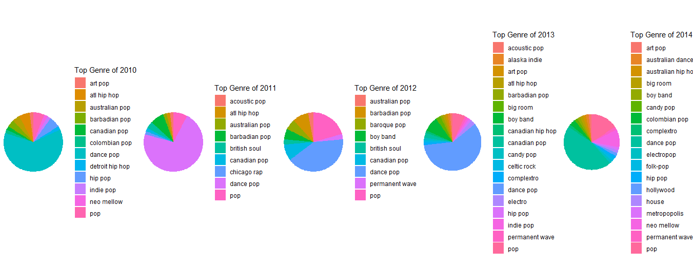

grid.arrange(plot6,plot7,plot8,plot9,plot10 ,ncol=5)

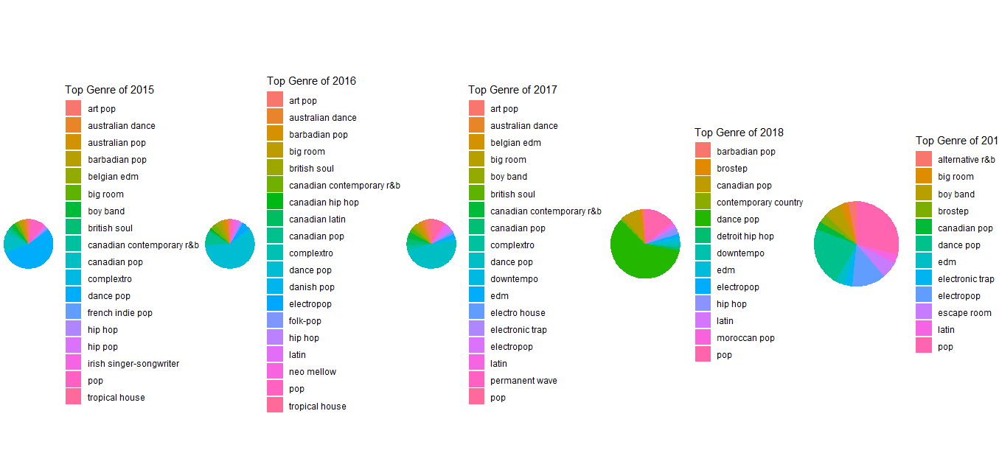

#Checking if there is a optimal duration for a song  
dur_data = Data[,c(1,2,7,13,14)]  
durmin = round(dur_data$Duration/60, digits=1)  
dur_data$Duration<- durmin #minute(period)  
dur_data

## X  
## 1 1  
## 2 2  
## 3 3  
## 4 4  
## 5 5  
## 6 6  
## 7 7  
## 8 8  
## 9 9  
## 10 10  
## 11 11  
## 12 12  
## 13 13  
## 14 14  
## 15 15  
## 16 16  
## 17 17  
## 18 18  
## 19 19  
## 20 20  
## 21 21  
## 22 22  
## 23 23  
title  
## 1 Hey, Soul Sister  
## 2 Love The Way You Lie  
## 3 TiK ToK  
## 4 Bad Romance  
## 5 Just the Way You Are  
## 6 Baby  
## 7 Dynamite  
## 8 Secrets  
## 9 Empire State of Mind (Part II) Broken Down  
## 10 Only Girl (In The World)  
## 11 Club Can't Handle Me (feat. David Guetta)  
## 12 Marry You  
## 13 Cooler Than Me - Single Mix  
## 14 Telephone  
## 15 Like A G6  
## 16 OMG (feat. will.i.am)  
## 17 Eenie Meenie  
## 18 The Time (Dirty Bit)  
## 19 Alejandro  
## 20 Your Love Is My Drug  
## 21 Meet Me Halfway  
## 22 Whataya Want from Me  
## 23 Kills You Slowly  
## Duration Popularity Rating  
## 1 3.6 83 Above Average  
## 2 4.4 82 Above Average  
## 3 3.3 80 Above Average  
## 4 4.9 79 Above Average  
## 5 3.7 78 Above Average  
## 6 3.6 77 Above Average  
## 7 3.4 77 Above Average  
## 8 3.8 77 Above Average  
## 9 3.6 76 Above Average  
## 10 3.9 73 Above Average  
## 11 3.9 73 Above Average  
## 12 3.8 73 Above Average  
## 13 3.5 73 Above Average  
## 14 3.7 73 Above Average  
## 15 3.6 72 Above Average  
## 16 4.5 72 Above Average  
## 17 3.4 71 Above Average  
## 18 5.1 70 Above Average  
## 19 4.6 69 Above Average  
## 20 3.1 69 Above Average  
## 21 4.7 68 Above Average  
## 22 3.8 66 Below Average  
## 23 3.6 66 Below Average  
## 24 3.6 65 Below Average  
## 25 4.0 65 Below Average  
## 26 3.5 65 Below Average  
## 27 3.4 64 Below Average  
## 28 3.8 63 Below Average  
## 29 3.8 63 Below Average  
## 30 3.9 62 Below Average  
## 31 3.5 62 Below Average  
## 32 3.2 62 Below Average  
## 33 2.9 62 Below Average  
## 34 4.3 62 Below Average  
## 35 4.2 62 Below Average  
## 36 3.3 61 Below Average  
## 37 4.4 61 Below Average  
## 38 3.8 59 Below Average  
## 39 4.5 59 Below Average  
## 40 4.2 58 Below Average  
## 41 3.1 58 Below Average  
## 42 4.5 57 Below Average  
## 43 4.2 57 Below Average  
## 44 3.2 56 Below Average

ggplot(dur_data, aes(x=dur_data$Duration, y=dur_data$Popularity,color=dur_data$Rating)) +  
 geom_point()+ labs(y = 'Popularity', x = "Duration in mins", title = "Duration vs popularity and Rating")

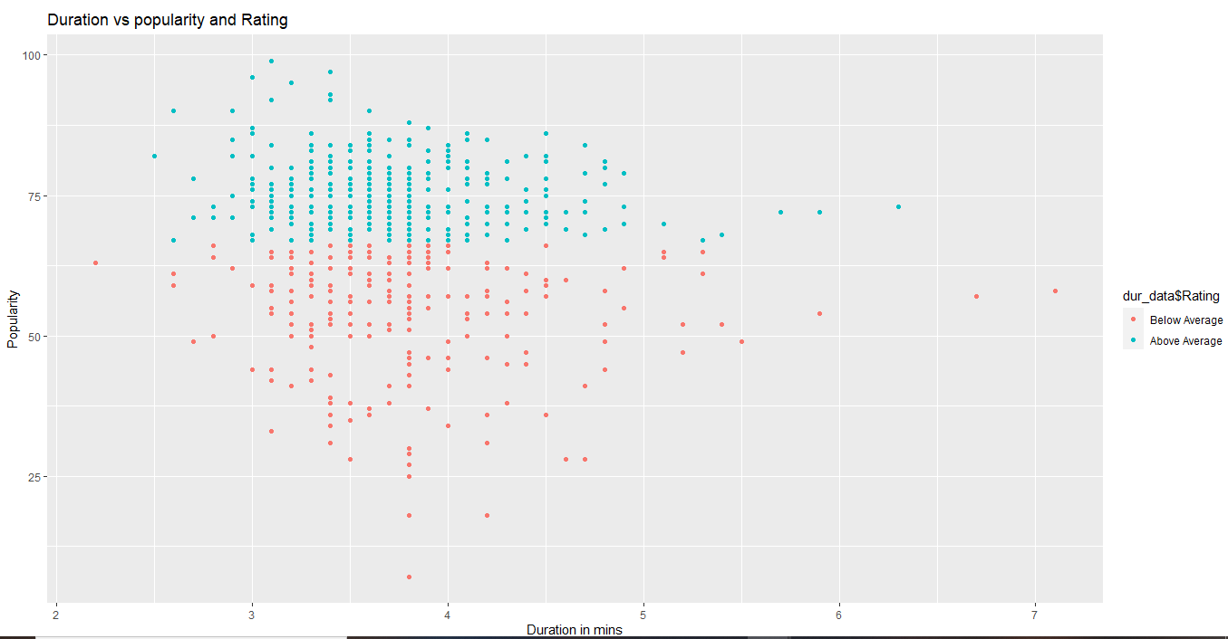

props = Data[,c(8:13)]  
  
nrow(props)

## [1] 598

colMeans(props)

## Energy Dancebility Loudness Valence Acoustiveness   
## 70.58863 64.52676 73.23244 52.33946 14.39632   
## Popularity   
## 67.07692

var(props)

## Energy Dancebility Loudness Valence Acoustiveness  
## Energy 256.21910 28.37283 138.353736 143.687619 -193.319104  
## Dancebility 28.37283 172.98337 22.193938 146.175994 -69.080136  
## Loudness 138.35374 22.19394 171.455093 100.537378 -95.835994  
## Valence 143.68762 146.17599 100.537378 504.412209 -118.667426  
## Acoustiveness -193.31910 -69.08014 -95.835994 -118.667426 433.331779  
## Popularity -19.44066 12.85388 4.353949 5.183224 3.440149  
## Popularity  
## Energy -19.440665  
## Dancebility 12.853885  
## Loudness 4.353949  
## Valence 5.183224  
## Acoustiveness 3.440149  
## Popularity 175.159902

density_data <- data.frame(  
 name=c("Energy","Dancebility","Loudness",  
 "Valence","Acoustiveness","Popularity"),  
 value=c( rnorm(598, 70, 256), rnorm(598, 64, 172), rnorm(598, 73, 171),  
 rnorm(598, 52, 504), rnorm(598, 14, 433), rnorm(598,67,175))  
)  
  
ggplot(density_data, aes(x = value, y = name, fill = name)) +  
 geom_density_ridges() +  
 theme_ridges() +   
 theme(legend.position = "none")

## Picking joint bandwidth of 60.8

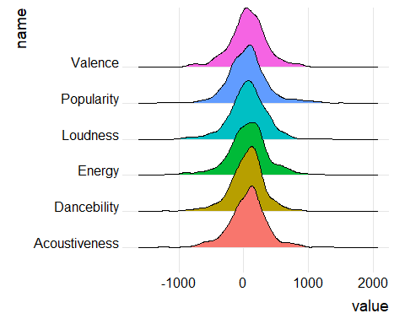

ggplot(density_data, aes(x=value, fill=name)) +  
 geom_histogram( color="#e9ecef", alpha=0.6, position = 'identity',bins=15) +  
 labs(fill="") + facet_wrap(~name)

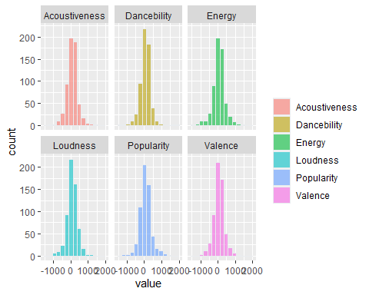

#------------------Statistical Testing-------------------------------#

Data_num = Data[,6:13]  
Corr_mat = cor(Data_num)  
Corr_mat

## bpm Duration Energy Dancebility Loudness  
## bpm 1.000000000 -0.02078528 0.10794891 -0.17258993 0.05654377  
## Duration -0.020785282 1.00000000 -0.14955130 -0.18096389 -0.17058486  
## Energy 0.107948905 -0.14955130 1.00000000 0.13477048 0.66010032  
## Dancebility -0.172589927 -0.18096389 0.13477048 1.00000000 0.12887153  
## Loudness 0.056543770 -0.17058486 0.66010032 0.12887153 1.00000000  
## Valence 0.003892528 -0.26790249 0.39968772 0.49485856 0.34186887  
## Acoustiveness -0.117685930 0.09020716 -0.58017466 -0.25231364 -0.35159540  
## Popularity -0.000492410 -0.11296345 -0.09176731 0.07384394 0.02512412  
## Valence Acoustiveness Popularity  
## bpm 0.003892528 -0.11768593 -0.00049241  
## Duration -0.267902487 0.09020716 -0.11296345  
## Energy 0.399687717 -0.58017466 -0.09176731  
## Dancebility 0.494858557 -0.25231364 0.07384394  
## Loudness 0.341868875 -0.35159540 0.02512412  
## Valence 1.000000000 -0.25382153 0.01743772  
## Acoustiveness -0.253821529 1.00000000 0.01248676  
## Popularity 0.017437725 0.01248676 1.00000000

heatmap(Corr_mat)

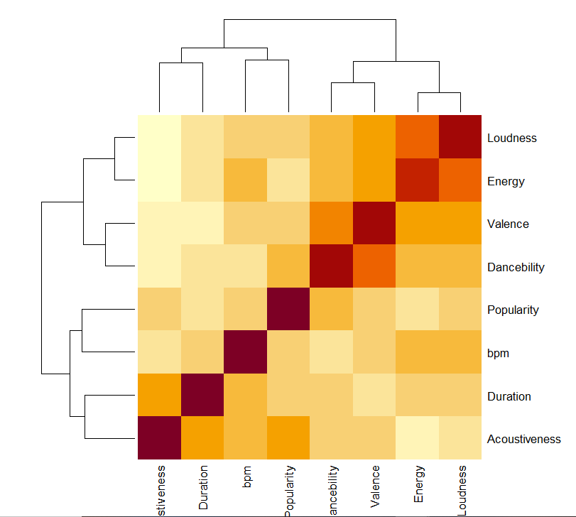

# T-Test on dataset columns Duration and Popularity  
t.test(Data$Duration,Data$Popularity, var.equal = TRUE, paired=FALSE)

##   
## Two Sample t-test  
##   
## data: Data$Duration and Data$Popularity  
## t = 105.2, df = 1194, p-value < 2.2e-16  
## alternative hypothesis: true difference in means is not equal to 0  
## 95 percent confidence interval:  
## 154.6432 160.5207  
## sample estimates:  
## mean of x mean of y   
## 224.65886 67.07692

# p-value is <2.2e-16 which is very less and hence we reject the null hypothesis  
  
  
  
with(Data,t.test(Energy,Valence))

##   
## Welch Two Sample t-test  
##   
## data: Energy and Valence  
## t = 16.181, df = 1079.1, p-value < 2.2e-16  
## alternative hypothesis: true difference in means is not equal to 0  
## 95 percent confidence interval:  
## 16.03621 20.46212  
## sample estimates:  
## mean of x mean of y   
## 70.58863 52.33946

with(Data,t.test(Valence,Dancebility))

##   
## Welch Two Sample t-test  
##   
## data: Valence and Dancebility  
## t = -11.451, df = 963.38, p-value < 2.2e-16  
## alternative hypothesis: true difference in means is not equal to 0  
## 95 percent confidence interval:  
## -14.27594 -10.09865  
## sample estimates:  
## mean of x mean of y   
## 52.33946 64.52676

with(Data,t.test(Energy,Acoustiveness))

##   
## Welch Two Sample t-test  
##   
## data: Energy and Acoustiveness  
## t = 52.329, df = 1120.1, p-value < 2.2e-16  
## alternative hypothesis: true difference in means is not equal to 0  
## 95 percent confidence interval:  
## 54.08538 58.29924  
## sample estimates:  
## mean of x mean of y   
## 70.58863 14.39632

# (Energy, Valence), (Valence,Dancebility) and Energy,Acoustiveness have very low p-value  
# as seen from heat map earlier it has significant correlation and hence we reject the null  
# hypothesis for these audio properties.  
  
with(Data,t.test(Popularity,Duration))

##   
## Welch Two Sample t-test  
##   
## data: Popularity and Duration  
## t = -105.2, df = 772.33, p-value < 2.2e-16  
## alternative hypothesis: true difference in means is not equal to 0  
## 95 percent confidence interval:  
## -160.5223 -154.6416  
## sample estimates:  
## mean of x mean of y   
## 67.07692 224.65886

with(Data,t.test(Popularity,Energy))

##   
## Welch Two Sample t-test  
##   
## data: Popularity and Energy  
## t = -4.1347, df = 1153.3, p-value = 3.812e-05  
## alternative hypothesis: true difference in means is not equal to 0  
## 95 percent confidence interval:  
## -5.178120 -1.845291  
## sample estimates:  
## mean of x mean of y   
## 67.07692 70.58863

with(Data,t.test(Popularity,Dancebility))

##   
## Welch Two Sample t-test  
##   
## data: Popularity and Dancebility  
## t = 3.3423, df = 1194, p-value = 0.0008567  
## alternative hypothesis: true difference in means is not equal to 0  
## 95 percent confidence interval:  
## 1.053184 4.047151  
## sample estimates:  
## mean of x mean of y   
## 67.07692 64.52676

with(Data,t.test(Popularity,Loudness))

##   
## Welch Two Sample t-test  
##   
## data: Popularity and Loudness  
## t = -8.0852, df = 1193.9, p-value = 1.511e-15  
## alternative hypothesis: true difference in means is not equal to 0  
## 95 percent confidence interval:  
## -7.649213 -4.661824  
## sample estimates:  
## mean of x mean of y   
## 67.07692 73.23244

with(Data,t.test(Popularity,Valence))

##   
## Welch Two Sample t-test  
##   
## data: Popularity and Valence  
## t = 13.825, df = 967.01, p-value < 2.2e-16  
## alternative hypothesis: true difference in means is not equal to 0  
## 95 percent confidence interval:  
## 12.64547 16.82945  
## sample estimates:  
## mean of x mean of y   
## 67.07692 52.33946

with(Data,t.test(Popularity,Acoustiveness))

##   
## Welch Two Sample t-test  
##   
## data: Popularity and Acoustiveness  
## t = 52.224, df = 1011.9, p-value < 2.2e-16  
## alternative hypothesis: true difference in means is not equal to 0  
## 95 percent confidence interval:  
## 50.70115 54.66005  
## sample estimates:  
## mean of x mean of y   
## 67.07692 14.39632

# Checking the relation between dependent variable Popularity and different audio properties as independent variables  
# we found out that the p-value is very low for all the t-test conducted between Popularity  
# and independent variable and hence we reject the null hypothesis stating there is significant   
# relationship between dependent and independent variables.