Top_song_analysis.R

Apurva Sarode

2020-04-16

pca_data = Data  
props = pca_data[,c(8:12)] #taking out only numeric variables  
  
#Correlation between different Variables  
#We see that the correlation coefficient for popularity with other   
#variables is very low. Thus we will see if our audio properties are correlated   
corr = cor(props)  
corr

## Energy Dancebility Loudness Valence Acoustiveness  
## Energy 1.0000000 0.1347705 0.6601003 0.3996877 -0.5801747  
## Dancebility 0.1347705 1.0000000 0.1288715 0.4948586 -0.2523136  
## Loudness 0.6601003 0.1288715 1.0000000 0.3418689 -0.3515954  
## Valence 0.3996877 0.4948586 0.3418689 1.0000000 -0.2538215  
## Acoustiveness -0.5801747 -0.2523136 -0.3515954 -0.2538215 1.0000000

pca <- prcomp(props, scale=TRUE, center=TRUE)  
summary(pca)

## Importance of components:  
## PC1 PC2 PC3 PC4 PC5  
## Standard deviation 1.5744 1.0615 0.8345 0.66545 0.50505  
## Proportion of Variance 0.4958 0.2254 0.1393 0.08856 0.05101  
## Cumulative Proportion 0.4958 0.7211 0.8604 0.94899 1.00000

pca$rotation

## PC1 PC2 PC3 PC4 PC5  
## Energy -0.5342671 0.3493423 -0.03541636 0.1309456 -0.7577055  
## Dancebility -0.3125889 -0.7231762 0.19091438 -0.5442459 -0.2159918  
## Loudness -0.4735052 0.3371536 -0.47234401 -0.5097276 0.4233074  
## Valence -0.4357433 -0.4583928 -0.37816833 0.6378852 0.2238190  
## Acoustiveness 0.4502971 -0.1765776 -0.77212514 -0.1411730 -0.3872284

pca$x

## PC1 PC2 PC3 PC4 PC5  
## [1,] -1.535915e+00 -0.034778025 -1.065836508 0.344579206 -0.341702918  
## [2,] -1.151681e+00 -0.309196987 -0.586026626 -0.130657263 -1.173511400  
## [3,] -1.856132e+00 -0.198489820 -0.691275873 -0.535825317 0.051201084  
## [4,] -1.943734e+00 0.210600418 -0.172641230 0.118214874 -0.269233738  
## [5,] -6.583107e-01 0.714441401 0.443832614 -0.196344853 -0.366875133  
## [6,] -1.109122e+00 0.021752054 0.310645994 -0.253546690 -0.536930851  
## [7,] -1.808702e+00 -0.594377949 -0.254305717 0.109207912 0.420985115  
## [8,] 3.883708e-01 1.053310943 0.474661635 0.370278893 -0.192578940  
## [9,] 4.242540e+00 -0.042623399 -1.037048411 -0.335348254 -0.251195359  
## [10,] -1.014860e+00 -0.626925101 -0.311561019 -0.790002421 0.188211356  
## [11,] -1.056178e+00 1.005749924 0.015134907 -0.293640742 -0.196153779  
## [12,] -3.827760e-03 0.437577367 -0.817020981 -0.189988681 -0.813524398  
## [13,] -9.424514e-01 -0.587931267 -0.293268373 -0.291115923 -0.584010656  
## [14,] -1.352086e+00 -1.121081019 0.576052900 0.122713921 -0.592549198  
## [15,] -5.194181e-02 0.516048481 0.430959707 2.527459431 -0.414577033  
## [16,] 1.820295e-01 -0.406338515 0.456278581 -0.943960837 -0.863876007  
## [17,] -1.081229e+00 -0.863264041 -0.462535742 0.088771816 1.191926123  
## [18,] -6.550478e-02 -0.995796241 1.339135985 -0.075891767 -1.347059220  
## [19,] 1.145386e-01 0.435325378 1.154475408 0.239385347 -0.668619449  
## [20,] -1.293379e+00 -1.291295090 -0.036630067 -0.538098234 1.015928593  
## [21,] 2.197134e-01 -0.931662451 1.388341010 -0.517942717 -0.113184594  
## [22,] 2.906298e-01 1.432605031 0.192336461 0.563956218 0.757486231  
## [23,] -9.828871e-01 -0.745361698 0.162077953 0.194370613 0.588843151  
## [24,] -1.326091e+00 -0.276278227 0.106605594 0.396457047 0.012772130  
## [25,] -9.609980e-01 1.112728929 -1.289402278 0.499483129 -0.675505638  
## [26,] -6.000832e-01 0.750636094 0.054582731 1.663010200 0.030731440  
## [27,] -1.660348e+00 0.091888746 -0.370703022 1.254971920 -0.153173379  
## [28,] -2.140327e+00 0.651627627 -0.610015843 0.112221333 -0.072770280  
## [29,] -1.025362e+00 -0.139295980 0.299398957 -0.105676280 -0.149458617  
## [30,] -9.887691e-01 -0.022566607 0.517593625 -1.273741142 0.078748851  
## [31,] -1.832289e+00 -0.067180563 -0.987436701 -0.444191145 1.196467010  
## [32,] -2.007256e+00 0.001692534 -0.434183422 0.510476476 0.006605487  
## [33,] -1.506997e+00 0.261251695 -0.311684639 -1.020520637 -0.084519538  
## [34,] 1.432169e+00 -0.245134015 0.437876640 0.126006202 0.411093675  
## [35,] -1.887970e-01 1.076901704 -0.476302801 0.612497580 -0.183128646  
## [36,] -9.494916e-01 -1.484682961 -0.108496477 -0.061415891 0.605124772  
## [37,] 4.059376e+00 1.748128638 -2.367336194 -0.671597211 0.377854663  
## [38,] -1.925103e+00 0.291936147 -0.414803233 0.537370170 -0.078662643  
## [39,] -1.588260e+00 -0.615466469 0.142693464 1.005786306 -0.679643038  
## [40,] 1.260164e-01 1.757242702 0.496406720 -0.131179972 -0.182970727  
## [41,] -2.612377e-01 0.683448996 -2.193101251 0.556835445 -0.490177776  
## [42,] 1.836493e+00 -0.338567692 1.663151957 -1.204682327 0.702639904  
## [43,] 6.393097e-01 3.098059157 0.187864445 0.024079282 0.609244479  
## [44,] -1.875137e+00 -0.895278832 -0.956898281 -0.067714825 -0.410692572  
## [45,] 4.601289e+00 1.811434396 -2.235603818 -0.141815815 0.275232509  
## [46,] -1.100062e+00 -0.218394744 0.513622853 -0.391463431 -0.275108638  
## [47,] -1.499853e+00 0.840828456 -0.253190395 -0.047281114 -0.563838658  
## [48,] -1.720230e+00 0.576844660 -0.480186772 -0.228601869 0.191171282  
## [49,] -4.563618e-01 1.454235982 -0.274419737 0.998363004 -0.093048508  
## [50,] -1.361171e+00 0.289197840 0.211526185 0.310202596 -0.463644085  
## [51,] 2.993375e+00 0.904500037 0.139692229 -0.017350077 0.736430631  
## [52,] 4.238767e+00 -0.982778550 -1.704182301 -0.403209911 -0.332738321  
## [53,] -1.432090e+00 0.805657028 -0.874783002 -0.653869846 -0.621159315  
## [54,] -6.583107e-01 0.714441401 0.443832614 -0.196344853 -0.366875133

fviz_screeplot(pca, type='bar',main='Scree plot')

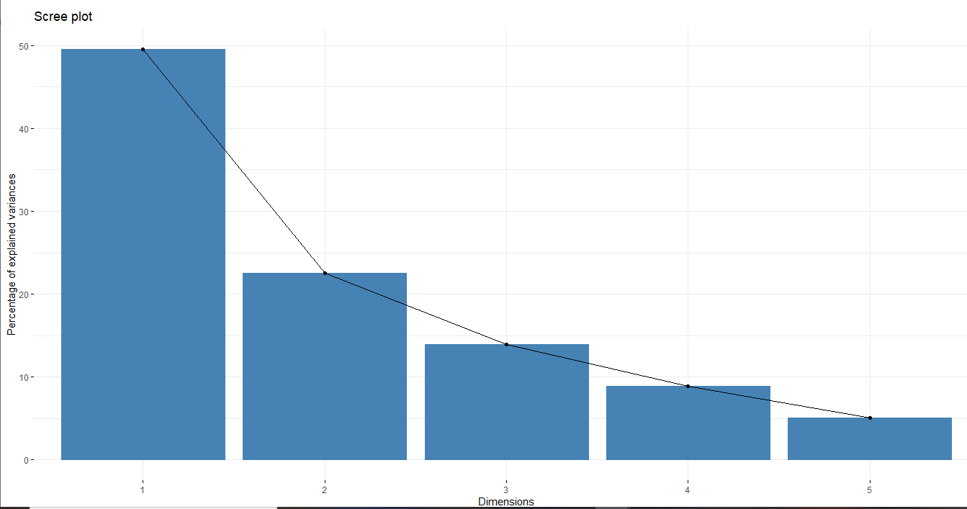

pca$rotation <- -pca$rotation  
fviz_pca_biplot(pca, col.var = "Blue", habillage=pca_data$Rating)

