Assisted Commerce 2.O
High Quality Lead Generation by AI agents (Phase 1) + Fully Agentic Flow (Phase 2)

1. Objective
Goal: Replace the top of the Assisted Commerce funnel — currently a fully human outbound calling layer — with an AI calling agent that qualifies leads/identifies purchase intent, and transfers only Hot/Warm leads to human agents. The first phase ('Phase 1') keeps a human-in-the-loop for order placement; the second phase ('Phase 2') extends agentic control to cart edits, address capture, coupon application, and search, etc. (This we can discuss later as and when the models progress and the accuracy is sustained)
Why now: POC across ~1300 real leads on Ringg AI demonstrates an end-to-end human conversion (lead assigned->sale done) of ~20% on transferred leads vs ~5% on the current human-only baseline, this indicates ~75% lower manpower required to do the same job. Coupled with increased concurrency on the bot layer, this increases both revenue (via faster, broader outreach) and reduces variable cost.
Currently, we have a CPO of ~250 rupees on a total cost (payroll + variable urmi, telephonic, etc. costs) of ~50L on ~20000 orders placed monthly. We are currently in talks over commercials, for it to be either purely on calling or outcome based, we shall update on this.

2. Strategic Context

2.1 Current funnel (baseline)
• Today: 100% human-driven Assisted Commerce team calls all eligible leads. Lead Assigned → Lead Converted ratio = ~5%. High cost-per-conversion, capacity-limited, slow time-to-first-call, are the limiting factors.
• Coverage gap: ~40% of eligible leads remain un-attempted today due to capacity limits — implying a meaningful unconverted revenue universe to be tapped. (Out of ~17000 eligible leads where we have both address + patient details, we are able to attempt only ~10000 leads as of today)

2.2 Proposed funnel (Phase 1 — High Quality Lead Generation Layer)
AI Agent (calling customers) → Intent Identification (Hot/Warm/Cold) → Hot/Warm leads will be assigned to Human Agents (with an expected call back in < 5 mins) → Order placement by humans.
This will help us expand to our serviceable universe of ~17000 leads (with patient and address details) with a quicker touchpoint.

3. POC Results

POC headline results (Phase 1)
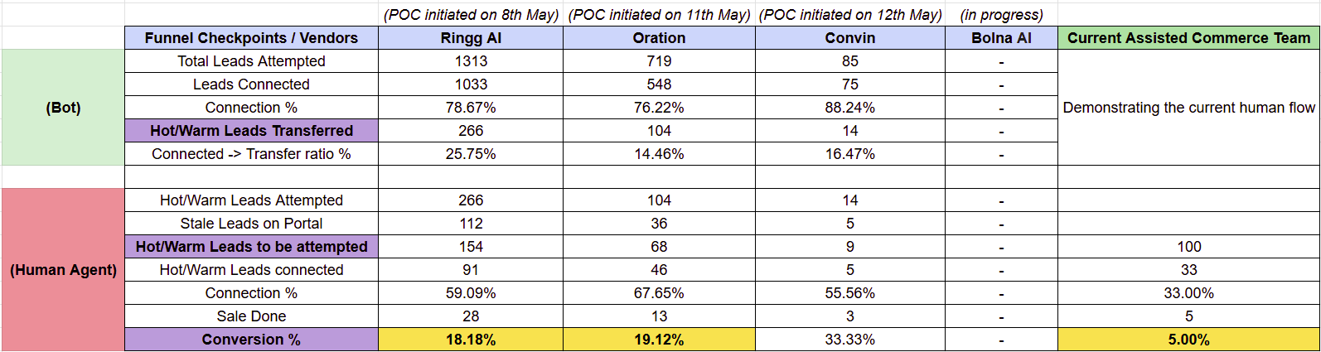

4. Proposed Process Flow

Current Flow - Currently when a human agent clicks on ‘assign order’, an order is assigned as per our assigning logic (attached here - link, this has been tweaked 2-3 times in the past) and then the agent attempts a call to place the order -
- When an order completes more than 30 mins of inactivity post cart modification (without placing the order), the order enters our waiting pool for Assisted Commerce, post this the assigning logic comes into effect. (Majorly driven by only AOV sorted in descending order)

A quick and structured way of going live with this is defined below.
Analogy - Think of Ringg agents as human agents who will get an order assigned to them as they click on the ‘Assign Order’ button, and orders will be assigned based on the current assigning logic* (defined below). (As and when we define the concurrency for Ringg they will keep pulling orders from us by hitting our assigning logic to act on it)
There will be 2 types of categories for the human agents -
- Category 1 - For Hot/Warm leads
- Category 2 - For unattended leads by Ringg
  - This will be function of concurrency, if concurrency = order inflow then this category will have ~0 leads assigned (at full scale)

Ringg order assigning logic - Same as the current assigning logic with an added layer of filtration for a tailored conversation - (for empty cart details - we will handle at the bot’s end)
- Only orders with filled patient details and address details to be sent to Ringg
  - Patient id and address id should be present for the order id

Step 1 - Using the above assigning logic Ringg pulls orders from us and acts on it, till it closes an endpoint with the order (all the checkpoints in between will be handled by Ringg till the thread is closed for the order). The following could be the endpoints -
- Call was not connected - Ring handles it itself for the re-attempt logic, which can be handled externally
  - Post max attempts (4 in POC) and no connection, it returns back the order
- Call was scheduled - Ring handles it itself for the schedule logic, till either it is connected or goes to max attempts
- Call was connected - The conversation happened and Ringg came back with a final verdict on the order as Hot/Warm/Cold
This will ensure Ringg pulls the order from us (the thread for this order will be closed when Ringg informs us about the final state of the order, defined in the above scenarios), the order is out of the Assisted Commerce pool when Ringg agents get the order assigned and it only comes back to us when the order’s thread is closed either by max attempts or with the order’s verdict (Hot/Warm/Cold)

Step 2 - Parallely, human agents (Category 2) will get orders assigned to them based on the current assigning logic and continue with the current operational flow. All other logics continue to remain the same.

Step 3 - From Step 1, as and when we get the webhooks from Ringg, we need to filter the Hot/Warm leads, and using the current assigning logic (majorly driven by AOV) the Category 1 agents will get leads assigned to them, and they shall continue with the normal flow. All logic for hold (re-attempt), schedule, etc. remain the same for the flow.
- (a thought for an edge case) - At the start if the inflow of orders is low and there are multiple agents in this category, we can create a replica category 2 for the agents to take on the normal order flow. (rare case, but a heads up for the solve)
(We would also want to attempt cold leads basis a priority logic if hot/warm leads are over or in max attempts or in the hold pool - a P1 thought. With a good quality feedback analysis we will solve this at the bot’s end to be accurate in defining hot leads)

A heads up - Here, we have some feedback from the Ringg team to ensure low latency and low packet loss touch points with Knowlarity/TATA Tele for better conversations - Knowlarity has had some issue on packet loss and currently the ACOM team uses Knowlarity, we can explore using TATA which gives a better experience on packet loss. [Will evaluate this and this will be a single number change in the backend for us if we switch to TATA, will keep posted]

Fall back - If something fails, Ring’s concurrency will be brought down to 0 and the normal order flow and operations continue post that. (we can control concurrency and time b/w 2 attempts by the bot)

5. Bot Workflow (to be handled externally)

AI agent call flow (bot side)
(Attaching a sample workflow on the bot side - thought process with which it was built)

- Workflow - (External)
  - Step 1 - Call is initiated by the agent
  - Step 2 (Agentic layer) - Here the goal of the agent is to try and solve for issues over call (as much as possible) and only transfer high intent classified customers to the next call
    - Problem identification
    - Problem Rebuttals/Resolution (different for different issues)
      - Extent of convincing to be different for different issues
    - Intent Clarification
      - Hot/Warm/Cold
  - Step 3 (Human Intervention) - We shall pass on Hot/Warm intent leads from the agentic layer to the human layer

- Conversation script/Objection Handling (External) -
  - This will be defined by the workflow

- Structured data (to be captured from Bot’s conversation for assigning orders and passing to humans) - Intent labels + Context of the conversation + Reason/Objection Tag + Transcript/Recording link + Order details like Order ID, mobile number, etc. for us to pass this forward to human agents. (in the form of a webhook for the identifiers)

- Intent Classification Tag (logic) (External) - Will add in a detailed tag classification logic here. With quality control we will keep the lead classification accurate, to keep the funnel high quality.

- Customer personalised variables - POC was run on a thin variable set. Expanding this will be key for better conversion. Current variables passed to the bot pre-call during the POC (and used inside the conversation):
  - Customer: Name and Mobile Number
  - Order details: Order ID, Cart contents (SKU + Qty), Total MRP, Total SP, Total Discount %, previously bought medicines.
  - Address: Flat, Building, Area, City, State, Pincode.
  - ETA: Number of days to deliver the order
We need to do some tweaks in the data format to be used to share with Ringg for a better human-like conversation. For instance, in the data point ‘Address’ - we will pass on the 5 data points separately to be used in different stages of the conversation). For eg -
- If someone asks ETA - Just tell <# of days> and Area, City
- If someone asks the complete address - tell the complete address
(This we can also tweak with Ringg to understand if they can delimit at their end and we ensure we send the data in a structured format for something like Address)

We will expand this dataset for variables, have some learnings from the call recordings; will use it to see feasible options that can be passed that will improve conversion/better objection handling for the customers. For eg-
- An identifier for TM Cash currently available with the customer.

Ensuring we pass these points in a structured and clean format (like avoiding NAs, etc.) is the key for a better conversation. Need to define or introduce validations if some data is missing or unstructured.

- FAQ/Objection Handling library (External) - We have already fed in a lot of context to the bot, more information/knowledge base around Truemeds or handling orders needs to be passed or fed into the system for a better experience. Organising this from multiple sources -
  - TBD: Top 50 / 100 objections + canonical answers, in Hindi + Hinglish + English
  - All policies within Truemeds like NQA, etc.
  - Customer care number - For different order status query
  - Multiple such data points/resources, etc.

- Compliance/Recording - NDA is already signed, recordings to be saved on our end for the bot conversation.

Sample workflow (for understanding purposes) - Used to build the current AI agent, we will make some more tweaks on top of it with more customer personalised variables for better conversion.
(This workflow is v3 and I had made 3-4 iterations on top of it for the current version)
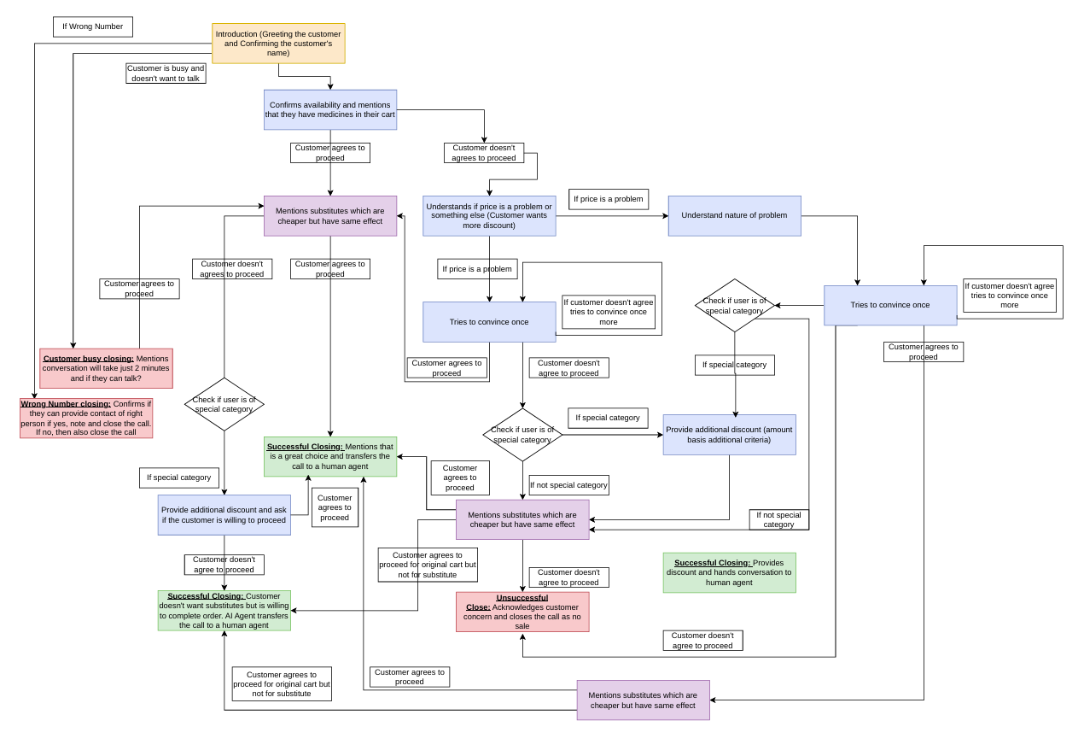
6. Portal Changes
We will need to build the following changes in the human facing end of the portal -

- Pre-populated context box: Bot summary (intent reason, objections raised) in the order detail page
- Recording/Transcript link: For a quick recap for the human agent
- Human Agent Dispositions: For orders that were not confirmed if we can capture those reasons in a drop-down format or text box, to improve/tighten the agent rules to classify the calls as Hot/Warm. (Priority - P1)

7. Funnel and Cost Structure

Cost structures to be added here (WIP)

(Attaching a directional sense of CPO reduction (tentative*), we are currently discussing commercials and expect more goodness here)
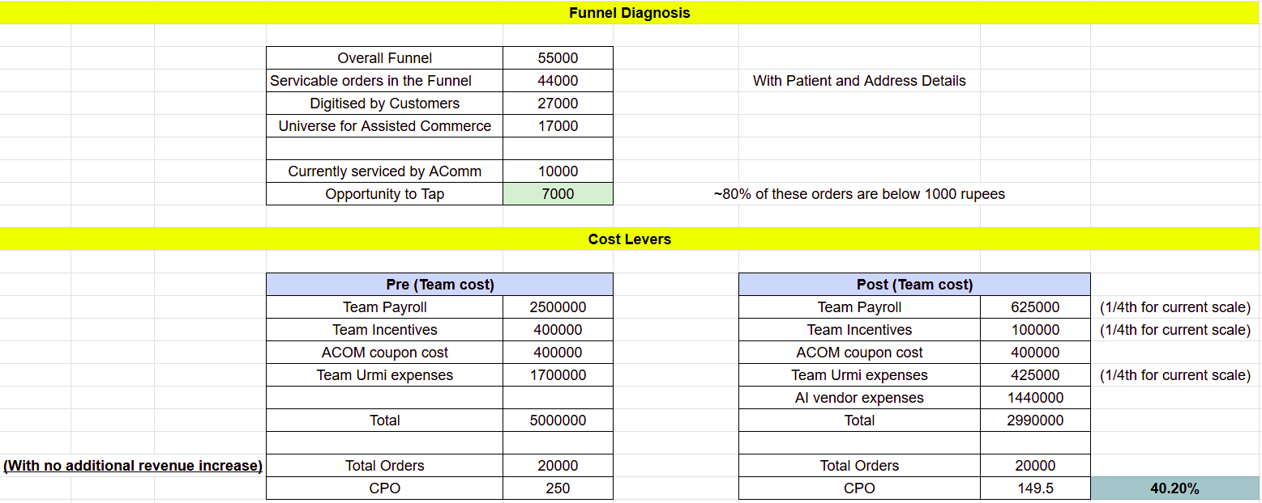

8. Metrics and Analytics

