**Install instructions for the Halo-VMware Integration**

Update the packages on the Ubuntu OS by running the following command:

$ *sudo apt-get -y update*

Download and copy the VMware VIX SDK from the following location:

<http://www.vmware.com/support/developer/vix-api/>

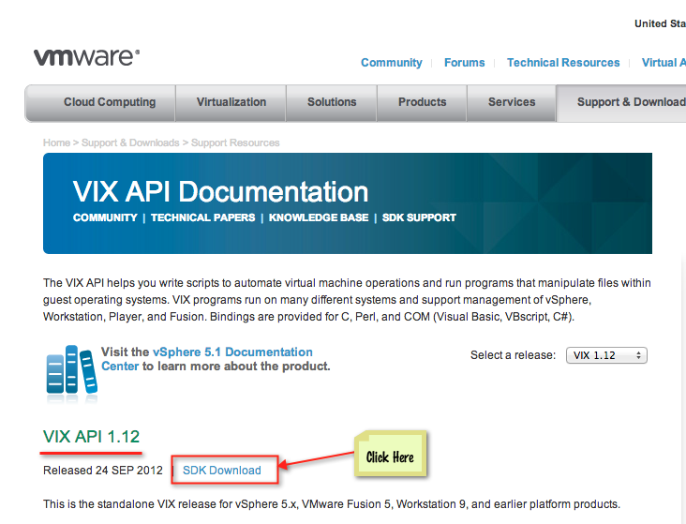

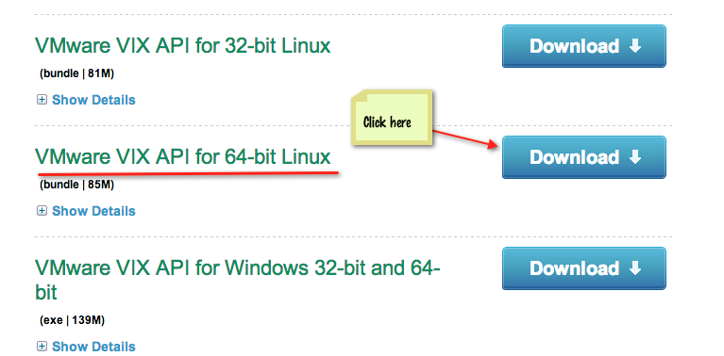

Clicking on “Download” will download a file named “VMware-VIX-1.12.2-1031769.x86_64.bundle” to your local machine. Copy the file over to the Ubuntu machine that you will run the Vmware integration program from.

Install the VIX SDK by running the following command on the Ubuntu machine:

$ *sudo sh VMware-VIX-1.12.2-1031769.x86_64.bundle*

Unzip the vmhalo.zip on the Ubuntu machine by running the following command:

Download the vmhalo.zip file from [here](https://docs.google.com/a/cloudpassage.com/file/d/0B4FFVopObdQoUFRvRlRsZHJnaVE/edit?usp=sharing).

$ *unzip vmhalo.zip*

Note: If unzip is not present on your machine, install by running the following command:

$ *sudo apt-get -y install unzip*

After the unzip is complete, go to the vmhalo/bin directory, and run

$ *./vmhalo -h*

to view usage of the program:

Open the vmhalo.cfg file and edit the line that says “halokey=<your_daemon_registration_key>”

**Note**: Unless you provide your CloudPassage Halo daemon registration key, the Halo daemon will not activate and connect to the Halo Grid.