ON THE LIST
Frontend Copy & UX Changes
Dev Team Brief — 7 May 2026

This document details all copy changes, label renames, and content additions required across the platform. Each change is specified with the exact location, what to remove, and what to replace it with. Screenshots are included for visual reference.
Pages affected: Home, Events, How It Works (separate page), My Tickets, Help Centre, Trust & Safety

1. Events Page
The Events page has a dismissible banner at the top and a calendar date selector. Two changes are needed here.

1.1 Events Page Banner
The banner currently reads:
"On The List has two ways to get in - buy direct from the organiser, or claim a spot passed on by another student. Same price. Fully secure."

Remove this since we do not have separate lists now. Remove it from wherever it pops up.

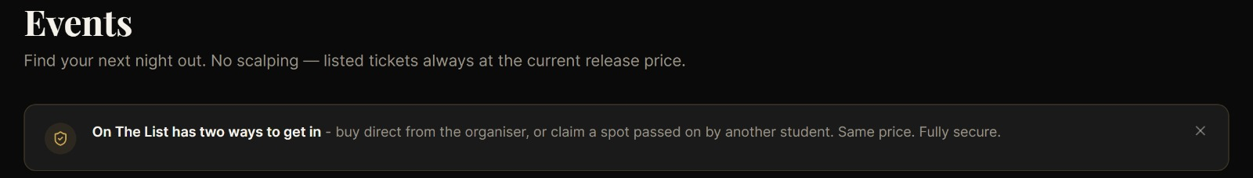
Fig 1.1 — Events page banner.

1.2 Calendar — Default State
Currently: today's date is highlighted with a full gold block by default, even when no date has been selected by the user.
Required change: on page load, today's date should show a small gold dot indicator beneath the date number only. The full block highlight should only appear when a user actively taps/clicks a date.

CURRENT BEHAVIOUR
- Today's date has full gold block highlight on load
- This implies the user has made a selection when they have not

REQUIRED BEHAVIOUR
- On load: gold dot beneath today's date number only
- On user tap/click of any date: full gold block highlight activates for that date
- Clicking the same date again should deselect and return to dot indicator

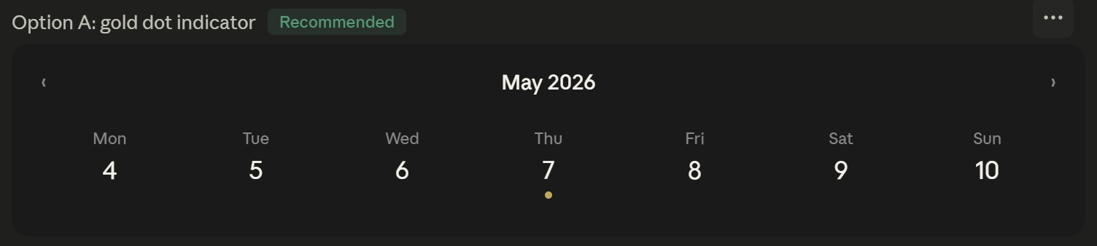
Fig 1.2 — Target state: gold dot indicator for today, full block only on user selection.

1.3 Past Events Visibility
Required change: once a date has passed, that event should not appear in the Events tab listing. Apply a date filter so only upcoming events (today or future) are returned.
RULE
- Event date < today (midnight): hide from Events tab entirely
- Event date >= today: show as normal

2. Home Page

2.1 Featured Events

Below the featured events area, add a secondary link:
"Are you an organiser? List your event here."
This link should point to the organiser dashboard.

2.2 "Got a ticket you can't use?" — CTA Button
The button currently reads "Pass it On The List". This is a wordplay reference that backfires for new users who have no existing relationship with the brand name. They read it as a nonsensical instruction.

Home / Resale CTA button | REMOVE  Pass it On The List | REPLACE WITH  List My Ticket for Resale

"List My Ticket for Resale" tells the user exactly what will happen when they click. The wordplay can be reintroduced in post-action screens (confirmation email, success state) once the user understands the platform.

Make this replacement everywhere.

2.3 How It Works — Home Page Section
The How It Works section on the home page currently has three cards: "No Scalping, Ever", "Atomic QR Transfer", "Verified & Secure". These are feature claims, not process steps. The section subtitle says "Secure transfers in three steps" but no card describes a step.
The home page section should be updated to match the content of the separate How It Works page (detailed in Section 3 below). The resale model money flow block and the three rules strip should also be added beneath the three cards, between How It Works and Featured Events.
Visual reference for the new home page How It Works content: see Section 3 screenshots.

3. How It Works — Separate Page
All changes below apply to the dedicated /how-it-works page. The layout and visual structure remain unchanged. Only copy is updated.

3.1 Page Header
How It Works / Subtitle | REMOVE  From browsing to entry — three simple steps. Secure payments, verified transfers, and fair pricing built into every transaction. | REPLACE WITH  Buy early, if plans change, get your money back. Every transfer is secure, every price is fair, and scalping is impossible by design.

3.2 Browse & Buy — Step 01 (Add this step to the home page instead of the ‘No Scalping, Ever’ block)
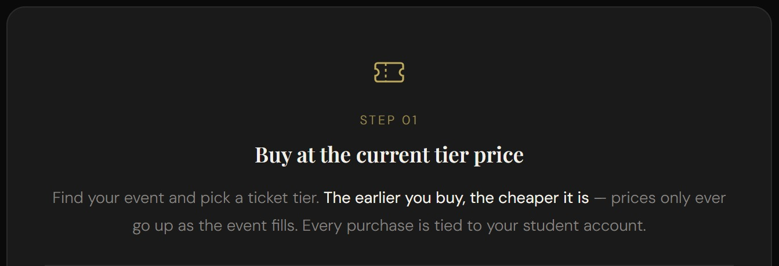
Fig 3.2 — Step 01 as it should appear. This screenshot reflects the target copy.

How It Works / Step 01 body | REMOVE  Browse upcoming events near you. Filter by date, category, or venue to find exactly what you're looking for. | REPLACE WITH  Browse upcoming student events. Every listing shows the current tier price — the earlier you buy, the cheaper your ticket. Prices only ever go up as the event fills.

3.3 Browse & Buy — Step 02 (Add this step to the home page instead of the ‘Atomic QR Transfer’ block)
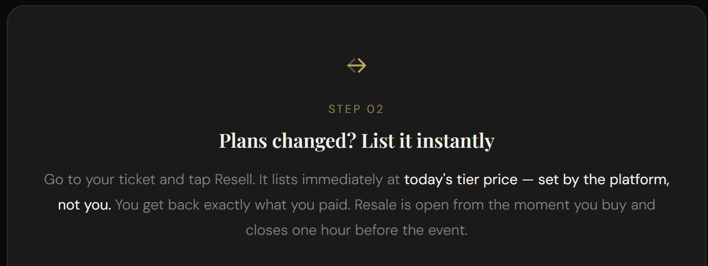
Fig 3.3 — Step 02 as it should appear.

How It Works / Step 02 body | REMOVE  Pick your tickets, choose your quantity, and pay securely through Stripe. Your QR code is generated instantly. | REPLACE WITH  Go to your ticket and tap Resell. It lists immediately at today's tier price — set by the platform, not you. You get back exactly what you paid. Resale is open from the moment you buy and closes one hour before the event.

3.4 Browse & Buy — Step 03 (Add this step to the home page instead of the ‘Verified & Secure’ block)
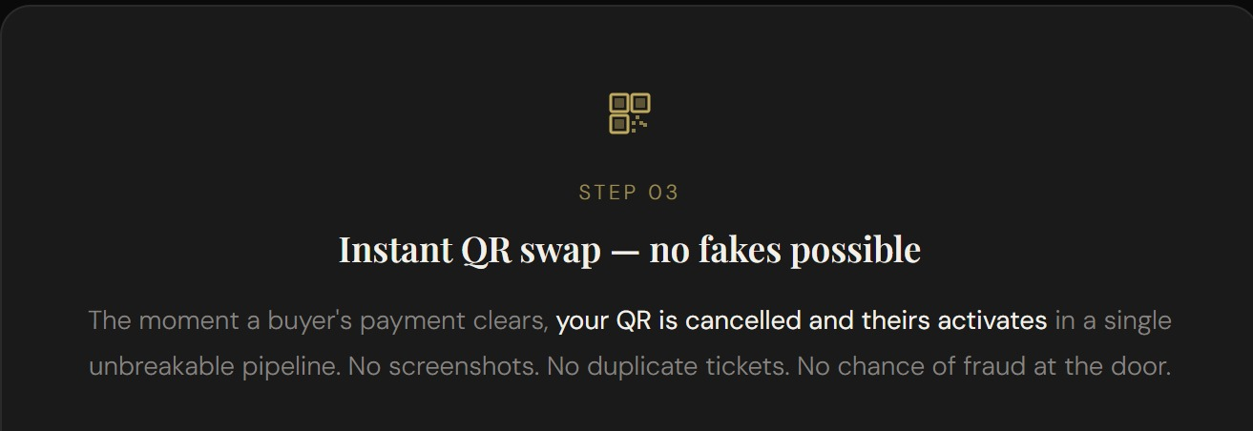
Fig 3.4 — Step 03 as it should appear.

How It Works / Step 03 body | REMOVE  A unique, tamper-proof QR code is issued to your account. Show it at the door — that's your ticket in. | REPLACE WITH  A unique, tamper-proof QR code is issued to your account. If you ever resell your ticket, this QR is instantly cancelled and a new one is generated for the buyer. Show it at the door — that's your ticket in.

3.5 Built for Fairness — Card 1: Secure Resale
How It Works / Card 1 body | REMOVE  Need to sell your ticket? List it at or below the current release price. When it sells, your old QR code is instantly invalidated and a brand-new one is generated for the buyer. No duplicates, no fraud. | REPLACE WITH  Need to sell your ticket? List it in one tap. The platform automatically sets the resale price at today's tier — you get back exactly what you originally paid. Your old QR is instantly cancelled and a new one goes to the buyer. No screenshots. No scams. No WhatsApp anxiety.

3.6 Built for Fairness — Card 2: Atomic Transfers
How It Works / Card 2 body — final sentence only | REMOVE  There is never a moment where two valid tickets exist for the same seat. | REPLACE WITH  There is never a moment where two valid tickets exist for the same event. Payment goes through, ownership changes, old QR dies, new QR lives — one pipeline, no gaps.

3.7 Built for Fairness — Card 3: Replace entirely
Remove the "Fair Pricing, Always" card completely. Replace with a new card:

NEW CARD — TITLE
Your Money Is Safe
NEW CARD — ICON
Padlock icon, or pound sign inside a shield. Gold colour, matching existing icon style.
NEW CARD — BODY
Buy early without the fear of being stuck. If your plans change, you list your ticket and get back exactly what you paid — guaranteed. Prices only go up, never down, so your original spend is always covered. No risk, no loss.

3.8 New Block: The Resale Model — Money Flow (Add this below the ‘How It Works’ in the home page as well)
This entire block is new and should be added below the three "Built for Fairness" cards. It consists of two parts: a left-hand explanatory paragraph and a right-hand worked example breakdown, followed by a plain-English summary box.

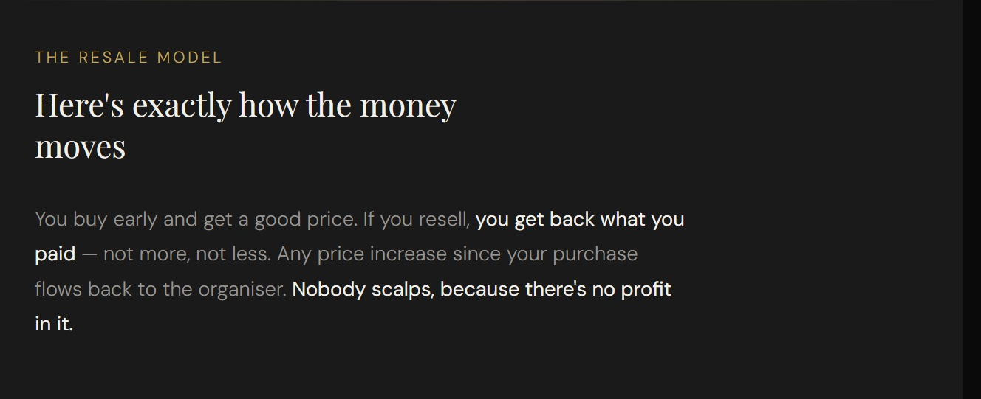
Fig 3.8a — Left side: "THE RESALE MODEL" label with "Here's exactly how the money moves" heading and explanatory paragraph.

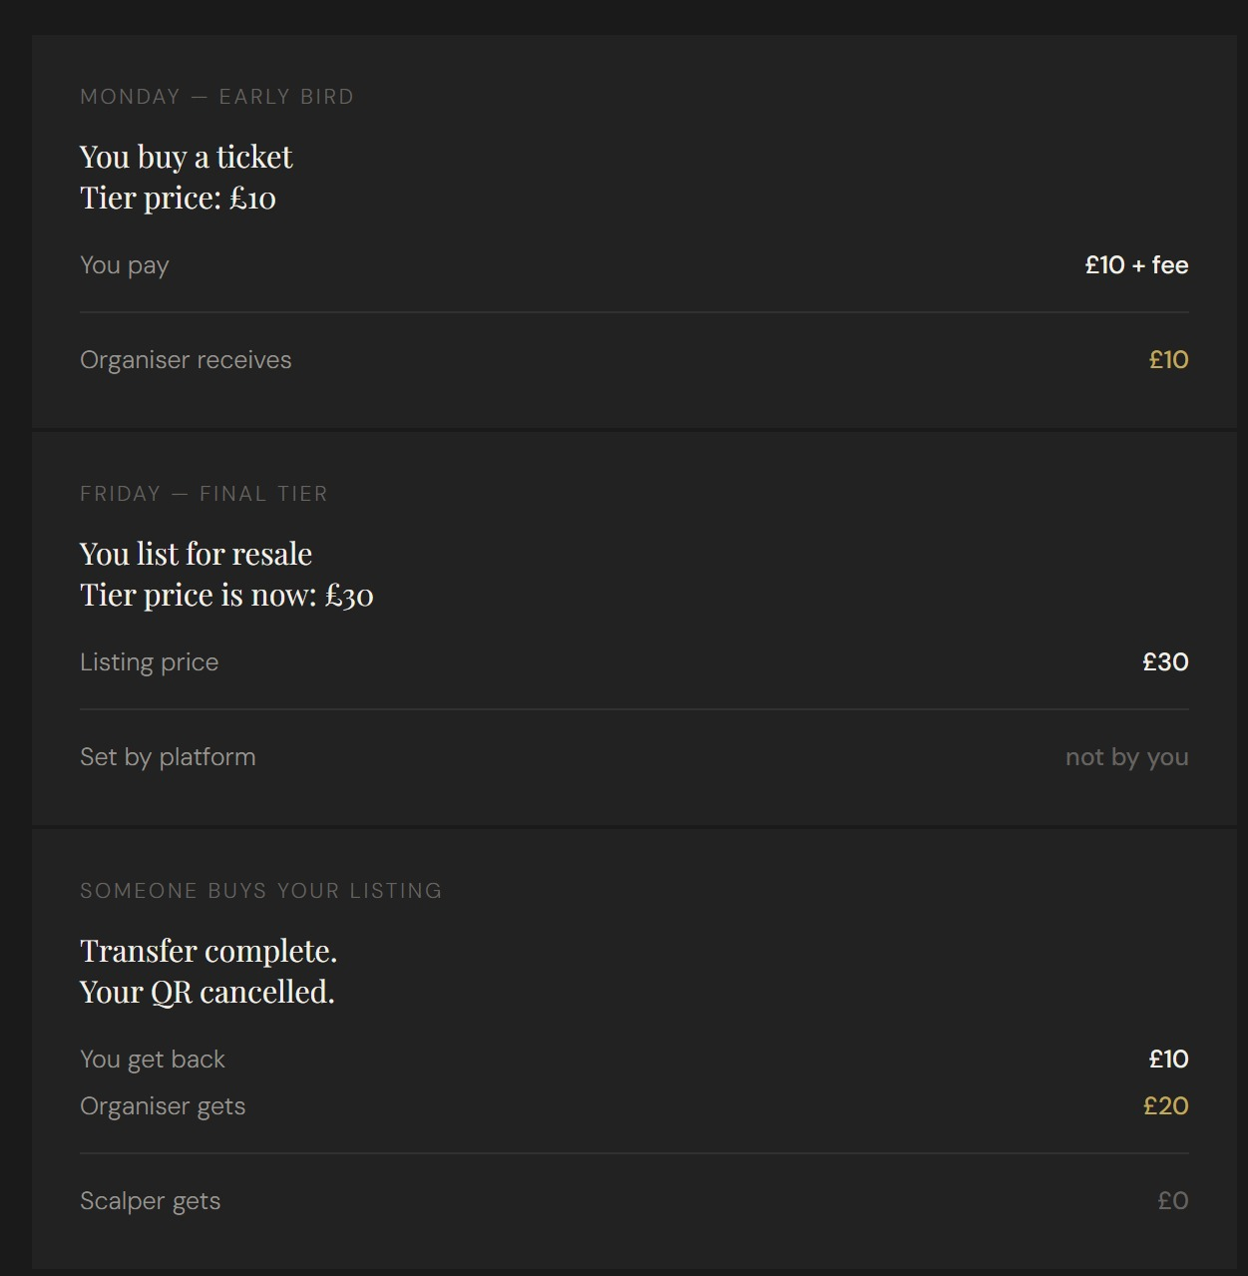
Fig 3.8b — Right side: three-stage money flow breakdown (Monday Early Bird / Friday Final Tier / Transfer Complete).

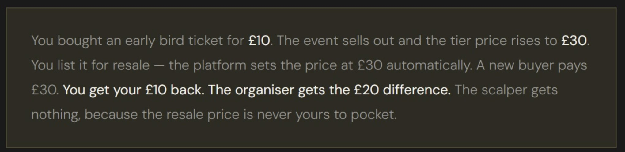
Fig 3.8c — Plain-English summary box beneath the money flow.

LEFT COLUMN COPY
Eyebrow label: THE RESALE MODEL
Heading: Here's exactly how the money moves
Body: You buy early and get a good price. If you resell, you get back what you paid — not more, not less. Any price increase since your purchase flows back to the organiser. Nobody scalps, because there's no profit in it.
RIGHT COLUMN — MONEY FLOW TABLE
Three sections, each with a label, heading, and two or three line items with right-aligned values. Exact copy as follows:

Section | Label / Heading | Line items (label — value)
Stage 1 | MONDAY — EARLY BIRD  You buy a ticket  Tier price: £10 | You pay — £10 + fee  Organiser receives — £10 (gold)
Stage 2 | FRIDAY — FINAL TIER  You list for resale  Tier price is now: £30 | Listing price — £30  Set by platform — not by you (muted)
Stage 3 | SOMEONE BUYS YOUR LISTING  Transfer complete.  Your QR cancelled. | You get back — £10  Organiser gets — £20 (gold)  Scalper gets — £0 (muted)

PLAIN-ENGLISH SUMMARY BOX (GOLD-TINTED BACKGROUND)
"You bought an early bird ticket for £10. The event sells out and the tier price rises to £30. You list it for resale — the platform sets the price at £30 automatically. A new buyer pays £30. You get your £10 back. The organiser gets the £20 difference. The scalper gets nothing, because the resale price is never yours to pocket."

4. My Tickets Page

4.1 Tab Label Rename
The second tab in My Tickets currently reads "On The List (1)". This is a brand wordplay reference that is meaningless to a new user. The tab label must be changed.

My Tickets / second tab label | REMOVE  On The List | REPLACE WITH  Listed for Resale

The counter in brackets remains unchanged. "Active Tickets (4)" and "Listed for Resale (1)" is the correct pairing — both labels are immediately self-explanatory.

4.2 Guest User — Back Button
Currently: when a logged-out guest clicks "My Tickets" in the nav, they are redirected to the login page. There is no back button or way to return to the homepage from the login screen.
REQUIRED CHANGE
- Add a back arrow or "Back to home" text link at the top of the login page
- This link should navigate to the homepage (/)
- Must be visible without scrolling on mobile

5. Help Centre Page

5.1 Remove: "What is the Smart Timing Fee?"
This FAQ entry references a feature that does not exist on the platform. The booking fee is fixed, not dynamic. Remove this question and answer entirely.
ACTION
- Delete the FAQ entry titled "What is the smart timing fee" and its answer

5.2 Remove: "Can I get a refund?"
Remove this FAQ entry entirely.
ACTION
- Delete the FAQ entry titled "Can I get a refund?" and its answer

5.3 Edit: "How do I list my ticket for resale?"
Help Centre / How do I list my ticket for resale? | REMOVE  [existing answer — update to the following] | REPLACE WITH  Go to your tickets page, find the ticket you want to sell, and tap 'List for Resale'. Your ticket will appear in the resale marketplace. You can cancel the listing at any time before it sells.

6. Trust & Safety Page

6.1 Remove: Student Verification section
Remove the following section from the Trust & Safety page entirely:
Student Verification On The List is built for verified students. Our platform ensures that ticket holders are genuine members of the student community, keeping events safe and authentic.

ACTION
- Delete the "Student Verification" heading and its paragraph from Trust & Safety

7. Change Summary
Quick-reference list of all changes in this brief:

Page | Element | Change
Events page | Calendar default state | Gold dot on today, block only on tap
Events page | Past events | Hide events where date < today
Home page | Featured Events empty state | Updated copy + organiser link
Home page | Resale CTA button | "Pass it On The List" → "List My Ticket for Resale"
Home page | How It Works section | Update to match HIW page content + add money flow block
How It Works page | Page subtitle | New copy — see Section 3.1
How It Works page | Step 01 body | New copy — see Section 3.2
How It Works page | Step 02 body | New copy — see Section 3.3
How It Works page | Step 03 body | New copy — see Section 3.4
How It Works page | Card 1 — Secure Resale | New copy — see Section 3.5
How It Works page | Card 2 — Atomic Transfers | Updated final sentence — see Section 3.6
How It Works page | Card 3 — Fair Pricing | Replace entirely with "Your Money Is Safe" — see Section 3.7
How It Works page | New block | Add Resale Model money flow below cards — see Section 3.8
My Tickets | Tab label | "On The List" → "Listed for Resale"
My Tickets | Guest login screen | Add back button to homepage
Help Centre | FAQ entry | Remove "What is the smart timing fee?"
Help Centre | FAQ entry | Remove "Can I get a refund?"
Help Centre | FAQ entry | Update "How do I list my ticket for resale?" — see Section 5.3
Trust & Safety | Section | Remove "Student Verification" section entirely

End of brief — On The List Dev Report — 7 May 2026

