## Assignment

1. select doc_name from doctors where en_time >"12:00:00" and ex_time <="12:00:00";

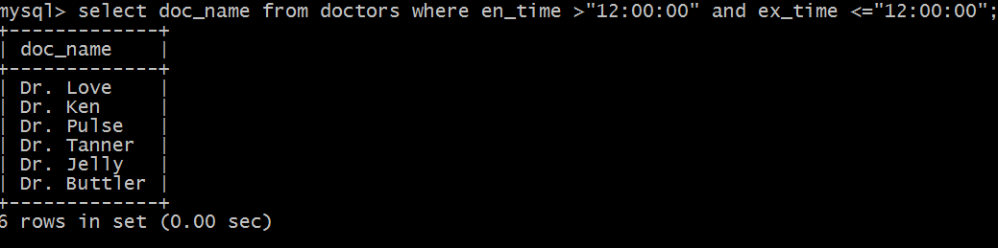

2. select count(*),date_opr from pat_opr group by date_opr;

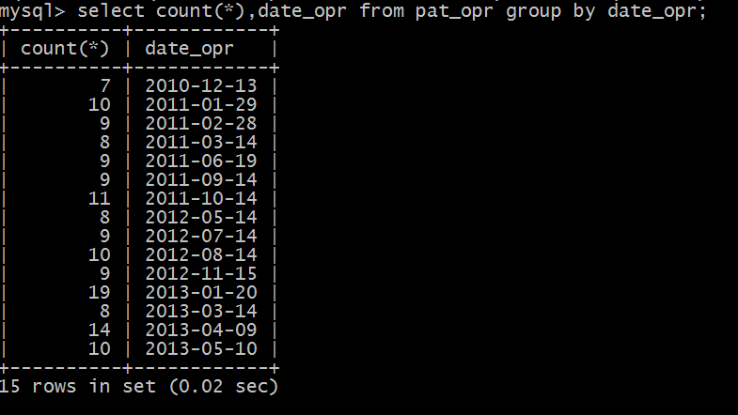

3. select doc_name from doctors,department where doctors.department=department.d_name and department.d_location="D";

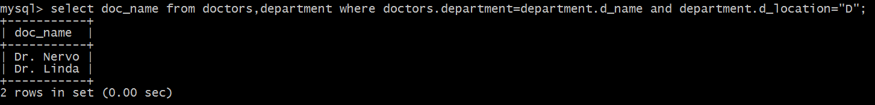

4. select typeoperation from pat_opr where doc_no = (select doc_no from doctors where doc_name="Dr. Lukes");

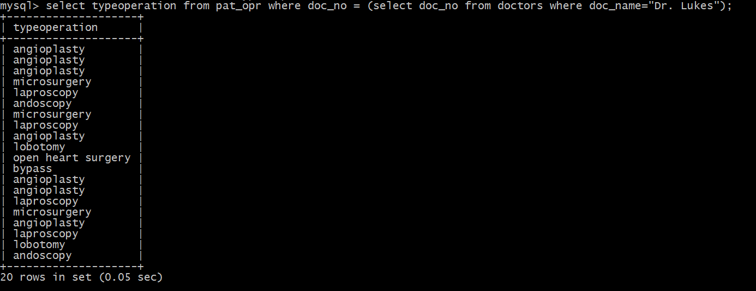

5. select pat_name from pat_entry as p1 where 2< (select count(pat_no) from pat_chup as p2 where p2.pat_no=p1.pat_no);

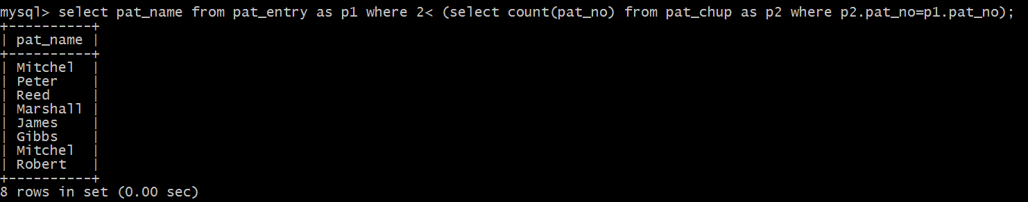

6. select pat_name,pat_no, (select count(pat_no) from pat_opr where pat_opr.pat_no=p1.pat_no and pat_opr.typeoperation="angioplasty") as count from pat_entry as p1 where 0<(select count(pat_no) from pat_opr where pat_opr.pat_no=p1.pat_no and pat_opr.typeoperation="angioplasty");

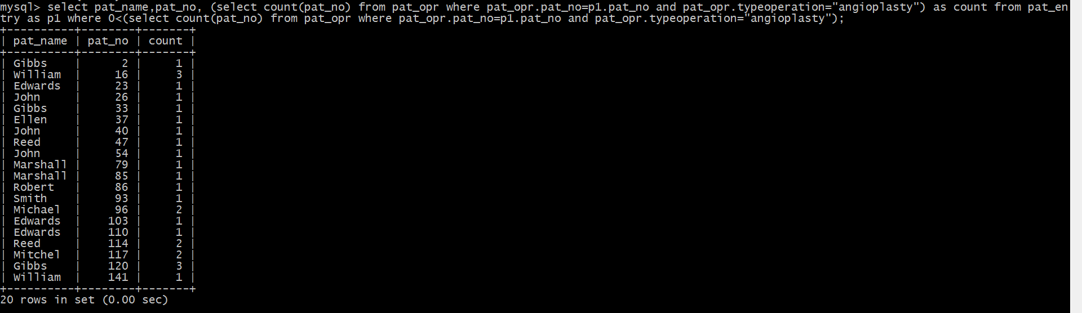

7. select pat_no,DATEDIFF(dis_on,admt_on) as No_of_Days from pat_dis;

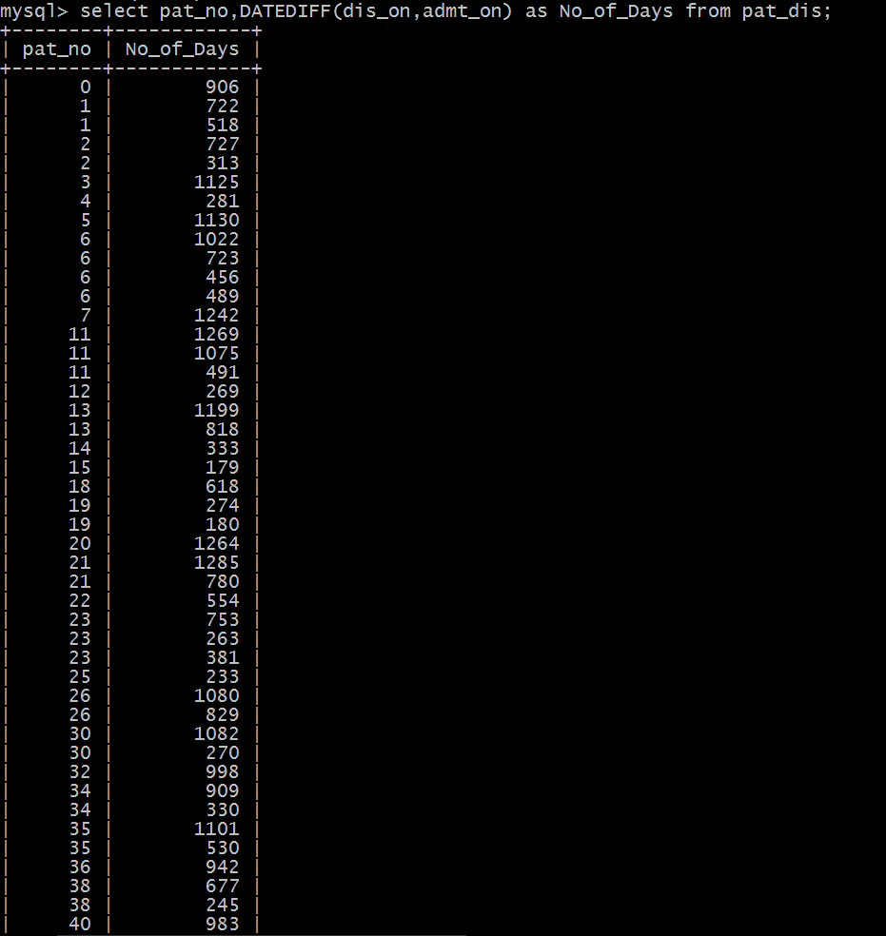

8. select pat_no,pat_name from pat_entry where diagnosis="cancer";

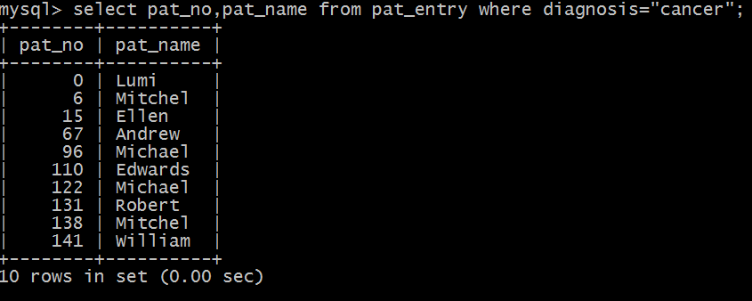

9. select pat_no,pat_name,(select count(typeoperation) from pat_opr as p2 where p2.pat_no=p1.pat_no) as No_of_Opr from pat_entry as p1 where p1.pat_no=111 or p1.pat_no=120;

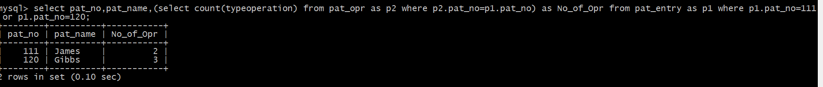

10. select doc_name from doctors where qualification="MS" and department="General Surgery";



11. select pat_no, pat_name from pat_entry where rfd = (select doc_no from doctors where doc_name="Dr. Ken");

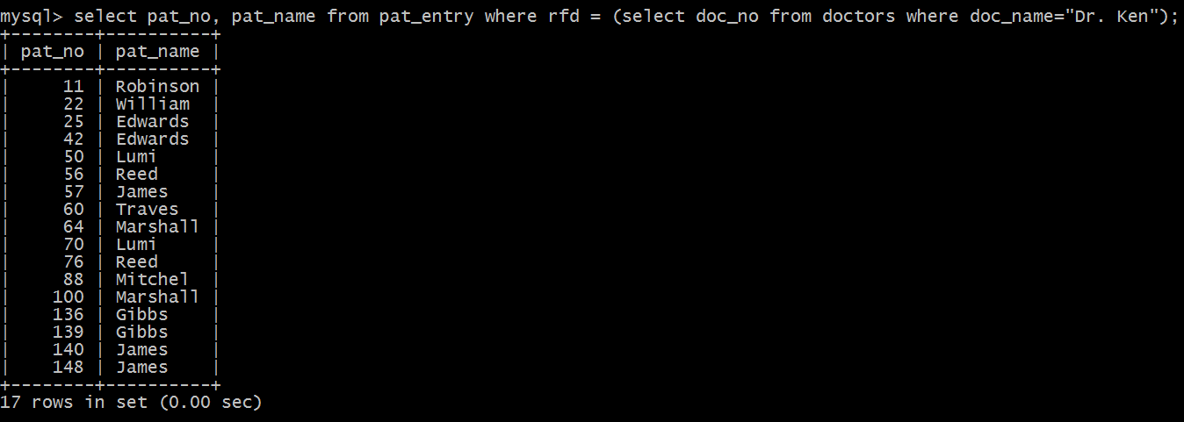

12. select doc_name from doctors where qualification="MS" and doj>"2004-01-01";

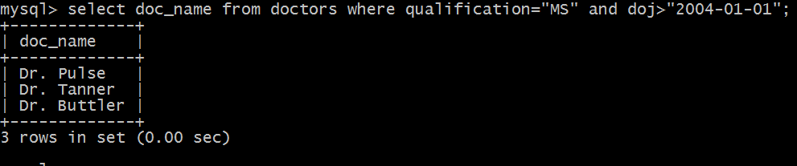

13. select p1.pat_no,p1.pat_name from pat_entry as p1, pat_chup as p2 where p2.status="life threat" and p2.pat_no=p1.pat_no;

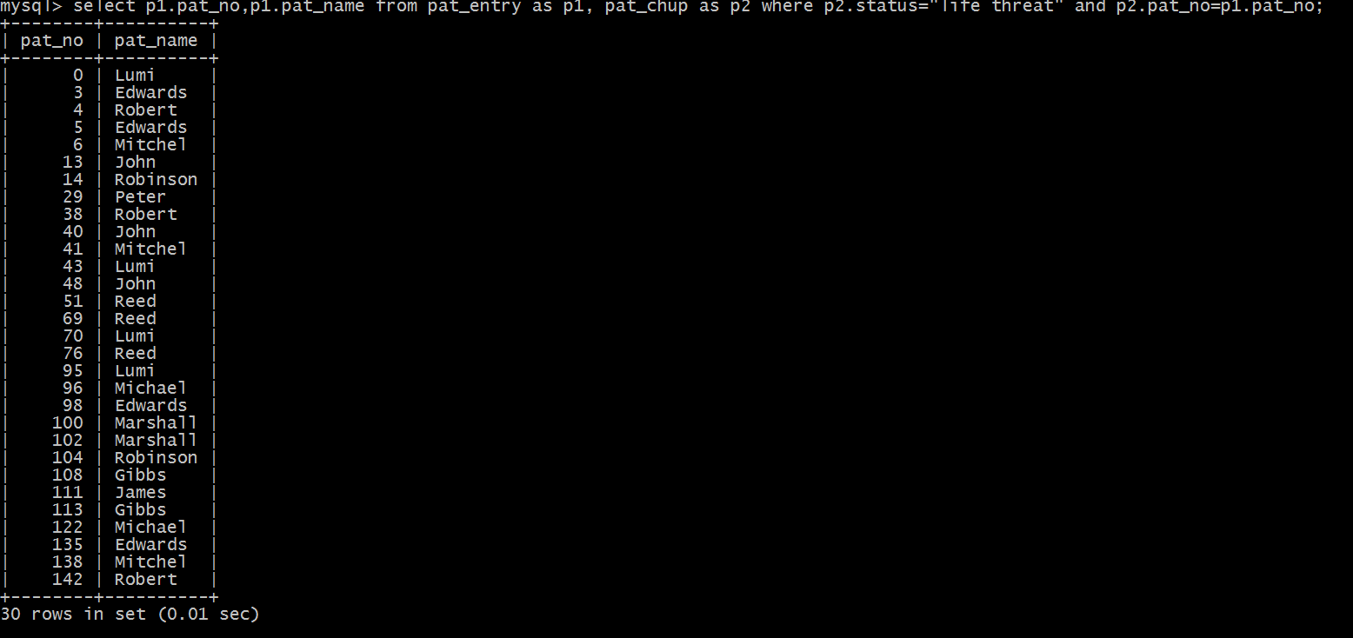

14. select pat_name, pat_no from pat_entry where pat_no in ((select pat_no from pat_chup where diagnosis="cancer")intersect(select pat_no from pat_admit where adv_pymt>50000));

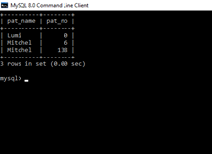

15. select d.doc_name,count(p.doc_no) as No_of_opr from doctors as d natural join pat_opr as p group by p.doc_no order by No_of_opr desc;

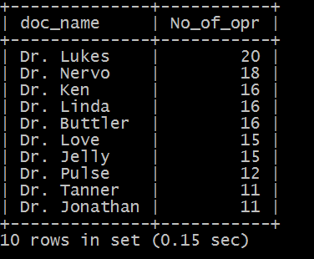

16. select doc_name from doctors as d,pat_entry as p where d.department="Diagnostic imaging" or (p.pat_name="James" and p.rfd=d.doc_no);

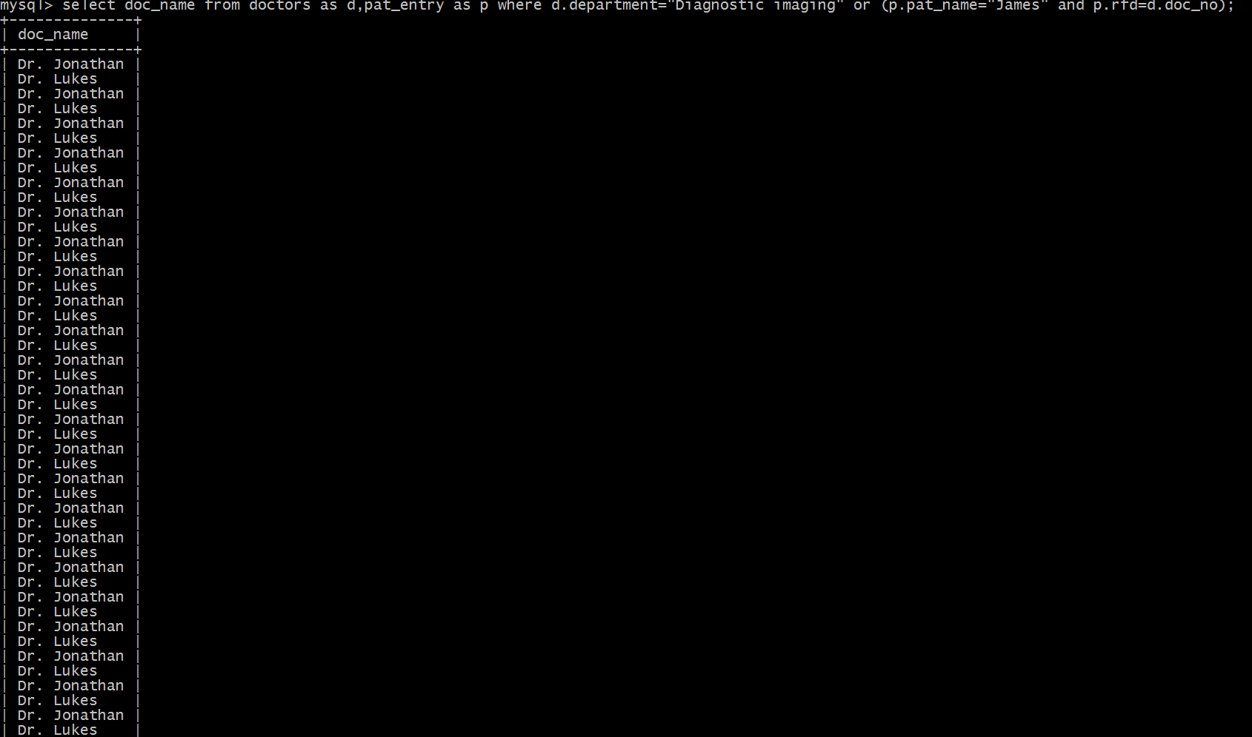

17. select distinct pat_name from pat_entry where rfd in (select doc_no from doctors where doc_name="Dr. Tanner" and doc_name!="Dr. Love");

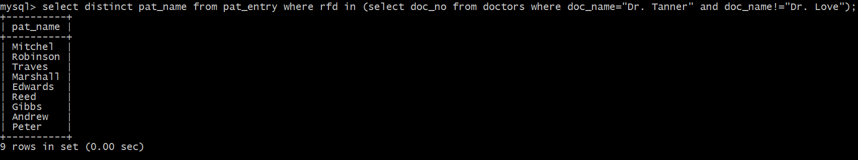

18. select p1.pat_name,p1.pat_no from pat_entry as p1, pat_admit as p2 where p1.pat_no=p2.pat_no and p1.rfd=(select doc_no from doctors where doc_name="Dr. Love");

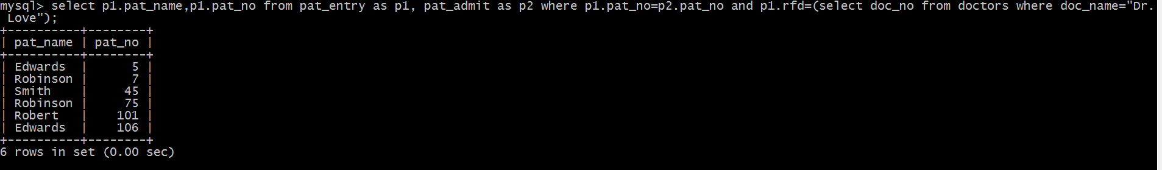

19. select p2.pat_no,p2.room_no from pat_entry as p1, pat_admit as p2 where p2.pat_no=p1.pat_no and p1.rfd=(select doc_no from doctors where doc_name="Dr. Love");

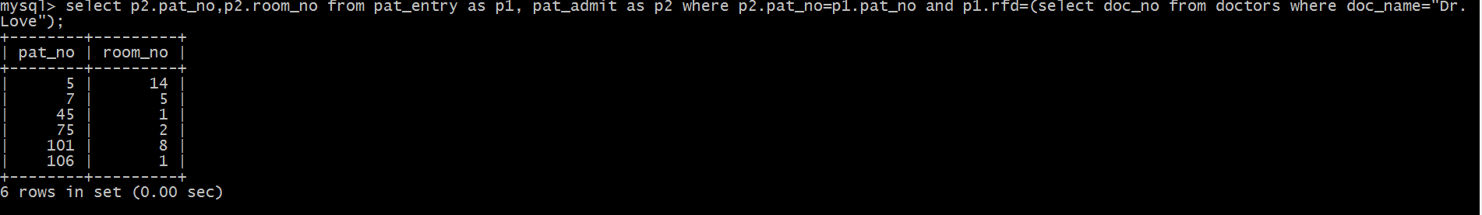

20. select advice_given from pat_dis as p1, pat_opr as p2 where p1.pat_no=p2.pat_no and p2.typeoperation="angioplasty";

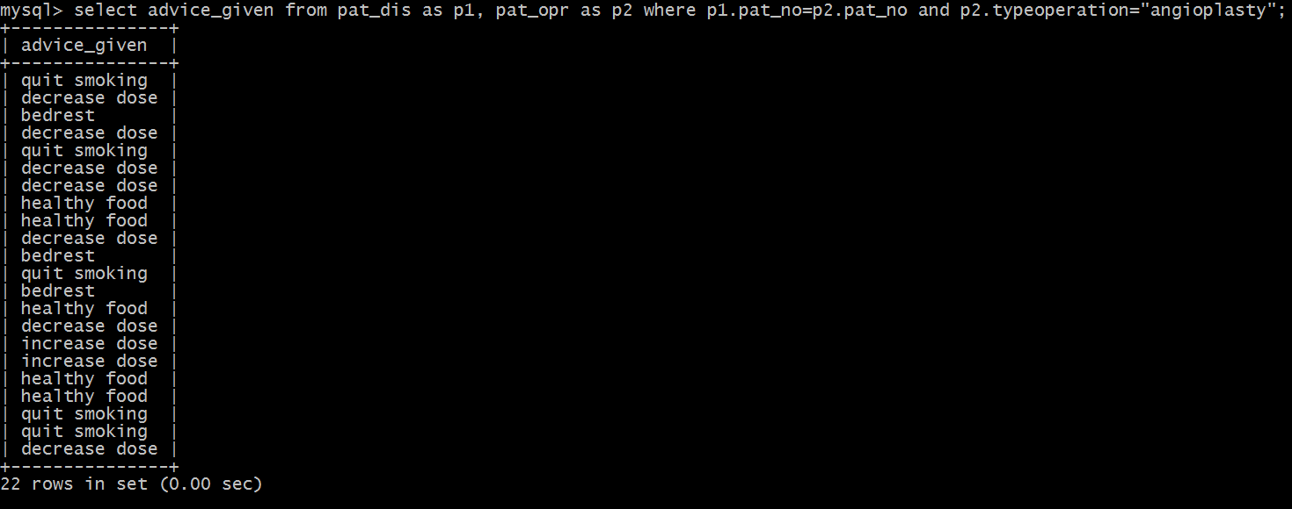

21. select p1.pat_no,medicines as med_operation,medicins as med_discharge from pat_opr as p1 left outer join pat_dis as p2 on p1.pat_no=p2.pat_no;

