**Graph terminology**

In a graph nodes are called vertices. And links between those nodes are called Edges.

A graph can be represented as a ordered pair of vertices and Edges.

G=(V,E)

V represent set of all vertices of the graph

E represent set of all Edges of the graph

using this definition of graph, we can say that a tree is also a graph. since, a tree can also be represented as a ordered pair

of vertices and edges.

An edge of a graph can be uniquely identified by its starting and ending points. so, an edge of a graph can be

represented as a pair (ordered or unordered) of vertices.

E1=(V1,V2) or {V1,V2}

and the set of edges is the unordered collection of these edges.

types of edges: -

1. Directed
2. Undirected

Directed Edges :-

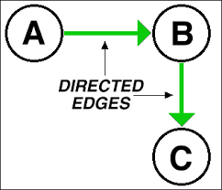

A edge which has a particular direction is called directed edge. Using directed edges, we can only traverse in the direction of that edge. So, in this case an edge is represented as an ordered pair of edges.

E1=(A,B)

E2=(B,C)

Which means edge E1 is directed towards B from A and edge E2 is directed towards C from B.

Undirected Edges: -

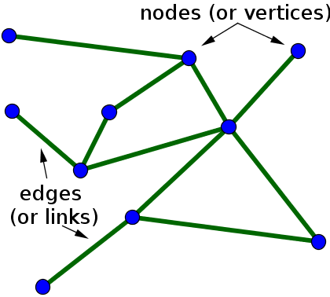

As the name suggest these types of edges don’t have any particular direction. So, it means we can traverse in both directions using these edges.

So, in this case edges are represented as unordered collection of starting and ending points of a particular edge or unordered pair of vertices joined by the edge.

E.g. - E1={V1,V2}

Directed graph: -

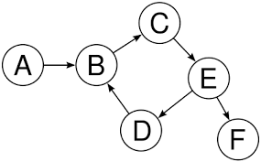

A graph with all directed edges is called directed graph or Digraph.

Undirected graph: -



A graph with all undirected edges is called undirected graph.

Properties of graph: -

Self-loop: - when both vertices of a edge are same then that edge is called self-loop.



Both directed and undirected graph can have a self-loop.

Multi-edge: - when more than one edge starts from one particular vertex and end on same vertex then it is called multi-edge graph.

Multi-edge is also called parallel edge.

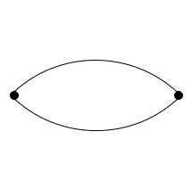

Simple Graph: - if a graph doesn’t contain any self-loop or multi-edges then it is called simple graph.

* Number of edges in a simple directed graph is

0 ≤ |E|≤ n(n-1)

* Number of edges in a simple undirected graph is

0 ≤ |E|≤ n(n-1)/2

Dense graph: - A graph is called dense when it’s total number of edges are close to maximum possible number of edges.

Sparse graph: - A graph with too few edges are called sparse graph. Typically, in a sparse graph total number of edges are close to total number of vertices in the graph.

Path: - A path in a graph is defined as a sequence of vertices where each adjacent pair of vertices are joined by an edge.

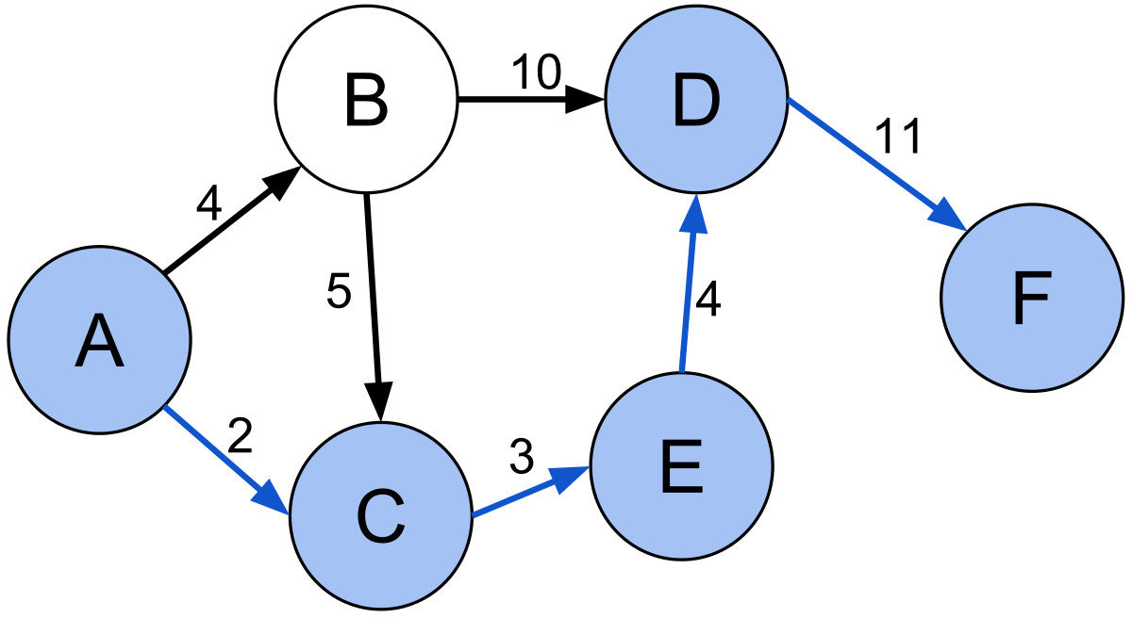

So <A, C, E, D, F> represent a path. Similarly, <A, B, D, F> also represent a path.

Simple Path: - A path which has no vertices repeated(and thus no repeated edges ) are called simple path.

Let’s suppose the above drawn graph is undirected.

Path <A, C, E, D, F> is a simple path while <C, E, D, B, C, A> is not a simple path as it has a vertex repeated.

* In most cases when path is used in graph theory it means simple path and when vertices can be repeated then we use the term “walk” in place of path .

Length of a walk: - the number of edges in a path is called length of a walk.

Closed walk: - A walk is called closed walk if it starts and ends at same vertex and length of the walk is greater than 0.

Simple cycle: - A cycle in which there is no other repetitions of vertices other than start/end vertex.

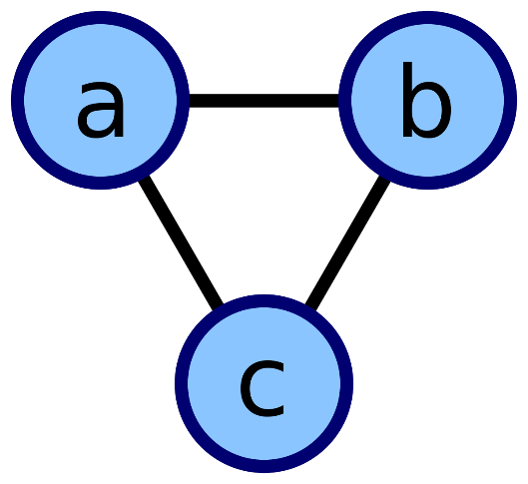

Acyclic graph: - A graph with no cycles is called Acyclic graph. E.g.- a tree. Both directed and undirected graph can be a Acyclic graph.

Degree of a vertex: - number of edges going through that vertex.

In-degree: - it is only defined for directed graph. In-degree represents the number of edges coming in to the vertex.

Out-degree: - it is only defined for directed graph. Out-degree represents the number of edges coming out of the vertex.

* Sum of all indegrees = number of edges