**Project Structure**

The main components and files of the project are organized as follows:

/document_management

│

├── backend/

│ ├── main.py # FastAPI main application file

│ ├── auth.py # Authentication logic

│ ├── database.py # Database configuration and session management

│ ├── file_storage.py # File handling for AWS S3

│ ├── nlp_processing.py # NLP-based document querying

│ ├── models.py # Database models for User and Document

│ ├── parsing.py # Document parsing utility

│ └── Dockerfile # Backend Dockerfile

│

├── frontend/

│ ├── public/

│ │ └── index.html # HTML template for the React app

│ ├── src/

│ │ ├── components/

│ │ │ ├── UploadForm.js # Component for file upload

│ │ │ └── QueryComponent.js # Component for querying documents

│ │ └── App.js # Main React application

│ ├── Dockerfile # Frontend Dockerfile

│

└── docker-compose.yml # Docker Compose file for orchestrating services

└── .env # Environment variables file (excluded from version control)

**1. Application Overview**

This diagram represents the overall structure of DOCZY, showing interactions between frontend, backend, AWS S3, and the PostgreSQL database.

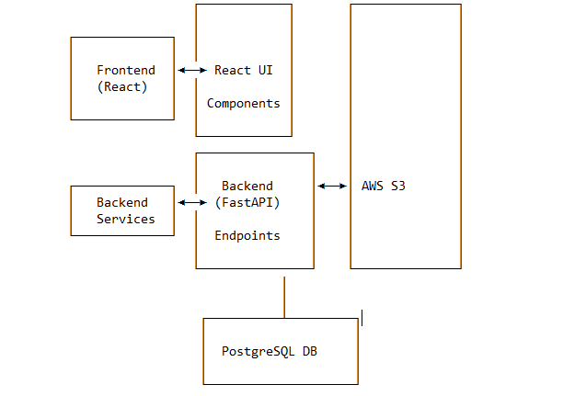

**2. Backend Module Breakdown**

This structure shows a more detailed view of the backend components, illustrating how each module interacts to fulfill core functions.

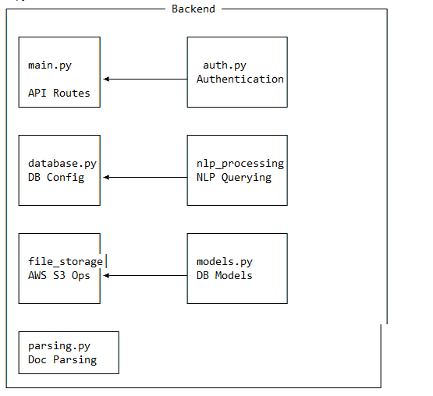

**3. Data Flow Diagram**

This diagram outlines the data flow across the system when a user uploads a document or performs a query.

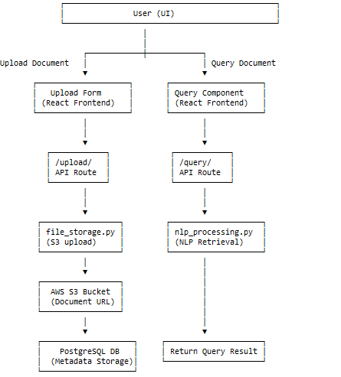

**4. Database Models Overview**

This diagram displays the database model relationships in the PostgreSQL database.

