Sprint 1
Problem statement: When the factory is full, urgent reorders are sent to one of 8 outside workshops through a quick group-chat message. The person deciding has to work out whether each workshop can make the product, has free capacity, and is allowed to take the job. One wrong call sends the batch back and the deadline is missed, and nobody records why that workshop was chosen. In a sample inbox of 30 requests, 7 are ambiguous or missing key details, and 4 ask for a workshop that isn't allowed to take the job.
Proposed solution: a dispatcher desk that reads chat requests, checks every workshop against the data, estimates delivery date and cost for each candidate, recommends one with the reasoning, and keeps an auditable record after a human confirms it.
Primary objective: Minimise lateness
Secondary objective: Robust to failure & hybrid
System Architecture
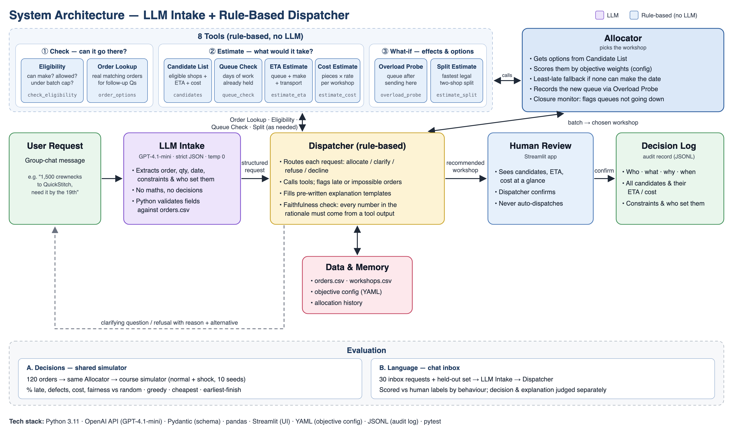
Business Value:
- Customer experience (on-time delivery): reorders reach customers on time. In the shared simulator, late batches drop from 34% (random allocation) to under 2% with our allocator.
- Operational efficiency: the decision no longer depends on one dispatcher's memory. Every request is checked against all 8 workshops, and incomplete or ambiguous messages get a follow-up question instead of a wrong guess.
- Audit trail: every decision is stored with the options considered, the numbers behind them, and who set each constraint, so it can be reviewed weeks later.
- Fewer bounced batches and better resilience: no batch goes to a workshop that can't take it (0 ineligible allocations in 200 simulator runs). When a workshop suddenly closes, late batches only rise from 1.7% to 1.9% (random: 34% → 38%).
Risk Assessment:
# | Risk | Prob. | Impact | Mitigation
1 | LLM mis-extracts a request (wrong order, quantity or date) | Med | High | Python cross-checks extracted details against data; human confirmation before logging
2 | Explanation includes a made-up number | Med | High | Faithfulness checker blocks unsupported numbers; explanations are filled from templates using tool outputs
3 | Evaluation is biased because labels were written after the system was built | High | Med | Two independent reviewers label and reconcile the 30 requests; write fresh held-out requests and report them separately
5 | Simulator assumptions differ from reality | Med | Med | State the simulator's assumptions clearly; present results as simulator evidence, not real factory figures
6 | API cost or outage during the demo | Low | High | Save AI replies so the demo can run offline; the simulator needs no AI at all

Sprint 1 (Progress)
What we have built so far:

What we've built so far
- AI reads the message: the LLM pulls out the order, quantity, deadline and any instructions from a group-chat message.
- Rules decide what to do: Python checks each detail against the order data, then recommends a workshop, asks a follow-up question, refuses an unsuitable workshop (giving the reason and an alternative), or says the data can't answer it.
- 8 calculation tools + an allocator: the tools check who can take the job, how busy each workshop is, when it would come back, what it would cost, and whether splitting helps. The allocator then picks the best one.
- Choice of goal: the team can switch between on-time delivery, quality, fair sharing of work, or a mix, by changing a settings file rather than the code.
- Number check: every number in the explanation must come from a tool, or the answer is blocked.
- Dispatcher app (Streamlit): shows the recommendation and all options side by side. Nothing is saved until the dispatcher confirms.
Assumptions:
- Workshop profile cards (capacity, queue, status, defect rate) are accurate on the day of the decision
- Delivery time = queue + making time + transport
- The AI can reliably pull the right details out of short, informal chat messages
- A dispatcher will review and confirm each recommendation rather than auto-send it
- Cost = pieces × per-piece rate (no transport or rework fees)

Sprint 2 development roadmap

Area | Priority | Description
Human labelling of the 30 requests | High | Two reviewers label independently, then reconcile (eval/labeling/)
Live inbox evaluation | High | Run all 30 requests through the live LLM; score the decision and the explanation separately
Held-out test set | High | Write 10+ new unseen chat requests so we don't tune on the evaluation set
Demo online | High | Deploy the app to Streamlit Cloud; make the GitHub repo public; check both links work
Sprint 2 video and demo | High | 5-minute video covering the objective, the tech and a live demo
Dispatcher UI polish | Med | Recommendation, candidates and ETAs visible at a glance; faster confirm flow
Remember the follow-up conversation | Med | When the user answers a follow-up question, combine the reply with the original message
Let the dispatcher choose a different workshop | Low | Add an override option, with the reason saved in the log
Measure response time | Low | Time each request from message to recommendation

Success Criteria
Proving the chat side works
Roadmap item | Success looks like | Target
Human labelling | All 30 requests labelled by two reviewers, with disagreements resolved | 30/30 labelled
Live inbox evaluation | Correct response overall (recommend / ask / refuse / can't answer) | At least 26 of 30 (85%)
 | Unclear or incomplete requests: asks instead of guessing | 7/7
 | Unsuitable workshop suggested: refuses with the right reason and offers an alternative | 4/4
 | Can't be answered from the data: says so instead of inventing | 3/3
 | Impossible deadline: says so, gives the earliest date and options | 3/3
 | Instructions followed (e.g. "keep it away from BudgetWorks") and recorded with who gave them | 6/6
 | Explanations containing a number that didn't come from a tool | 0
Held-out test set | 10+ new requests run and reported separately from the 30 | Reported, whatever the score

Making the app usable
Roadmap item | Success looks like | Target
Demo online | GitHub and demo links open from any computer | Both working
Dispatcher UI polish | Recommendation, ETA and cost visible without scrolling or clicking | Yes
Remember the follow-up | After a follow-up question, the user can reply with just the missing detail (e.g. "ORD-020") and get a recommendation | Works for the unclear and missing-info requests
Dispatcher override | Dispatcher can pick a different workshop; the reason is saved in the log | Working, with reason logged
Response time | Time from message to recommendation | Under 10 seconds

Simulator
Criterion | Target
Fewer late orders than all 3 baselines | Lower % late than random, biggest and cheapest
Robustness & and hybrid reported | Report against baseline

