Readme
Threadline, Group 01, Track 2. This page shows how to install Threadline on your own computer and check that it works. The quickest check needs no API key and takes about two minutes.
Code: https://github.com/apurwakumari16nus/Track2_Dispatcher
Demo link: TO BE ADDED BEFORE SUBMISSION

What you need
To do this | You need
Simulator, tests, offline evaluation | Python 3.11+, uv, Git. No API key
Web desk with live reading | The above, plus an Anthropic API key with credit
iPhone app | A Mac with Xcode 26 or newer and iOS 26. A simulator is enough. A real phone also needs your own Apple developer team
Telegram | A bot token from @BotFather and a group with Topics turned on
Live spoken words | whisper-cli from whisper.cpp and a small English model. Optional: without it, the phone's own words stand

No Java, database, Node.js or GPU is needed.

Set up
Mac or Linux:
git clone https://github.com/apurwakumari16nus/Track2_Dispatcher.git
cd Track2_Dispatcher
uv sync
cp .env.example .env
Windows PowerShell:
git clone https://github.com/apurwakumari16nus/Track2_Dispatcher.git
cd Track2_Dispatcher
uv sync
Copy-Item .env.example .env
For live reading, open .env and set these. Never commit this file.
LLM_PROVIDER=anthropic
ANTHROPIC_API_KEY=your-key
ANTHROPIC_INTAKE_MODEL=claude-sonnet-5-5
Run every command from the repository root. Keep data/ beside harness/.

Check it works, with no API key
uv run pytest -q
uv run python eval/run_simulator.py --output-dir /tmp/threadline_sim
uv run python harness/simulate.py --shock --seeds 10
You should see 592 tests pass. /tmp/threadline_sim/results.csv should match eval/results.csv exactly.

Run the web desk
uv run streamlit run src/app.py
Open http://localhost:8501. Keep the date at 01/04/2026 and the objective at Minimise lateness, pick request R09, and evaluate it. The desk should recommend Nimble Needle, back on 4 April with five days to spare, at a cost of 180. Pressing Confirm writes one line to the local log. Nothing is sent to any workshop.
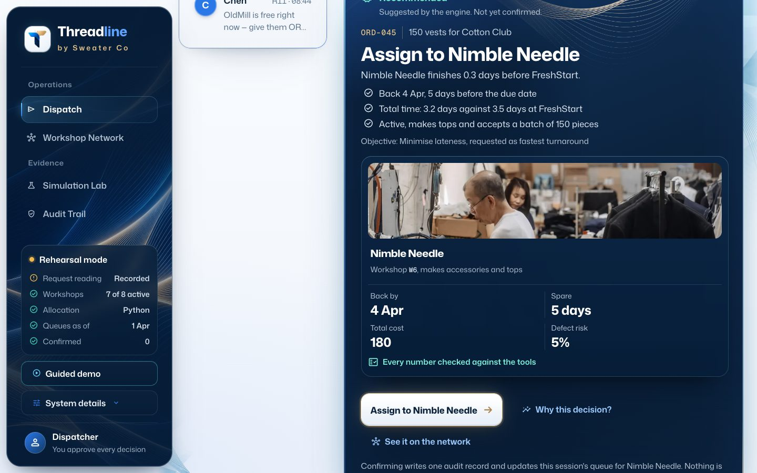
The web desk recommending Nimble Needle for request R09.
With no API key, open System details in the sidebar and choose Rehearsal: test fixtures. These are labelled synthetic extractions, not model output.

Run the iPhone app in a simulator
Start the desk in one terminal:
uv run python src/api.py
Then open ios/Threadline.xcodeproj in Xcode, pick an iPhone simulator and press Run. The app connects to http://127.0.0.1:8600. The desk starts in demo mode, which writes only to rehearsal logs and begins from eight earlier decisions. Without an API key it reads from test fixtures. In the simulator, speech is a labelled sample sentence, because there is no dependable microphone.
If you change ios/project.yml, run xcodegen generate in ios/.

On a real iPhone
- Set your own team in Xcode under Signing and Capabilities. The committed project uses ours.
- Put the Mac and phone on one network. The phone's hotspot is the most reliable.
- Run the desk on the network. It needs a token so nobody else can use it:
THREADLINE_API_TOKEN=pick-a-token uv run python src/api.py --lan
- Run the app from Xcode. In Settings, enter http://<your Mac's name>.local:8600 and the token.
Lock Screen updates with the app closed need an Apple push key (ios/AuthKey_XXXXXXXXXX.p8), which is never committed. Without one, the Island catches up when you open the app.

Connect Telegram (optional)
- Set TELEGRAM_BOT_TOKEN in .env, and make one group with Topics turned on. Add the bot.
- Send /chatid, and add the ID to TELEGRAM_ALLOWED_CHATS.
- In a topic per workshop or client, send /iam QuickStitch or /iam Cotton Club. Send /iam Team in the team's topic.
src/api.py runs the bot itself, so do not also run src/telegram_bot.py. This link-up passes automated tests with a stand-in and has not been tried in a real group.

Reproduce the evaluation
No API key is needed for any of these. They re-score recorded model replies or use no model.
uv run python eval/replay_cache.py eval/guardrails_v2/sonnet_dev/inbox_audit.json /tmp/cache_dev
uv run python eval/run_inbox.py --offline --cache-dir /tmp/cache_dev --model claude-sonnet-5-5 --labels eval/labels_v2.csv --output-dir /tmp/dev
uv run python eval/replay_cache.py eval/guardrails_v2/sonnet_heldout/inbox_audit.json /tmp/cache_held
uv run python eval/run_inbox.py --offline --cache-dir /tmp/cache_held --model claude-sonnet-5-5 --labels eval/labels_heldout_v2.csv --requests data/heldout_requests.txt --output-dir /tmp/held
uv run python eval/run_inbox.py --offline --cache-dir eval/heldout_round2/cache --model claude-sonnet-5-5 --labels eval/labels_heldout_round2.csv --requests data/heldout_round2_requests.txt --output-dir /tmp/round2
uv run python eval/run_redteam.py --offline --output-dir /tmp/red
uv run python eval/run_rule_baseline.py
uv run python eval/run_explanation_review.py eval/guardrails_v2/sonnet_dev/inbox_audit.json eval/guardrails_v2/sonnet_heldout/inbox_audit.json
Expected: 30/30 behaviour and 29/30 decision on the supplied set, 15/16 and 15/16 on held-out, 34/34 and 33/34 on Round 2, 16/16 behaviour on the red team. The first Round 2 run, before its fixes, scored 33/34 and 32/34 and is saved in eval/heldout_round2/. The last two commands rewrite eval/rule_baseline/ and eval/explanation_review.csv.
A live run (uv run python eval/run_inbox.py) makes 30 model calls and needs a key.

Where things are
Path | What it holds
src/ | Desk: intake, guards, tools, allocator, control, API, Telegram, web UI
ios/ | iPhone app, widgets, Siri intents
harness/, data/ | Unchanged course simulator and data, plus held-out and red-team requests
eval/ | Runners, labels, recorded results
tests/ | Automated tests. No model calls by default
docs/ | Design and specification notes. Start with docs/design/mobile_app.md

Troubleshooting
You see | Do this
Language model not configured | Add the key to .env, or choose a rehearsal source
The app cannot reach the desk | Start src/api.py first. On a phone, check that the address and token are right and that both devices are on the same network
The phone app is slow | Xcode's scheme runs Release. Debug builds are much slower on a phone, and Low Power Mode slows it too
Set THREADLINE_API_TOKEN first | --lan needs a token, as above
Data file not found | Run from the repository root

