Monthly crime trends: global patterns and city departures
Andrew P. Wheeler

Introduction
Crime trends are often summarized with two numbers and a percent change. That is convenient, but it makes normal volatility look important and hides whether a change is temporary or sustained. Prior work has shown how time-series graphs, prediction intervals, and fan charts give a more honest picture of crime trends than binary before-and-after comparisons (Wheeler 2016; Wheeler and Kovandzic 2018; Yim, Riddell, and Wheeler 2020). Those tools answer whether a recent observation is unusual. Here I address a related question: what part of a city’s change is shared with other cities, and what part is local?
There are at least three patterns worth separating. Crime can follow a gradual trend shared across the country, a city can have a persistently different trajectory or seasonal pattern, and an individual month can depart sharply from both. Lumping those patterns into one residual term makes a short-lived spike look like a new trend (or smooths away a local trend that is actually different).
I use monthly reported crime from the Real-Time Crime Index (RTCI) (AH Datalytics 2026) and fit a hierarchical binomial model separately for 7 offenses. The model has a smooth trend and seasonal pattern shared across the sample, but it also gives every city its own partially pooled trend and season. Two additional terms separate monthly movement shared by all cities from the remaining city-month variation.
The goal is descriptive. The model provides a practical way to compare the national pattern, sustained city departures, and unusual months. It is not a test of why crime changed, and it is not a forecasting model.

Data and rate construction
I use 458,392 city-month-offense observations from 586 RTCI cities, covering 7 offenses from January 2017 through May 2026. I do not impose a population threshold. For the figures, a monthly count $Y$ and population $N$ are displayed as $12\left(Y/N\right)100,000$. This is an annualized rate per 100,000: it preserves the observed monthly count but puts cities on a familiar scale.
The upstream files used for this build were downloaded on August 5, 2026 at 13:22 UTC. Before rendering, the workflow checks the current RTCI file revisions and atomically replaces only source files whose contents changed. A content-signature change triggers the sequential model workflow; otherwise the validated checkpoints are reused. Exact upstream revisions and local checksums are stored with the source metadata and city crosswalk. This keeps the paper and application reproducible while separating reported counts from model-generated output. Data preparation uses R and the tidyverse (R Core Team 2026; Wickham et al. 2019).

Model
The practical goal is to distinguish level, trend, season, common monthly movement, and local monthly noise. I fit a separate aggregated-binomial generalized linear mixed model for each offense. This is equivalent to a stacked model with no coefficients shared across offenses, but it avoids building all 7 random-effect systems at the same time. For city $i$ in month $t$,
$$Y_{it}∼Binomial\left(N_{it},p_{it}\right),$$
$$logit\left(p_{it}\right)=α+B{\left(t\right)}^{T}β+F{\left(m_{t}\right)}^{T}γ+b_{i}+B{\left(t\right)}^{T}u_{i}+F{\left(m_{t}\right)}^{T}v_{i}+a_{t}+e_{it}.$$
The global intercept is $α$. The vector $B\left(t\right)$ contains five natural cubic spline basis functions evaluated at time $t$, with boundary and interior knots fixed from the complete analysis period. Its fixed coefficients $β$ define the smooth global long-run trajectory. The vector $F\left(m_{t}\right)$ contains sine and cosine pairs for the first three annual harmonics; $γ$ therefore defines a smooth seasonal curve that joins continuously from December to January. Natural cubic regression splines provide a low-rank representation of gradual change, while paired Fourier terms provide a direct cyclic representation of seasonality (S. N. Wood 2017).
The city random intercept $b_{i}∼N\left(0,σ_{b}^{2}\right)$ captures persistent between-city differences in level. Each city also has its own trend-basis coefficients $u_{i}$ and seasonal-basis coefficients $v_{i}$:
$$u_{i}∼N\left(0,σ_{u}^{2}I_{5}\right), v_{i}∼N\left(0,σ_{v}^{2}I_{6}\right).$$
Thus the city trend is the global trend plus $B{\left(t\right)}^{T}u_{i}$, and the city seasonal curve is the global seasonal curve plus $F{\left(m_{t}\right)}^{T}v_{i}$. These are the city-varying smooth terms: partial pooling shrinks weakly supported departures toward the global curves instead of fitting an unrelated curve to every city. This global-plus-deviation construction follows the logic of factor-smooth comparisons described by Simpson (2017) and hierarchical GAMs more generally (Pedersen et al. 2019), implemented here through explicit low-rank random coefficients.
The time-period intercept $a_{t}∼N\left(0,σ_{a}^{2}\right)$ is shared by all cities observed in month $t$. It captures nonsmooth national monthly departures after the global trend and cyclic seasonal curve have been fitted. The final term is an observation-level random effect, $e_{it}∼N\left(0,σ_{e}^{2}\right)$, unique to city $i$ in month $t$. It accommodates extra-binomial variation without changing the binomial response distribution. The distinction matters. The term $a_{t}$ moves every city in a given month, whereas $e_{it}$ belongs to one city and one month.
In the fitted glmmTMB model, the corresponding computational specification is
cbind(count, trials - count) ~ 1 +
trend_b1 + ... + trend_b5 +
season_s1 + season_c1 + ... + season_s3 + season_c3 +
(1 | city_id) + (1 | time_period) +
homdiag(0 + trend_b1 + ... + trend_b5 | city_trend_group) +
homdiag(0 + season_s1 + ... + season_c3 | city_season_group) +
(1 | cell_id)
Here homdiag assigns one estimated variance to all coefficients in a basis block, sets their correlations to zero, and allows the coefficients to vary by city. Despite their names, city_trend_group and city_season_group do not combine cities into artificial groups. Each is a one-to-one copy of city_id with the same 586 levels. The copies let glmmTMB represent the city intercept, city trend coefficients, and city seasonal coefficients as three independent covariance blocks; every city still receives its own five trend and six seasonal coefficients. homdiag is a parsimonious ridge penalty: replacing it with diag would estimate a separate variance for each basis coefficient, while an unstructured block would also estimate their correlations. The homogeneous assumption is computationally stable but depends on the scaling of the chosen basis. The natural-spline knots and boundary knots are cached with each fitted object, as are the three seasonal harmonics, so later predictions use exactly the estimation bases. Models are estimated by restricted maximum likelihood with glmmTMB, whose Template Model Builder backend uses automatic differentiation and sparse random-effect calculations (Brooks et al. 2017; Kristensen et al. 2016). Each complete fitted model is saved and reload-verified before the next offense begins.
Predictions are reported at four levels. The global curve contains the intercept and fixed trend and seasonal basis terms. The city curve additionally contains $b_{i}+B{\left(t\right)}^{T}u_{i}+F{\left(m_{t}\right)}^{T}v_{i}$. The shared time-period remainder adds $a_{t}$, and the final fitted value adds $e_{it}$. There is no continuity correction or constructed “stabilized probability”; zeros are valid binomial outcomes and all displayed components come directly from the fitted model.

Computational implementation
I first implemented the model with mgcv factor smooths through gamm4: global thin-plate and cyclic smooths were combined with city-specific fs trend and seasonal smooths, while lme4 represented the city, time-period, and observation-level intercepts (S. N. Wood 2011, 2017; S. Wood and Scheipl 2025; Bates et al. 2015). That model worked on reduced sets of cities and years. The full offense data were a different problem. Linux runs used more than 20 GB of memory before completing, and Windows runs repeatedly terminated inside the sparse Matrix factorization. A model that works only on a large rented machine is not a useful default for this project.
The final implementation retains the structure that motivated the factor-smooth model—a global intercept, global trend and season, city random intercepts, city-varying trend and season, a common month effect, and an observation-level effect—but changes its computational representation. The explicit five-column natural-spline and six-column Fourier bases make the size of each city’s coefficient block fixed and transparent. Fitting those blocks with glmmTMB reduced the full model to a sparse random-coefficient problem that could be estimated and reload-verified one offense at a time. This is not a general claim that mgcv factor smooths are infeasible. It is a practical result for this combination of 586 cities, 458,392 city-month-offense observations, two city-varying bases, and an observation-level random effect.

Global trends
Figure 1 shows the gradual change shared across cities after removing seasonal, city-specific, and monthly variation. I use a separate vertical scale for each offense; otherwise property crime would flatten the lower-rate murder and rape series. Figures are produced with ggplot2 (Wickham 2016). From January 2017 through May 2026, the fitted burglary trend declined by 62.7%, robbery by 56.5%, murder by 35.9%, and theft by 32.5%. Assault was the exception: its fitted global trend ended 9.3% above its January 2017 level. These endpoint comparisons summarize the curves; they are not causal estimates. The paths between the endpoints are more useful than the percentage alone.
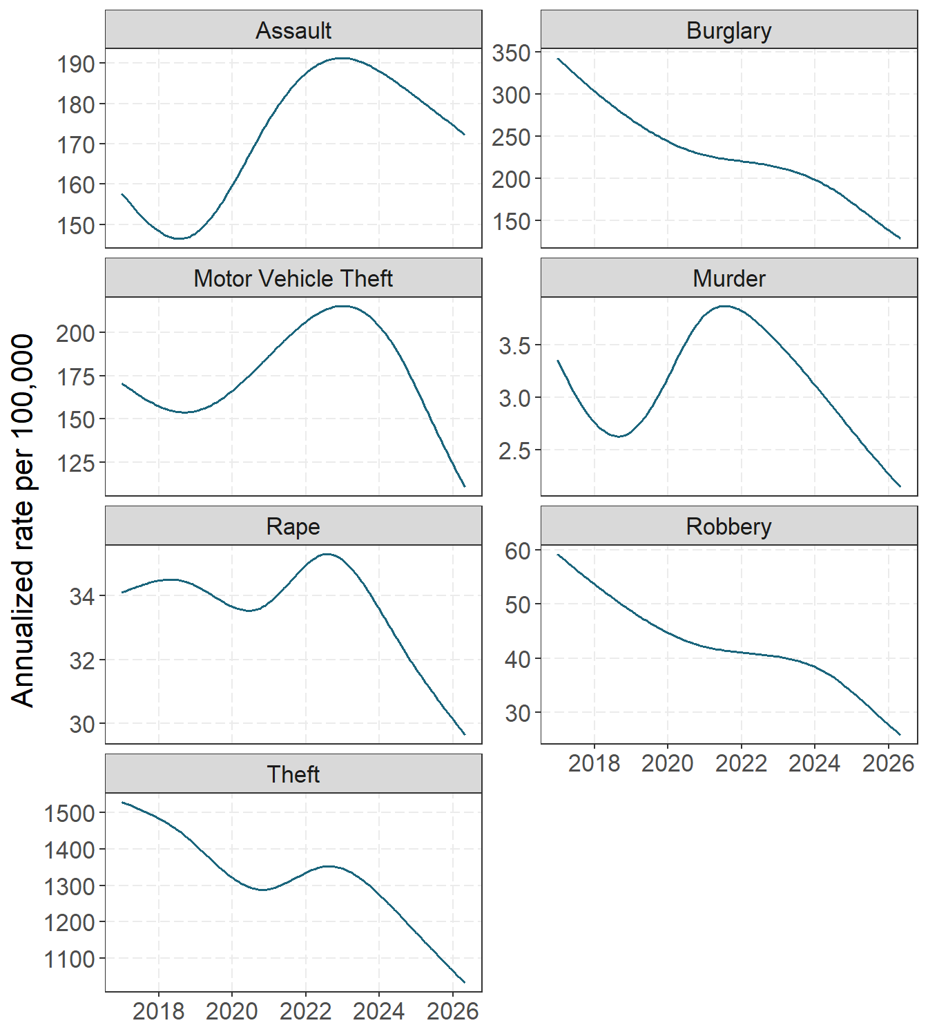
Figure 1: Estimated global long-run trend for each offense, expressed as an annualized rate per 100,000. Each panel has its own vertical scale so that the shape of lower-rate offenses remains visible. The curves exclude city intercepts, city-specific smooth departures, and observation-level residuals.

Global seasonal patterns
Figure 2 answers a simple question: after accounting for the long-run trend, which months tend to be higher or lower? Values above zero are months above the fitted trend, and values below zero are months below it. The effect is displayed on the annualized rate scale, so its magnitude depends on the baseline rate for the offense as well as the logit-scale seasonal curve.
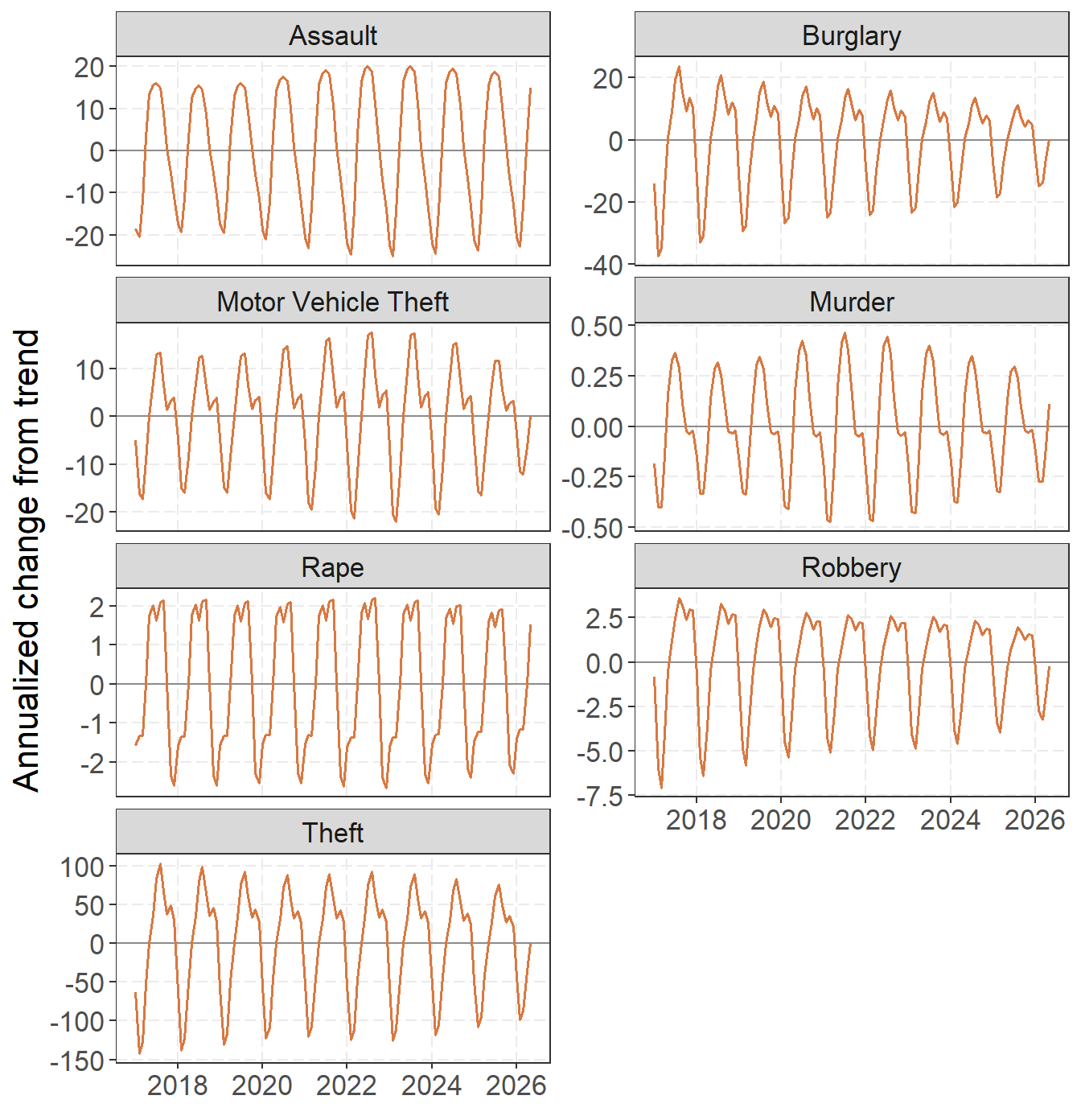
Figure 2: Estimated global cyclic seasonal departure for each offense on the annualized rate scale. Zero denotes the corresponding global trend; positive values indicate months above that trend and negative values indicate months below it. Panels use offense-specific vertical scales.

A city example: Philadelphia

Robbery
Philadelphia robbery illustrates what each layer adds. The global curve is the robbery pattern shared across the sample. The city curve adds Philadelphia’s level, trend, and seasonal departures. The observed series is much noisier because it also includes shared monthly movement and the Philadelphia-specific city-month residual.
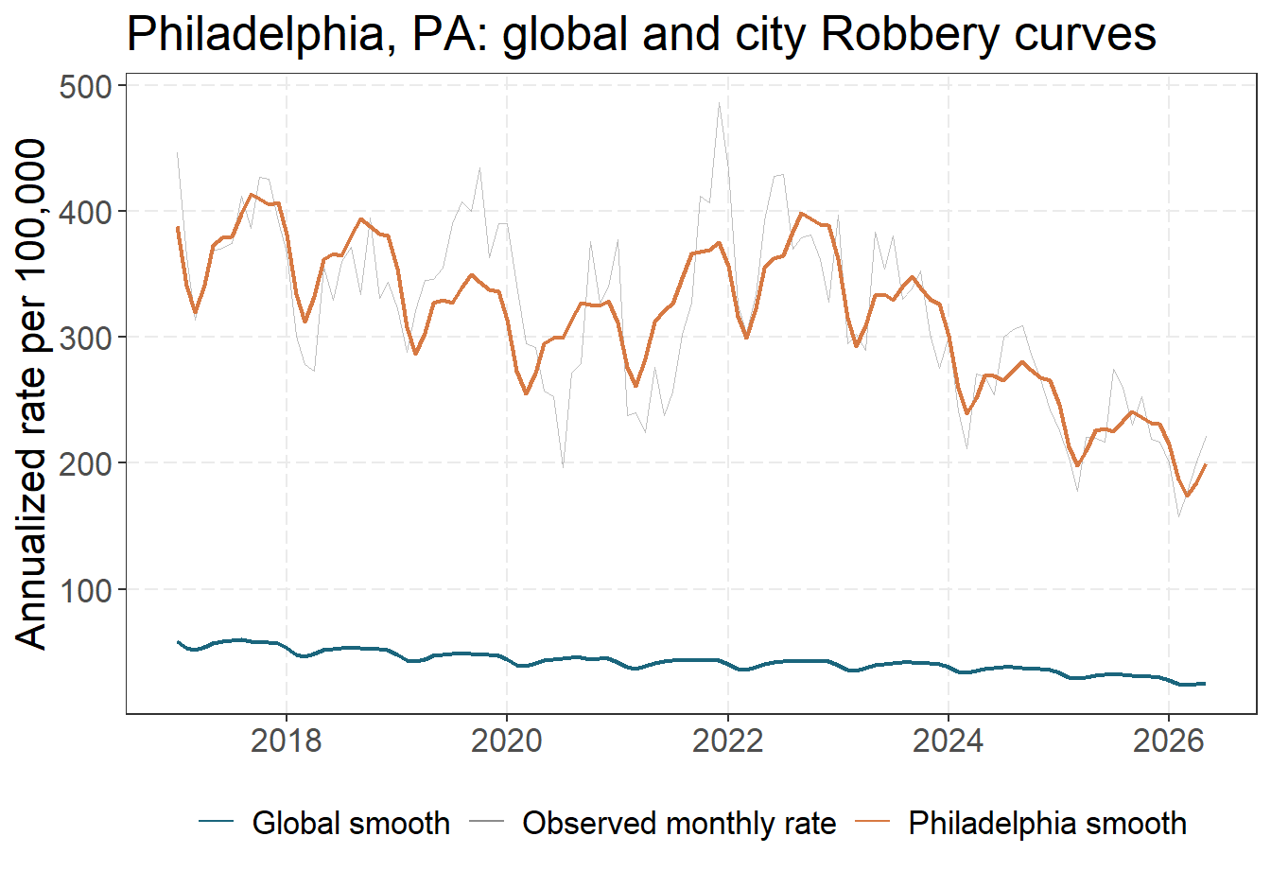
Observed robbery rate and fitted global and Philadelphia curves.
Across the series, Philadelphia’s fitted city curve differs from the global curve by an average of 2.01 on the logit scale. That average includes the city intercept. The departure ranges from 1.83 in March 2017 to 2.23 in October 2022; movement within that range reflects the city-specific trend and seasonal deviations. The largest fitted monthly row residual occurs in July 2020. It is not folded back into either smooth curve, which keeps an unusual month from being mistaken for a persistent local trajectory. Figure 3 compares like components directly. The trend panel removes intercepts and centers both curves, so it compares shape rather than level. The seasonal panel superimposes Philadelphia’s fitted seasonal pattern on the global pattern. The residual panel compares the time-period effect shared by the full sample with Philadelphia’s total monthly residual, $a_{t}+e_{it}$. Shaded ribbons around the Philadelphia trend and seasonal curves are approximate 95% pointwise conditional intervals for the city-specific coefficient deviations.
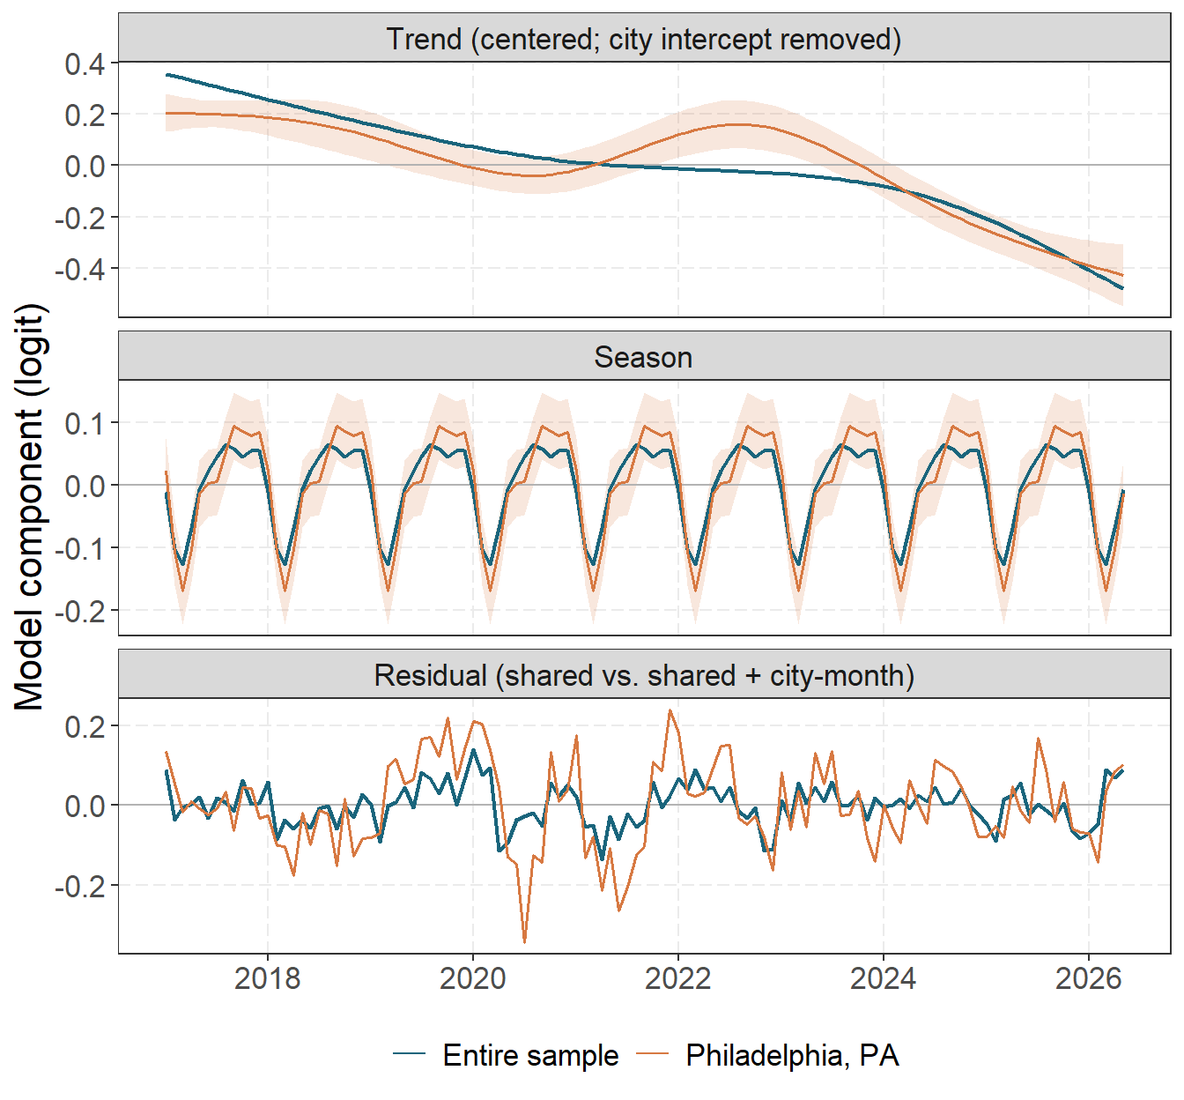
Figure 3: Philadelphia and full-sample robbery components on the logit scale: centered long-run trends with the city intercept removed (top), Fourier seasonal curves (middle), and the sample-wide time-period residual compared with Philadelphia’s time-period plus city-month residual (bottom). Shading gives approximate 95% pointwise conditional intervals for Philadelphia’s trend and seasonal deviations.

Burglary
Philadelphia burglary provides a useful contrast because several abrupt 2020 changes are visible in the reported series but should not be absorbed into the city’s long-run trend. In the RTCI source snapshot downloaded on August 5, 2026 at 13:22 UTC, Philadelphia reported 722 burglaries in May, 1,347 in June, and 986 in October 2020. Those counts correspond to annualized monthly rates of 554.5, 1034.6, and 757.3 per 100,000, respectively. These values are calculated directly from RTCI’s reported count and population fields, rather than from a model-generated artifact.
Figure 4 shows that the partially pooled city curve remains smooth through these spikes. This is intentional: the smooth trend and season describe persistent structure, while isolated city-month departures belong to the residual term. The largest fitted Philadelphia burglary row residual occurs in June 2020.
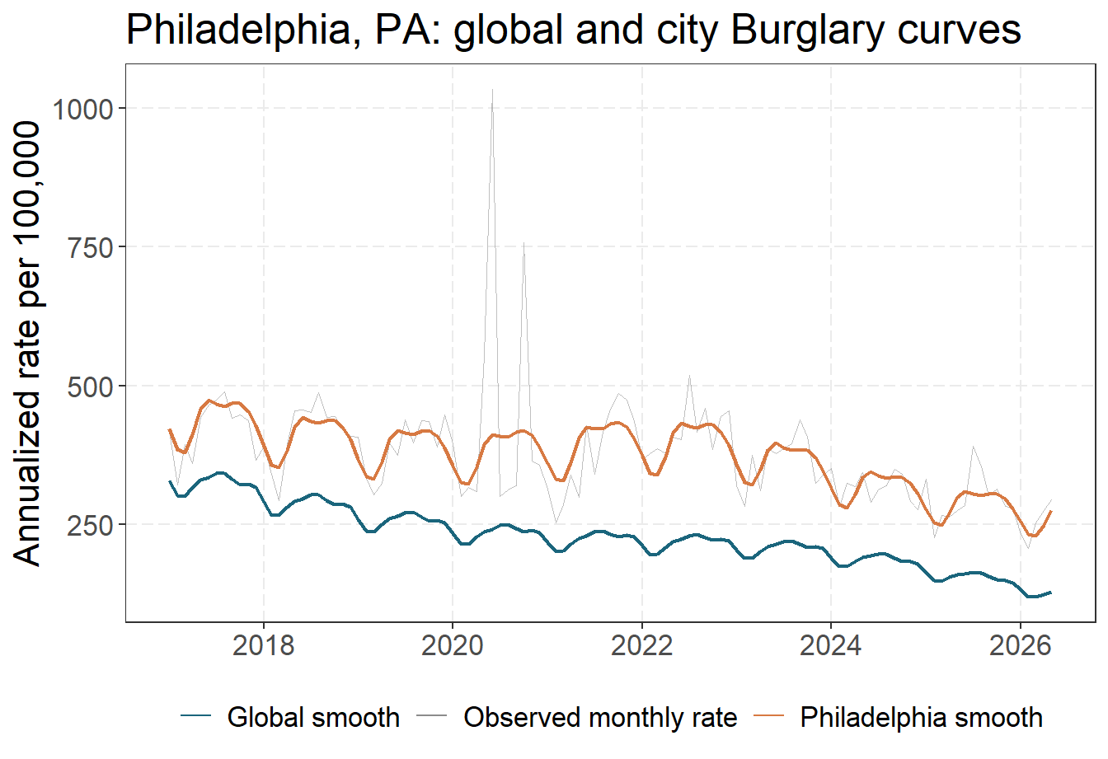
Figure 4: Philadelphia burglary rates: reported monthly observations, the global structural curve, and Philadelphia’s fitted city curve. The pronounced May, June, and October 2020 observations come directly from the RTCI source counts; the smooth curves exclude shared time-period and city-month residual effects.

Figure 5 separates the same series into trend, season, and residual components. The centered trend panel removes Philadelphia’s city intercept; the seasonal panel compares like Fourier components; and the bottom panel shows how the city-month term isolates the abrupt burglary departures from the residual movement shared by the national sample.
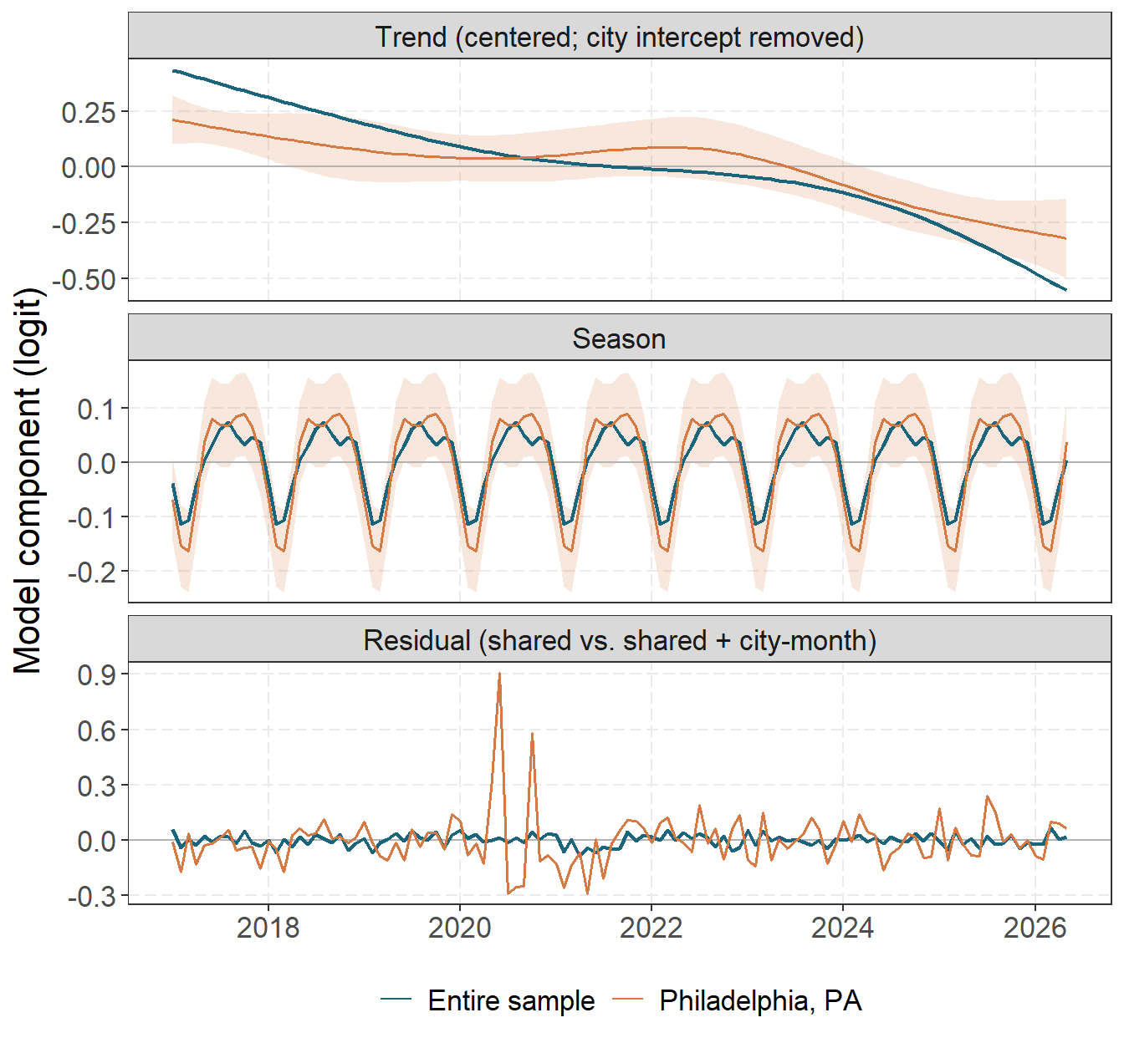
Figure 5: Philadelphia and full-sample burglary components on the logit scale: centered long-run trends (top), Fourier seasonal curves (middle), and the sample-wide time-period residual compared with Philadelphia’s time-period plus city-month residual (bottom). Approximate 95% pointwise conditional intervals are shown for Philadelphia’s trend and seasonal deviations.

Shared time period variation
Figure 6 shows the fitted common time-period effect $a_{t}$. I transform it from the logit scale to a change in the annualized global rate. This isolates monthly movement shared across the sample after accounting for trend and season; it does not include the city-specific effect $e_{it}$. A positive monthly effect can therefore occur during a declining trend whenever that month is above its still-declining baseline.
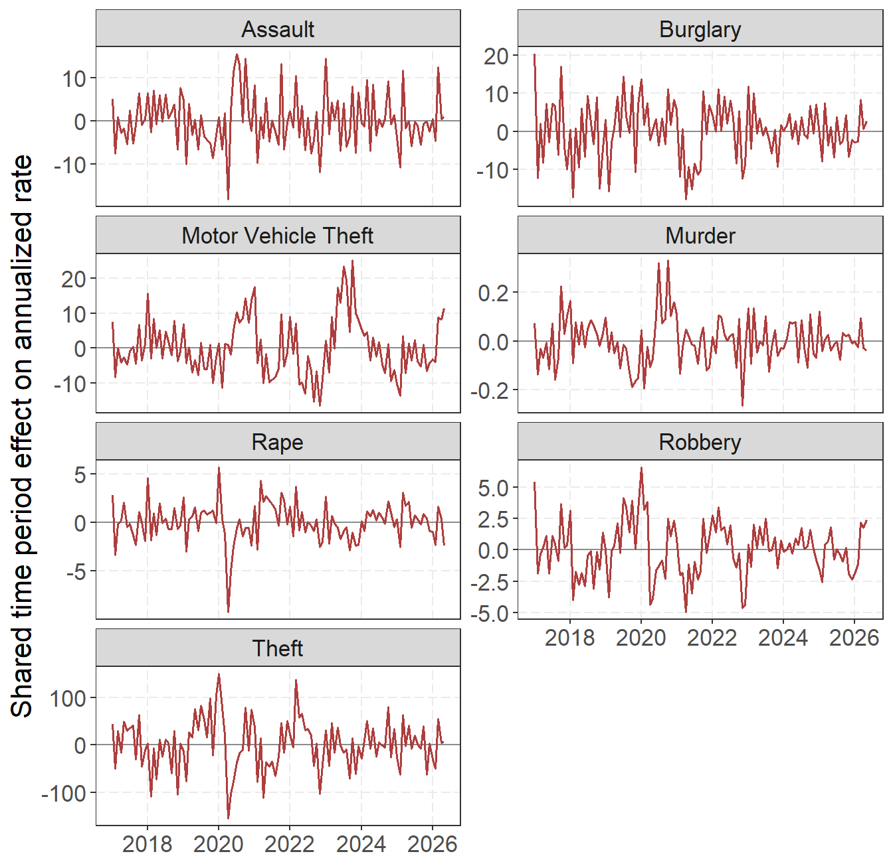
Figure 6: Fitted shared time-period random effect for each offense, transformed to its change in the annualized global rate. Positive values are time-period departures above the global trend-plus-seasonal curve; negative values are departures below it. Panels use offense-specific vertical scales.
The common time-period term separates abrupt movement from gradual change. April 2020 is a prominent negative departure for rape, assault, and theft; motor vehicle theft has a large positive shared departure in October 2023. Their timing does not identify a cause.

Cities with unusually different trends
A large city intercept only says that a city has a different average level. It does not show that the city is moving in a different direction. To find unusual trend shapes, I center each city’s spline departure over time and summarize it with its root-mean-square (RMS) magnitude. City-offense pairs with fewer than 60 months were excluded. Log RMS was then standardized within each offense using its median and median absolute deviation. Thus, every offense contributes its two most unusual city trends, rather than allowing the largest deviations from one offense to dominate the comparison. The ranking excludes city intercepts, seasonal effects, shared time-period shocks, and observation-level effects.
For each selected city, the conditional variances of its spline coefficients were propagated through the centered trend basis. The shaded region is the resulting estimate plus or minus 1.96 pointwise standard errors. Because glmmTMB supplies diagonal conditional variances for these homdiag blocks, the calculation omits posterior covariance among basis coefficients and conditions on the fitted global curve and variance parameters. The ribbons are therefore approximate pointwise uncertainty intervals, not simultaneous bands or intervals for a new city’s trajectory.
Two cities with the largest standardized trend departures within each offense. RMS is calculated on the centered logit-scale spline departure; score is the within-offense robust standardized log RMS.
Offense | First city | Second city
Murder | Portland, OR (RMS 0.287; score 3.58) | Baltimore, MD (RMS 0.237; score 3.14)
Rape | Paulding, GA (RMS 0.787; score 4.58) | State College, PA (RMS 0.684; score 4.19)
Robbery | Arlington, VA (RMS 0.561; score 4.17) | Livingston, LA (RMS 0.398; score 3.18)
Assault | Scranton, PA (RMS 0.855; score 4.82) | Euclid, OH (RMS 0.596; score 3.82)
Burglary | San Mateo, CA (RMS 0.574; score 4.06) | Palatine, IL (RMS 0.554; score 3.96)
Theft | Vallejo, CA (RMS 0.574; score 5.08) | Upper Darby, PA (RMS 0.539; score 4.88)
Motor Vehicle Theft | Tulare, CA (RMS 0.952; score 4.92) | Burlington, VT (RMS 0.900; score 4.75)
Figure 7 and Figure 8 compare each selected city’s centered trend with the corresponding global trend. Centering removes both the global intercept and the city random intercept, so separation between the lines represents trajectory rather than average crime level.
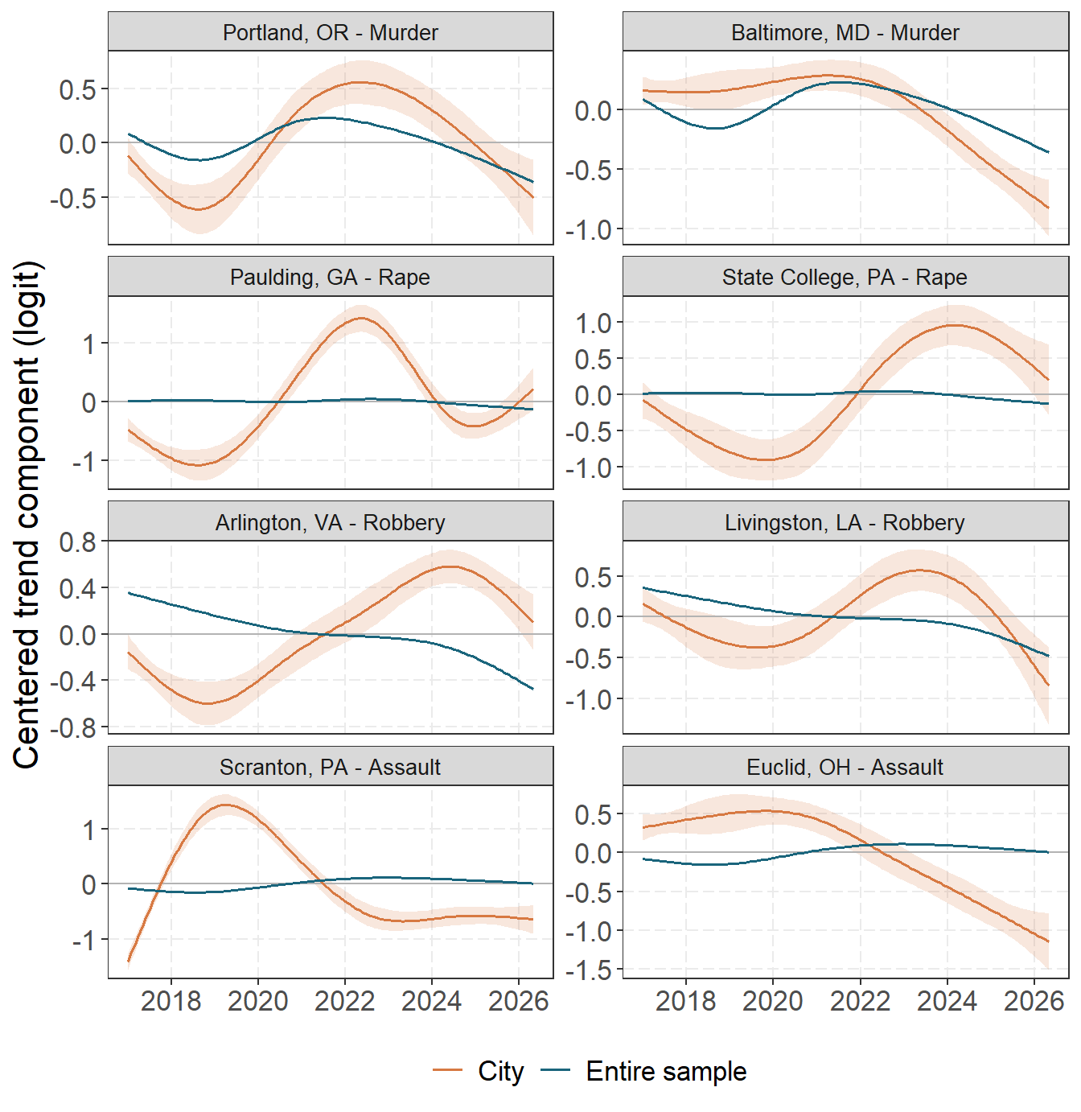
Figure 7: The two most unusual city-specific trends within murder, rape, robbery, and assault. City and global spline trends are centered separately, removing intercept differences. Selection uses within-offense robust standardized RMS trend departure; seasonal and residual terms are excluded. Shading gives approximate 95% pointwise conditional intervals for each city’s trend deviation.

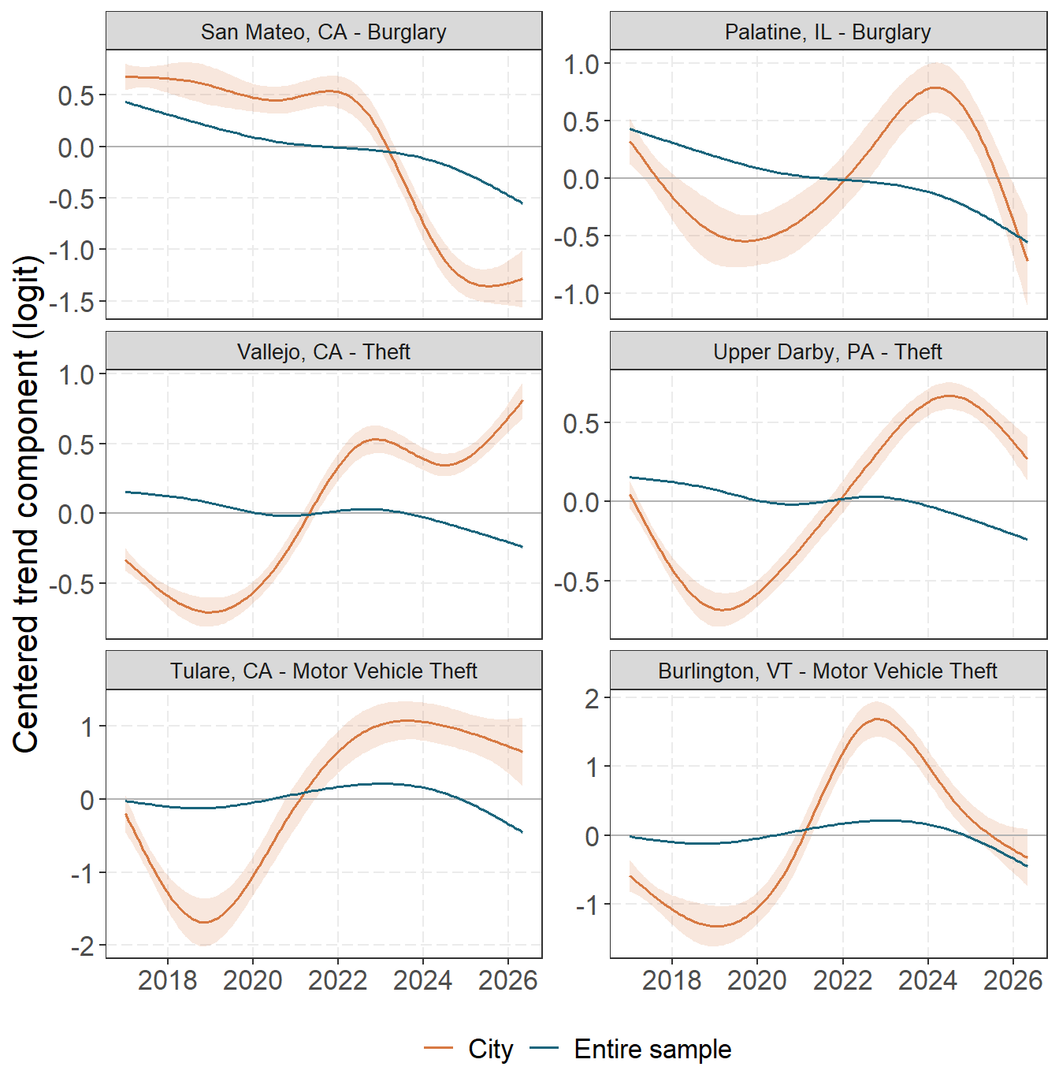
Figure 8: The two most unusual city-specific trends within burglary, theft, and motor vehicle theft. City and global spline trends are centered separately, removing intercept differences. Selection uses within-offense robust standardized RMS trend departure; seasonal and residual terms are excluded. Shading gives approximate 95% pointwise conditional intervals for each city’s trend deviation.

Cities with different seasonal patterns
I rank seasonal departures separately from trend departures. For each city-offense pair, I evaluate its six city-specific Fourier coefficients over the 12 months and summarized by the RMS departure from the global seasonal curve. Log RMS was standardized within offense by its median and median absolute deviation. The two leading cities are retained separately for every offense. This metric excludes city intercepts, long-run trend departures, common monthly shocks, and observation-level effects. Seasonal ribbons use the same diagonal conditional-variance propagation through the centered Fourier basis and have the same pointwise, conditional interpretation as the trend ribbons.
Two cities with the largest standardized seasonal departures within each offense. RMS is calculated from the city-specific Fourier departure over the 12 months; score is the within-offense robust standardized log RMS.
Offense | First city | Second city
Murder | Chicago, IL (RMS 0.087; score 4.37) | St Louis, MO (RMS 0.065; score 3.79)
Rape | Paulding, GA (RMS 0.051; score 4.31) | Colorado Springs, CO (RMS 0.048; score 4.18)
Robbery | Minneapolis, MN (RMS 0.109; score 4.08) | Salt Lake City, UT (RMS 0.078; score 3.22)
Assault | Cincinnati, OH (RMS 0.069; score 3.91) | Newark, NJ (RMS 0.057; score 3.24)
Burglary | Shawnee, KS (RMS 0.110; score 4.48) | Utica, NY (RMS 0.097; score 3.94)
Theft | Burlington, VT (RMS 0.120; score 4.26) | Manchester, NH (RMS 0.081; score 3.00)
Motor Vehicle Theft | Owensboro, KY (RMS 0.069; score 3.79) | Galveston, TX (RMS 0.062; score 3.43)
Figure 9 and Figure 10 superimpose every selected city’s fitted seasonal curve on the corresponding offense-wide curve.
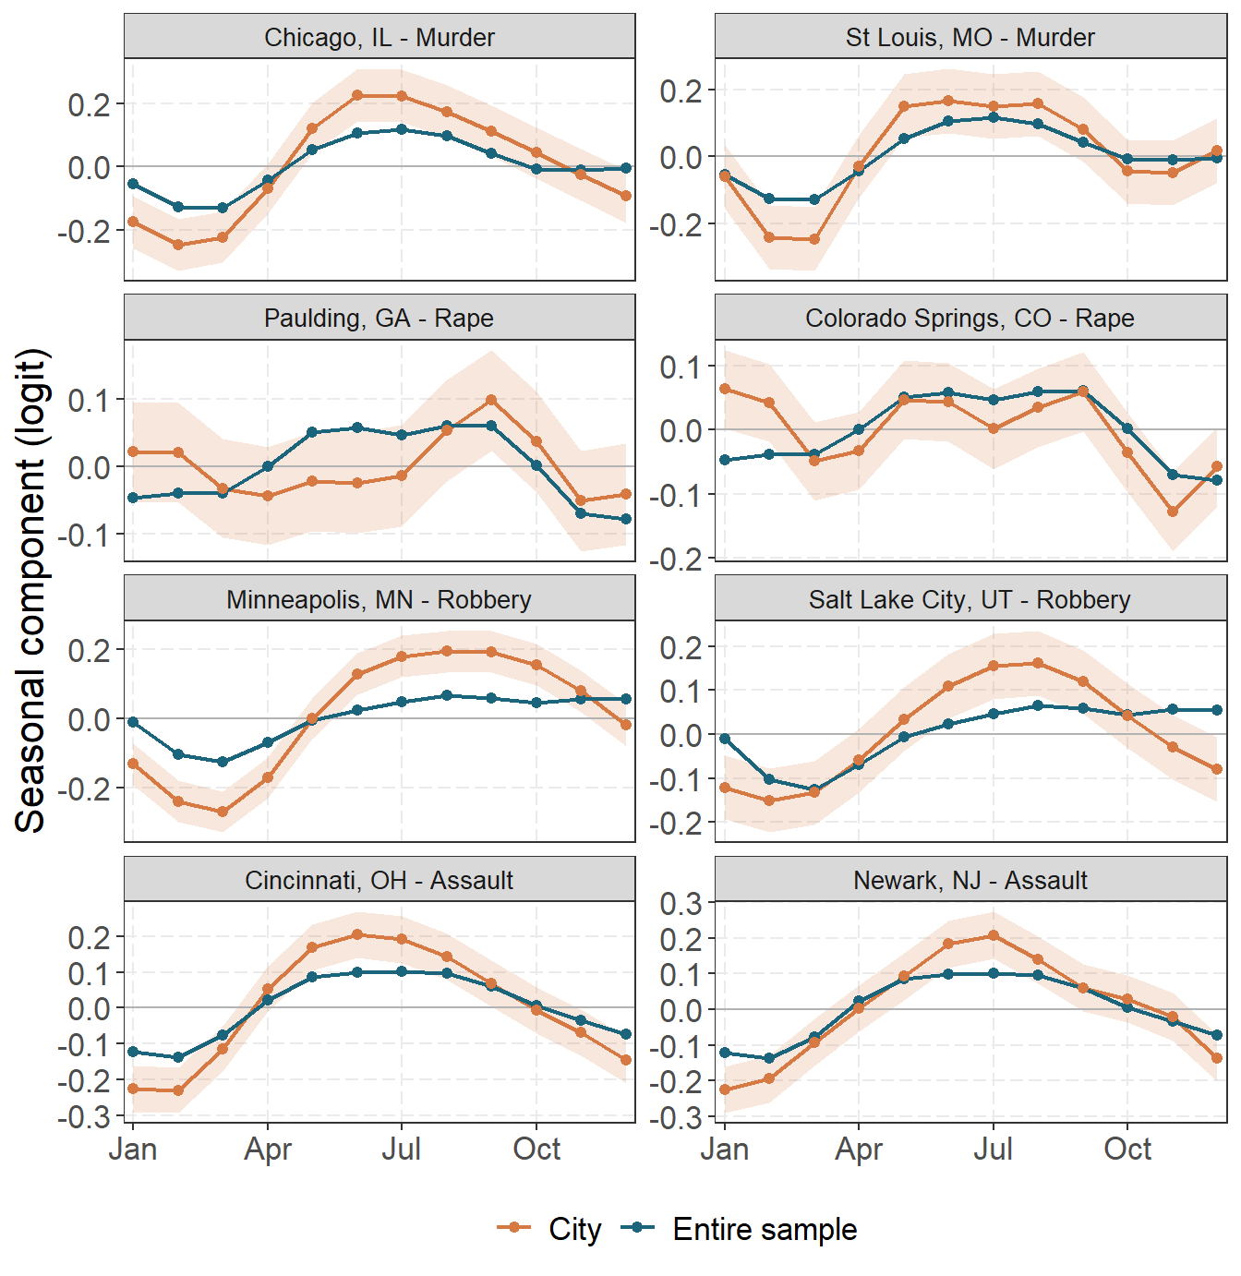
Figure 9: The two most unusual city-specific seasonal patterns within murder, rape, robbery, and assault. Curves show the global and city-specific Fourier seasonal components over month of year on the logit scale; intercepts, trends, and residual terms are excluded. Shading gives approximate 95% pointwise conditional intervals for each city’s seasonal deviation.

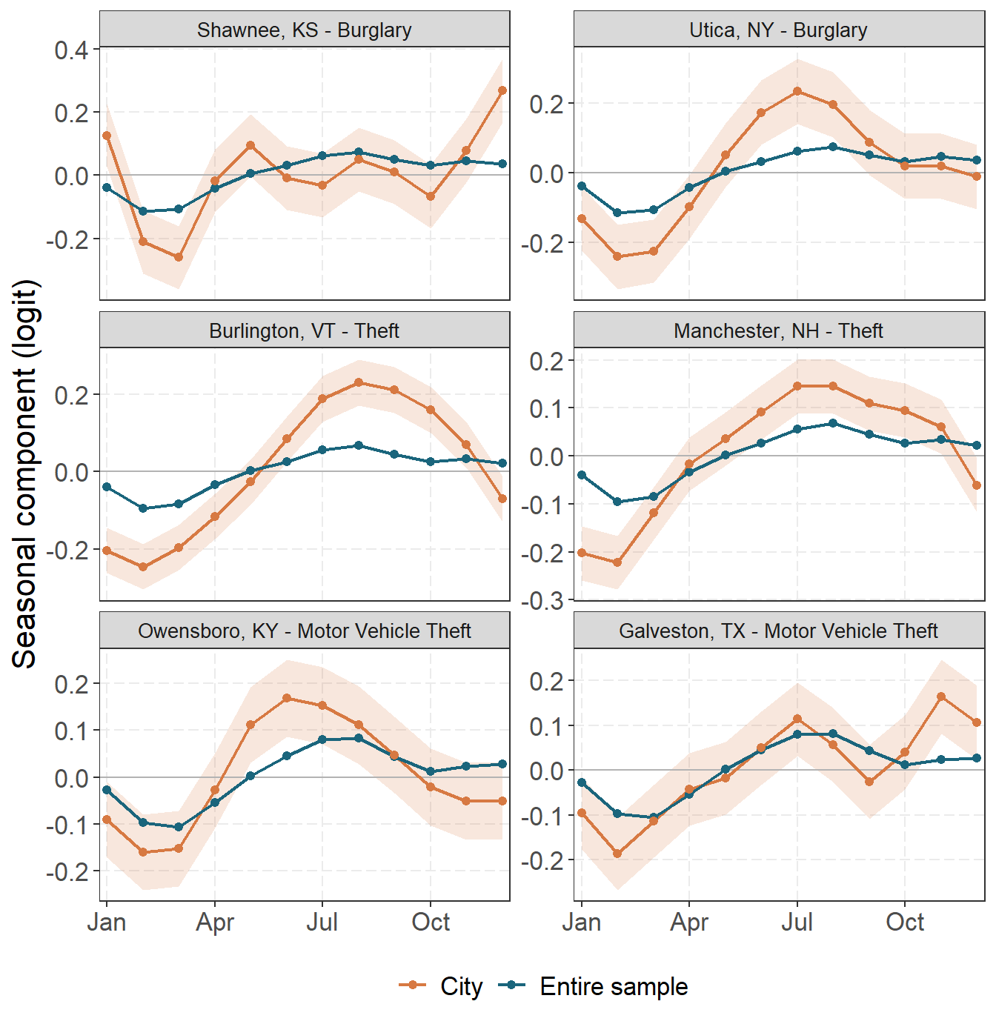
Figure 10: The two most unusual city-specific seasonal patterns within burglary, theft, and motor vehicle theft. Curves show the global and city-specific Fourier seasonal components over month of year on the logit scale; intercepts, trends, and residual terms are excluded. Shading gives approximate 95% pointwise conditional intervals for each city’s seasonal deviation.

Cities with unusually large monthly residuals
Trend and seasonal rankings describe persistent shapes. They are not designed to identify one unusual month. For that task, I retain the month with the largest absolute fitted observation-level effect $\left|e_{it}\right|$ within each city and offense. I then select the two cities with the largest values separately for each offense. Ranking one maximum per city ensures that a single city cannot occupy both positions for an offense. Because $e_{it}$ is on the common logit scale within each offense, the ordering does not depend on city population or on converting the effect to an annualized rate. It does, however, identify fitted residual extremes rather than raw-count anomalies.
For each selected city-month, Table 1 compares the observed outcome with the model-predicted mean before adding $e_{it}$. The prediction therefore includes the city’s intercept, trend, and seasonal terms plus the shared time-period effect, but not the observation-level residual used to rank the city. Both observed and predicted counts are monthly.
Table 1: Observed and model-predicted monthly counts for the two cities with the largest absolute fitted city-month residual within each offense. Pred. n and Obs. n are monthly counts; e is the signed logit-scale residual.
Offense | City | Month | $e$ | Pred. n | Obs. n
Murder | Las Vegas, NV | 10/17 | +1.0 | 13.5 | 71
Murder | San Antonio, TX | 06/22 | +0.8 | 19.7 | 71
Rape | Bismarck, ND | 05/25 | +0.6 | 4.8 | 39
Rape | Riverside, CA | 12/19 | +0.5 | 11.7 | 45
Robbery | Washington, DC | 07/23 | +0.6 | 252.5 | 475
Robbery | Indianapolis, IN | 06/19 | -0.5 | 212.7 | 90
Assault | Bismarck, ND | 05/25 | +1.3 | 15.1 | 101
Assault | Indianapolis, IN | 06/19 | -1.2 | 476.8 | 96
Burglary | St. Clair Shores, MI | 12/24 | +2.1 | 10.1 | 129
Burglary | Bismarck, ND | 05/25 | +1.9 | 18.5 | 165
Theft | Bismarck, ND | 05/25 | +1.6 | 131.9 | 772
Theft | Washoe, NV | 06/17 | +1.5 | 56.1 | 342
Motor Vehicle Theft | Washoe, NV | 06/17 | +1.6 | 12.2 | 105
Motor Vehicle Theft | Bismarck, ND | 05/25 | +1.6 | 15.3 | 114

Bismarck, North Dakota appears for five different offenses in May 2025, with each observed count far above its model-predicted mean. That synchronized cross-offense pattern is more consistent with a reporting or data-processing issue than with simultaneous spikes in five distinct crime types. These rows should therefore be treated as a data-quality flag, not as evidence by themselves of a sudden broad-based increase in crime.
Figure 11 and Figure 12 show the complete city-month residual series for each selected city, with the ranked month marked in red. These plots exclude the global trend, global season, city intercept, city-specific trend and season, and shared time-period effect. Their vertical scales are symmetric around zero within each panel so positive and negative departures can be compared directly.
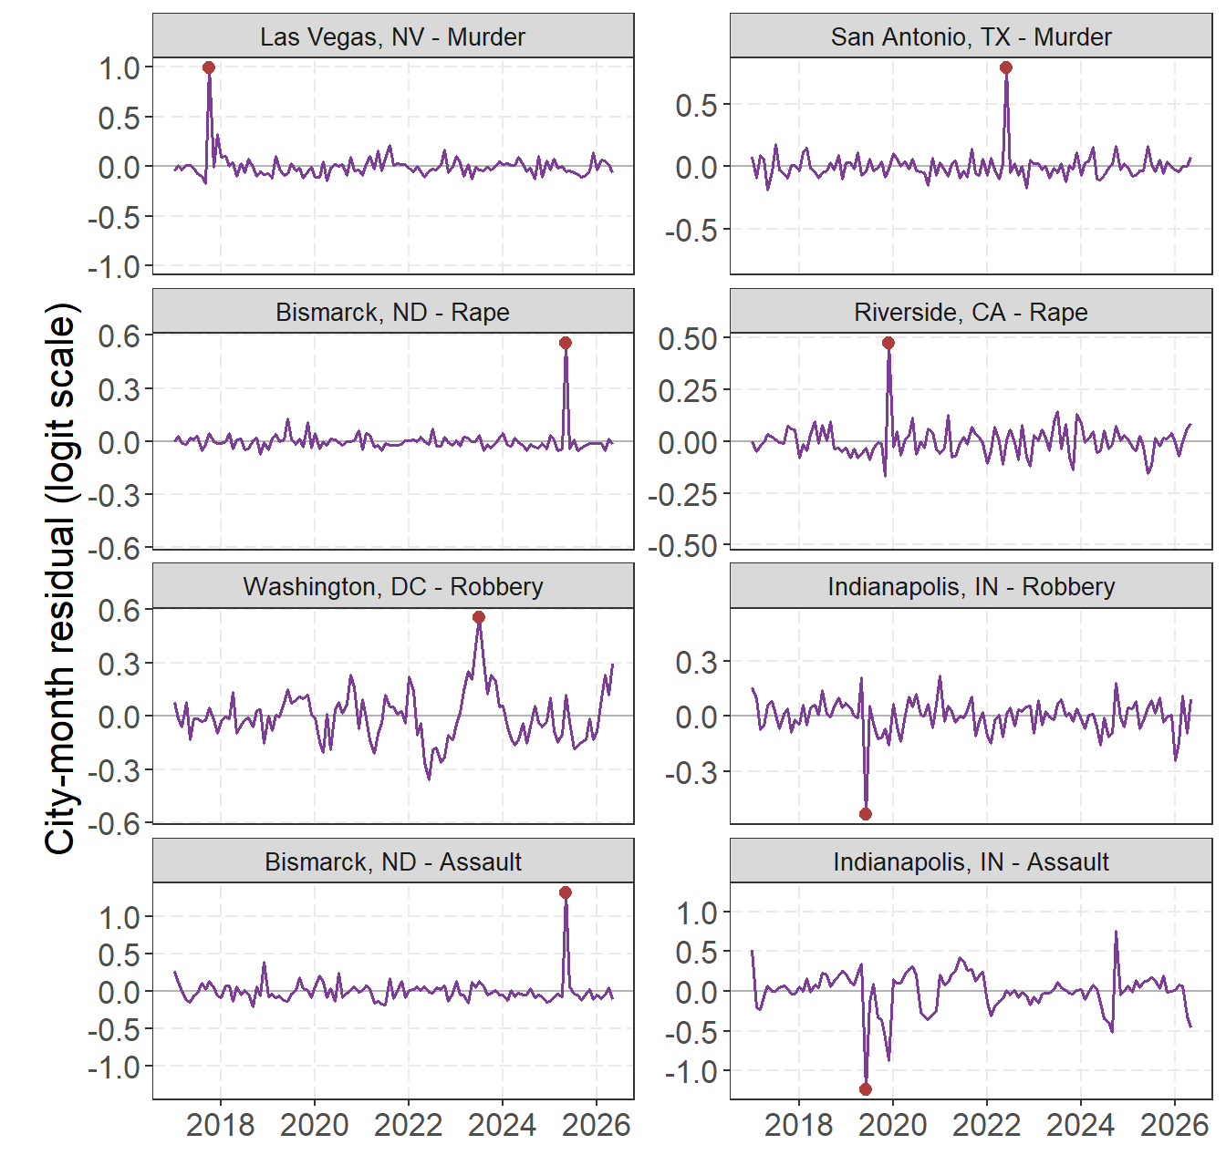
Figure 11: The two cities with the largest absolute fitted city-month residuals within murder, rape, robbery, and assault. Lines show the observation-level city-month effect over time; red points mark the month used for ranking. Panels are centered at zero and use city-specific symmetric vertical scales.

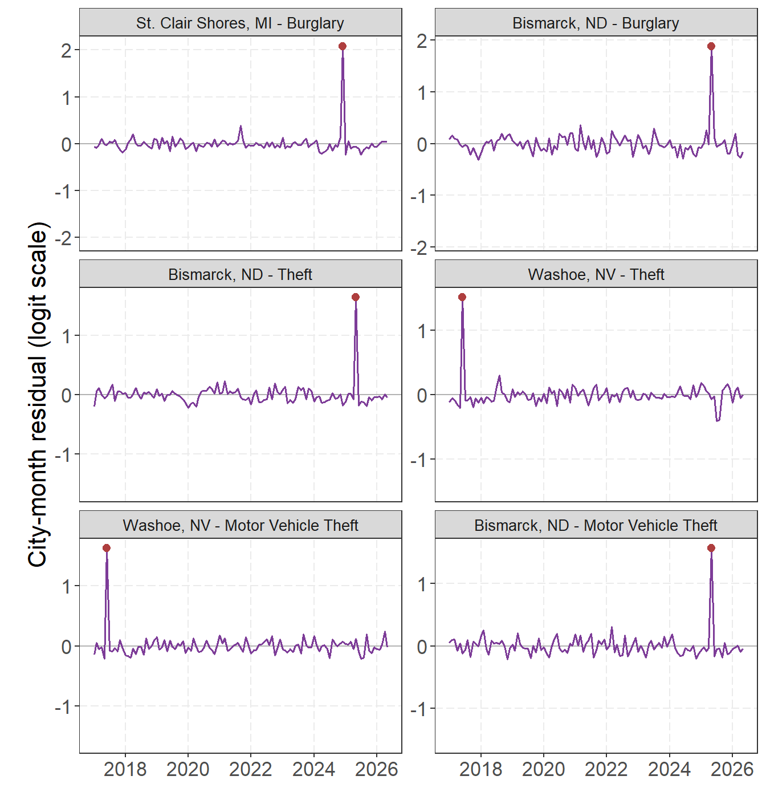
Figure 12: The two cities with the largest absolute fitted city-month residuals within burglary, theft, and motor vehicle theft. Lines show the observation-level city-month effect over time; red points mark the month used for ranking. Panels are centered at zero and use city-specific symmetric vertical scales.

Most recent month residual outliers
The preceding ranking asks which cities had the most unusual fitted month at any point in the series. For a current monitoring question, I instead restrict the comparison to the latest available observation within each offense. All 7 offenses currently end in May 2026. Within that single monthly cross-section, I rank cities by the absolute fitted observation-level effect $\left|e_{it}\right|$ and retain the two largest values for each offense. This identifies the clearest recent local departures after removing the global and city-specific trends, seasonal terms, city intercept, and shared time-period effect. The ranking is descriptive: it does not attach a separate hypothesis test to each city or account for revisions to the most recent data.
For each selected city, Table 2 compares the observed outcome with the model-predicted mean before adding $e_{it}$. The prediction therefore includes the city’s intercept, trend, and seasonal terms plus the shared time-period effect, but not the observation-level residual used to rank the city. Counts are monthly. Rates are annualized from that month’s count or fitted mean and expressed per 100,000 residents. The reported standard error for $e_{it}$ is the conditional standard deviation of the fitted random effect, holding the estimated fixed effects and variance parameters fixed. It describes uncertainty after partial pooling and is not a standard error for the raw observed-minus-predicted difference.
Table 2: Observed outcomes and model-predicted means for the two cities with the largest absolute fitted city-month residual in the most recent available month for each offense. Pred. n and Obs. n are monthly counts; rate columns are annualized per 100,000 residents; e is the signed logit-scale residual.
Offense | City | $e$ | SE($e$) | Pred. n | Obs. n | Pred. rate | Obs. rate
Murder | St Louis, MO | +0.17 | 0.15 | 13.7 | 22 | 59.8 | 96.1
Murder | Fort Wayne, IN | +0.15 | 0.16 | 2.5 | 8 | 10.9 | 34.9
Rape | Houston, TX | +0.19 | 0.09 | 88.2 | 117 | 43.9 | 58.2
Rape | Bakersfield, CA | +0.19 | 0.13 | 7.3 | 19 | 20.8 | 54.2
Robbery | Washington, DC | +0.30 | 0.09 | 79.6 | 126 | 137.7 | 218.0
Robbery | Little Rock, AR | -0.21 | 0.11 | 25.5 | 7 | 148.8 | 40.9
Assault | Indianapolis, IN | -0.46 | 0.09 | 373.7 | 219 | 496.2 | 290.8
Assault | Fayetteville, NC | -0.43 | 0.14 | 39.5 | 11 | 226.9 | 63.1
Burglary | Roanoke, VA | +0.99 | 0.13 | 33.3 | 112 | 409.3 | 1375.9
Burglary | Portsmouth, VA | +0.80 | 0.13 | 42.4 | 113 | 528.0 | 1407.2
Theft | Fayetteville, NC | -0.70 | 0.10 | 95.7 | 7 | 549.3 | 40.2
Theft | Medford, OR | -0.55 | 0.09 | 212.2 | 91 | 2951.3 | 1265.4
Motor Vehicle Theft | Tucson, AZ | -0.65 | 0.14 | 69.1 | 19 | 148.9 | 40.9
Motor Vehicle Theft | Milwaukee, WI | -0.44 | 0.10 | 407.2 | 251 | 873.1 | 538.1

Figure 13 and Figure 14 retain each selected city’s full residual history for context, while the red point marks the latest observation used in the ranking. Consequently, earlier residuals shown in these panels do not influence which cities were selected.
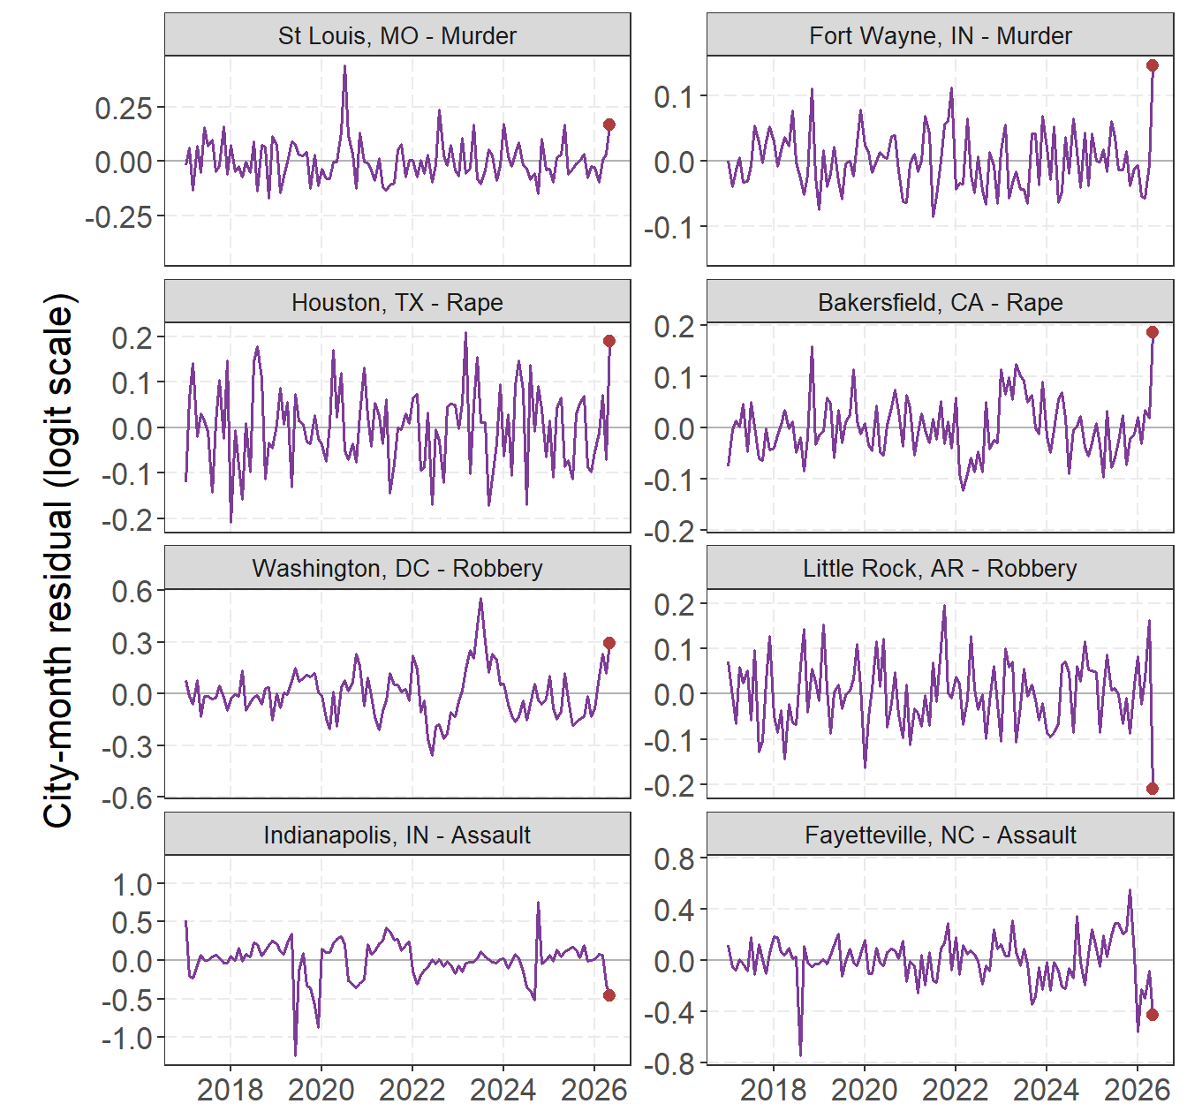
Figure 13: The two largest absolute fitted city-month residuals in the most recent month within murder, rape, robbery, and assault. Lines provide each selected city’s full residual history for context; red points mark the latest month used for ranking. Panels are centered at zero and use city-specific symmetric vertical scales.

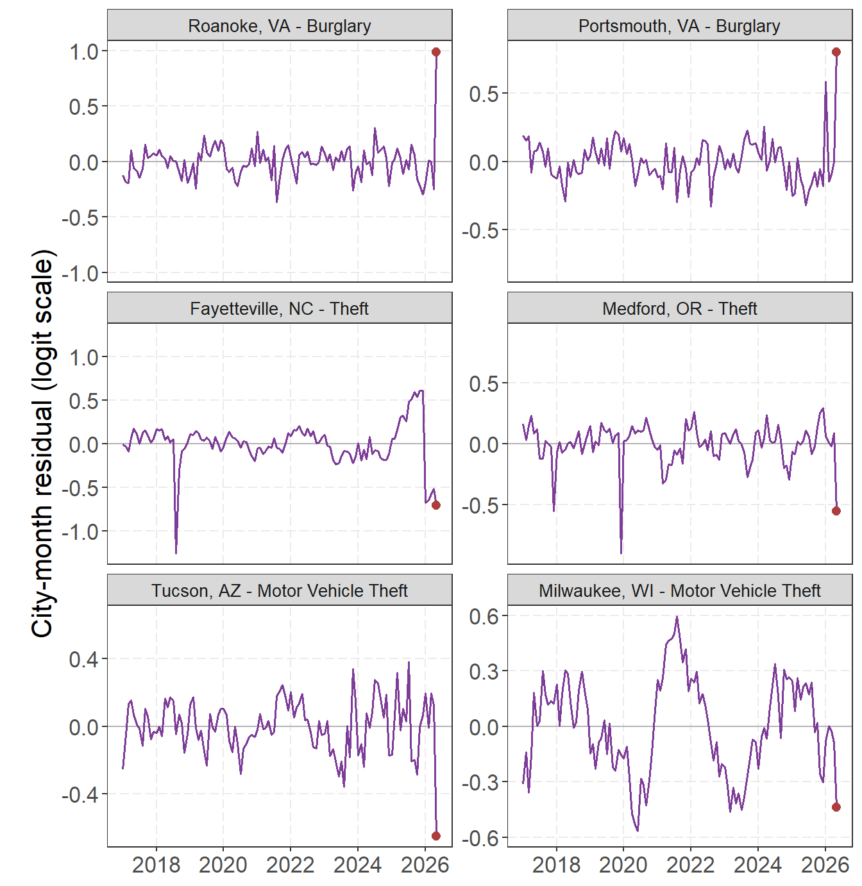
Figure 14: The two largest absolute fitted city-month residuals in the most recent month within burglary, theft, and motor vehicle theft. Lines provide each selected city’s full residual history for context; red points mark the latest month used for ranking. Panels are centered at zero and use city-specific symmetric vertical scales.

Discussion
The main lesson is to avoid forcing every change into one story. The global smooth describes movement shared across the sample. A changing gap between a city and that smooth indicates a different local trajectory. The residual term then identifies months that neither smooth explains. Philadelphia burglary in 2020 is a clear example: June and October are important observations, but they should not redefine the city’s long-run curve.
This distinction extends the practical monitoring argument in my earlier work. Percent changes can make ordinary low-count variation look dramatic, while a single national series can hide substantial differences among cities (Wheeler 2016; Wheeler and Kovandzic 2018). Fan charts address uncertainty around a forecast (Yim, Riddell, and Wheeler 2020). The present model instead separates smooth common movement, sustained city departures, and local monthly residuals. These are complementary tasks, not competing definitions of a crime trend.
Partial pooling is what makes the city comparisons useful. If I estimated an unconstrained curve for every city, the noisiest series would tend to look the most distinctive. The shared variance parameters let well-supported city patterns depart from the global curve while pulling unstable patterns toward it (Pedersen et al. 2019; Simpson 2017). This is especially important when comparing 586 cities with very different populations and crime counts.
A useful future extension would turn the residual screen into a formal multiple-testing procedure. For each city-month effect, one could calculate a standardized statistic from $e_{it}$ and its conditional standard error, convert that statistic to a two-sided p-value, and then apply a false discovery rate (FDR) correction across a prespecified family of cities and offenses. This would address the fact that, when hundreds of cities are screened at once, some apparently unusual residuals will occur by chance. Similar multiplicity issues arise when the spatial point pattern test is used to identify local differences across many areas; my prior work examined corrected local proportion tests, and the Buffalo shooting analysis applied an FDR correction to the local spatial comparisons (Wheeler, Steenbeek, and Andresen 2018; Drake et al. 2023; Benjamini and Hochberg 1995). Because the proposed tests would use shrunken random-effect estimates rather than independent raw contrasts, their calibration should first be checked with simulation or a parametric bootstrap.
The results are not causal effects or forecasts. Reported crime depends on reporting practices, agency participation, revisions, and population denominators. The binomial model gives counts and population a coherent link, but it does not mean that residents have independent and identical risks. The observation-level random effect accommodates extra variation; it does not tell us why a particular month is unusual. I therefore view the estimates as a monitoring and comparison tool. They show where to look next, not what caused the pattern.

Reproducibility and acknowledgments
The code, initial paper, and web application were created in OpenAI Codex using Luna and Sol, with substantive review and direction from the author. Generated metadata records the exact model formulas and settings, while source data, geocoding results, and manual coordinate overrides are cached in the repository.

References
AH Datalytics. 2026. “Real-Time Crime Index: Reported Crime Trends Data.” https://github.com/AH-Datalytics/rtci.
Bates, Douglas, Martin Mächler, Ben Bolker, and Steve Walker. 2015. “Fitting Linear Mixed-Effects Models Using Lme4.” Journal of Statistical Software 67 (1): 1–48. https://doi.org/10.18637/jss.v067.i01.
Benjamini, Yoav, and Yosef Hochberg. 1995. “Controlling the False Discovery Rate: A Practical and Powerful Approach to Multiple Testing.” Journal of the Royal Statistical Society: Series B (Methodological) 57 (1): 289–300. https://doi.org/10.1111/j.2517-6161.1995.tb02031.x.
Brooks, Mollie E., Kasper Kristensen, Koen J. van Benthem, Arni Magnusson, Casper W. Berg, Anders Nielsen, Hans J. Skaug, Martin Mächler, and Benjamin M. Bolker. 2017. “glmmTMB Balances Speed and Flexibility Among Packages for Zero-Inflated Generalized Linear Mixed Modeling.” The R Journal 9 (2): 378–400. https://doi.org/10.32614/RJ-2017-066.
Drake, Gregory, Andrew P. Wheeler, Dae-Young Kim, Scott W. Phillips, and Kathryn Mendolera. 2023. “The Impact of COVID-19 on the Spatial Distribution of Shooting Violence in Buffalo, NY.” Journal of Experimental Criminology 19 (2): 513–30. https://doi.org/10.1007/s11292-021-09497-4.
Kristensen, Kasper, Anders Nielsen, Casper W. Berg, Hans Skaug, and Bradley M. Bell. 2016. “TMB: Automatic Differentiation and Laplace Approximation.” Journal of Statistical Software 70 (5): 1–21. https://doi.org/10.18637/jss.v070.i05.
Pedersen, Eric J., David L. Miller, Gavin L. Simpson, and Noam Ross. 2019. “Hierarchical Generalized Additive Models in Ecology: An Introduction with Mgcv.” PeerJ 7: e6876. https://doi.org/10.7717/peerj.6876.
R Core Team. 2026. R: A Language and Environment for Statistical Computing. Vienna, Austria: R Foundation for Statistical Computing. https://www.R-project.org/.
Simpson, Gavin L. 2017. “Comparing Smooths in Factor-Smooth Interactions i.” https://fromthebottomoftheheap.net/2017/10/11/difference-splines-i/.
Wheeler, Andrew P. 2016. “Tables and Graphs for Monitoring Temporal Crime Trends: Translating Theory into Practical Crime Analysis Advice.” International Journal of Police Science & Management 18 (3): 159–72. https://doi.org/10.1177/1461355716642781.
Wheeler, Andrew P., and Tomislav V. Kovandzic. 2018. “Monitoring Volatile Homicide Trends Across u.s. Cities.” Homicide Studies 22 (2): 119–44. https://doi.org/10.1177/1088767917740171.
Wheeler, Andrew P., Wouter Steenbeek, and Martin A. Andresen. 2018. “Testing for Similarity in Area-Based Spatial Patterns: Alternative Methods to Andresen’s Spatial Point Pattern Test.” Transactions in GIS 22 (3): 760–74. https://doi.org/10.1111/tgis.12341.
Wickham, Hadley. 2016. Ggplot2: Elegant Graphics for Data Analysis. Springer-Verlag New York. https://doi.org/10.1007/978-3-319-24277-4.
Wickham, Hadley, Mara Averick, Jennifer Bryan, Winston Chang, Lucy D’Agostino McGowan, Romain François, Garrett Grolemund, et al. 2019. “Welcome to the Tidyverse.” Journal of Open Source Software 4 (43): 1686. https://doi.org/10.21105/joss.01686.
Wood, Simon N. 2011. “Fast Stable Restricted Maximum Likelihood and Marginal Likelihood Estimation of Semiparametric Generalized Linear Models.” Journal of the Royal Statistical Society: Series B 73 (1): 3–36. https://doi.org/10.1111/j.1467-9868.2010.00749.x.
———. 2017. Generalized Additive Models: An Introduction with r. 2nd ed. Chapman; Hall/CRC.
Wood, Simon, and Fabian Scheipl. 2025. Gamm4: Generalized Additive Mixed Models Using Mgcv and Lme4. https://doi.org/10.32614/CRAN.package.gamm4.
Yim, Ha-Neul, Jordan R. Riddell, and Andrew P. Wheeler. 2020. “Is the Recent Increase in National Homicide Abnormal? Testing the Application of Fan Charts in Monitoring National Homicide Trends over Time.” Journal of Criminal Justice 66: 101656. https://doi.org/10.1016/j.jcrimjus.2019.101656.

