ROC and Calibration Plots — All Property Crime Models
Marc Olson
2026-06-08
Table of contents

This document reports results for individual-level property crime prediction models evaluated on a held-out period. The original pre-registration specified individual-level violent crime prediction, identifying high-risk persons for future involvement in gun violence, robbery, aggravated assault, and related offenses, to support a planned randomized home-visit intervention conducted in partnership with Denver Police Department.
The present analysis reflects the same analytical framework specified by the preregistration, but shifts its focus to property crime outcomes. This shift reflects a change in Denver PD’s operational priorities.

ROC Curves
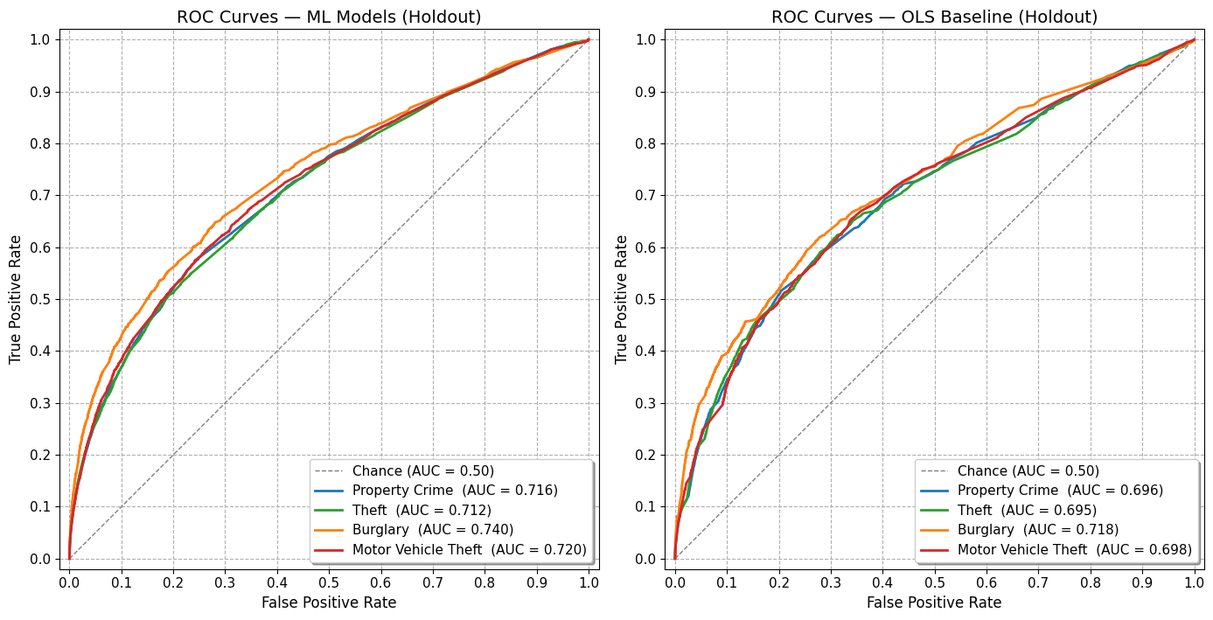

Calibration Plots
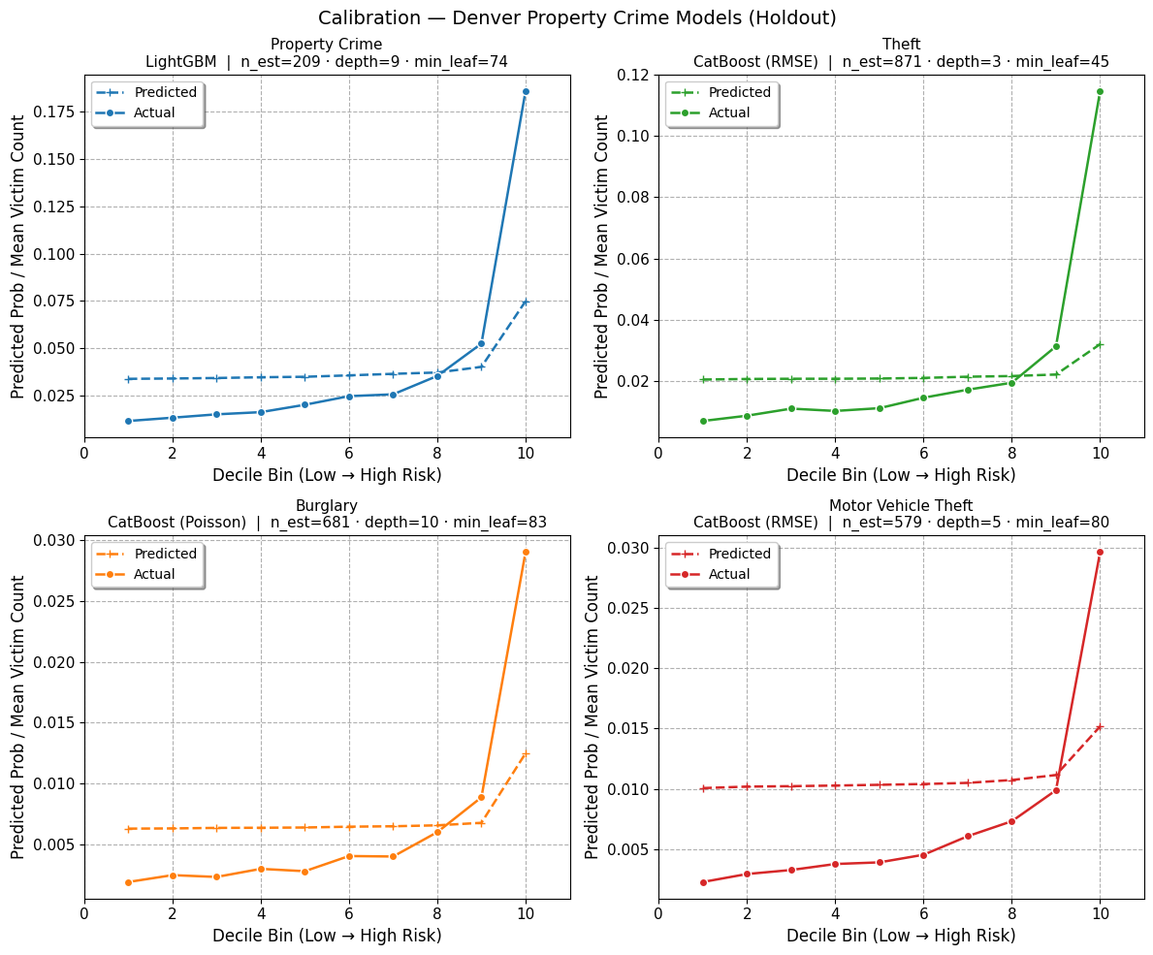
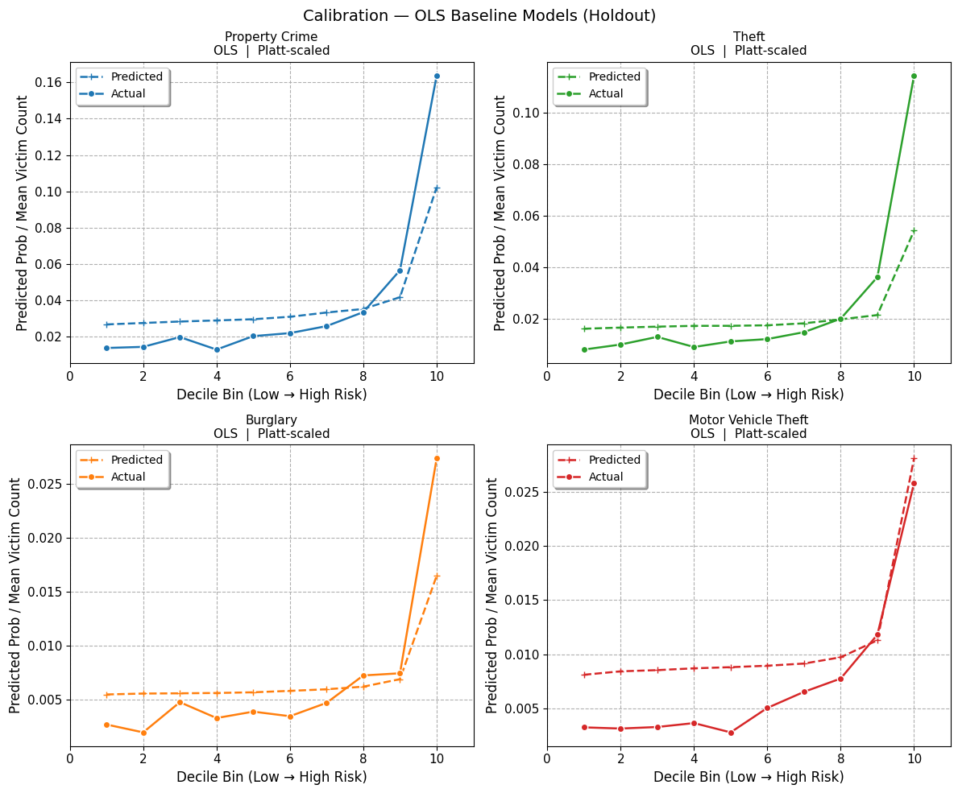

Model Accuracy
Four gradient-boosted regression models (LightGBM and CatBoost) were evaluated on a held-out period to predict victim-weighted aggregate property crime, theft, motor vehicle theft, and burglary counts. Performance is assessed via three diagnostics: (1) standard AUC on the binary outcome, (2) weighted AUC matching which tests the models’ ability to identify repeat offenders, and (3) probability calibration across decile bins.

Property Crime
Metric | ML Model | OLS
Holdout N | 493,921 | 493,921
Base rate | 2.81% positive | 2.81% positive
Standard AUC | 0.716 | 0.696
Weighted AUC (tuning criterion) | 0.759 | 0.743
Top-1,000 capture (victim-weighted) | 2,232 events | 2,149 events
Top-1,000 capture (unweighted cells) | 433 with ≥1 event | 389 with ≥1 event
Expected under random (unweighted) | ~28 | ~28

Theft
Metric | ML Model | OLS
Holdout N | 493,921 cells | 493,921 cells
Base rate | 1.74% positive | 1.74% positive
Standard AUC | 0.712 | 0.695
Weighted AUC (tuning criterion) | 0.766 | 0.753
Top-1,000 capture (victim-weighted) | 1,901 events | 1,963 events
Top-1,000 capture (unweighted cells) | 344 with ≥1 event | 324 with ≥1 event
Expected under random (unweighted) | ~17 | ~17

Burglary
Metric | ML Model | OLS
Holdout N | 493,921 cells | 493,921 cells
Base rate | 0.55% positive | 0.55% positive
Standard AUC | 0.740 | 0.718
Weighted AUC (tuning criterion) | 0.756 | 0.736
Top-1,000 capture (victim-weighted) | 243 events | 231 events
Top-1,000 capture (unweighted cells) | 148 with ≥1 event | 138 with ≥1 event
Expected under random (unweighted) | ~6 | ~6

Motor Vehicle Theft
Metric | ML Model | OLS
Holdout N | 493,921 cells | 493,921 cells
Base rate | 0.67% positive | 0.67% positive
Standard AUC | 0.720 | 0.698
Weighted AUC (tuning criterion) | 0.729 | 0.710
Top-1,000 capture (victim-weighted) | 235 events | 178 events
Top-1,000 capture (unweighted cells) | 145 with ≥1 event | 108 with ≥1 event
Expected under random (unweighted) | ~7 | ~7

