**Technical Appendix**

The goal of this methodology is to take individual police departments reported domestic violence incidents, and *adjust* them given that we know there is under-reporting of domestic violence. For example, if a police department had a reported 100 domestic violence incidents in 2022, how many domestic violence incidents actually happened in that jurisdiction, given we know that 100 reported incidents *is an undercount*.

If we know that the reporting rate for domestic violence events was only 50%, we would then up-adjust the observed rate of 100 events by 100/0.5, which would then suggest there are a total of 200 events.

Not all crime events have the same reporting rate though. Imagine out of the 100 events, 80 are for younger victims, with a reporting rate of 60%, and 20 are for older victims, with a reporting rate of 40%. In this scenario, the total up-adjusted weight for the jurisdiction will be 80/0.5 + 20/0.4, which is 210 incidents. The older individuals had a higher weight.

This paper shows how to take this methodology further, every particular *observed* crime event can have its own weight to up-adjust. We show, using a set of normalized data across the National Crime Victimization Survey (NCVS), and the police reported National Incident Based Reporting System (NIBRS) how to create tailored estimates to up-adjust police reports.

This fills a gap in our current data eco-system, the NCVS provides domestic violence rates for the entire nation, but does not allow one to drill down into more specific geographics. This approach allows one to take into account non-reporting, but for smaller geographics. Given that police departments can report NIBRS data in a more up to date fashion, it also provides an opportunity to establish more real time trends than relying on the NCVS, which is published every fall.

**Definition & Measurement of Domestic Violence**

Measuring domestic violence depends on both the definition of domestic violence as well as how incidence and prevalence (via clinical, official, or self-reported estimates) are measured, a point made by Gelles well over a quarter of a century ago—yet remains the case today. As would be expected, answers to the second question rely on how domestic violence is defined. Unfortunately, consensus among researchers, practitioners, and even policymakers as to what constitutes domestic violence has not been reached. Some stakeholders seek to focus the definition solely on physical or sexual violence, other wish to include emotional and psychological abuse. How severity is measured and quantified is also debated. Some stakeholders focus on women as survivors and men as perpetrators, while others explore violence which occurs in same-sex relationships or on men as survivors and women as perpetrators. Some reporting systems do not define domestic violence and instead just list the term, while the others rely on how a law enforcement codes a domestic violence (e.g., a separate offense code or included within an aggravated assault code).

*Official Estimates from the FBI*

Since 1930, law enforcement agencies have voluntarily provided crime statistics through the Uniform Crime Reporting (UCR) Program to the FBI. Known as the summary reporting system, the crime data collection captures basic information on the number of crimes and arrests for seven “part one” offenses (murder/non-negligent manslaughter, robbery, forcible rape, aggravated assault, burglary, larceny-theft, motor vehicle theft, and arson) and a larger number of part two offenses (e.g., simple assault, driving under the influence, disorderly conduct). The problem with these larger categories is that they only consider the most series offense within an overall incident (where there could have been multiple offenses and contain limited information about victim, offender, and situational characteristics). Recognizing that very little incident-based information had been captured with that summary data collection system and that there were a wider array of offenses that needed to be measured to provide a more complete national picture of crime in the United States (National Academies of Sciences, 2016), on January 1, 2021 the FBI sunsetted the summary reporting system and moved to the National Incident-Based Reporting System (NIBRS), which includes all of the individual offenses that were part of an incident, and also includes information about the victim, offender, property involved, and any arrests made. Because transition to the more expansive but complex reporting system had been slow and only about two-thirds of agencies reported NIBRS data for the initial NIBRS release in fall 2022 (which included data from calendar year 2021), the FBI worked with BJS to also include estimates for the crime data. And for the 2022 data year (for which data were released in fall 2023), the FBI decided to also accept summary reporting data submission for the non-transitioned agencies in order to provide more nationally representative data.

Starting in 2019, the FBI UCR Program (2019) began collecting data about domestic and family violence in accordance with the following definition:

Domestic and Family Violence—The use, attempted use, or threatened use of physical

force of a weapon; or the use of coercion or intimidation; or committing a crime against

property by a current or former spouse, parent, or guardian of the victim; a person with

whom the victim shares a child in common; a person who is or has been in a social

relationship of a romantic or intimate nature with the victim; a person who is cohabiting

with or has cohabited with the victim as a spouse, parent, or guardian; or by a person

who is or has been similarly situated to a spouse, parent, or guardian of the victim.

Specific changes within NIBRS to pinpoint such occurrences included replacing the data value of

Lover’s Quarrel with Domestic Violence as a circumstance for murder and aggravated assault

offenses. In addition to other data values that specify the relationship of victims to their

offenders, an additional value for Ex-relationship was added.

To be sure, even with this definition, it is difficult for law enforcement to distinguish intimate partner violence with this definition and raises additional concerns as to whether child abuse could be coded/considered as a form of intimate partner/domestic violence.

*Self-Reported Survey Estimates*

The Bureau of Justice Statistics’ National Crime Victimization Survey (NCVS) administered in consultation with the Census Bureau is a nationally representative sample of several hundred thousands of persons age 12 and older within over one hundred thousand households who respond about their victimization experiences. Within the NCVS, domestic violence is defined as attacks, threatened attack, and/or unwanted sexual activity by someone they know, such as a relative or family member. Specific questions within the NCVS cover aggravated assault and assault as well as rape/sexual assault (<https://ncvs.bjs.ojp.gov/terms#terms>). For aggravated assault, these would include an attack or attempted attack with a weapon, regardless of whether the victim is injured, or an attack without a weapon when serious injury results. For assault, these would include the threat, attempt, or intentional infliction of bodily injury. Assault may be classified as aggravated or simple. Excludes rape, attempted rape, sexual assault, robbery, and attempted robbery. The severity of assault ranges from minor threats to near fatal incidents. For rape, this would include unlawful penetration of a person against the will of the victim, with use or threatened use of force, or attempting such an act. Includes psychological coercion and physical force. Forced sexual intercourse means vaginal, anal, or oral penetration by the offender. Also includes incidents where penetration is from a foreign object, such as a bottle. Includes male and female victims, and heterosexual and same-sex rape. Attempted rape includes verbal threats of rape. Rape and sexual assault are combined into one victimization measure. For sexual assault, this would encompass a wide range of victimizations, separate from rape or attempted rape. Includes attacks or attempted attacks generally involving unwanted sexual contact between victim and offender, with or without force. Includes grabbing or fondling and verbal threats. Rape and sexual assault are combined into one victimization measure. The NCVS has administered stalking supplements to its NCVS but has not done so recently.

According to the Bureau of Justice Statistics’ (2023) Criminal Victimization 2022 report, there were an estimated number of 1,370,440 domestic violence incidents (or a rate of 4.9 per 1,000 households)[1] as well as an estimated number of 951,930 intimate partner violence incidents (or a rate of 3.4 per 1,000 households)[2] reported in 2022. Both of these numbers and rates were the highest over the five-year period covered in the report. It is also noteworthy that 54% of domestic violence victimizations and 52% of intimate partner violence victimizations were reported to the police (both slightly higher than 2021 figures; see Table 4). Another way to look at these estimates is that nearly half of domestic violence and intimate partner violence victimizations are not reported to law enforcement and hence would not show up in police statistics, and consequently the annual estimates published by the FBI. (Note: When converted to rates per 1,000 persons, BJS reports that 2.6 and 1.7 (per 1,000 persons) of domestic violence and intimate partner violence victimizations were reported to the police in 2022 (see Table 6).[3]

**Data used for This Analysis**

We use three different data sources for this report. The first source is the NCVS, specifically the concatenated file of the NCVS data from 1992 through 2022, available currently at ICSPR study number 38604. We limit the analysis to domestic violence assaults, using the same methodology and variable definitions as Powers & Bleeker (2023). Note that NCVS only surveys individuals that are over 12 years old.

After filtering the data to domestic violence aggravated assaults, we subsequently have a total of 1,527 reported incidents over the 21 year sample. Recall that the NCVS measures self-reported victimization from over 200,000 individuals in over 100,000 households.

The second data source is the NIBRS police report data, specifically we use the concatenated files provided by Jacob Kaplan (Kaplan, 2024). For this data, we filter incidents that are reported as aggravated assaults (via the victimization *aggravated assault* question, not the specific NIBRS crime category). Specifically, the aggravated assault circumstance variable with a category of domestic violence. Since the NCVS only includes those over 12 years old, we also eliminated NIBRS events for those under 12. We also eliminate any agency-years with only partial reporting, by only including agencies that had reported crime incidents in all twelve months.

For the NIBRS data, we do need to impute the age, Hispanic status, and race of the victim for a small number of cases. We do a regression approach, using the other variables available, to impute the age for each separate year of the NIBRS data. For Hispanic status we impute as not-Hispanic, and for race we impute as multi-racial. (We encourage those curious on the methodology to review the open source computer code to replicate, available at <https://github.com/apwheele/dvtrends>.)

The last data source are mappings of reported population served estimates, downloaded from the FBI’s data explorer tool (that are derived from the Law Enforcement Officer’s Killed in Action data series). Agencies are represented in NIBRS using an ORI (originating agency identifier). When an agency-year does not have a reported population estimate, we impute the missing data as having a population of the under 50,000 population category (as these tend to be small agencies or non-city police departments).

**Modelling Approach**

The regression equation predicting the probability of reporting the domestic violence assault to the police is a logistic regression equation as follows:

Where the *probability* of reporting the assault to the police is a function of the *victim’s* sex, Hispanic status, racial category (black, Asian, native American, multiple, white reference), region category (northeast, Midwest, south, west). For the NCVS, earlier years did not include the region, and so for these years we include a dummy variable of missing region.

The model also includes non-linear restricted cubic spline terms for the victim’s age (with knots at 25, 40, and 65), and year spline variables (with knots at 1999, 2007, 2015). Restricted cubic splines allow one to model non-linear terms (Harrell, 2001).

These variables were intentionally chosen, as one needs to have a consistent set of variables across both the NCVS and NIBRS to apply the methodology. Even if one knows of other characteristics that *predict* reporting in the NCVS, they are only useful in this methodology if they are regularly captured in NIBRS.

The model *does not* include sampling weights in its estimates. Those are typically not including in regression modelling, only for estimating national level rates.

**Regression Model Results**

Table 1 displays the regression model results for the logistic model, including the linear coefficient estimates.

Table 1: Logistic Regression Model Coefficients

|  |  |  |  |  |
| --- | --- | --- | --- | --- |
| **Coefficient** | **B** | **SE** | **p-value** |  |
| Intercept | -78.61 | 42.92 | 0.07 | 0.07 |
| rcs(year,1) | 0.04 | 0.02 | 0.07 | 0.07 |
| rcs(year,2) | -0.04 | 0.02 | 0.13 | 0.13 |
| rcs(age,1) | 0.03 | 0.01 | < 0.01 | * |
| rcs(age,2) | -0.05 | 0.02 | 0.01 | * |
| Female | 0.15 | 0.12 | 0.22 |  |
| Black | 0.14 | 0.16 | 0.37 |  |
| Native American | 0.09 | 0.36 | 0.81 |  |
| Asian/Islander | -0.23 | 0.42 | 0.59 |  |
| multi-race | -1.19 | 0.29 | < 0.01 | * |
| Hispanic | 0.57 | 0.19 | < 0.01 | * |
| Northeast | -0.10 | 0.26 | 0.70 |  |
| Midwest | -0.20 | 0.24 | 0.41 |  |
| South | -0.10 | 0.23 | 0.66 |  |
| West | -0.24 | 0.24 | 0.32 |  |
| Pop 50k to 250k | 0.18 | 0.15 | 0.23 |  |
| Pop over 250k | 0.21 | 0.16 | 0.19 |  |

*p < .05

The coefficients are often not of much interest directly. We note that here all that matters is the accuracy of the predicted probability, the fact that many coefficients are not statistically significant is immaterial to whether our estimates are accurate or not. The non-linear terms of age and year show perhaps the most interesting patterns. Figure 1 shows the marginal age effect and Figure 2 shows the marginal year effect over the sample. Age effects show a curve, with a peak at the early 40’s with a reporting rate of 73%. Year effects show a decrease in recent years, with rates climbing post 1992 and peaking at 72% in 2008 and declining to 68% in 2022.

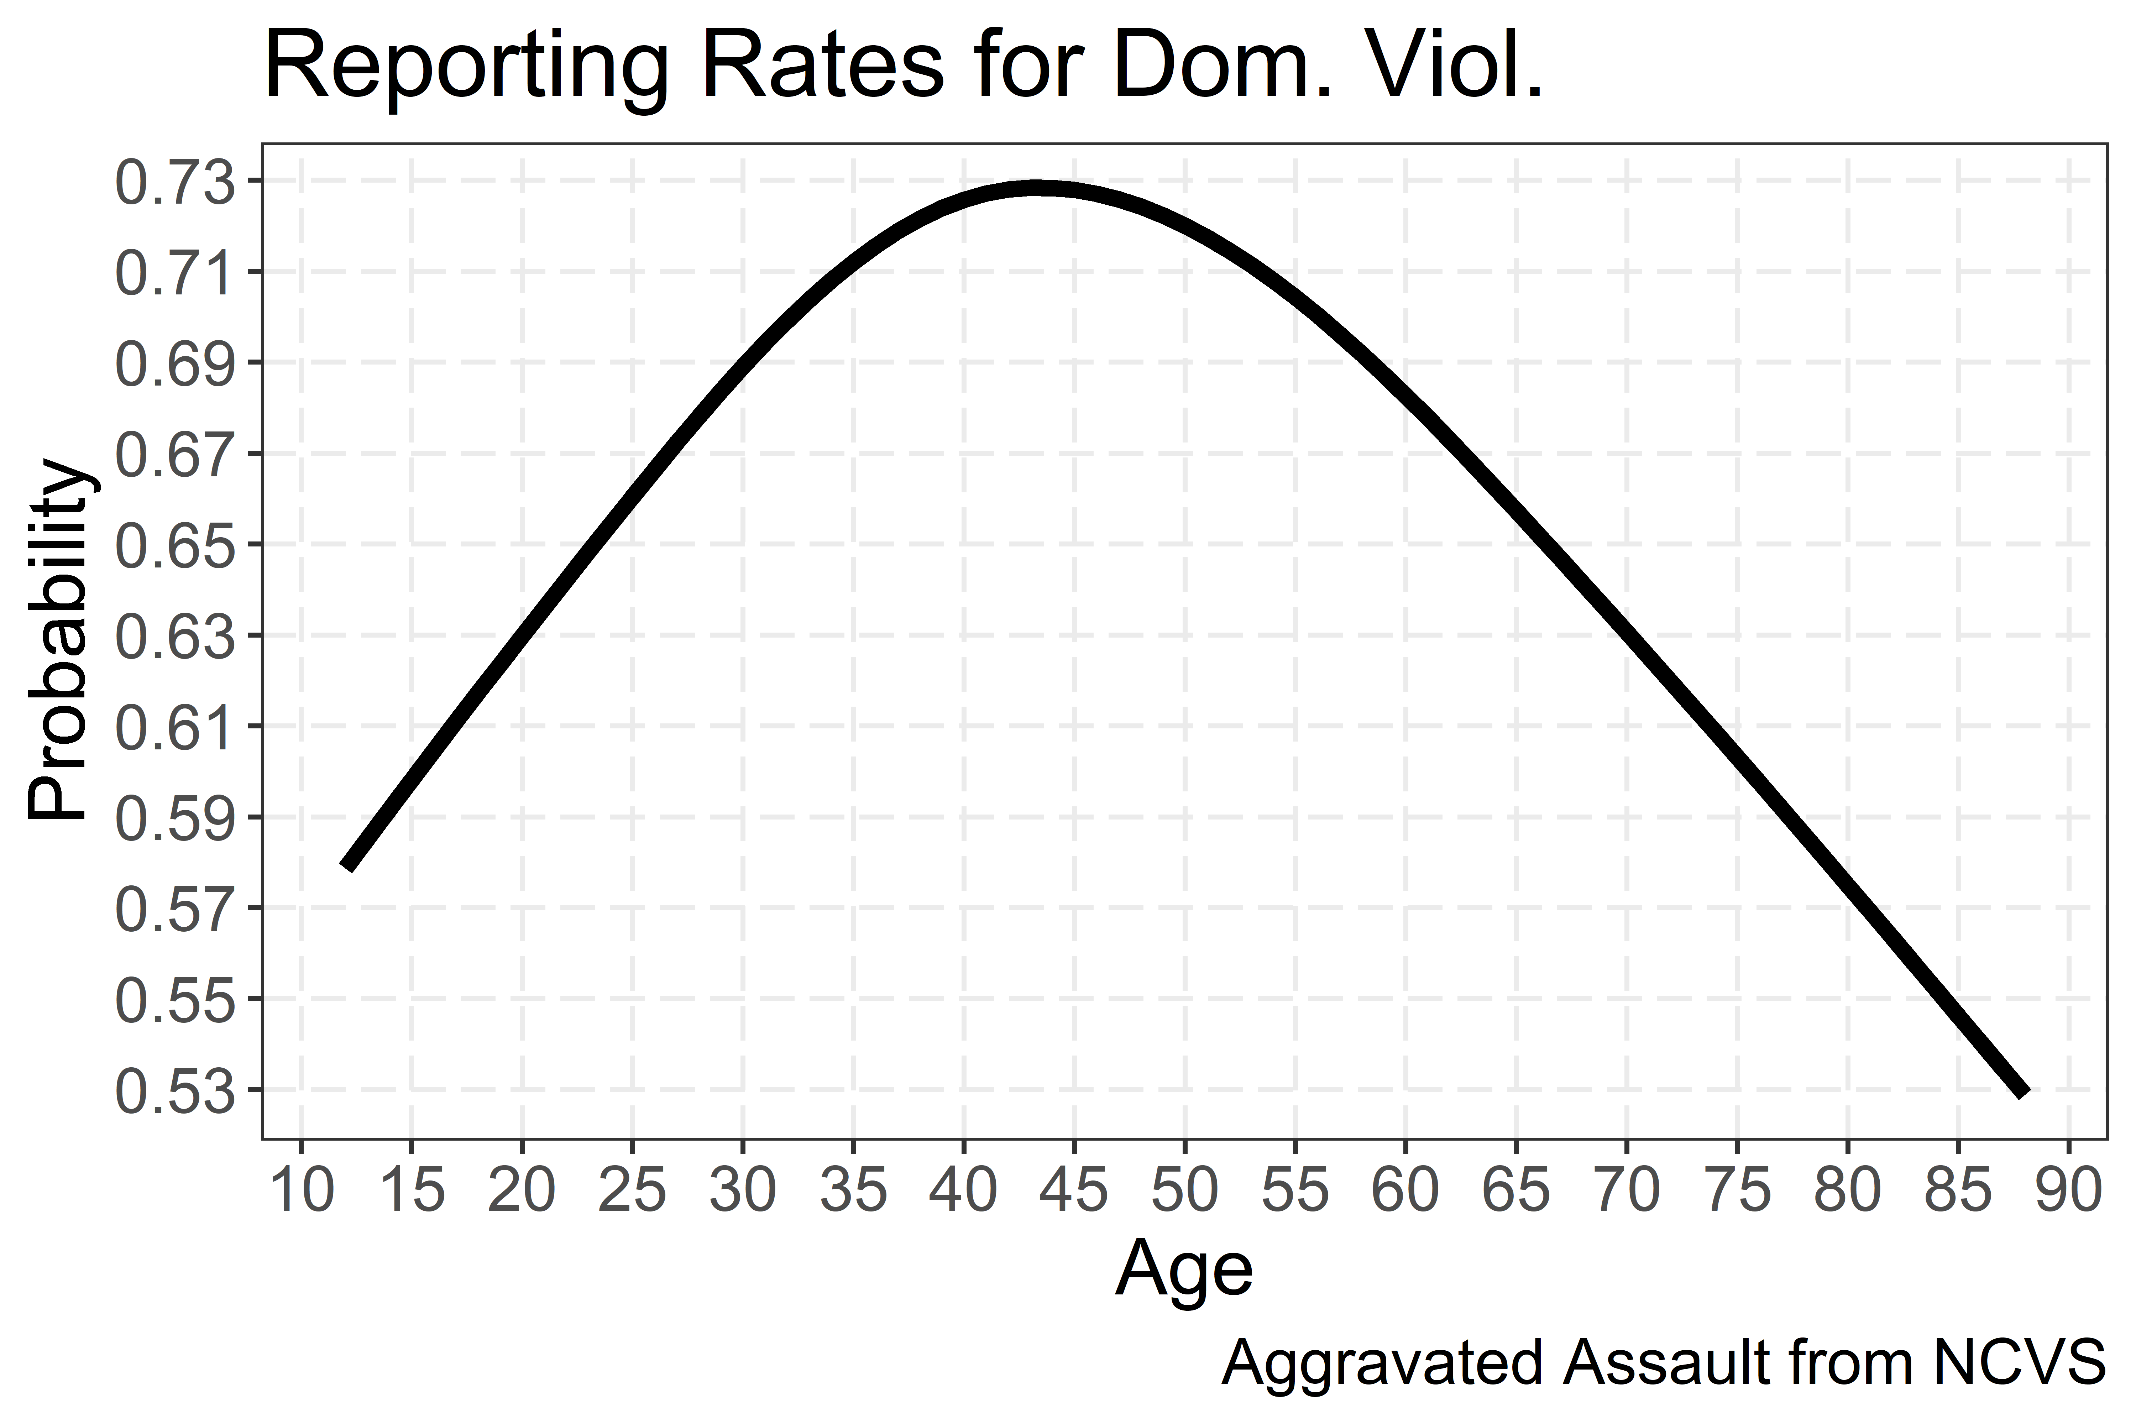

Figure 1: Marginal Age Effects in NCVS Sample

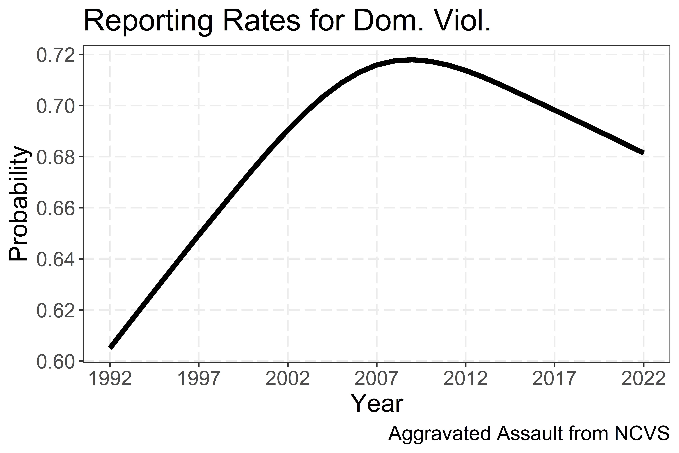

Figure 2: Marginal Year Effects in NCVS Sample

To establish the validity of the model, we show the models predicted calibration. Table 2 takes the predicted probability values for the slightly more than 1,500 NCVS reports, and cuts them into deciles, and shows the models predicted total reported events versus those predicted. One can see from Table 2 that the model is well calibrated, and thus is likely valid to up-adjust reported NIBRS data.

Table 2: Calibration of Model

|  |  |  |
| --- | --- | --- |
| **Decile** | **Observed Reports** | **Predicted Reports** |
| 1 | 74 | 75.4 |
| 2 | 95 | 89.8 |
| 3 | 91 | 96.1 |
| 4 | 104 | 101.7 |
| 5 | 95 | 101.6 |
| 6 | 109 | 106.1 |
| 7 | 116 | 108.0 |
| 8 | 105 | 111.7 |
| 9 | 122 | 117.2 |
| 10 | 118 | 121.4 |

**NIBRS Estimates**

With the model to generate each individual up-weight for the NIBRS reported incidents, one can then examine a particular agency. (It is difficult to estimate specific *geographic areas* that are larger than a single agency, as you would need to have an estimate of the total reporting in the area. There is no simple way to say estimate at the county level with the NIBRS data Kaplan, 2023.)

First, Figure 3 shows some of the agencies with the largest reported number of aggravated domestic assaults in 2022, and their up-adjusted total domestic violence incidents given these models. For example, Las Vegas had a total of just under 1,500 aggravated assault domestic violence incidents, but when taking into account partial reporting, has an estimated over 2,000 events. The average probability of reporting in the sample is around 70%, so the reported counts will be approximately increased by around 40%. This approach however can modify that proportion given the particular reported data, which can vary the multiplier for agencies from 2 (so reporting probabilities closer to 50%), to 1.25 (reporting probabilities closer to 80%).



Figure 3: Top 20 Cities and Upadjusted Domestic Violence Counts

Figures 4 and 5 show the yearly estimates for the Denver Police Department. Figure 4 shows an increase in the NIBRS data starting in 2015, and with more recent increases. This shows that just using the NIBRS reported data, the *trends* are similar when taking into account non-reporting, but just examining the reported NIBRS counts would be an underestimate by several hundred domestic violence incidents in the past several years.

Because the regression model is a statistical estimator, one can generate confidence intervals around the aggregated up-adjusted weight. We use a simulation approach to generate different probabilities for the individual reported NIBRS events (given the standard errors of the predicted probabilities) then calculate the up-adjusted counts (and population rates) for the simulations, and then take the 1st and 99th quantile (so these show 98% confidence intervals). One can see that the errors in the regression modelling are small compared to the yearly variability in Denver.



Figure 4: Denver Counts by Year

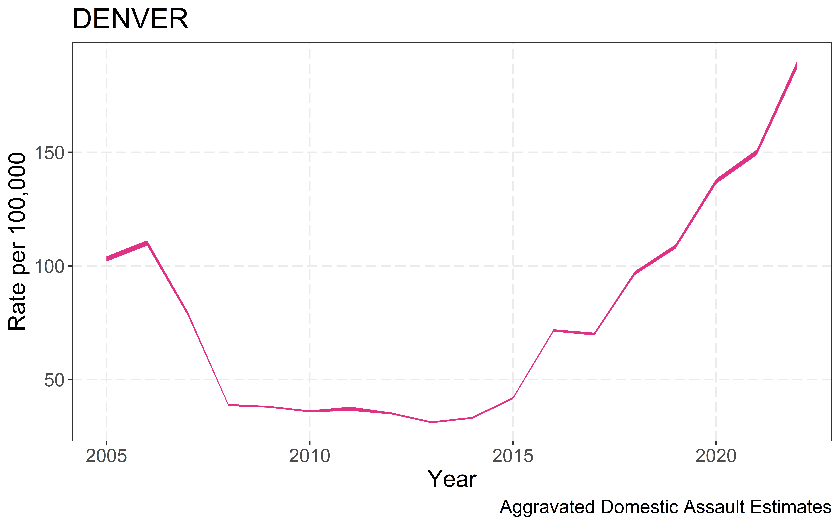

Figure 5: Error estimates in the overall rate per 100,000. Displayed are 99% confidence intervals.

Because NIBRS is voluntary, one only has estimates for agencies since they have been reporting. Honolulu shows recent increases in their data, but has only reported since 2018. Even though it has shown a *slight* decrease in 2022, this is within the margin of error when considering the changes in the two years for the rates over time.



Figure 6: Honolulu Counts by Year

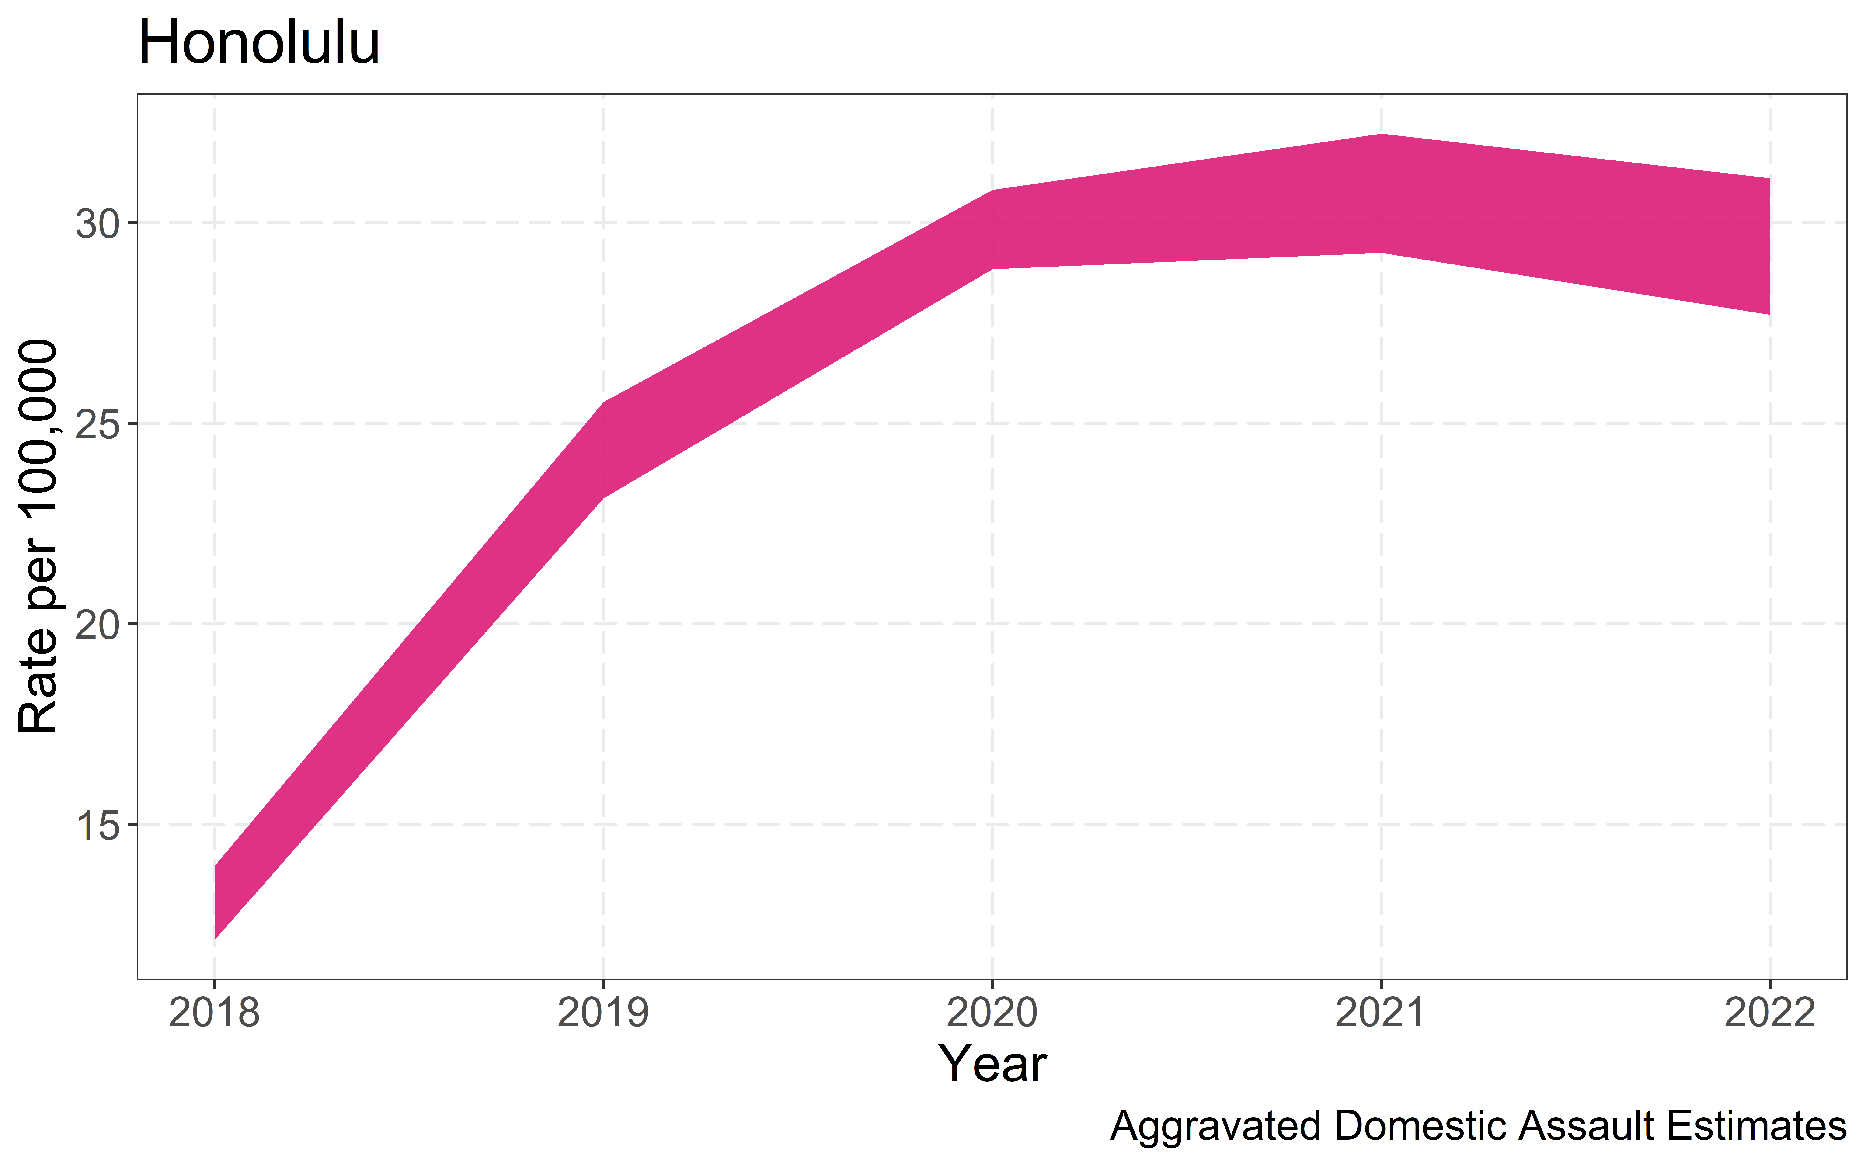

Figure 7: Error Estimates for Honolulu DV Rates

We provide a handful of additional cities graphs in the appendix. This set of cities we have highlighted are for illustrative purposes, but again one can replicate the work and generate graphs for any particular city of interest.

**Conclusion**

Our contributions here are to provide statistical estimates of the dark figure of domestic violence. We show that using police reported aggravated assaults for domestic violence likely undercount counts of assaults by around 40%. We also show in a handful of cities recent increases in domestic violence crimes. These changes in trends would be evident in just examining counts in the NIBRS data itself, but these estimates provide more realistic total counts of domestic violence over time taking into account under-reporting.

Future work can likely extend this in multiple ways. One is to expand the models to not just domestic violence, but additional crimes. Aggravated assault domestic violence overall has reasonably high reporting rates, less serious crimes will have lower reporting rates. Thus, they will have bigger impacts on trends over time. It will also be the case that more accurate modelling of reporting rates can likely be done, given that more serious events are quite rare, but using a multi-level modelling approach of the NCVS. It bears investigating whether reporting rates decreasing in recent years for domestic violence are idiosyncratic to that crime type, or is a more general pattern across multiple crime types.

One aspect of the NIBRS data collection that also is important to consider is that NIBRS is difficult to generate other sub-population estimates. Say, for example, someone wanted the rate in the state of North Carolina, or in counties across the US. Given that agencies have overlapping jurisdictions, and that there is no single repository of geographic areas jurisdictions cover, this is difficult.

To be able to generate geographic estimates, one will need to collate data on jurisdictional boundaries across the NIBRS sample. Once that is completed, generating spatial area estimates for large areas will be more feasible.

A final aspect for future work is applying such estimates in *real time*. Currently, this methodology relies on NIBRS data disseminated by the FBI. There is no fundamental reason however this cannot be done using real time data for a police department(s). A department could generate such estimates using open data they disseminate, given the same information used here for models is disseminated in the open source data. These models aggregate up to the yearly level, but there is no fundamental reason they cannot be applied to smaller temporal slices.

**References**

Harrell, F. E. (2001). *Regression modeling strategies: with applications to linear models, logistic regression, and survival analysis*. New York: Springer.

Kaplan, J. (2023). *Uniform Crime Reporting (UCR) Program Data: A Practitioner’s Guide*. <https://ucrbook.com/>

Kaplan, J. (2024) Jacob Kaplan's Concatenated Files: National Incident-Based Reporting System (NIBRS) Data, 1991-2022. https://www.openicpsr.org/openicpsr/project/118281/version/V9/view

Powers, R. A., & Bleeker, K. (2023). Self-defense and police reporting of intimate partner violent victimization: A comparison of White, Black, and Hispanic women victims*. Journal of Interpersonal Violence*, 38(3-4), 4189-4214.

United States. Bureau of Justice Statistics. *National Crime Victimization Survey, Concatenated File*, [United States], 1992-2022. Inter-university Consortium for Political and Social Research [distributor], 2023-09-18. https://doi.org/10.3886/ICPSR38604.v1

**Additional City Graphs**

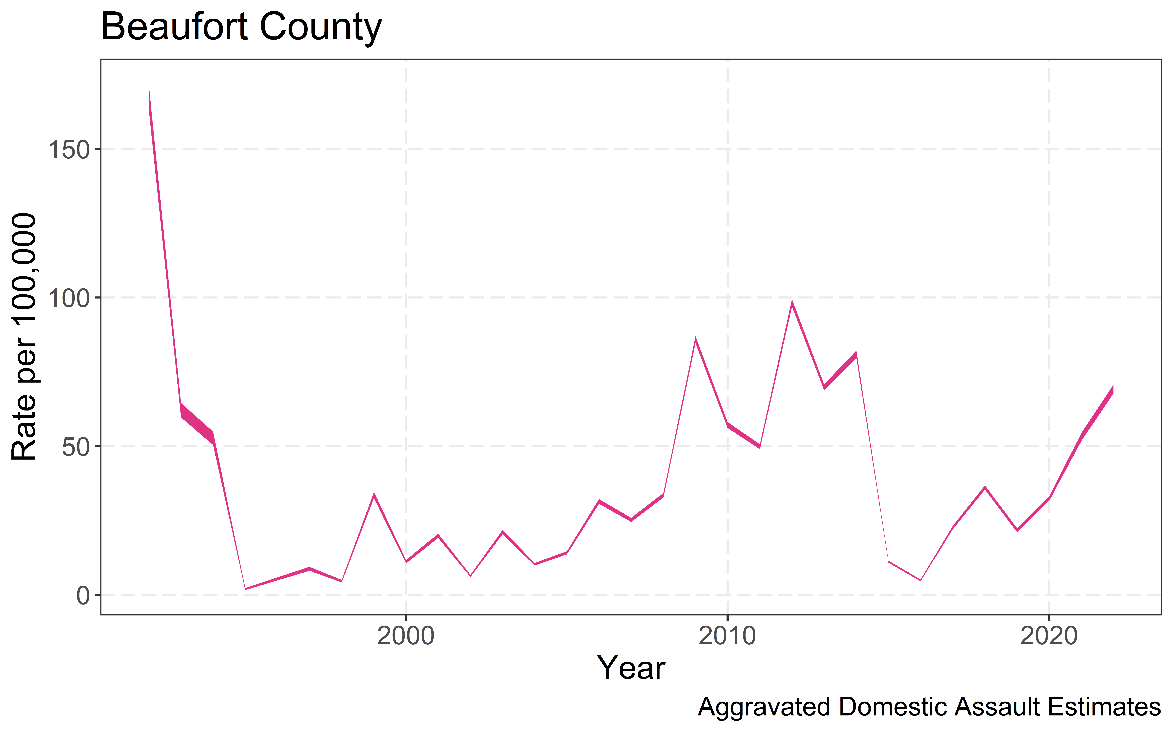



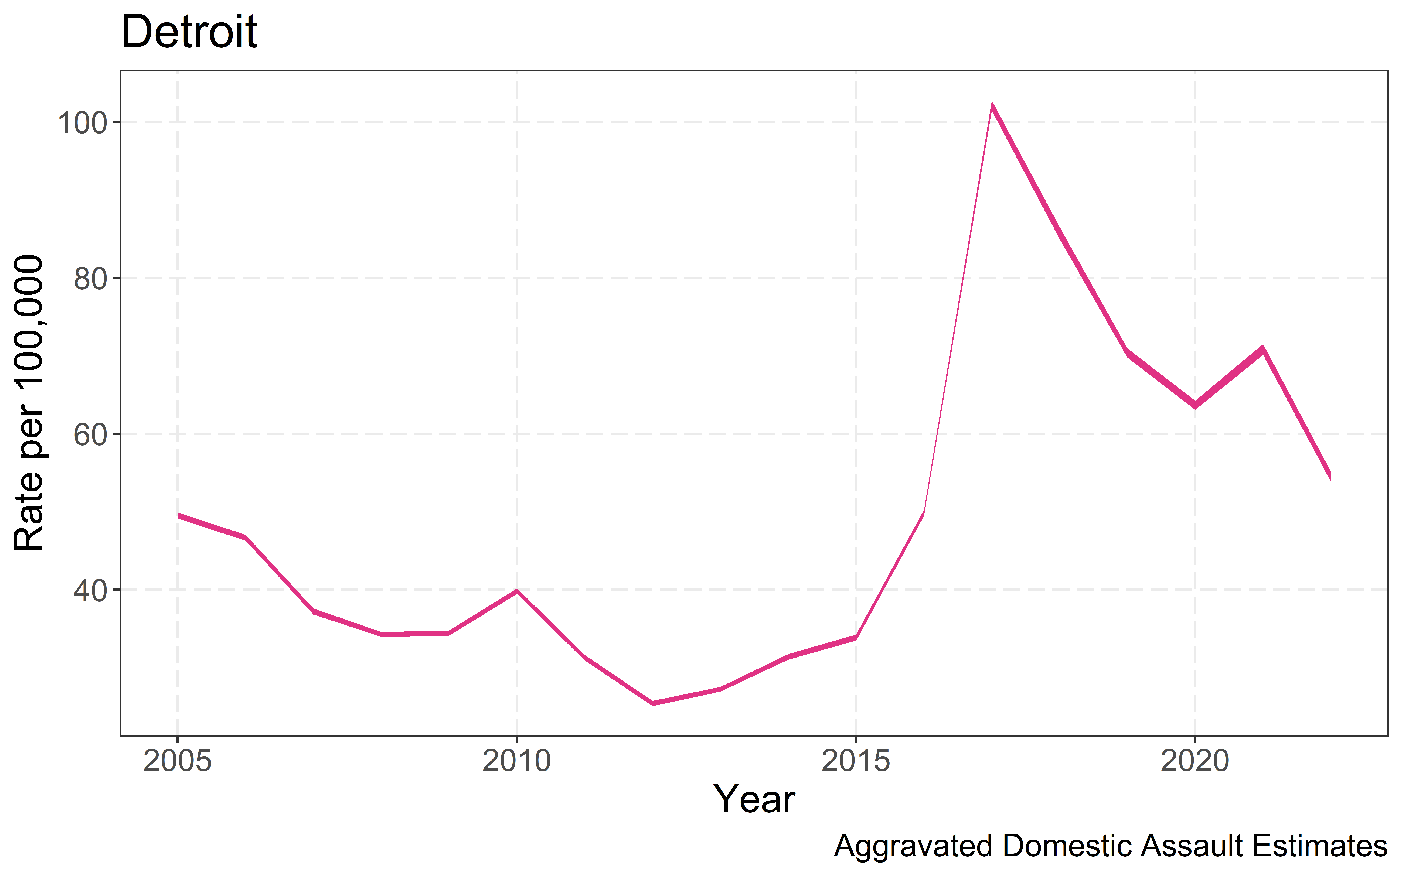



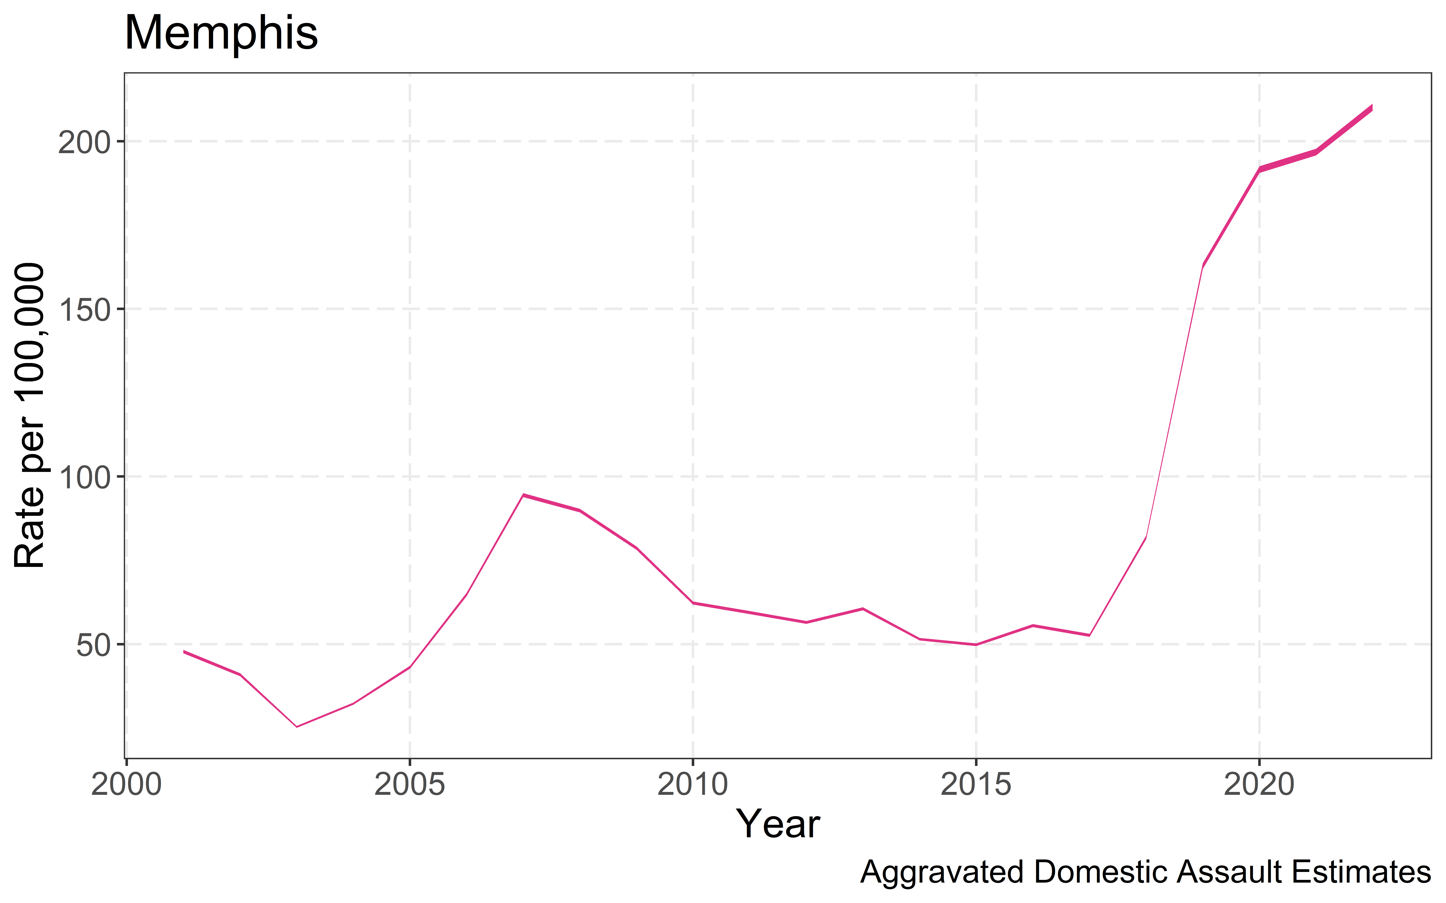



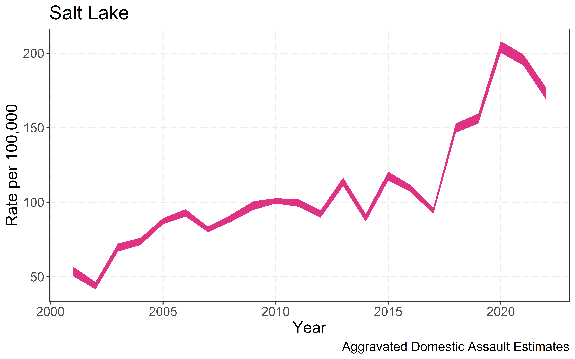

1. Includes the subset of violent victimizations that were committed by current or former intimate partners or family members.
2. Includes the subset of violent victimizations that were committed by current or former spouses, boyfriends, or girlfriends.
3. During Piquero’s term as Director of the Bureau of Justice Statistics, our team of statisticians provided members of the National Plan to End Gender-Based Violence with specific estimates of domestic violence over time. As noted in the Plan (p.18: “An analysis of NCVS data over the past three decades indicates significant declines in incidences of rape, sexual assault, and intimate partner violence. Between 1993 and 2019, the NCVS reflects a 74% decline in intimate partner violence crimes and a 60% decline in rapes and sexual assaults, which tracks a similar (and indeed, even more substantial) decline in other criminal victimizations over the same period.”